**Online Supplement to Pathak et al**

**Supplemental Table 1. Pediatric Case Definitions Used in Study of 2143 Pediatric COVID-19 Cases in China, and Current USA Standard of Care**

|  |  |  |
| --- | --- | --- |
| **Severity Level** | **Definition used in China Study1** | **USA Standard of Care2** |
| Asymptomatic | * No clinical symptoms and signs * Chest imaging is normal while the 2019-nCoV nucleic acid test is in a positive period | None; Few cases identified due to testing shortages |
| Mild | * Symptoms of acute upper respiratory tract infection, including fever, fatigue, myalgia, cough, sore throat, runny nose, and sneezing. * Physical examination shows congestion of the pharynx but no auscultatory abnormalities. * Some cases may have no fever, or have only digestive symptoms such as nausea, vomiting, abdominal pain and diarrhea. | Outpatient and home care with quarantine2 |
| Moderate | * Pneumonia * Frequent fever and cough * Mostly dry cough, followed by productive cough, some may have wheezing, but no obvious hypoxemia such as shortness of breath * Lungs can hear sputum or dry and/or wet snoring. * Some cases may have no clinical signs and symptoms, but chest CT shows lung lesions, which are subclinical. | Outpatient and home care. See clinical care guidelines for pneumonia in children.2 |
| Severe | * Early respiratory symptoms, such as fever and cough, may be accompanied by gastrointestinal symptoms such as diarrhea. * The disease usually progresses around 1 week, and dyspnea occurs with central cyanosis. * Oxygen saturation is less than 92%, with other hypoxia manifestations. | Hospital Admission  Supplemental Oxygen  Supportive Care |
| Critical | * Progression to acute respiratory distress syndrome (ARDS) or respiratory failure * May also have shock, encephalopathy, myocardial injury or heart failure, coagulation dysfunction, and acute kidney injury. * Organ dysfunction can be life threatening. | Pediatric ICU Admission  Mechanical Ventilation  Supportive Care |

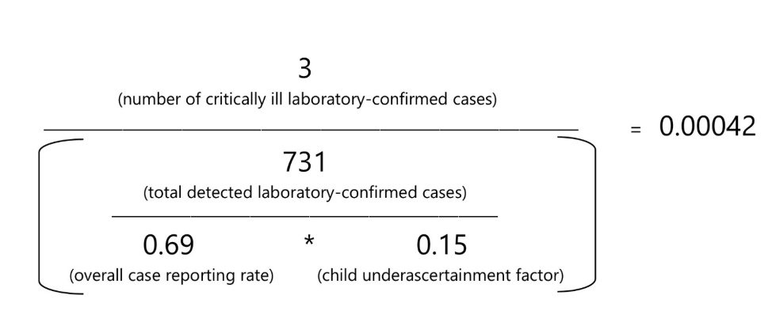 **Supplemental Figure 1. Calculation of Adjusted Pediatric Criticality Proportion**

**Supplemental Table 2. Derivation of Age-Specific Severity and Criticality Proportions from the Empirical Results of Dong et al.**

|  |  |  |  |  |  |  |  |  |  |  |  |  |  |  |
| --- | --- | --- | --- | --- | --- | --- | --- | --- | --- | --- | --- | --- | --- | --- |
|  | **All Cases of COVID-19 (Confirmed + Suspected)** | | | | | | | **Confirmed Cases of COVID-19 Only** | | | | | | |
| **Age Range in Years** | **Severe Cases** | **Critical Cases** | **Severe + Critical Cases** | **Total Detected Cases** | **\* Adjusted Total Cases** | **^  Severity Proportion** | **^^  Criticality Proportion** | **Severe Cases** | **Critical Cases** | **Severe + Critical Cases** | **Total Detected Cases** | **\* Adjusted Total Cases** | **\*\*  Severity Proportion** | **\*\*\*  Criticality Proportion** |
| <1 | 33 | 7 | 40 | 379 | 3662 | 0.01092 | 0.00191 | NR | NR | NR | 86 | 831 | 0.00537 | 0.00127 |
| 1-5 | 34 | 2 | 36 | 493 | 4763 | 0.00756 | 0.00042 | NR | NR | NR | 137 | 1324 | 0.00372 | 0.00028 |
| 6-15 | 36 | 3 | 39 | 934 | 9024 | 0.00432 | 0.00033 | NR | NR | NR | 351 | 3391 | 0.00212 | 0.00022 |
| 16-17 | 9 | 1 | 10 | 335 | 3237 | 0.00309 | 0.00031 | NR | NR | NR | 157 | 1517 | 0.00152 | 0.00021 |
| 0 to 17 | 112 | 13 | 125 | 2141 | 20686 | 0.00604 | 0.00063 | 18 | 3 | 21 | 731 | 7063 | 0.00297 | 0.00042 |
| NR = not reported (by Dong et al)  * Adjusted total cases = all detected cases + all non-detected cases. Non-detected cases were estimated using the formula: (detected cases / (0.69 * 0.15))  Best-fit model posterior estimate of reporting rate for Jan 24 to Feb 8, per Li et al Supplement p.42 is 0.69 (95% CI 0.66-0.71).  Because detection varies by age, with children having higher non-detection rates, we adjust the detection rate downward for kids.  Using age-specific data presented in Verity et al, we estimate that child detection is only 15% of adult detection.   ^ Severity proportion for all cases = number of severe + critical cases / adjusted total cases  ^^ Criticality proportion for all cases = number of critical cases / adjusted total cases  ** Severity proportion for confirmed cases = number of severe + critical cases / adjusted total cases.  Since the severity of illness breakdown was not provided by age for confirmed cases in Dong et al, the age-specific severity proportions for confirmed cases were calculated by multiplying the age-specific severity proportions for all cases by 0.4917, the ratio of the severity proportion among confirmed cases to the severity proportion among all (confirmed + suspected) cases.   *** Criticality proportion for confirmed cases = number of critical cases / adjusted total cases.  Since the severity of illness breakdown was not provided by age for confirmed cases in Dong et al, the age-specific severity proportions for confirmed cases were calculated by multiplying the age-specific severity proportions for all cases by 0.6667, the ratio of the criticality proportion among confirmed cases to the criticality proportion among all (confirmed + suspected) cases. | | | | | | | | | | | | | | |

**Supplemental Table 3. Estimated Number of Children Infected with SARS-CoV-2 in the United States**

**March 18, 2020, to April 6, 2020**

|  |  |  |  |  |
| --- | --- | --- | --- | --- |
| **Date** | **< 2 years old** | **2-11 years old** | **12-17 years old** | **0-17 years old** |
| 3/18 | 2381 (2288, 2461) | 0 (0, 0) | 0 (0, 0) | 2381 (2288, 2461) |
| 3/19 | 2381 (2288, 2461) | 2381 (2288, 2461) | 0 (0, 0) | 4762 (4576, 4922) |
| 3/20 | 2381 (2288, 2461) | 2381 (2288, 2461) | 7143 (6863, 7384) | 11 905 (11 439, 12 306) |
| 3/21 | 2381 (2288, 2461) | 2381 (2288, 2461) | 7143 (6863, 7384) | 11 905 (11 439, 12 306) |
| 3/22 | 2381 (2288, 2461) | 7143 (6863, 7384) | 7143 (6863, 7384) | 16 667 (16 015, 17 229) |
| 3/23 | 4762 (4576, 4922) | 7143 (6863, 7384) | 9524 (9151, 9845) | 21 429 (20 590, 22 151) |
| 3/24 | 14 286 (13 727, 14 767) | 14 286 (13 727, 14 767) | 14 286 (13 727, 14 767) | 42 857 (41 181, 44 302) |
| 3/25 | 16 667 (16 015, 17 229) | 14 286 (13 727, 14 767) | 19 048 (18 302, 19 690) | 50 000 (48 044, 51 686) |
| 3/26 | 16 667 (16 015, 17 229) | 14 286 (13 727, 14 767) | 23 810 (22 878, 24 612) | 54 762 (52 620, 56 608) |
| 3/27 | 21 429 (20 590, 22 151) | 14 286 (13 727, 14 767) | 33 333 (32 029, 34 457) | 69 048 (66 346, 71 376) |
| 3/28 | 26 190 (25 166, 27 074) | 14 286 (13 727, 14 767) | 38 095 (36 605, 39 380) | 78 571 (75 498, 81 221) |
| 3/29 | 30 952 (29 741, 31 996) | 26 190 (25 166, 27 074) | 40 476 (38 893, 41 841) | 97 619 (93 800, 100 911) |
| 3/30 | 33 333 (32 029, 34 457) | 26 190 (25 166, 27 074) | 47 619 (45 756, 49 225) | 107 143 (102 951, 110 756) |
| 3/31 | 33 333 (32 029, 34 457) | 26 190 (25 166, 27 074) | 52 381 (50 332, 54 147) | 111 905 (107 527, 115 678) |
| 4/1 | 42 857 (41 181, 44 302) | 28 571 (27 454, 29 535) | 59 524 (57 195, 61 531) | 130 952 (125 829, 135 368) |
| 4/2 | 42 857 (41 181, 44 302) | 33 333 (32 029, 34 457) | 61 905 (59 483, 63 992) | 138 095 (132 693, 142 752) |
| 4/3 | 47 619 (45 756, 49 225) | 35 714 (34 317, 36 919) | 61 905 (59 483, 63 992) | 145 238 (139 556, 150 135) |
| 4/4 | 47 619 (45 756, 49 225) | 40 476 (38 893, 41 841) | 64 286 (61 771, 66 453) | 152 381 (146 420, 157 519) |
| 4/5 | 52 381 (50 332, 54 147) | 40 476 (38 893, 41 841) | 71 429 (68 634, 73 837) | 164 286 (157 859, 169 825) |
| 4/6 | 52 381 (50 332, 54 147) | 42 857 (41 181, 44 302) | 80 952 (77 785, 83 682) | 176 190 (169 298, 182 131) |

This table is based on the same data as Figure 2 in the main text. For each day between March 18 and April 6, 2020, and for each age group, the estimated number of children infected with SARS-CoV-2 in the United States is presented. The estimated detection rate from Li et al upon which estimates are based was 69%. The estimate bounds in parentheses were created by a sensitivity analysis that recalculated estimates using the bounds of the 95% CI interval for the detection rate in Li et al (66% to 71%).

**REFERENCES**

1. Dong Y, Mo X, Hu Y, et al. Epidemiological Characteristics of 2143 Pediatric Patients with 2019 Coronavirus Disease in China. *Pediatrics.* 2020.
2. Bradley JS, Byington CL, Shah SS, et al. The Management of Community-Acquired Pneumonia in Infants and Children Older Than 3 Months of Age: Clinical Practice Guidelines by the Pediatric Infectious Diseases Society and the Infectious Diseases Society of America *Clin Infect Dis*. 2011 Oct 1; 53(7): e25–e76.