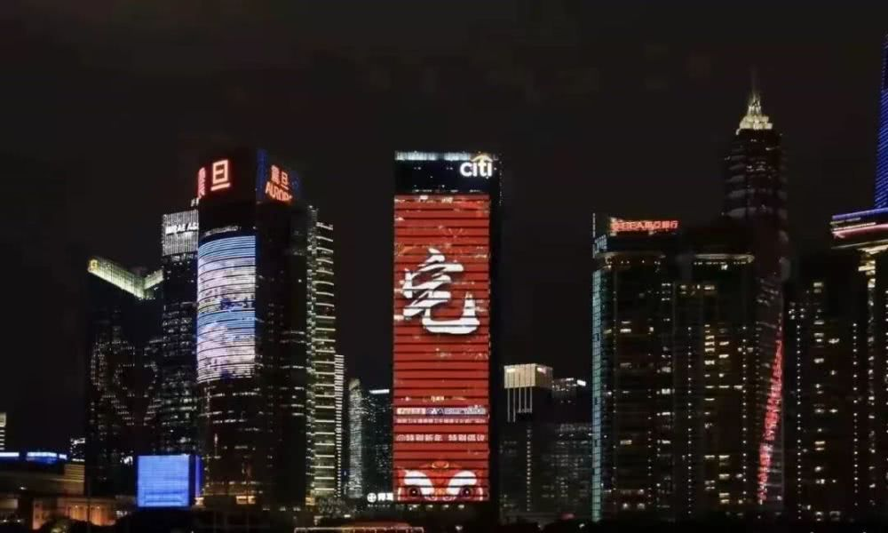
Supplemental Digital Content Figure 1. Exterior lighting of high-rise buildings to promote COVID-19 prevention “stay-at-home” strategy.¹⁴

