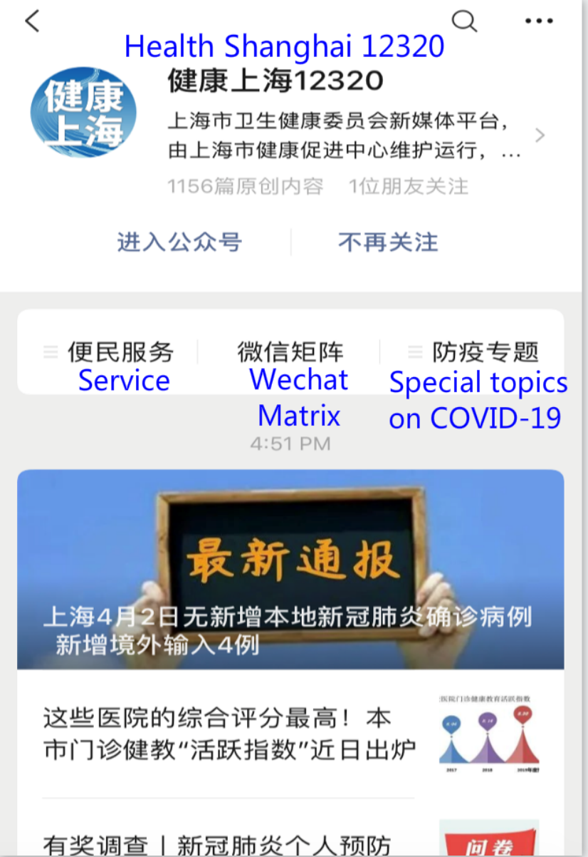
Supplemental Digital Content Figure 2. The Health Shanghai 12320 WeChat official account run by the Shanghai Health Commission.¹⁵

