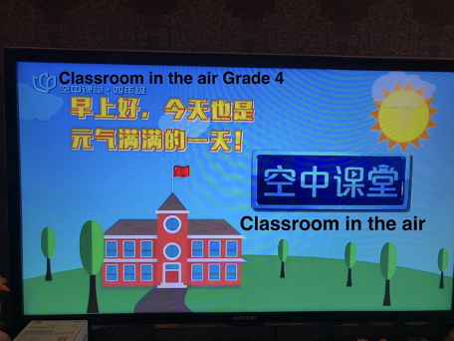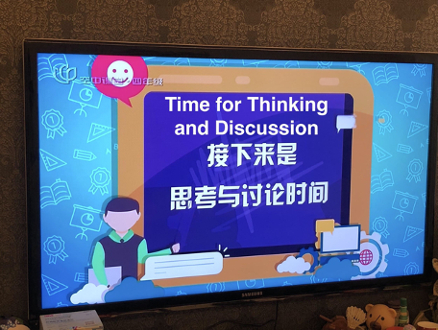
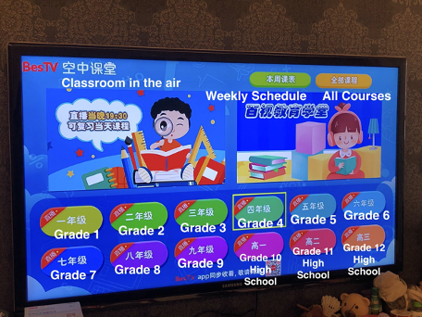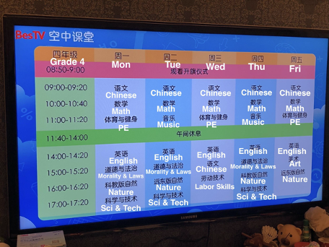
Supplemental Digital Content Figure 3. A unified teaching schedule has been adopted by all the primary and secondary schools in Shanghai. The online courses have been broadcast on TV in 12 channels.^{17,18}

