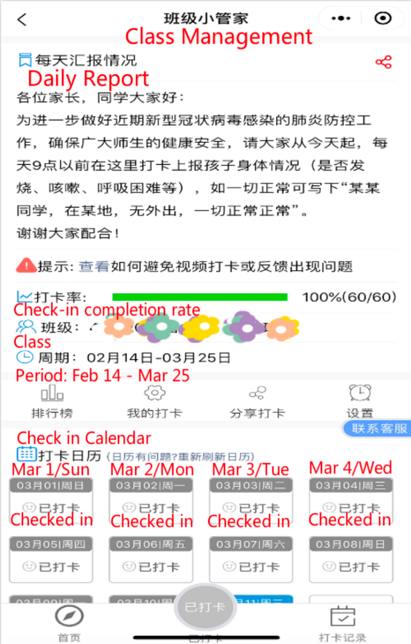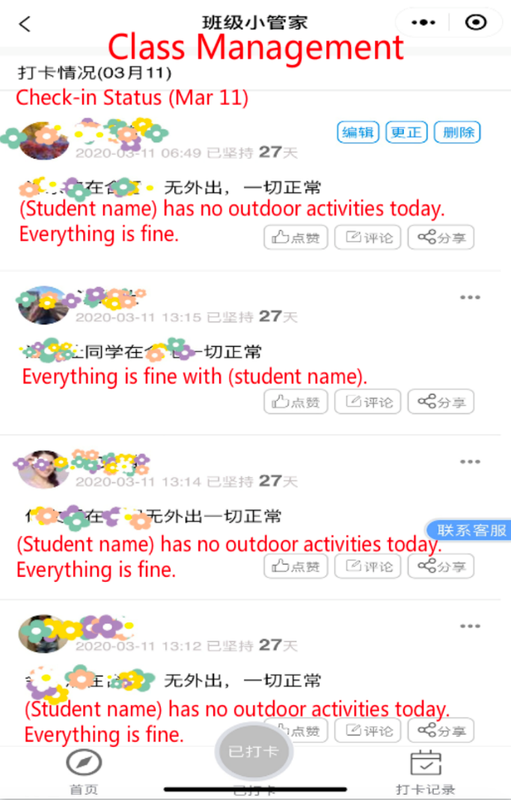
Supplemental Digital Content Figure 4. Parents check in daily with teachers about students’ health status using WeChat

