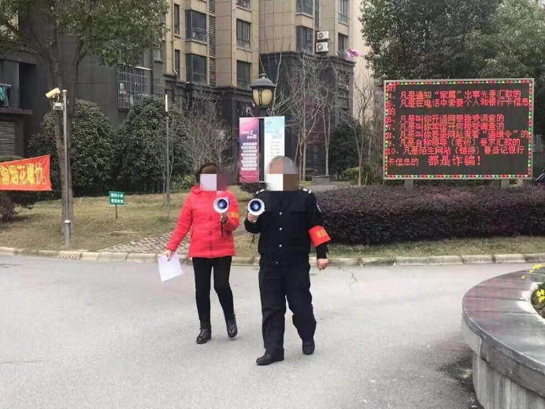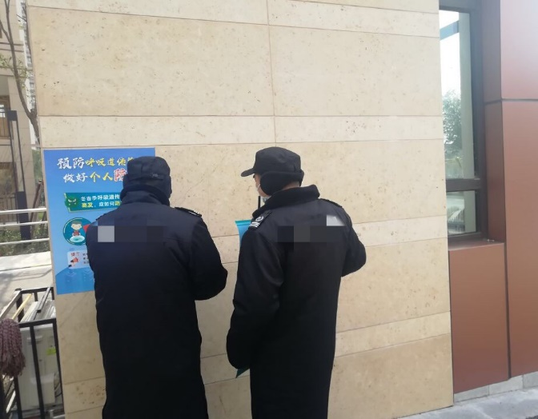
Supplemental Digital Content Figure 7. Neighborhood committee members (Left), and property management staff (Right) promote health management for residents.²¹

