251658240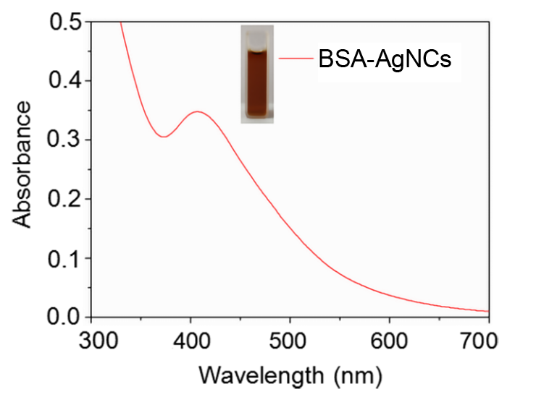

Additional Figure 1. The UV-Vis spectra of BSA-AgNCs. BSA-AgNCs=bovine serum albumin-silver nanoclusters, UV-Vis=ultraviolet and visible spectrophotometry.

251658240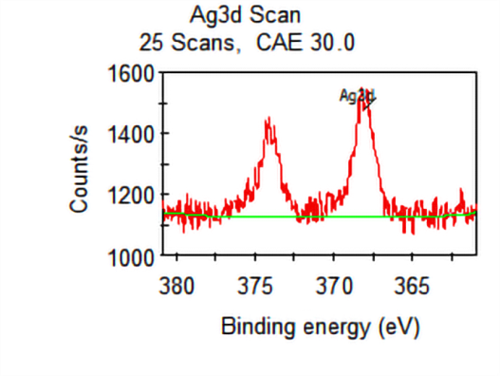
Additional Figure 2. The XPS spectra of BSA-AgNCs. BSA-AgNCs=bovine serum albumin-silver nanoclusters, XPS=X-ray photoelectron spectroscopy.

