Additional files

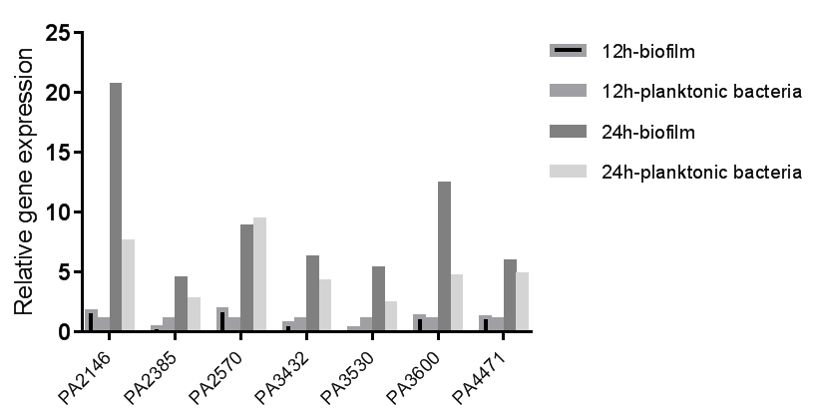
Additional Figure 1. The different expressed genes between the biofilm bacteria and planktonic bacterial of PAO1. PAO1 were cultured as biofilm (static) and planktonic (shake, 180rpm) cells for 12 and 24 hours respectively, the bacterial was collected and the genes transcription was measured by qPCR.

Additional Table 1. Primers for qPCR and PA2146 complementation
Primers | Oligonucleotide (5’→3’) | Reference
Primers for qPCR
16S rRNA-F | GCGCAACCCTTGTCCTTAGTT |  | Zhao et al^{[1]}
16S rRNA-R | TGTCACCGGCAGTCTCCTTAG
pqsA-F | GACCGGCTGTATTCGATTC |  | Yin et al^{[2]}
pqsA-R | GCTGAACCAGGGAAAGAAC
pqsB-F | ACGTCAAGGGACACCTCAAC |  | Cummins et al^{[3]}
pqsB-R | GATCAGCAGCAGTTCATCCA
pqsC-F | CGAGTCCTGGTGGCAATTCT |  | Knoten et al^{[4]}
pqsC-R | TCAGCATGTCCACGCTATCC
pqsD-F | GTGGATCGTCTGGGCAACAT |  | Knoten et al^{[4]}
pqsD-R | CTCCTCAGGTTTGCGGTACA
pqsE-F | TGATGACCTGTGCCTGTTGG |  | Knoten et al^{[4]}
pqsE-R | GTCGTAGTGCTTGTGGGTGA
pqsH-F | GCGCGGATCGAGTTCATC |  | Viducic et al^{[5]}
pqsH-R | CAGGGCGATTCCCACTGA
phnA-F | ACGTGGACAGCAAGGCTGCG |  | Knoten et al^{[4]}
phnA-R | GGGCCGGACAGTCCTCGCTC
lasR-F | ACGCTCAAGTGGAAAATTGG |  | El-Mowafy et al^{[6]}
lasR-R | GTAGATGGACGGTTCCCAGA
rhlR-F | AGGAATGACGGAGGCTTTTT |  | El-Mowafy et al^{[6]}
rhlR-R | CCCGTAGTTCTGCATCTGGT
rhlI-F | CTCTCTGAATCGCTGGAAGG |  | El-Mowafy et al^{[6]}
rhlI-R | GACGTCCTTGAGCAGGTAGG
rhlA-F | GATCGAGCTGGACGACAAGTC |  | Pattnaik et al^{[7]}
rhlA-R | GCTGATGGTTGCTGGCTTTC
PA3600-F | ATGAAAGTCCTCGCCTCGCT |  | This study
PA3600-R | GGATTCGACTTGCAGATCACGT
PA3530-F | CTGCCTCTGCCAAGGTGTTAC |  | This study
PA3530-R | GCACTTGCCGCACTGGGTAC
PA3432-F | GCTGATGAGCCTGCTCGACTACGG |  | This study
PA3432-R | CGGCACATCCACTCCACCGACA
PA4471-F | TTCGAGAAAGCCTACAACCTCCTG |  | This study
PA4471-R | CTGCCGTTGGTGGTCAGTCG
PA2385-F | GCGGGTTGCTGGCTTTCTCC |  | This study
PA2385-R | TCGGCGTCGATCTGCCTGTC
PA2146-F | ATGGCACAGCATCAAGGTGG |  | This study
PA2146-R | CGCTGCGGATCGTTCTTGA
PA2570-F | TATCTACAATCCGGGCGATG |  | This study
PA2570-R | GACCAGCGCACCACAAAA
Primers for PA2146 complementation
pRK415-F | caacgcaattaatgtgagttagctcac |  | This study
pRK415-R | ctcttcgctattacgccagctg
PA2146-up | atatctagaTAATCTGAACCACTGGCGAAACACC XbaI |  | This study
PA2146-down | atagaattCACTTCACTGCGCGGTTATCAGTTC EcoRI

References
[1] Zhao J, Jiang H, Cheng W, et al. The role of quorum sensing system in antimicrobial induced ampC expression in Pseudomonas aeruginosa biofilm. J Basic Microbiol 2015;55:671-678.
[2] Yin S, Jiang B, Huang G, et al. The Interaction of N-acetylcysteine and serum transferrin promotes bacterial biofilm formation. Cell Physiol Biochem 2018;45:1399-1409.
[3] Cummins J, Reen FJ, Baysse C, et al. Subinhibitory concentrations of the cationic antimicrobial peptide colistin induce the pseudomonas quinolone signal in Pseudomonas aeruginosa. Microbiology (Reading). 2009;155:2826-2837.
[4] Knoten CA, Wells G, Coleman JP, et al. A conserved suppressor mutation in a tryptophan auxotroph results in dysregulation of Pseudomonas quinolone signal synthesis. J Bacteriol 2014;196:2413-2422.
[5] Viducic D, Murakami K, Amoh T, et al. RpoN modulates carbapenem tolerance in Pseudomonas aeruginosa through Pseudomonas quinolone signal and PqsE. Antimicrob Agents Chemother 2016;60:5752-5764.
[6] El-Mowafy SA, Abd El Galil KH, El-Messery SM, et al. Aspirin is an efficient inhibitor of quorum sensing, virulence and toxins in Pseudomonas aeruginosa. Microb Pathog 2014;74:25-32.
[7] Pattnaik S, Ahmed T, Ranganathan SK, et al. Aspergillus ochraceopetaliformis SSP13 modulates quorum sensing regulated virulence and biofilm formation in Pseudomonas aeruginosa PAO1. Biofouling 2018;34:410-425.

