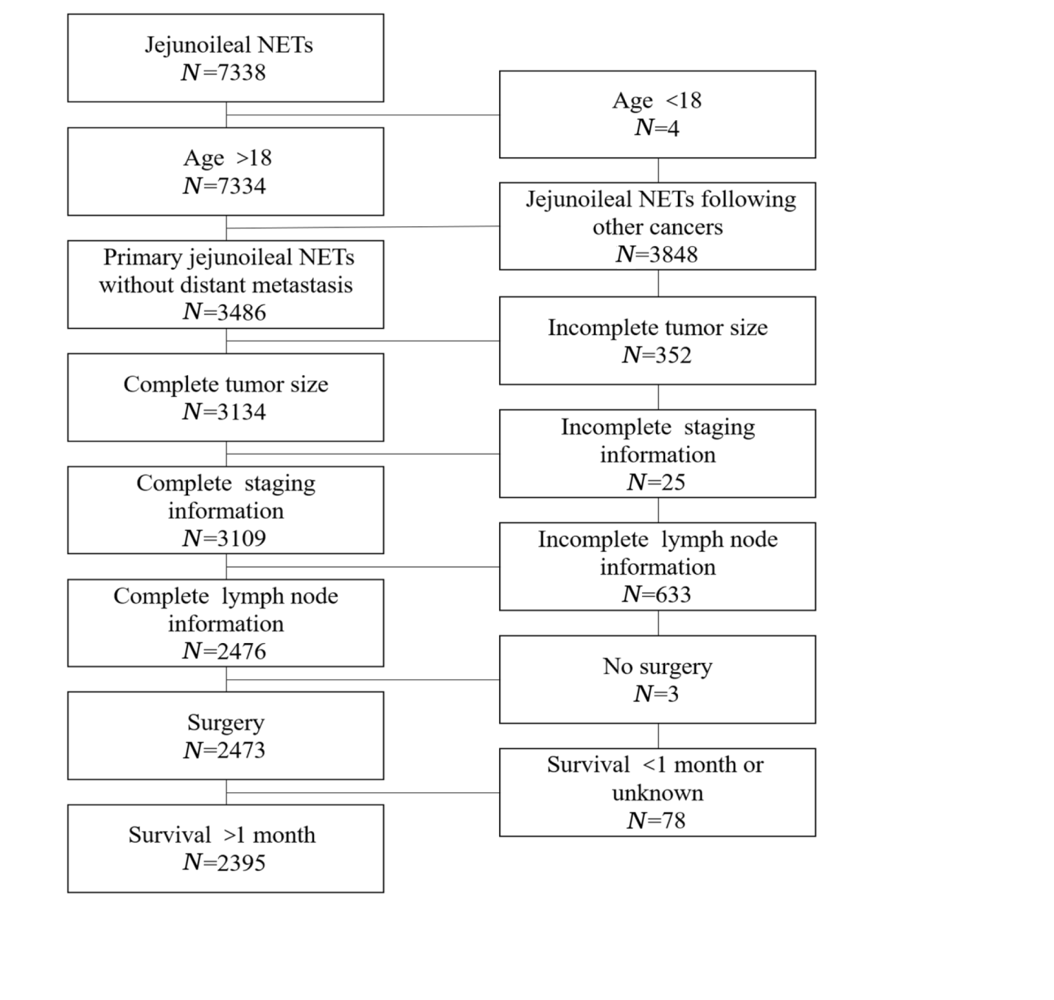
Additional Figure 1. The program selection details for the Surveillance, Epidemiology and End Results (SEER) database queries. NETs=neuroendocrine tumors.

Additional Table 1
Multivariate analysis of the number of PLNs influencing overall survival in patients with jejunoileal neuroendocrine tumors.
Characteristic | HR(95%CI) | P-value
Age (year) |  | <0.001
≤60 | — | —
61-75 | 2.914(2.283-3.719) | <0.001
>75 | 8.711(6.737-11.265) | <0.001
Site |  | 0.512
Jejunum | — | —
Ileum | 0.899(0.655-1.235) | 0.512
Size (cm) |  | 0.001
≤1 | — | —
1-2 | 0.754(0.561-1.012) | 0.060
>2 | 1.116(0.824-1.510) | 0.478
T classification |  | <0.001
T1 | — | —
T2 | 1.608(0.885-2.920) | 0.119
T3 | 2.855(1.619-5.032) | <0.001
T4 | 2.889(1.611-5.180) | <0.001
PLNs |  | 0.236
Negative | — | —
<12 | 0.962(0.751-1.231) | 0.756
≥12 | 0.417(0.152-1.144) | 0.089
CI=confidence interval, HR=hazard ratio, PLNs=positive lymph nodes. P<0.05, indicates a significant difference.

