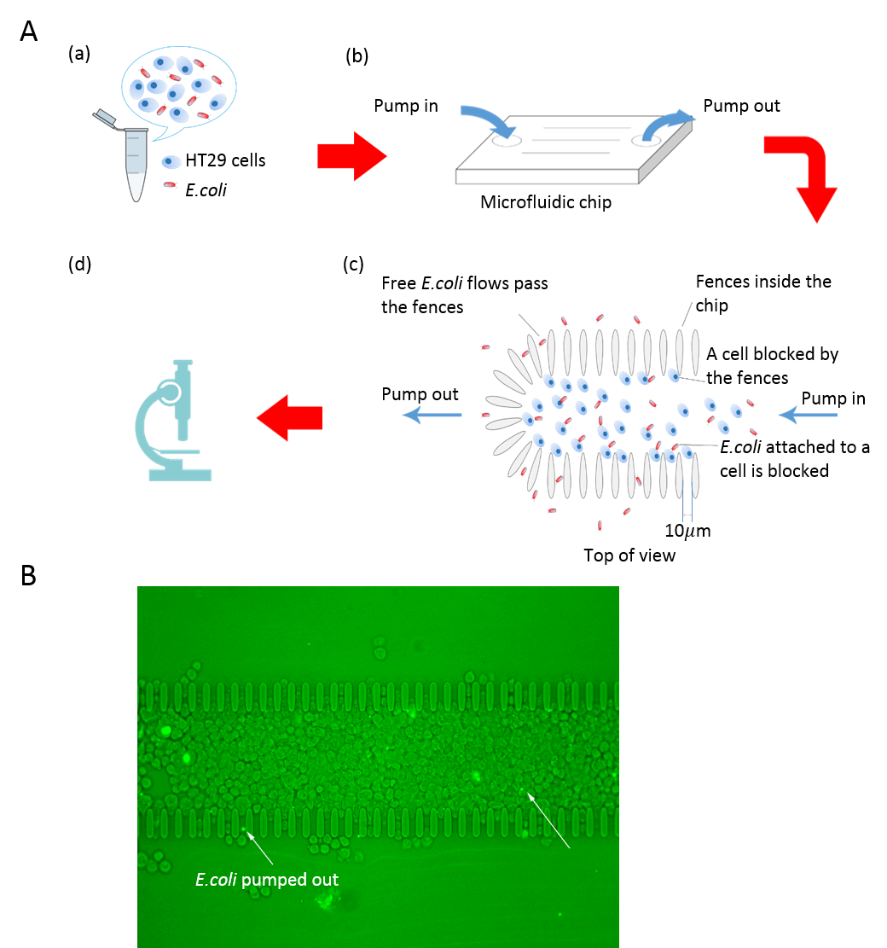
Additional Figure 1. Microfluidic chip observation. (A) Workflow of microfluidic observation. (a) Pretreatment step. colorectal adenocarcinoma cell line (HT29) cells and engineered ice nucleation protein (INP)-P30-1 + enhanced green fluorescent protein (EGFP) Escherichia coli (E. coli) are co-incubated in 37°C for 0.5hour. (b) Sample loading step. A suspension composed both of bacteria and cells is then injected into a hole on a designed microfluidic chip and removed from the chip through an air pump. (c) Top view of the chip. The overall structure of the microfluidic chip is designed as a ‘U’ shape pocket, with an open mouth for embracing the suspension and a close end for filtering out the free bacteria. The gap of the grating is 10, in such case, E. coli bound to the cell is trapped in the pocket while free E. coli could continuously flow pass the zone under the pressure of the air pump. (d) Fluorescence observation. (B) A snapshot of real-time fluorescence observation. The free E. coli and that bound to the cell can be observed under the Alex fluorescent 488 channel with the reporter EGFP.

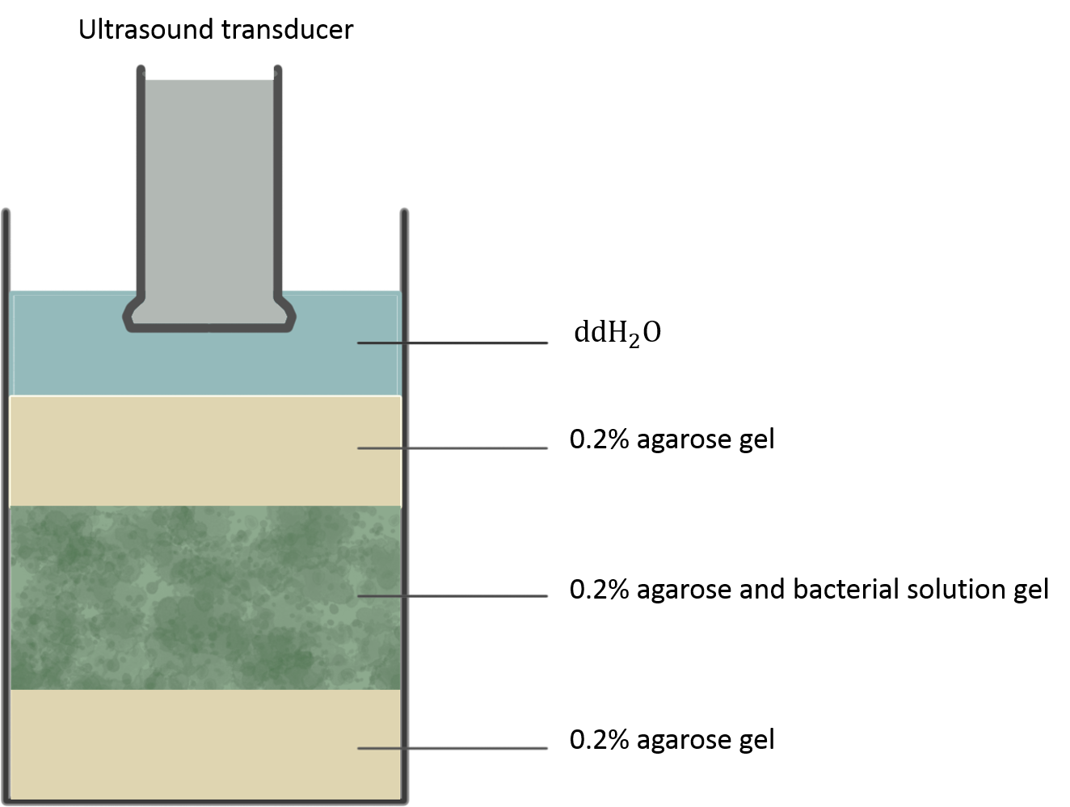
Additional Figure 2. Diagram of experiment setup for ultrasound imaging in vitro. ddH₂O=double distilled H₂O.

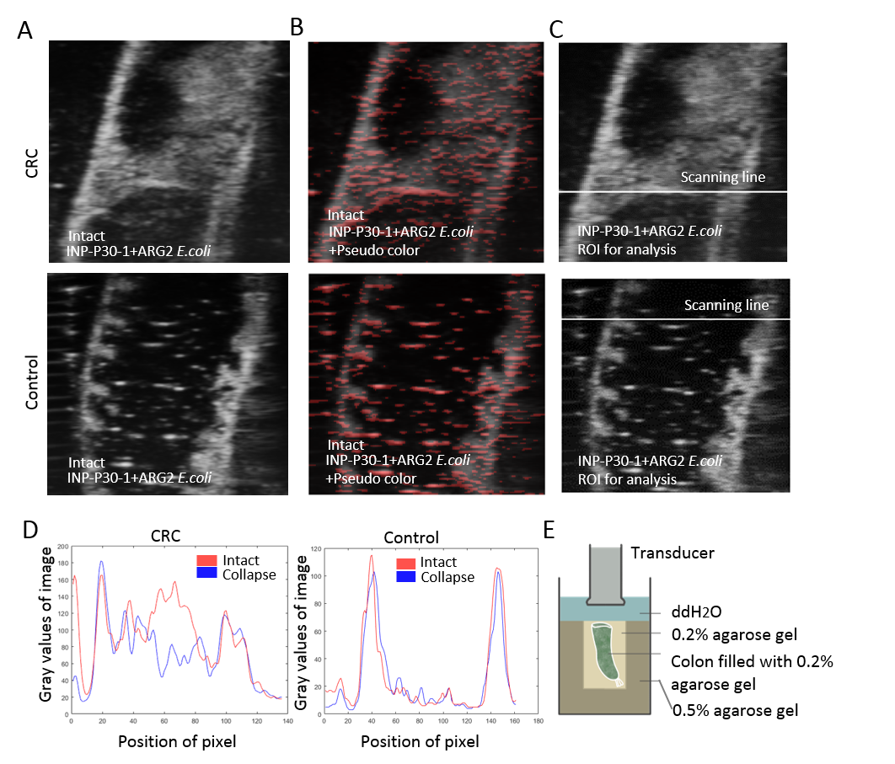
Additional Figure 3. Imaging experiment of INP-P30-1 + ARG2 Escherichia coli (E. coli) in the screening of normal colon and colorectal cancer (CRC) colon ex vivo. (A) Ultrasound images of INP-P30-1 + ARG2 E. coli in CRC colon and control normal colon before gas vesicle collapse. INP-P30-1 + ARG2 E. coli was injected into both CRC and control colon. After incubating for 30minutes in 37°C, both colons were washed with PBS for three times to eliminate unspecific binding and filled with 0.2% agarose gel to stabilize. Ultrasound imaging of the colons was then performed. (B) The blended images of the original image in A and the pseudo-colored subtraction image before and after gas vesicle collapse. The pseudo color indicates pixel intensity change after collapse. Intensity change is observed in many areas outside the colon wall in control group, partly owing to the noise induced by motions of colon in imaging and collapse process. (C) The scanning line used for analysis in D. (D) The gray value plot of pixels on the scanning line before and after collapse. There is a significant signal drop in CRC group while not in control group at the analysis position, ie, the scanning line. It should be notified that the difference doesn’t hold up well in other analysis positions due to the high degree of false positive in control colon. (E) Experiment setup for ex vivo ultrasound imaging. ddH₂O=double distilled H₂O.

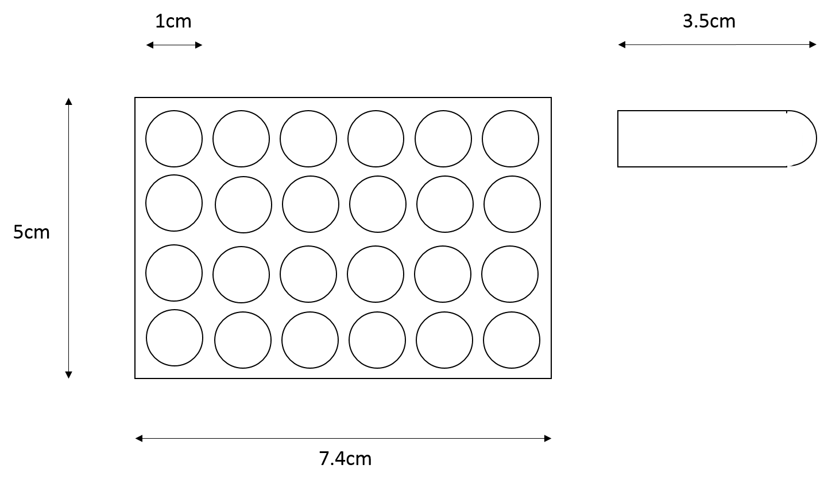
Additional Figure 4. Diagram of phantoms for magnetic resonance imaging.

Additional Table 1

Strains and plasmids used in this study
Strains/plasmids | Description | Source
Strains
E. coli DH5α | F⁻, φ80d lacZΔM15,Δ(lacZYA-argF)U169, recA1, endA1, hsdR17(rk⁻,mk⁺), phoA, supE44λ⁻, thi⁻¹, gyrA96, relA1 | Vazyme®
E. coli BL21(DE3) | F⁻, ompT, gal, dcm, lon, hsdS_{B}(r_{B}⁻, m_{B}⁻),λ(DE3[lacI, lacUV5-T7p07 ind1, sam7, nin5]) [malB⁺] _{K-12} (λ^{S}) | Vazyme®
Plasmids
pCDFDuet-1 | P_{T7}, CloDF13 ori, Str^{r} | Novagen®
pGEX-4T-EGFP | pGEX-4T-1 containing EGFP | Laboratory stock
pET28a-T7-ARG1 | pET28a containing ARGs | Bourdeau et al^{[5]}
pET28a-T7-ARG2 | pET28a containing ARGs | Bourdeau et al^{[5]}
pCDFD-INP-P30-1 | pCDFDuet-1 containing INP-P30-1 fusion gene | This study

EGFP=enhanced green fluorescent protein, INP=ice nucleation protein.

