Supplemental Data File 3. Forest plots of individual study effect sizes (Hedges g) and their 95% confidence intervals plotted in order of magnitude for the Star Excursion Balance Test a) Posterior, b) Anterolateral, c) Lateral directions. (= individual study; = mean overall effect)

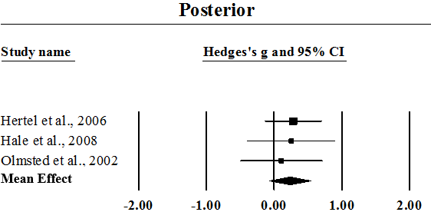A.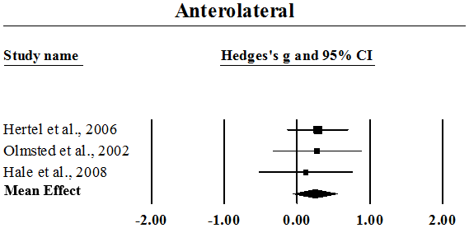B.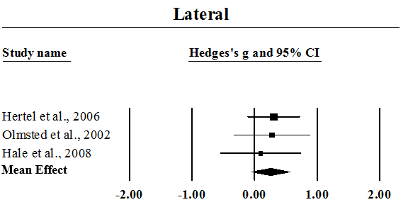C.

