Appendix
HIP EXERCISE PROGRAM
The purpose of this program is to strengthen your hip muscles. It is possible that by strengthening the musculature of your pelvis and hips you may improve the alignment of your knee, subsequently improving your pain and function and decreasing osteoarthritis progression. This program requires you to complete three 45 minute sessions per week for a total of twelve weeks. There are two stages to the hip program. This first stage is 6 weeks long and is performed with light resistance Thera-Bands, the second stage is the final 6 weeks and is performed with heavy resistance Thera-Bands.

Stage 1:
This is the initial strengthening component of your exercise program, consisting of three sets of 10 repetitions of dynamic light-resistance Thera-Band exercises including hip external rotation, internal rotation, flexion, extension, abduction and adduction exercises (Figures 1-6). You will be required to perform these exercises, on both your affected and unaffected legs, three times a week for the first 6 weeks. Your sessions will include 5 minutes of warm-up, 30-35 minutes of dynamic exercise and 5 minutes of light stretching. Since technique is extremely important for gaining maximum benefit, you will be required to attend supervised sessions 3 times a week for the first 3 weeks. After the completion of the first 3 weeks you will gradually increase the number of repetitions to 20 (it is suggested that you start by trying to achieve 15 repetitions before progressing to 20 repetitions, alternatively you may like to increase the number of repetitions in increments of 2 for example first complete 12 repetitions, then 14, then 16 and then 18 repetitions until you are able to comfortably perform 20 repetitions).
It is possible that you may initially have a painful response to these hip exercises. However, we encourage you to try and work through the pain unless it becomes too severe. It is recommended that you complete as many of the prescribed repetitions as possible as it is better for you to do some exercise than none at all. It is important that you record what exercises you were and were not able to complete in your Daily Activity Logs.
Light stretching will be completed after you complete all the dynamic exercises. The 4 stretches you will perform target the hip flexor, lateral hip/piriformis, quadricep and hamstring muscles (Figures 7-10). You will perform 1-2 repetitions of each stretch each session, holding each stretch for approximately 15 seconds.

Stage 2:
After the first 6 weeks of your program have been completed you will have a supervised check-up/progression session. During this session you will receive a heavier resistance Thera-Band. You will use this new band with the exercises that you have already been taught. For the next 3 weeks (weeks 6-9 of your program) you will perform 3 sets of 10 repetitions of each exercise. After the completion of the 9th week you will have another supervised check-up session after which you will gradually increase the number of repetitions from 10 to 20 repetitions (it is suggested that you start by trying to achieve 15 repetitions before progressing to 20 repetitions, alternatively you may like to increase the number of repetitions in increments of 2 for example first complete 12 repetitions, then 14, then 16 and then 18 repetitions until you are able to comfortably perform 20 repetitions).
Just as in the initial 6 weeks of the program, your sessions will consist of 5 minutes of warm-up, 30-35 minutes of dynamic exercise and 5 minutes of light stretching. The same stretching exercises you used in the first 6 weeks of the program will be used for the second six weeks maintaining the repetitions and holding time for each stretch.

Table 1 Exercise progression
Exercise | Weeks 1-3 |  | Weeks 4-6 |  | Weeks 7-9 |  | Weeks 10-12
 | sets | repetitions | Sets | Repetitions | sets | repetitions | sets | repetitions
Internal Rotation | 3 | 10 | 3 | 20 | 3 | 10 | 3 | 20
External Rotation | 3 | 10 | 3 | 20 | 3 | 10 | 3 | 20
CLAM | 3 | 10 | 3 | 20 | 3 | 10 | 3 | 20
Adduction | 3 | 10 | 3 | 20 | 3 | 10 | 3 | 20
Extension | 3 | 10 | 3 | 20 | 3 | 10 | 3 | 20
Flexion | 3 | 10 | 3 | 20 | 3 | 10 | 3 | 20
Hip Flexor Stretch | 1 | 2 | 1 | 2 | 1 | 2 | 1 | 2
Outer Hip Stretch | 1 | 2 | 1 | 2 | 1 | 2 | 1 | 2
Quad Stretch | 1 | 2 | 1 | 2 | 1 | 2 | 1 | 2
Hamstring Stretch | 1 | 2 | 1 | 2 | 1 | 2 | 1 | 2

HIP STRENGTHENING EXERCISES
(Pictures courtesy of David Lindsay, University of Calgary Sport Medicine Centre)

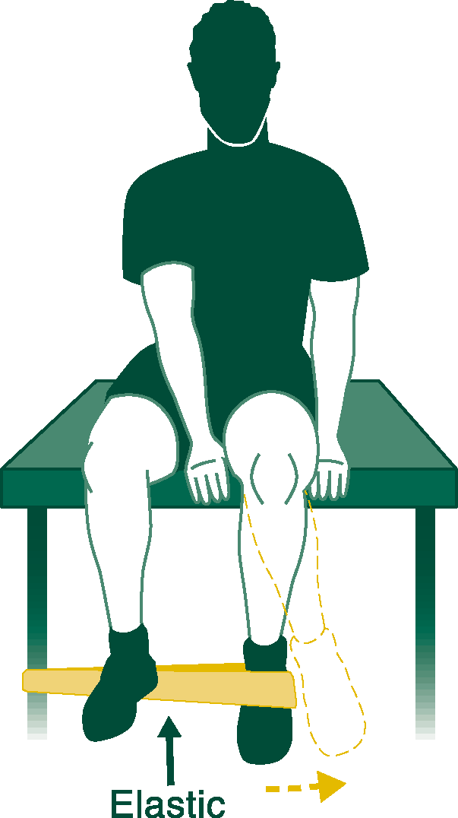 | Figure 1. HIP INTERNAL ROTATION  Sitting well back on a table with your feet off the ground. Attach the elastic so it loops around your instep (outside of your foot). Place your hands on each side of your thigh. While keeping your lower-leg vertical and your ankle at 90 degrees, slowly move your foot OUT as far apart as possible and against the elastic resistance. Consciously tighten your buttock muscles as you move your foot against the elastic. Hold briefly at this position then allow your foot to return to the start position. Do 3 sets of 10 repetitions gradually progressing to 20 repetitions. Fatigue should be felt in the outer hip/buttock region.

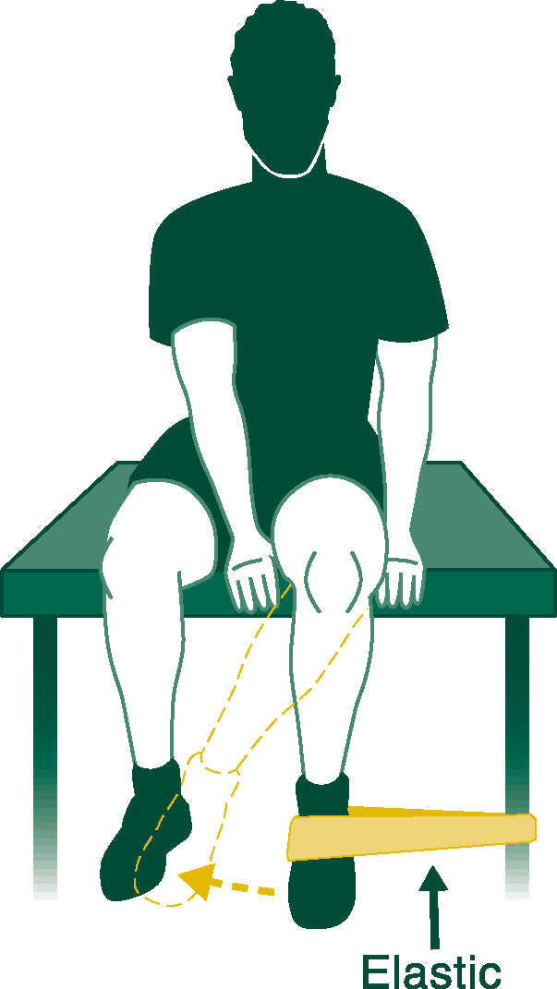 | Figure 2. HIP EXTERNAL ROTATION (GROIN):  Sit on a table so your feet are off the ground. Attach the tubing around your foot as shown. With your hands on each side of your thigh, slowly rotate your foot IN as far apart as possible and against the elastic resistance. Hold briefly at this position then allow the foot to return to the start position. Do 3 sets of 10 repetitions gradually progressing to 20 repetitions. Fatigue should be felt in the inner thigh/groin region.

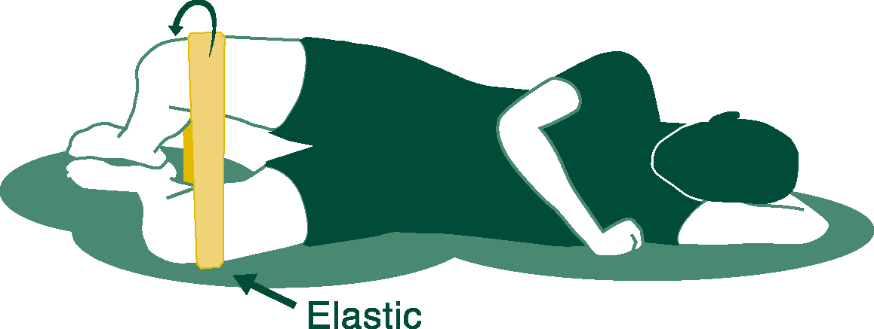 | Figure 3. SIDE LYING BUTTOCK (aka CLAM):  a) Lie on your side with your hips and knees bent such that your heels are inline with your buttocks. Your pelvis MUST be tilted forward slightly so that your belly-button is aimed at the ground in front of you. Place the elastic around both knees. While keeping your heels together, slowly rotate the top knee up towards the ceiling as far as possible and against the elastic resistance. Don’t let the pelvis or trunk move -- the only motion should be at the hip joint. Hold briefly at this position then allow your knees to come back together. Do 3 sets of 10 repetitions gradually progressing to 20 repetitions. Fatigue should be felt in the outer hip/buttock region.  b) Alternatively this exercise can be performed supine (on your back). Sitting on the floor with your knees bent and the elastic around your knees slowly spread your knees apart against the band. Don’t let the pelvis or trunk move -- the only motion should be at the hip joint. Hold briefly at this position then allow your knees to come back together. Do 3 sets of 10 repetitions gradually progressing to 20 repetitions. Fatigue should be felt in the outer hip/buttock region.

Start Position  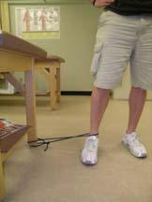  End Position  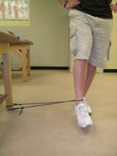 | Figure 4. STANDING HIP ADDUCTION  a) Loop the elastic band around your ankle and attach the elastic so it loops around a stationary object near the floor (for example a table leg or railing pole). Stand with the band to the side closest to the exercising leg so that the band rests just above your ankle. Keep your hands to your sides and stand tall (chin up, abdominals tight and not letting your pelvis or trunk move). Keeping your back straight slowly move your leg (try to keep it as straight as possible) inwards towards your other leg against the resistance of the elastic. Try to avoid leaning or bending over while performing the exercise (hold onto something if you need to). Hold briefly at this position then allow your foot to return to the start position. Do 3 sets of 10 repetitions gradually progressing to 20 repetitions. Fatigue should be felt in the inner thigh/groin region.  b) Alternatively this exercise can be performed lying on your side with your bottom leg straight and your top leg bent (knee close to your chest in a comfortable position. Keeping your bottom leg straight slowly raise your leg of off the ground bringing it towards your over leg. Hold briefly at this position then allow your leg to return to the start position. Do 3 sets of 10 repetitions gradually progressing to 20 repetitions. Fatigue should be felt in the anterior thigh region.

Start Position  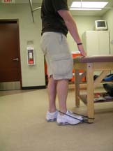  End Position  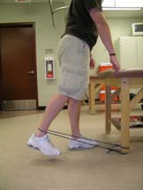 | Figure 5. STANDING HIP EXTENSION:  Loop the elastic band around your ankle and attach the elastic so it loops around a stationary object near the floor (for example a table leg or railing pole). Stand facing the attachment of the band so that the band rests just above your ankle. Keep your hands to your sides and stand tall (chin up, abdominals tight and not letting your pelvis or trunk move). Keeping your back straight slowly move your leg (try to keep it as straight as possible) backwards against the resistance of the elastic. Try to avoid leaning or bending over while performing the exercise (hold onto something if you need to). Hold briefly at this position then allow the foot to return to the start position. Do 3 sets of 10 repetitions gradually progressing to 20 repetitions. Fatigue should be felt in the buttock region.

Start Position  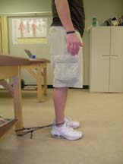  End Position  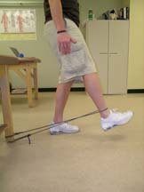 | Figure 6. STANDING HIP FLEXION:  a) Loop the elastic band around your ankle and attach the elastic so it loops around a stationary object near the floor (for example a table leg or railing pole). Stand facing away from the attachment of the band so that the band rests just above your ankle. Keep your hands to your sides and stand tall (chin up, abdominals tight and not letting your pelvis or trunk move). Keeping your back straight slowly move your leg (try to keep it as straight as possible) forwards against the resistance of the elastic. Try to avoid leaning or bending over while performing the exercise (hold onto something if you need to). Hold briefly at this position then allow the foot to return to the start position. Do 3 sets of 10 repetitions gradually progressing to 20 repetitions. Fatigue should be felt in the anterior thigh region.  b) Alternatively this exercise can be performed sitting. Sitting in a sturdy chair, loop the elastic around the top of the knee of the exercising leg and bring the ends of the band underneath the foot of the opposite leg to stabilize and create the resistance in the band. Keeping your back straight (not leaning forward) slowly flex the hip against the resistance of the band. Hold briefly at this position then allow the foot to return to the start position. Do 3 sets of 10 repetitions gradually progressing to 20 repetitions. Fatigue should be felt in the anterior thigh region.

HIP STRETCHING EXERCISES
(Pictures courtesy of David Lindsay, University of Calgary Sport Medicine Centre)

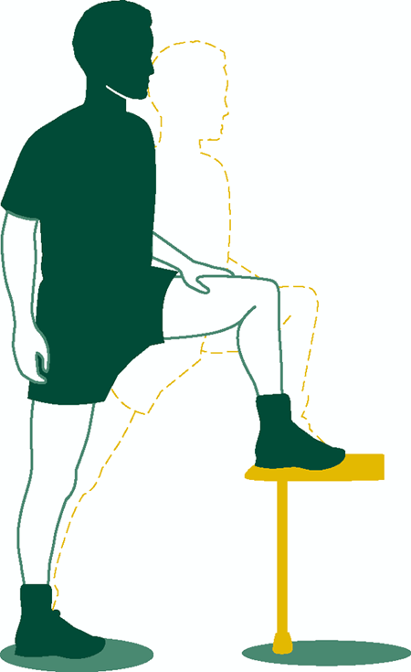 | Figure 7. HIP FLEXOR STRETCH:  Stand about 2-3 feet away from a chair or desk and place your left foot on the front edge of the chair/desk. Both feet should be aimed straight ahead. Draw in your belly button using your abdominal muscles. Tighten your right buttock to push your right hip forward until you feel a stretch at the front of the right hip. Keep your back vertical the whole time. Maintain the stretch for 15 seconds.  (Progress to having both feet on the floor)

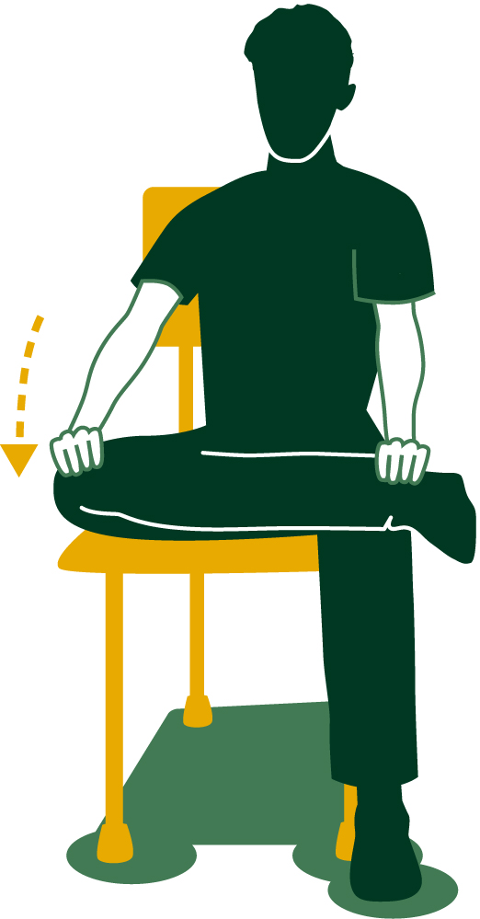 | Figure 8. OUTER HIP STRETCH:  Sit on the front part of a chair and cross your legs by placing the outside of one ankle on top of the other knee. Slowly let the knee fall out to the side as far as comfortable. Bend forward at the waist slightly until you feel a stretch in the outside of this hip. Gently pushing the knee down further with your hand will increase the stretch. DO NOT FORCE - no pain should be experienced. Maintain the stretch for 15 seconds.

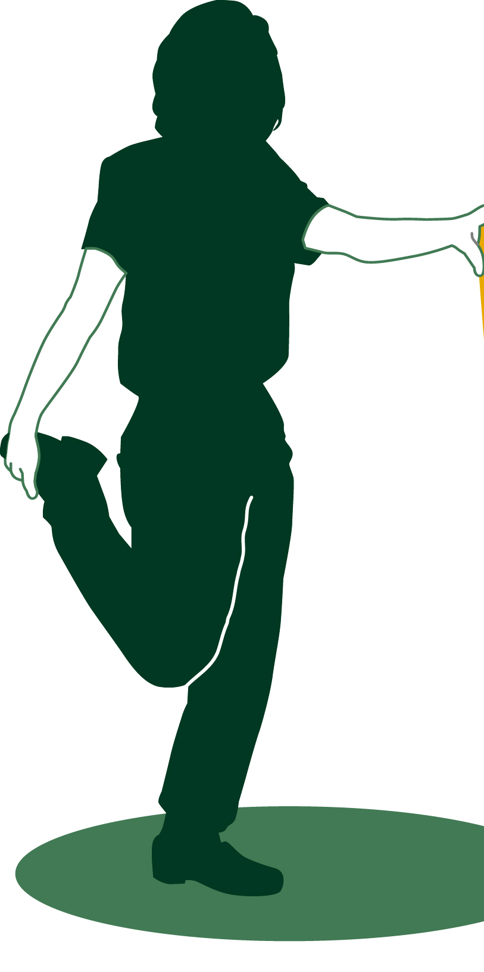 | Figure 9. QUADRICEP STRETCH:  Steady yourself using a wall and bend your right knee and hold your right ankle with your hand. Keep your back straight and tighten your stomach by drawing in your belly button. Now position your right knee just behind and touching your straight left knee (your right knee cap will be pointing just behind your left heel). A stretch should be felt in the front of the right thigh. Hold for 15 seconds.

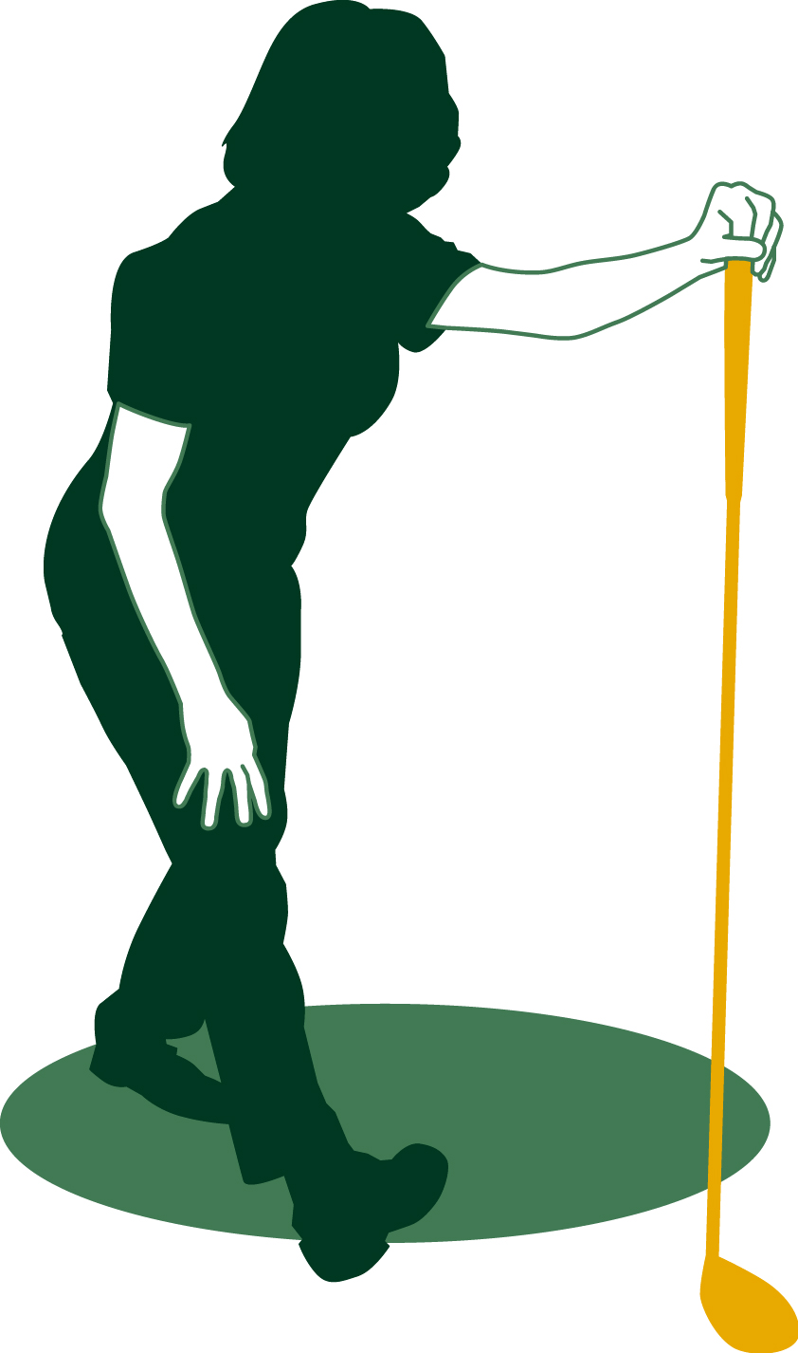 | Figure 10. HAMSTRING STRETCH:  Steady yourself using a wall and step forward with your right foot 2-3 feet. Keeping your right knee straight, pull your right foot and toes back then slowly bend forward at the waist until you feel a stretch in the back of your right thigh and knee. Pushing your backside out and letting the left knee bend slightly will increase the stretch. Hold for 15 seconds.

LEG EXERCISE PROGRAM
The purpose of this program is to strengthen the muscles of your legs. It has been shown that increasing the strength of the muscles of the legs helps to improve pain and function in knee osteoarthritis patients.^{[7-13]} This exercise program is an extension to the leg strengthening program used by Topp et al (2002) using Thera-Band elastic band dynamic resistance exercises. This program requires you to complete three 45 minute sessions per week for a total of twelve weeks. There are two stages to the leg program. This first stage is 6 weeks long and is performed with light resistance Thera-Bands, the second stage is the final 6 weeks and is performed with heavier resistance Thera-Bands.

Stage 1:
This is the initial strengthening component of your rehabilitation program, consisting of 3 sets of 10 repetitions of dynamic Thera-Band exercises including knee flexion, extension, leg press and calf raises (Figures 1-6). You will perform these exercises, on both your affected and unaffected knees, three times a week for the first 6 weeks. Your exercise sessions include 5 minutes of warm-up, 30-35 minutes of dynamic exercise and 5 minutes of light stretching. Since technique is extremely important for gaining maximum benefit, you will be required to attend supervised sessions 3 times a week for the first 3 weeks. After the completion of the first 3 weeks you will attend your first check-up session after which you will gradually increase the number of repetitions to 20, with the exception of calf raises which will progress to 3 sets of 12 repetitions (it is suggested that you start by trying to achieve 15 repetitions before progressing to 20 repetitions, alternatively you may like to increase the number of repetitions in increments of 2 for example first complete 12 repetitions, then 14, then 16 and then 18 repetitions until you are able to comfortably perform 20 repetitions).
It is possible that you may initially have a painful response to the leg exercises. However, we encourage you to try and work through the pain unless it becomes too severe. It is recommended that you complete as many of the prescribed repetitions as possible as it is better for you to do some exercise than none at all. It is important that you record what exercises you were and were not able to complete in your Daily Activity Logs.
Light stretching will be completed after you complete all the dynamic exercises. The 4 stretches you will perform target the hip flexor, lateral hip/piriformis, quadricep and hamstring muscles (Figures 7-10). You will perform 1-2 repetitions of each stretch each session, holding each stretch for approximately 15 seconds.

Stage 2:
After the first 6 weeks of the program have been completed you will have a supervised check-up/progression session (Stage2). During this session you will receive a heavier resistance Thera-Band. You will use this band with the exercises that you have already been taught. For the next 3 weeks (weeks 6-9 of your program) you will perform 3 sets of 10 repetitions of each exercise, with the exception of calf raises which will progress to 3 sets of 15 repetitions. After the completion of the 9th week you will have another supervised check-up session after which you will gradually increase the number of repetitions from 10 to 20 repetition (it is suggested that you start by trying to achieve 15 repetitions before progressing to 20 repetitions, alternatively you may like to increase the number of repetitions in increments of 2 for example first complete 12 repetitions, then 14, then 16 and then 18 repetitions until you are able to comfortably perform 20 repetitions).
Just as in the initial 6 weeks of the program, your sessions will consist of 5 minutes of warm-up, 30-35 minutes of dynamic exercise and 5 minutes of light stretching. The same stretching exercises you used in the first 6 weeks of the program will be used for the second six weeks maintaining the repetitions and holding time for each stretch.

Table 1 Exercise progression
Exercise | Weeks 1-3 |  | Weeks 4-6 |  | Weeks 7-9 |  | Weeks 10-12
 | sets | Repetitions | sets | Repetitions | sets | repetitions | sets | repetitions
Extension | 3 | 10 | 3 | 20 | 3 | 10 | 3 | 20
Flexion | 3 | 10 | 3 | 20 | 3 | 10 | 3 | 20
Calf Raises | 3 | 10 | 3 | 12 | 3 | 15 | 3 | 20
Mini-squat | 3 | 10 | 3 | 20 | 3 | 10 | 3 | 20
Terminal Knee Extension | 3 | 10 | 3 | 20 | 3 | 10 | 3 | 20
Leg Press | 3 | 10 | 3 | 20 | 3 | 10 | 3 | 20
Hip Flexor Stretch | 1 | 2 | 1 | 2 | 1 | 2 | 1 | 2
Outer Hip Stretch | 1 | 2 | 1 | 2 | 1 | 2 | 1 | 2
Quad Stretch | 1 | 2 | 1 | 2 | 1 | 2 | 1 | 2
Hamstring Stretch | 1 | 2 | 1 | 2 | 1 | 2 | 1 | 2

LEG STRENGHTENING EXERCISES

Start Position  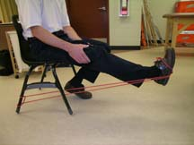  End Position | Figure 1. KNEE EXTENSION:  a) Secure one end of the elastic band behind the chair, attaching the other end of the band to your ankle. Sitting tall (chin up, abdominals tight and not letting your pelvis or trunk move) in the chair, holding onto the side of the chair, slowly extend your leg against the resistance of the band until the leg is straight. Hold briefly at this position then allow your leg to return to the start position. Do 3 sets of 10 repetitions gradually progressing to 20 repetitions. Fatigue should be felt in the quadriceps muscle.  b) Alternatively, wrap the middle of the band around your foot. Lay on your stomach (prone) holding the ends of the band in your hands. Begin with your knee bent and extend your leg against the resistance of the band until it reaches the floor. Hold briefly at this position then allow your leg to return to the start position. Do 3 sets of 10 repetitions gradually progressing to 20 repetitions. Fatigue should be felt in the quadriceps muscle.

Start Position  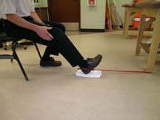  End Position  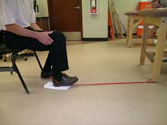 | Figure 2. KNEE FLEXION:  a) Tie the ends of the band together creating a loop and securely attach one end of the loop close to the floor. Wrapping the other end of the loop around the heel of your foot, sitting tall (chin up, abdominals tight and not letting your pelvis or trunk move) in a chair, slowly bend your knee bringing your foot closer to the base of the chair. Hold briefly at this position then allow your leg to return to the start position. Do 3 sets of 10 repetitions gradually progressing to 20 repetitions. Fatigue should be felt in the hamstring muscle.  b) Tie the ends of the band together creating a loop and securely attach one end of the loop close to the floor. Lay on your stomach (prone) place the other end of the loop around your ankle. Begin with your knee straight and bend your leg against the resistance of the band. Hold briefly at this position then allow your leg to return to the start position. Do 3 sets of 10 repetitions gradually progressing to 20 repetitions. Fatigue should be felt in the hamstring muscle.

Start Position  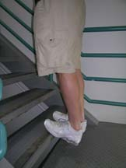  End Position  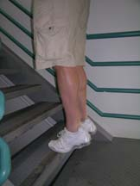 | Figure 3. CALF RAISES: (Not using Thera-Band)  Standing tall (ideally on a stair), holding onto a chair or railing if needed, keeping your legs straight slowly raising your heels so that you are standing on your toes. Hold briefly at this position then allow your legs to return to the start position. Do 3 sets of 10 repetitions gradually progressing to 20 repetitions. Fatigue should be felt in the calf muscle.

Start Position  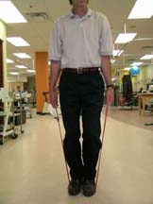  End Position  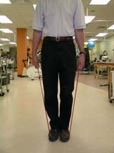 | Figure 4. MINISQUAT:  Hold the ends of the band in your hands (at hip level) and stand on the middle of the band with both feet. Keeping your back and arms straight slowly bend both knees slightly to the minisquat position (DO NOT allow your knees to rotate either inward or outward). Hold briefly at this position then allow your leg to return to the start position. Do 3 sets of 10 repetitions gradually progressing to 20 repetitions. Fatigue should be felt in the quadriceps muscle.

Start Position  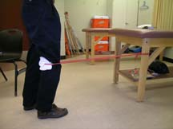  End Position  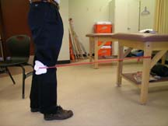 | Figure 5. Terminal Knee Extension:  Make a loop in the band and securely attach one end at knee height. Place your knee inside the loop (keeping the band above the knee joint) and take up the slack. Slowly bend and straighten your knee stretching the band as you extend your knee. Do 3 sets of 10 repetitions gradually progressing to 20 repetitions. Fatigue should be felt in the hamstring muscle.

Starting Position  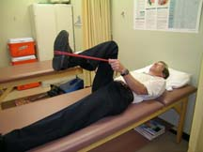  End Position  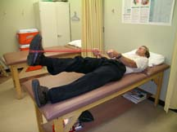 | Figure 6. Leg Press:  a) Lay on your back (supine) with your knee slightly bent and the middle of the band looped around the bottom of your foot. Grasp the ends of the band and place close to your shoulders. Slowly extend your leg against the resistance of the band until your leg is straight. Hold briefly at this position then allow your leg to return to the start position. Do 3 sets of 10 repetitions gradually progressing to 20 repetitions. Fatigue should be felt in the quadriceps muscle.  b) Sitting tall in a chair wrap the middle of the band around, grasp the ends of the bands around chest level. With your knee slightly bent slowly extend your leg against the resistance of the band until your leg is straight. Hold briefly at this position then allow your leg to return to the start position. Do 3 sets of 10 repetitions gradually progressing to 20 repetitions. Fatigue should be felt in the quadriceps muscle.

LEG STRETCHING EXERCISES
(Pictures courtesy of David Lindsay, University of Calgary Sport Medicine Centre)

Figure 7. HIP FLEXOR STRETCH:

Stand about 2-3 feet away from a chair or desk and place your left foot on the front edge of the chair/desk. Both feet should be aimed straight ahead. Draw in your belly button using your abdominal muscles. Tighten your right buttock to push your right hip forward until you feel a stretch at the front of the right hip. Keep your back vertical the whole time. Maintain the stretch for 15 seconds.
(Progress to having both feet on the floor)

Figure 8. OUTER HIP STRETCH:

Sit on the front part of a chair and cross your legs by placing the outside of one ankle on top of the other knee. Slowly let the knee fall out to the side as far as comfortable. Bend forward at the waist slightly until you feel a stretch in the outside of this hip. Gently pushing the knee down further with your hand will increase the stretch. DO NOT FORCE - no pain should be experienced. Maintain the stretch for 15 seconds.

Figure 9. QUADRICEP STRETCH:

Steady yourself using a wall and bend your right knee and hold your right ankle with your hand. Keep your back straight and tighten your stomach by drawing in your belly button. Now position your right knee just behind and touching your straight left knee (your right knee cap will be pointing just behind your left heel). A stretch should be felt in the front of the right thigh. Hold for 15 seconds.

Figure 10. HAMSTRING STRETCH:

Steady yourself using a wall and step forward with your right foot 2-3 feet. Keeping your right knee straight, pull your right foot and toes back then slowly bend forward at the waist until you feel a stretch in the back of your right thigh and knee. Pushing your backside out and letting the left knee bend slightly will increase the stretch. Hold for 15 seconds.

