Supplemental Digital Content 3. Figures of paraconduit hernia containing small bowel.
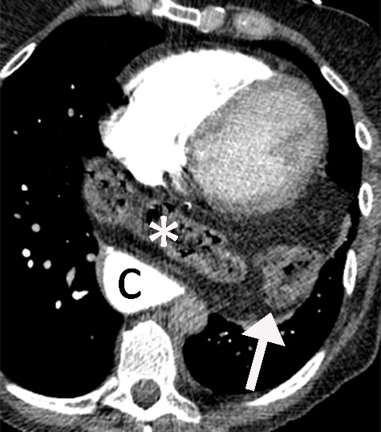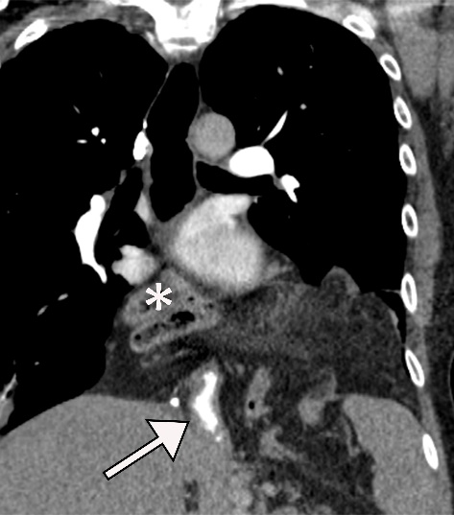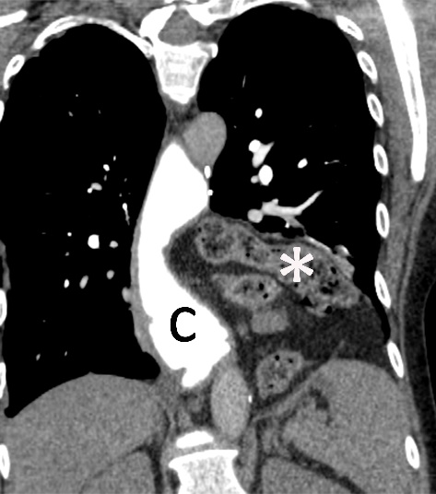
C
B
A

Para-conduit hernia containing small bowel. A 57-year-old woman is 8 months status-post MIE for multiple failed hiatal anti-reflux procedures. A) Axial and B, C) coronal CT images show that small bowel (asterisk) and omentum herniate into the left chest (arrow) and cross midline between the conduit (C) and the heart. The conduit is compressed (open arrow) at the hiatus. The small bowel was reduced laparoscopically, the peritoneal hernia sac and adhesions were resected, and the diaphragmatic defect was repaired primarily.

