Supplemental Digital Content 6. Figures of 3 patients with LINX® complications
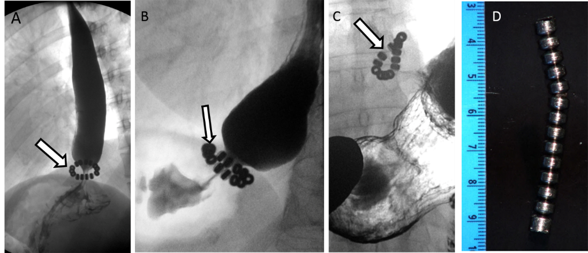

Esophagram of 3 patients with LINX® complications. A) A 68-year-old woman who is 1-year status post LINX® device placement presents with severe dysphagia. The device (arrow) is positioned at the EGJ, which is severely narrowed with marked delayed emptying. Symptoms improved following EGD dilation. B) 40-year-old woman with device placement, now has episodes of nausea and vomiting. The beads normally may not be evenly spaced (arrow). The distal esophagus is severely narrowed with delayed emptying. Symptoms improved following dilation. C, D) 44-year-old man, 3 years status post LINX®, has recurrent dysphagia unresponsive to dilations. The device is deformed (arrow) compatible with surrounding fibrosis. D) Photograph of the LINX specimen, which was removed.

