Supplemental Digital Content
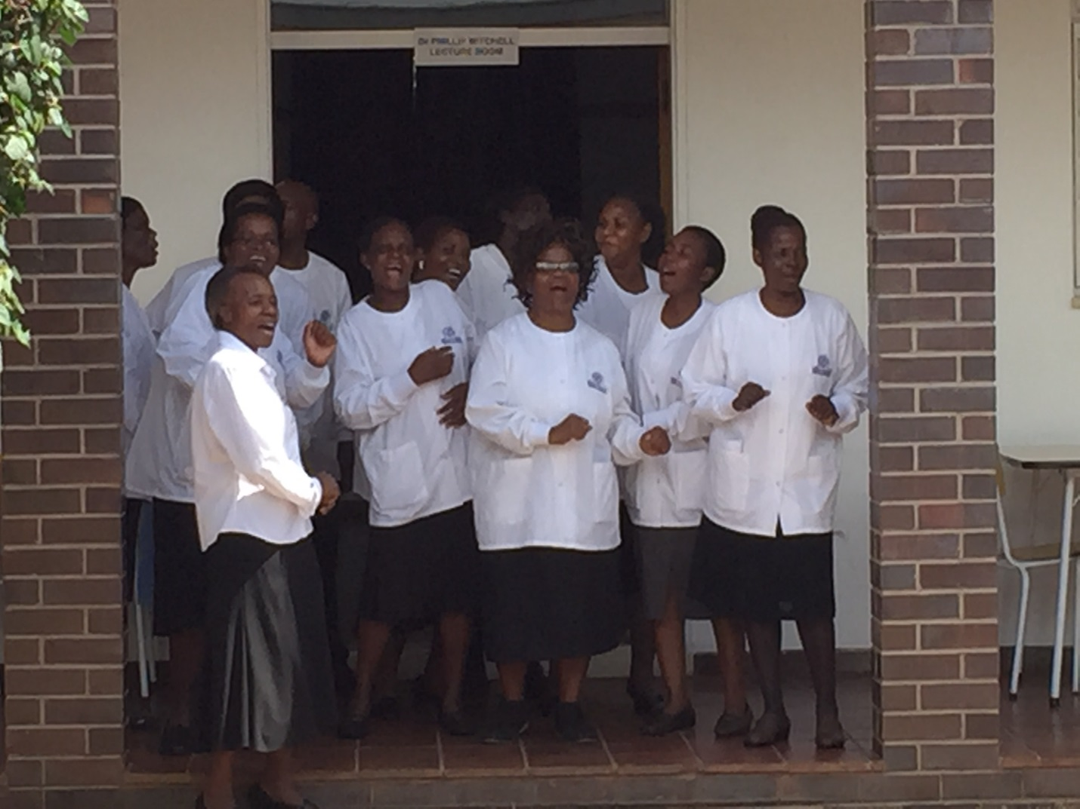
- Supplemental Digital Content 1. Image which shows our warm welcome to St. Philip’s. JPG

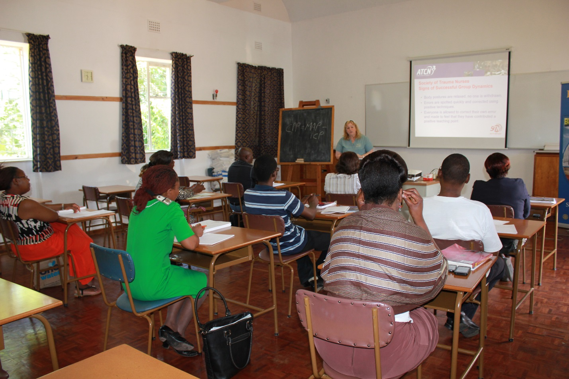

- Supplemental Digital Content 2. Image which shows our classroom lecture setting. JPG

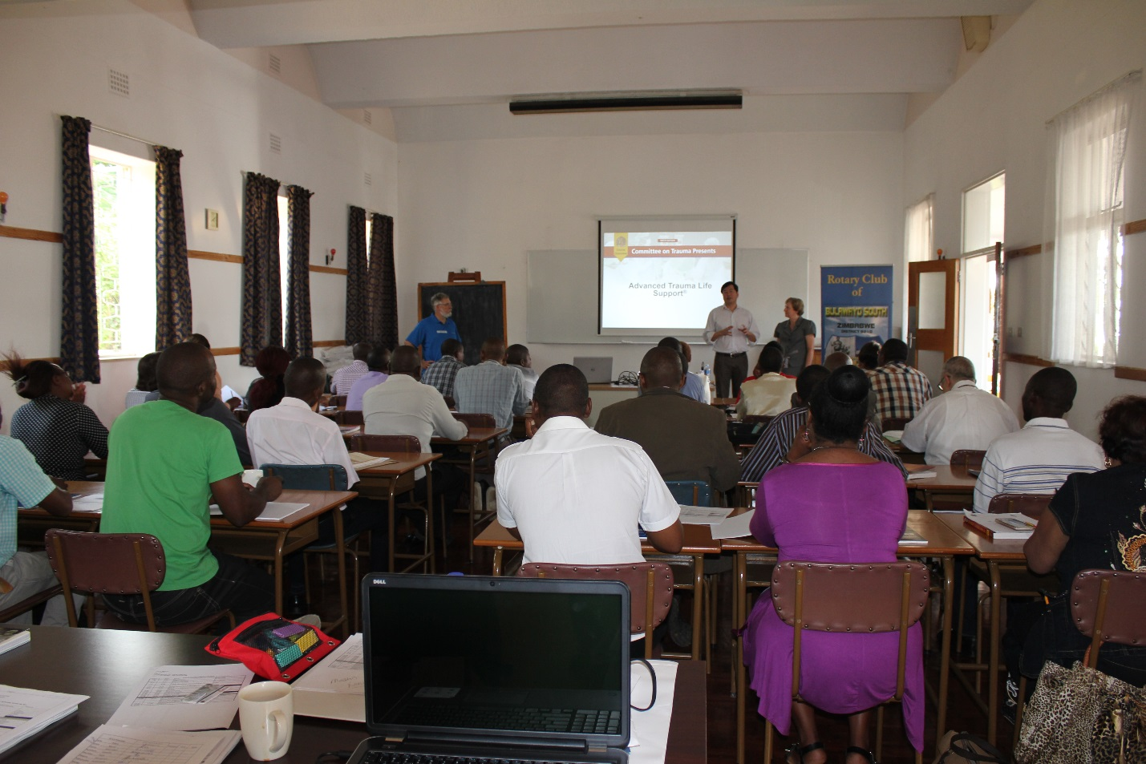

- Supplemental Digital Content 3. Image which shows the Skype process being introduced to students. JPG

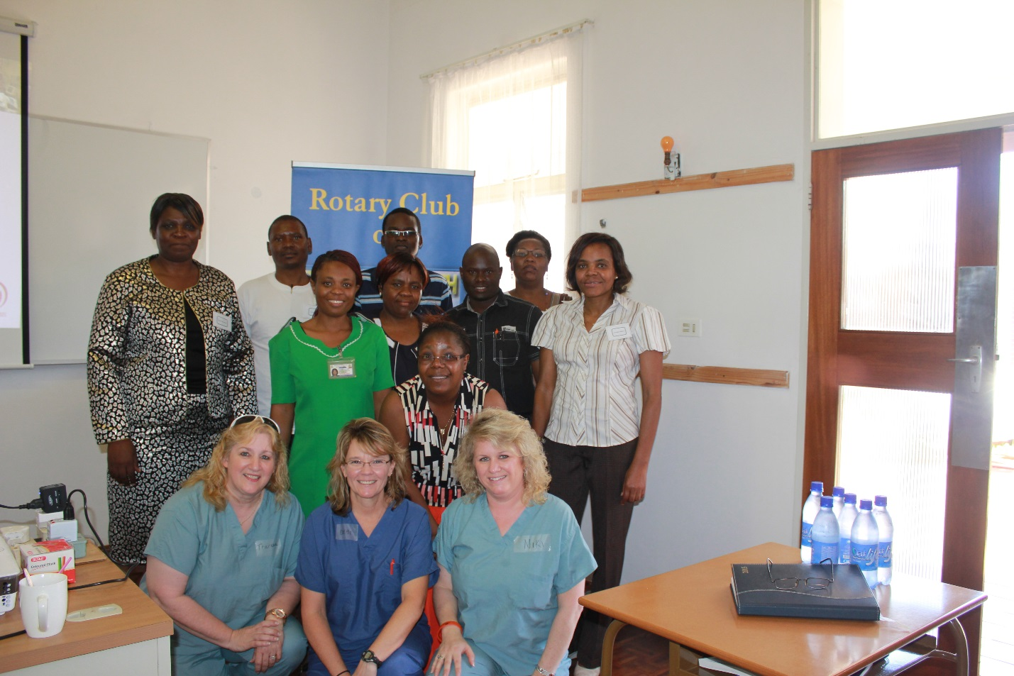

- Supplemental Digital Content 4. Image which shows the ATCN Faculty Candidates. JPG

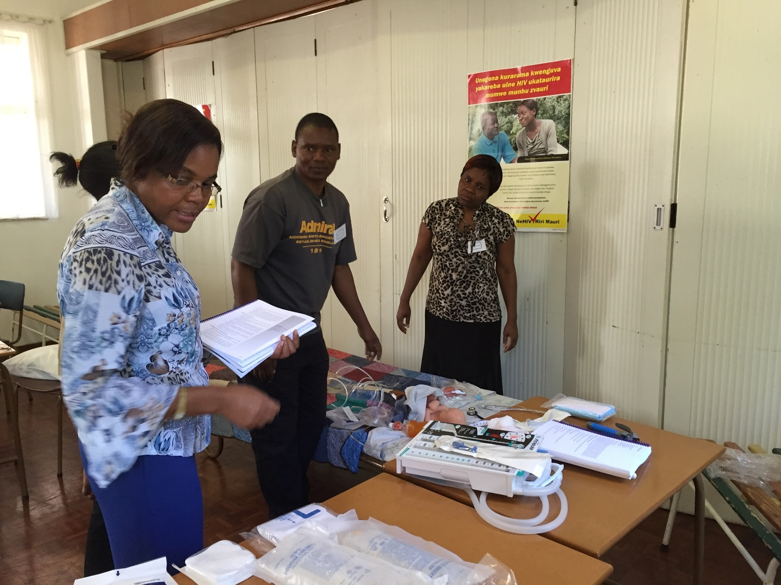

- Supplemental Digital Content 5. Image which shows Skills Station demonstration by ATCN Faculty. JPG

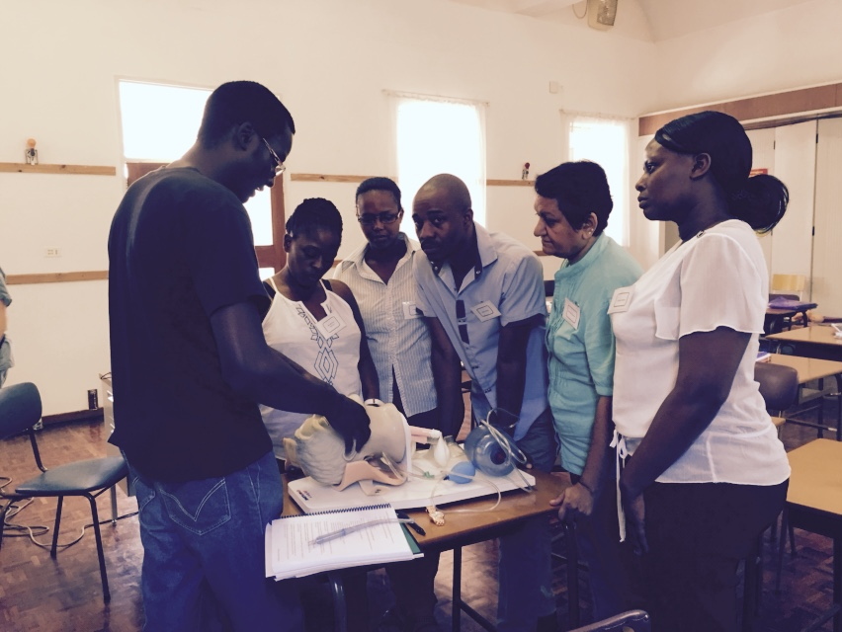

- Supplemental Digital Content 6. Image which shows Airway Skills Station demonstration by ATCN Faculty. JPG
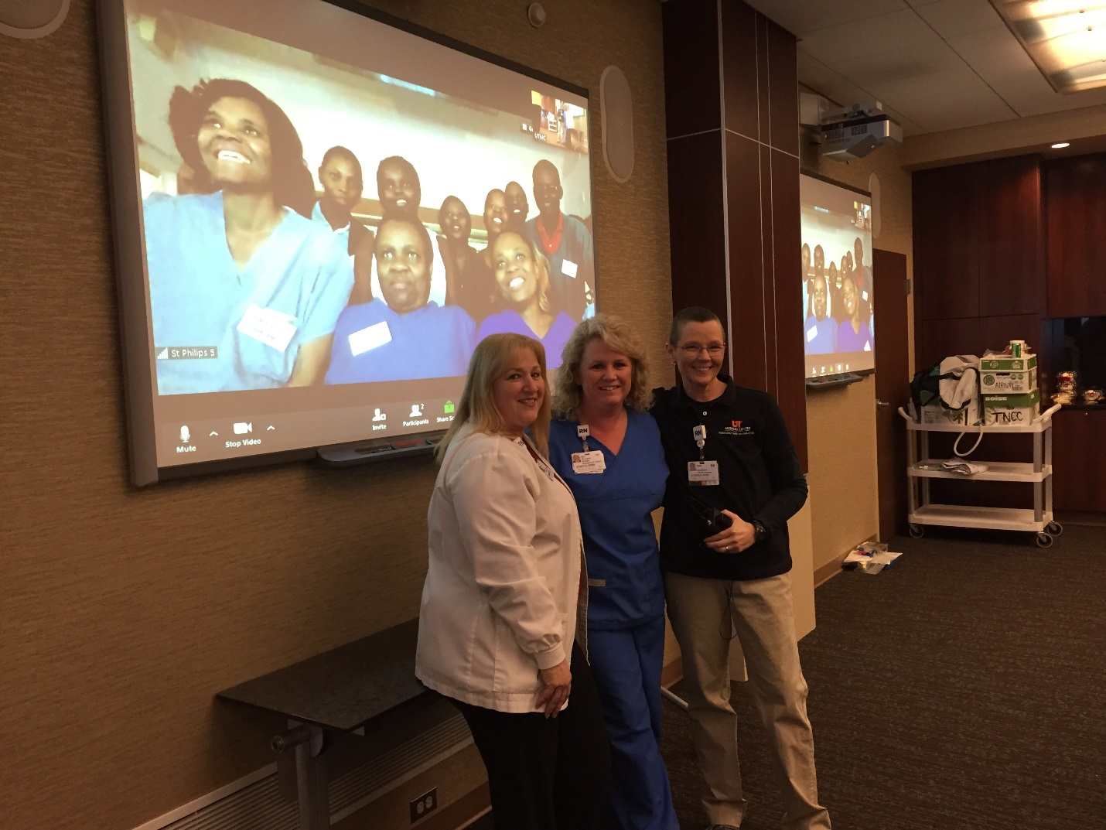

- Supplemental Digital Content 7. Image which shows ATCN Faculty from Zimbabwe and Tennessee via Skype. JPG

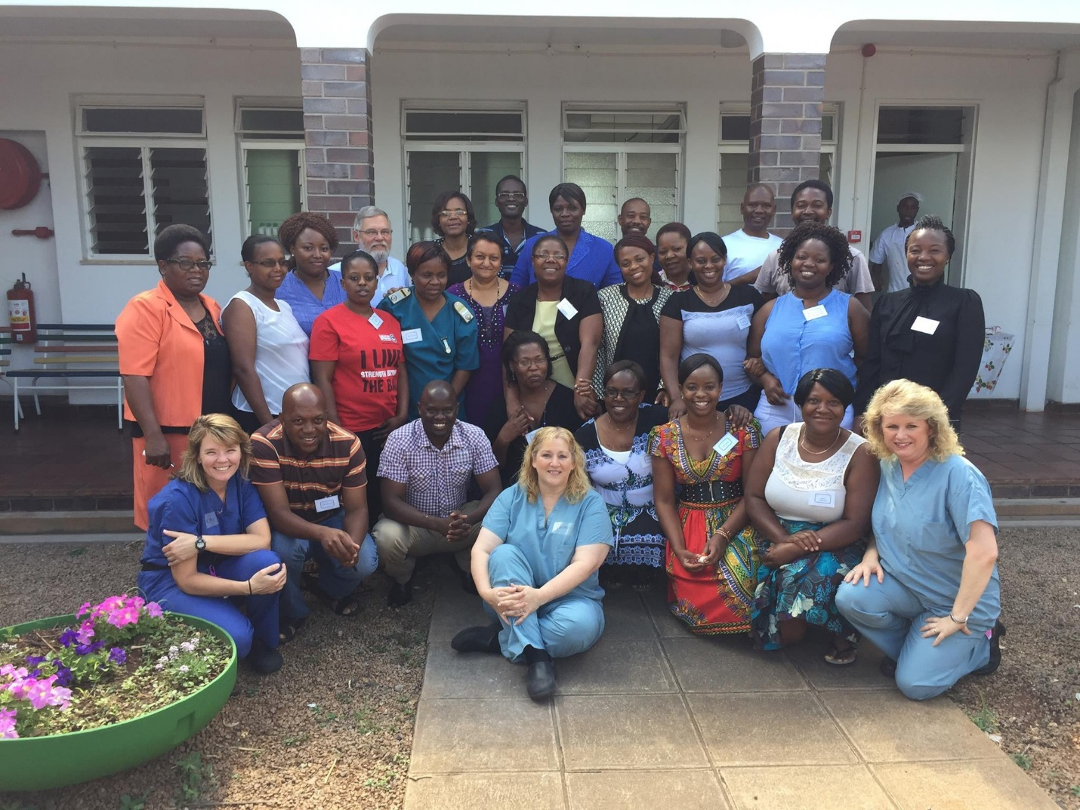
- Supplemental Digital Content 8. Image which shows ATCN Faculty from St. Philip’s and University of Tennessee Medical Center. JPG

