Supplement
Evaluation of different visualization systems for the IHC detection of ALK
The initial reports using conventional IHC methods to detect ALK expression in lung cancer resulted in high false negative findings due to a relatively low ALK protein expression in NSCLC with ALK translocation. Combining high affinity antibodies and different amplification systems have significantly improved the sensitivity. We compared different visualization systems for the detection of ALK protein on a tissue microarray (TMA) comprising 57 lung adenocarcinomas from consecutive patients. Of them 5 cases were confirmed to be EML4-ALK positive by FISH or RT-PCR. The following detection systems, iView, ultraView, and OptiView from Ventana, ADVANCE and EnVision Flex+ from DAKO, and Polymer Refined Detection Kit (Leica), were evaluated. Primary antibody incubation was kept constant at thirty minutes for all staining platforms. The incubation times and number of washing steps were carried out according to the manufacturer's instruction for each detection system.
The TMA was first subjected to conventional immunohistochemical staining with anti-ALK antibody (5A4, 1:100, Abcam) by a biotin streptavidin system (iView, Ventana) and a multimer-technology based detection system (ultraView, Ventana). Weak to moderate cytoplasmic stain was observed in 5 cases by the biotin streptavidin system (iView). Of them only 2 cases harbored EML4-ALK (Supplementary Table). The nonimmunospecific background stain leading to false positive results was likely due to endogenous avidin-binding activity. Thus iView gave a sensitivity of 40%, specificity of 94.2%, positive predictive value of 40% and negative predictive value of 94.2%. The multimer-based ultraView system gave a much clearer background that no false positive result was observed. However, only one EML4-ALK positive case was picked up by this detection system. The sensitivity, specificity, positive predictive value and negative predictive value of ultraView is 20%, 100%, 100% and 92.9%, respectively.
The higher false negative result by conventional immunhistochemistry appeared to be caused by lower sensitivity of the detection system. A number of non-biotin based amplification technologies have been developed that allowed sensitive and specific detection of low abundant proteins by IHC. We compared 4 commonly used non-biotin based amplification systems, namely OptiView (Ventana), Advance (DAKO), EnVision Flex+ (DAKO) and Polymer Refined Detection Kit (Leica) for the detection of ALK protein expression on TMA of lung adenocarcinomas. Using anti-ALK antibody 5A4 (1:100), all 4 detection systems picked up all the EML4-ALK positive tumors (5 out of 57) with 100% sensitivity and specificity (Supplementary Table). The EML4-ALK positive adenocarcinomas showed a diffuse immunoreactivity in majority of the tumor cells. None of the detection systems showed any obvious false positive staining in EML4-ALK negative tumors. Polymer Refined Detection Kit (Leica) gave a slightly stronger staining intensity than all other detection systems. Our study showed that there was no significant difference among these detection systems in sensitivity, specificity and the level of background staining.

Supplementary Table Immunohistochemical scoring of lung adenocarcinoma using different detection systems. I: Intensity Score, P: Proportion score, S: combined Score, C: Category. No. 3, 6, 13, 23, 48 were confirmed to be EML4-ALK positive by FISH and RT-PCR.
 | OptiVIew |  |  |  | ADVANCE |  |  |  | Flex+ |  |  |  | Leica
No. | I | P | S | C | I | P | S | C | I | P | S | C | I | P | S | C
1 | 0 | 0 | 0 | - | 0 | 0 | 0 | - | 0 | 0 | 0 | - | 0 | 0 | 0 | -
2 | 0 | 0 | 0 | - | 0 | 0 | 0 | - | 0 | 0 | 0 | - | 0 | 0 | 0 | -
3 | 1 | 4 | 4 | ++ | 2 | 4 | 8 | +++ | 2 | 4 | 8 | +++ | 2 | 4 | 8 | +++
4 | 0 | 0 | 0 | - | 0 | 0 | 0 | - | 0 | 0 | 0 | - | 0 | 0 | 0 | -
5 | 0 | 0 | 0 | - | 0 | 0 | 0 | - | 0 | 0 | 0 | - | 0 | 0 | 0 | -
6 | 1 | 4 | 4 | ++ | 1 | 4 | 4 | ++ | 1 | 4 | 4 | ++ | 2 | 4 | 8 | +++
7 | 0 | 0 | 0 | - | 0 | 0 | 0 | - | 0 | 0 | 0 | - | 0 | 0 | 0 | -
8 | 0 | 0 | 0 | - | 0 | 0 | 0 | - | 0 | 0 | 0 | - | 0 | 0 | 0 | -
9 | 0 | 0 | 0 | - | 0 | 0 | 0 | - | 0 | 0 | 0 | - | 0 | 0 | 0 | -
10 | 0 | 0 | 0 | - | 0 | 0 | 0 | - | 0 | 0 | 0 | - | 0 | 0 | 0 | -
11 | 0 | 0 | 0 | - | 0 | 0 | 0 | - | 0 | 0 | 0 | - | 0 | 0 | 0 | -
12 | 0 | 0 | 0 | - | 0 | 0 | 0 | - | 0 | 0 | 0 | - | 0 | 0 | 0 | -
13 | 1 | 4 | 4 | ++ | 1 | 4 | 4 | ++ | 1 | 4 | 4 | ++ | 2 | 4 | 8 | +++
14 | 0 | 0 | 0 | - | 0 | 0 | 0 | - | 0 | 0 | 0 | - | 0 | 0 | 0 | -
15 | 0 | 0 | 0 | - | 0 | 0 | 0 | - | 0 | 0 | 0 | - | 0 | 0 | 0 | -
16 | 0 | 0 | 0 | - | 0 | 0 | 0 | - | 0 | 0 | 0 | - | 0 | 0 | 0 | -
17 | 0 | 0 | 0 | - | 0 | 0 | 0 | - | 0 | 0 | 0 | - | 0 | 0 | 0 | -
18 | 0 | 0 | 0 | - | 0 | 0 | 0 | - | 0 | 0 | 0 | - | 0 | 0 | 0 | -
19 | 0 | 0 | 0 | - | 0 | 0 | 0 | - | 0 | 0 | 0 | - | 0 | 0 | 0 | -
20 | 0 | 0 | 0 | - | 0 | 0 | 0 | - | 0 | 0 | 0 | - | 0 | 0 | 0 | -
21 | 0 | 0 | 0 | - | 0 | 0 | 0 | - | 0 | 0 | 0 | - | 0 | 0 | 0 | -
22 | 0 | 0 | 0 | - | 0 | 0 | 0 | - | 0 | 0 | 0 | - | 0 | 0 | 0 | -
23 | 1 | 4 | 4 | ++ | 1 | 4 | 4 | ++ | 1 | 4 | 4 | ++ | 2 | 4 | 8 | +++
24 | 0 | 0 | 0 | - | 0 | 0 | 0 | - | 0 | 0 | 0 | - | 0 | 0 | 0 | -
25 | 0 | 0 | 0 | - | 0 | 0 | 0 | - | 0 | 0 | 0 | - | 0 | 0 | 0 | -
26 | 0 | 0 | 0 | - | 0 | 0 | 0 | - | 0 | 0 | 0 | - | 0 | 0 | 0 | -
27 | 0 | 0 | 0 | - | 0 | 0 | 0 | - | 0 | 0 | 0 | - | 0 | 0 | 0 | -
28 | 0 | 0 | 0 | - | 0 | 0 | 0 | - | 0 | 0 | 0 | - | 0 | 0 | 0 | -
29 | 0 | 0 | 0 | - | 0 | 0 | 0 | - | 0 | 0 | 0 | - | 0 | 0 | 0 | -
30 | 0 | 0 | 0 | - | 0 | 0 | 0 | - | 0 | 0 | 0 | - | 0 | 0 | 0 | -
31 | 0 | 0 | 0 | - | 0 | 0 | 0 | - | 0 | 0 | 0 | - | 0 | 0 | 0 | -
32 | 0 | 0 | 0 | - | 0 | 0 | 0 | - | 0 | 0 | 0 | - | 0 | 0 | 0 | -
33 | 0 | 0 | 0 | - | 0 | 0 | 0 | - | 0 | 0 | 0 | - | 0 | 0 | 0 | -
34 | 0 | 0 | 0 | - | 0 | 0 | 0 | - | 0 | 0 | 0 | - | 0 | 0 | 0 | -
35 | 0 | 0 | 0 | - | 0 | 0 | 0 | - | 0 | 0 | 0 | - | 0 | 0 | 0 | -
36 | 0 | 0 | 0 | - | 0 | 0 | 0 | - | 0 | 0 | 0 | - | 0 | 0 | 0 | -
37 | 0 | 0 | 0 | - | 0 | 0 | 0 | - | 0 | 0 | 0 | - | 0 | 0 | 0 | -
38 | 0 | 0 | 0 | - | 0 | 0 | 0 | - | 0 | 0 | 0 | - | 0 | 0 | 0 | -
39 | 0 | 0 | 0 | - | 0 | 0 | 0 | - | 0 | 0 | 0 | - | 0 | 0 | 0 | -
40 | 0 | 0 | 0 | - | 0 | 0 | 0 | - | 0 | 0 | 0 | - | 0 | 0 | 0 | -
41 | 0 | 0 | 0 | - | 0 | 0 | 0 | - | 0 | 0 | 0 | - | 0 | 0 | 0 | -
42 | 0 | 0 | 0 | - | 0 | 0 | 0 | - | 0 | 0 | 0 | - | 0 | 0 | 0 | -
43 | 0 | 0 | 0 | - | 0 | 0 | 0 | - | 0 | 0 | 0 | - | 0 | 0 | 0 | -
44 | 0 | 0 | 0 | - | 0 | 0 | 0 | - | 0 | 0 | 0 | - | 0 | 0 | 0 | -
45 | 0 | 0 | 0 | - | 0 | 0 | 0 | - | 0 | 0 | 0 | - | 0 | 0 | 0 | -
46 | 0 | 0 | 0 | - | 0 | 0 | 0 | - | 0 | 0 | 0 | - | 0 | 0 | 0 | -
47 | 0 | 0 | 0 | - | 0 | 0 | 0 | - | 0 | 0 | 0 | - | 0 | 0 | 0 | -
48 | 3 | 4 | 12 | +++ | 3 | 4 | 12 | +++ | 3 | 4 | 12 | +++ | 3 | 4 | 12 | +++
49 | 0 | 0 | 0 | - | 0 | 0 | 0 | - | 0 | 0 | 0 | - | 0 | 0 | 0 | -
50 | 0 | 0 | 0 | - | 0 | 0 | 0 | - | 0 | 0 | 0 | - | 0 | 0 | 0 | -
51 | 0 | 0 | 0 | - | 0 | 0 | 0 | - | 0 | 0 | 0 | - | 0 | 0 | 0 | -
52 | 0 | 0 | 0 | - | 0 | 0 | 0 | - | 0 | 0 | 0 | - | 0 | 0 | 0 | -
53 | 0 | 0 | 0 | - | 0 | 0 | 0 | - | 0 | 0 | 0 | - | 0 | 0 | 0 | -
54 | 0 | 0 | 0 | - | 0 | 0 | 0 | - | 0 | 0 | 0 | - | 0 | 0 | 0 | -
55 | 0 | 0 | 0 | - | 0 | 0 | 0 | - | 0 | 0 | 0 | - | 0 | 0 | 0 | -
56 | 0 | 0 | 0 | - | 0 | 0 | 0 | - | 0 | 0 | 0 | - | 0 | 0 | 0 | -
57 | 0 | 0 | 0 | - | 0 | 0 | 0 | - | 0 | 0 | 0 | - | 0 | 0 | 0 | -

Supplementary Figures
Supplementary Figure 1 Assessment of ALK IHC staining intensity (×400 magnification).
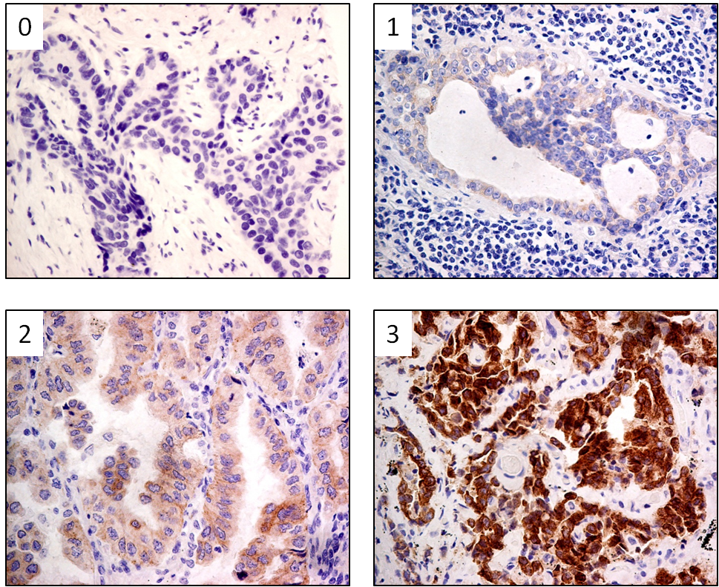
Representative cases with ALK IHC intensity scores 0 to 3 are shown. the staining intensities were defined according to the following rule: 0, no staining ; 1, weak staining, only reliable at high magnification (×40 objective lenses); 2, moderate staining, visible at intermediate levels of magnification (×10 or ×20 objective lenses); 3, strong staining, visible at low levels of magnification, (×4 objective lenses).

Supplementary Figure 2 Overall survival time of ALK-positive patients versus ALK-negative patients (p=0.255).
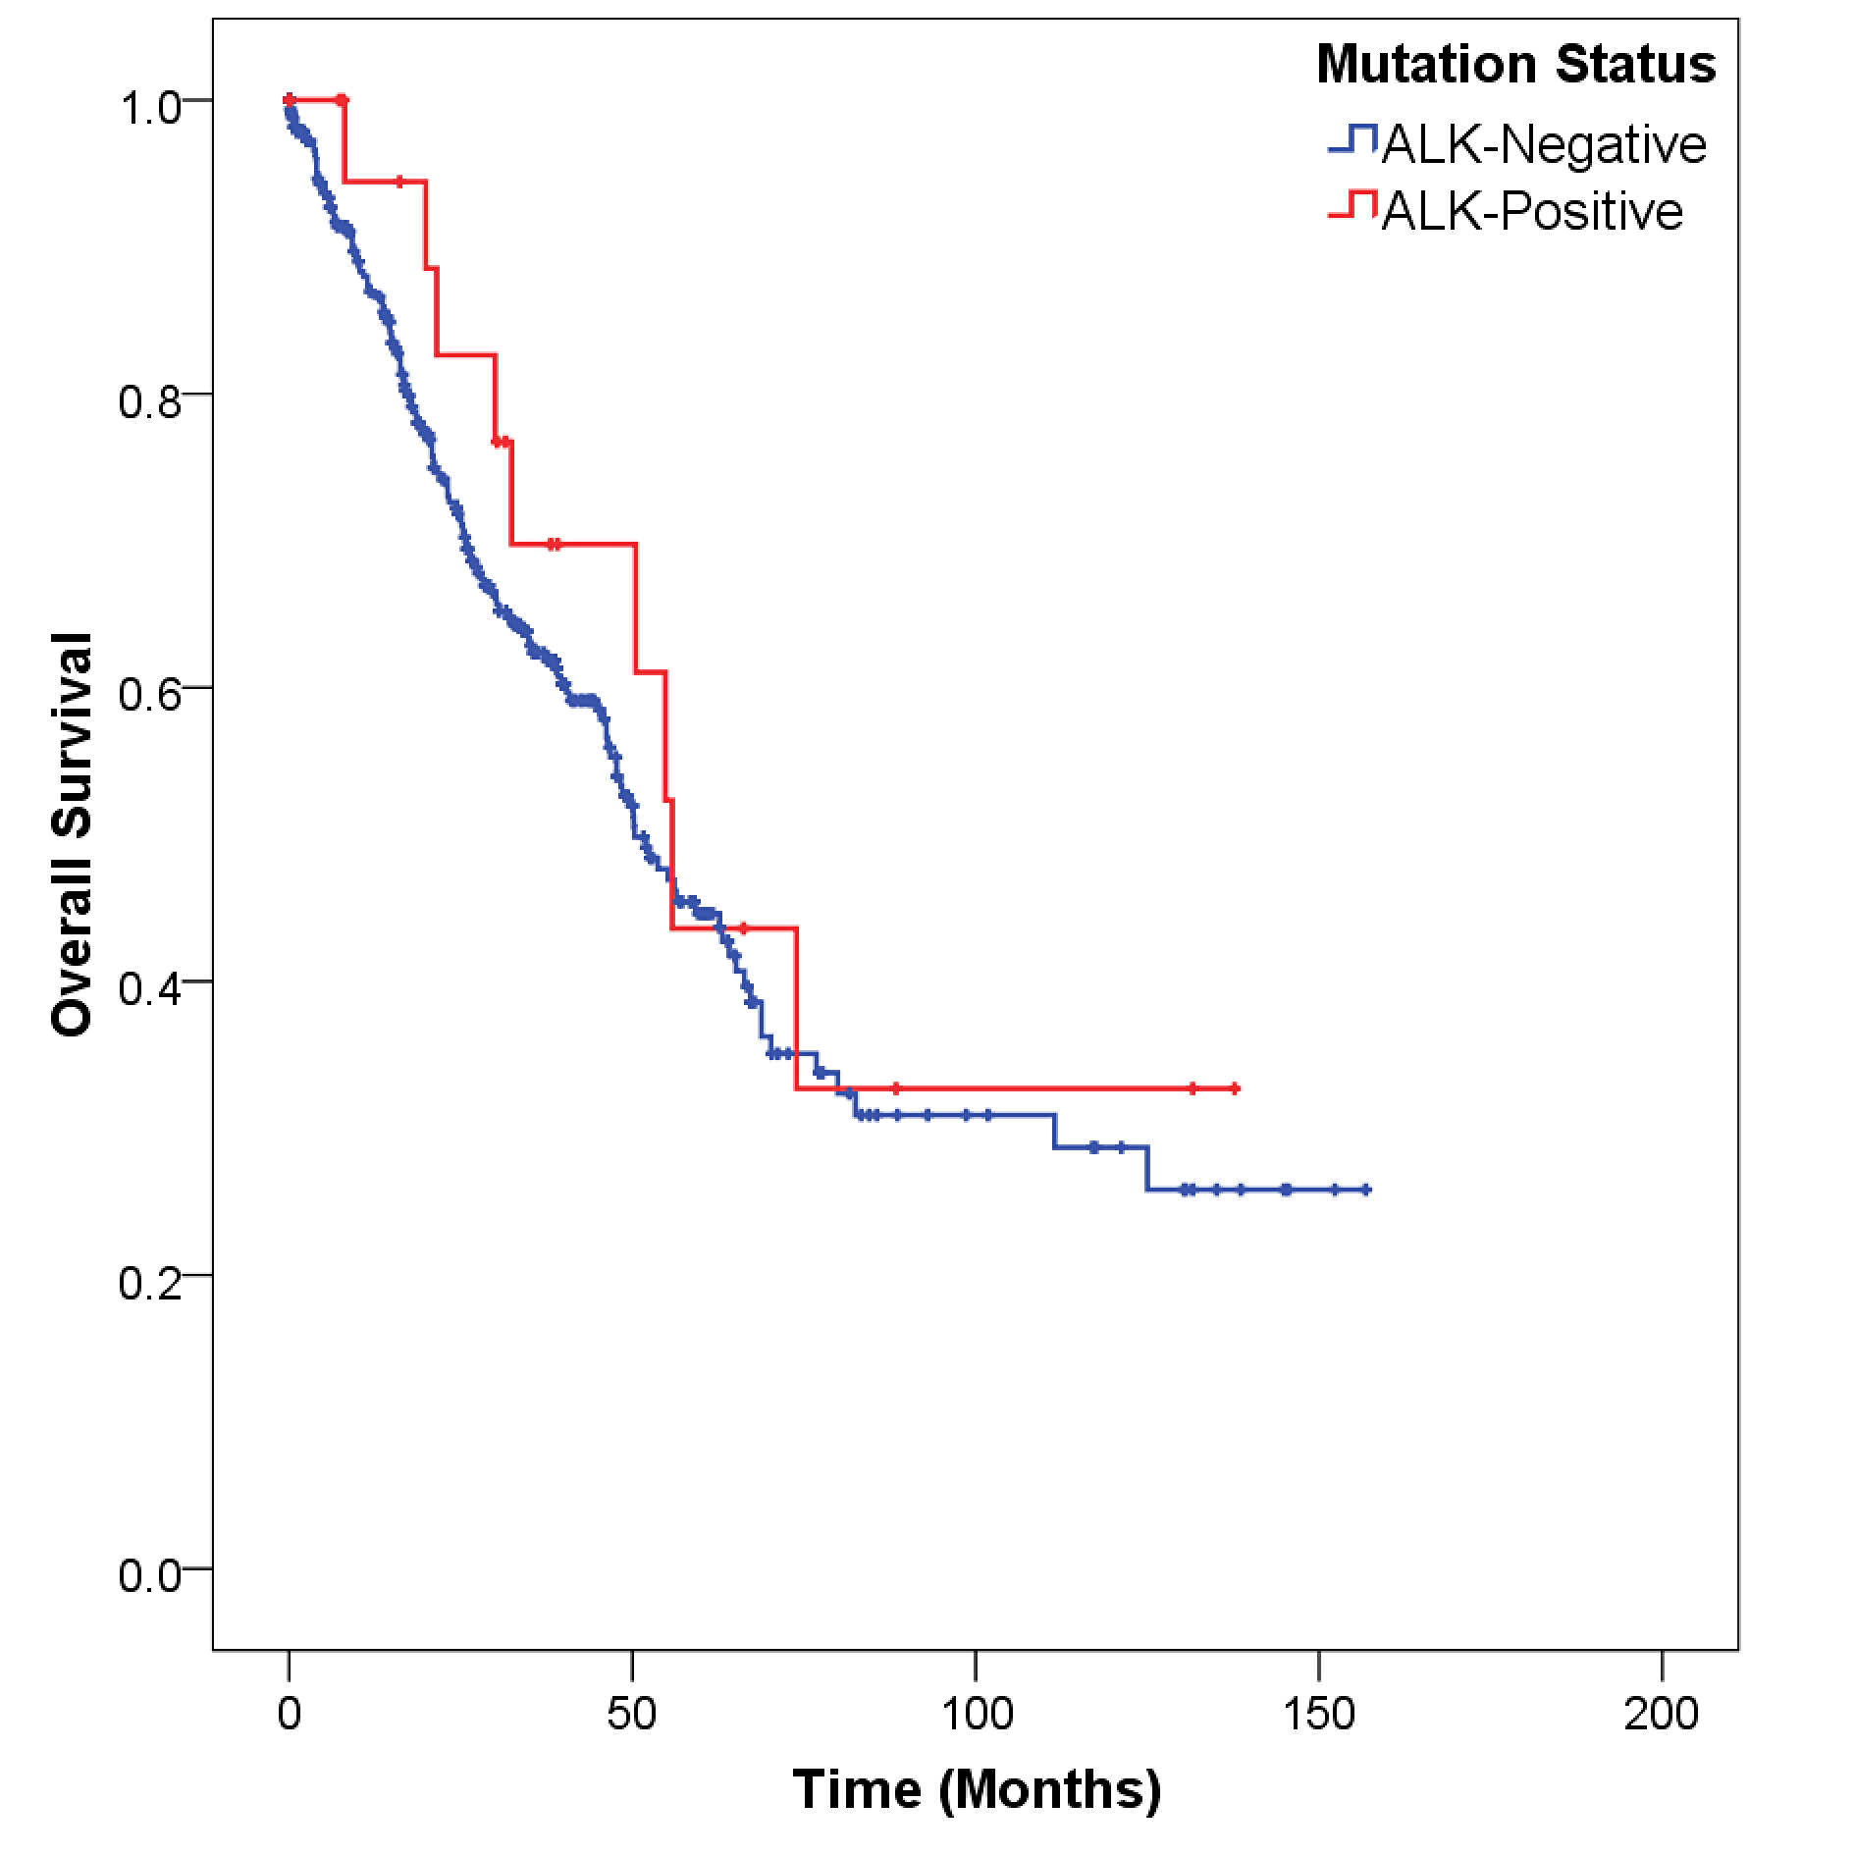

Supplementary Figure 3 Overall survival time of ALK-positive patients compared with EGFR-positive patients and wt/wt patients. ALK-positive versus wt/wt: p=0.076; EGFR-positive versus wt/wt: p=0.001.
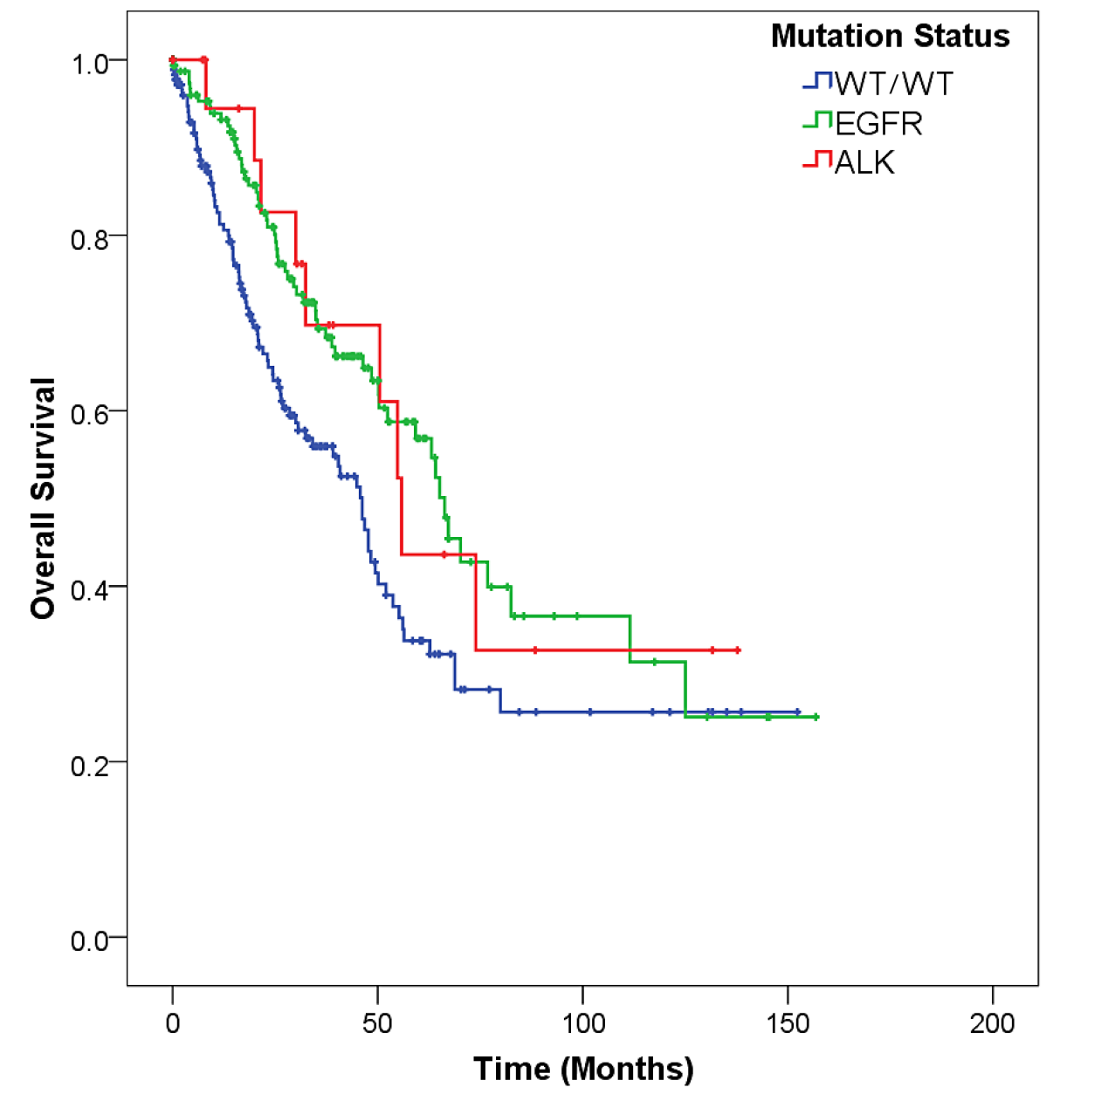

Supplementary Figure 4 Overall survival time of stage IV ALK-positive patients compared with EGFR-positive patients and wt/wt patients. ALK-positive versus wt/wt: p=0.253; EGFR-positive versus wt/wt: p=0.033.
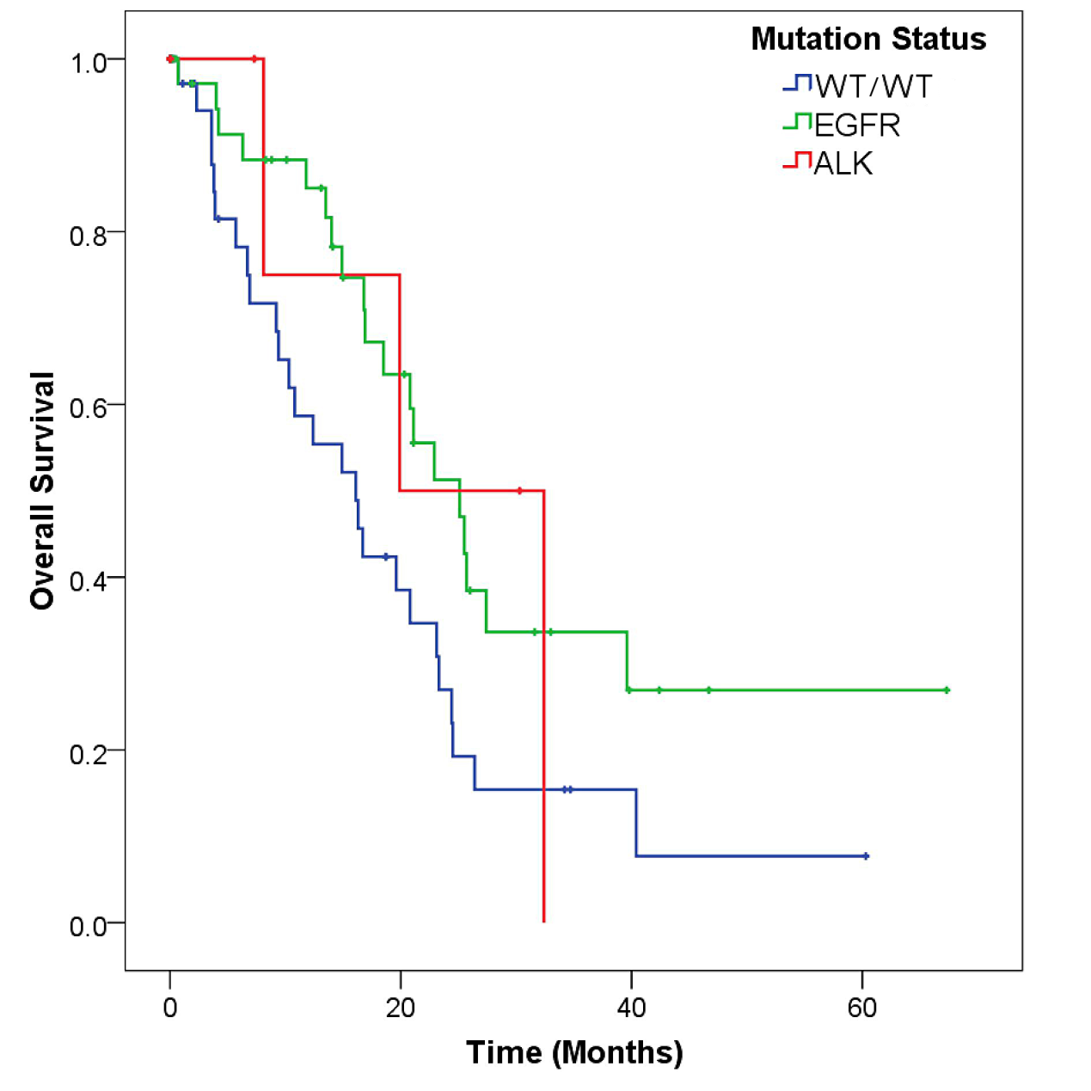

Supplementary Figure 5 Progression free survival time of early stage (stage I, II) ALK-positive patients compared with EGFR-positive patients and wt/wt patients. ALK-positive versus wt/wt: p=0.248; EGFR-positive versus wt/wt: p=0.022.


