Supplement to Circulating Tumor Microemboli Diagnostics for Patients with Non-Small Cell Lung Cancer

Anders Carlsson (1),† Viswam S. Nair (2),† Madelyn S. Luttgen (1), Khun Visith Keu (3), George Horng (4), Minal Vasanawala (5), Anand Kolatkar (1), Mehran Jamali (6), Andrei H. Iagaru (6), Ware Kuschner (7), Billy W. Loo Jr. (8), Joseph B. Shrager (9, 10), Kelly Bethel (11), Carl K. Hoh (12), Lyudmila Bazhenova (13), Jorge Nieva (14), Peter Kuhn (1),‡ Sanjiv S. Gambhir (6)‡

† Co-first authors; ‡ Co-senior authors

Supplemental Table 1. CTM Data for 25 Benign Patients
Supplemental Table 2. Logistic Regression Coefficients by Model
Supplemental Figure 1. Variables Assessed by Disease Group
Supplemental Figure 2. Predicted Cancer Risk by Disease Group
Supplemental Figure 3. LASSO Model ROC Curve

Supplemental Table 1. CTM Data for 25 Benign Patients
Total  CTC | Total  CTM | Cohort | Center | Age (yrs) | Gender | Smoking  History | Cancer  History | Lesion  Location | SUV  max | Lesion  Diameter (cm) | TTA  (hrs) | mL/  test | Description
16 | 2 | Training | PAVAHCS | 65 | Male | past | Yes | RML | 0.7 | 1 | 25 | 1.11 | Intra-pulmonary lymph node by surgical resection
8 | 0 | Training | Stanford | 65 | Male | current | No | RML | 12.3 | 2.2 | 21 | 2.21 | Video Assisted Thoracoscopy showed NTMB
7 | 0 | Training | Stanford | 62 | Female | past | No | LUL | 1.7 | 1.3 | 25 | 1.21 | Stable nodule over five years when compared to previous chest x-ray
5 | 0 | Training | Stanford | 71 | Male | past | No | LUL | 2.4 | 2.4 | 19 | 1.52 | Resolution of nodule on follow up imaging
5 | 0 | Test | CPMC | 43 | Female | none | Yes | RUL | 9.9 | 4.5 | 18 | 0.97 | M. tuberculosis on biopsy
5 | 0 | Training | Stanford | 69 | Male | past | No | RUL | 2.6 | 1.9 | 23 | 2.06 | C. immitis fungal nodule, resected surgically
4 | 0 | Test | Stanford | 77 | Male | none | Yes | LLL | 1.5 | 1.9 | 25 | 2.13 | Stability of round atelectasis over 2 years
4 | 0 | Test | PAVAHCS | 69 | Male | past | Yes | LUL | 2.7 | 5.4 | 27 | 1.35 | Resolution of nodule on follow-up imaging
3 | 0 | Training | PAVAHCS | 58 | Female | current | Yes | RUL | 0.38 | 1 | 23 | 0.88 | Follow-up chest x-ray shows no evidence of lesion
2 | 0 | Training | Stanford | 63 | Female | none | Yes | RLL | 6.9 | 2.3 | 28 | 2.38 | NTMB resected surgically
2 | 0 | Training | Stanford | 75 | Male | past | No | RUL | 1.6 | 2.1 | 21 | 1.11 | Biopsy proven granuloma and necrosis, question of NTMB disease
1 | 0 | Training | Stanford | 70 | Male | current | No | RLL | 9 | 3.8 | 24 | 2.70 | Resolution of round pneumonia on follow up imaging
1 | 0 | Training | Stanford | 72 | Male | past | Yes | RLL | 1.8 | 2 | 22 | 1.33 | Lung abscess by biopsy
1 | 1 | Training | Stanford | 26 | Female | none | No | LUL | 2 | 1 | 19 | 1.77 | Decreasing size of nodule with anti-bacterial therapy
1 | 0 | Training | PAVAHCS | 55 | Male | current | No | RLL | 0.5 | 1.2 | 21 | 0.70 | Benign per PET read (calcified with smooth margins)
0 | 0 | Training | PAVAHCS | 67 | Male | none | No | RLL | 1.4 | 1.6 | 24 | 1.09 | Decreasing size of nodule over time
0 | 0 | Test | CPMC | 50 | Female | past | Yes | RLL | 0.9 | 0.8 | 23 | 2.47 | Hamartoma by surgical resection
0 | 0 | Training | PAVAHCS | 51 | Male | current | Yes | RLL | 11 | 6 | 24 | 4.23 | Lung abscess by surgical resection
0 | 0 | Test | PAVAHCS | 60 | Male | past | No | LUL | 3 | 4 | 24 | 0.90 | Resolution of lesion on follow-up imaging
0 | 0 | Training | PAVAHCS | 61 | Male | current | Yes | RLL | 3.3 | 4.5 | 21 | 1.01 | Round atelectasis by imaging and superimposed Nocardia infection
0 | 0 | Test | Stanford | 60 | Female | past | No | RLL | 7.6 | 3.9 | 22 | 2.28 | Allergic bronchopulmonary aspergillosis with fleeting nodules
0 | 0 | Training | Stanford | 53 | Male | none | No | LUL | 0.7 | 1.7 | 21 | 1.51 | C. immitis fungal nodule on biopsy
0 | 0 | Test | CPMC | 68 | Female | past | Yes | LLL | 3.1 | 1.6 | 27 | 1.89 | Granulomatous disease (possibly H. capsulatum) by surgical resection
0 | 0 | Training | PAVAHCS | 78 | Male | past | Yes | RLL | 3.1 | 4 | 24 | 2.38 | C. immitis pneumonia by biopsy
0 | 0 | Test | Billings | 80 | Male | past | Yes | LLL | 3.6 | 2.2 | 27 | 1.37 | Mediastinoscopy positive for H. capsulatum

NA = Not available: PAVAHCS = Palo Alto VA Health Care System; CPMC = California Pacific Medical Center; UCSD = University of California San Diego Medical Center; RUL = Right upper lobe, RLL = Right lower lobe, LUL = Left upper lobe, LLL = Left lower lobe; TTA = Time to assay from phlebotomy; NTMB = Non-tuberculous mycobacteria.

Supplemental Table 2. Logistic Regression Coefficients by Model

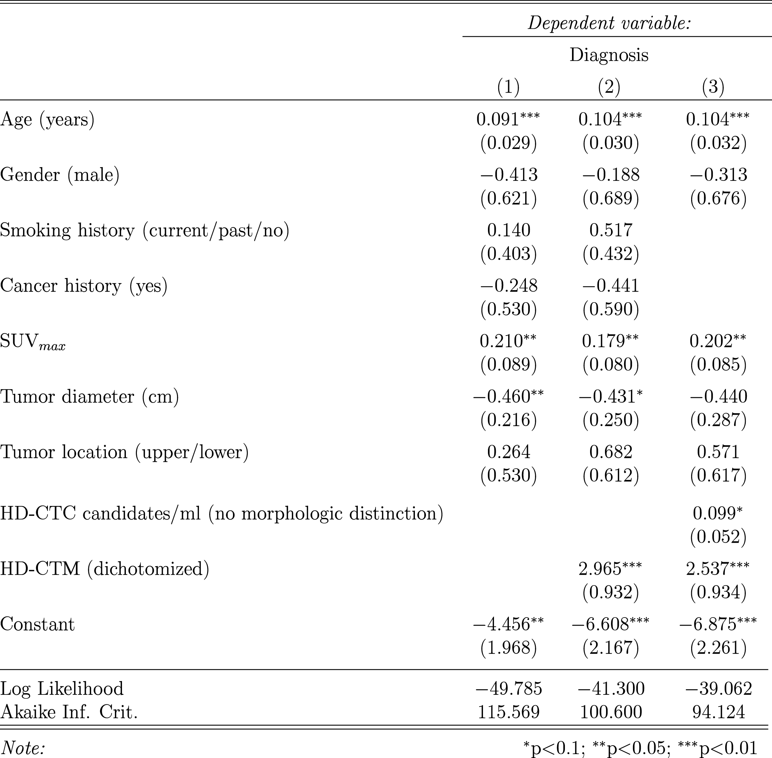

Models (1) Clinical; (2) Clinical and CTM; (3) Lasso. For the risk score calculation, variables were defined as follows: Age: years alive; Gender: male = 1, female = 0; Smoking history: none=0, past = 1, current = 2; Cancer history: none = 0, yes = 1; Diameter: size in centimeters at maximal diameter; Tumor Location: lower lobe = 0, upper lobe = 1; HD-CTM: none = 0, any = 1.
Supplemental Figure 1. Variables Assessed by Disease Group

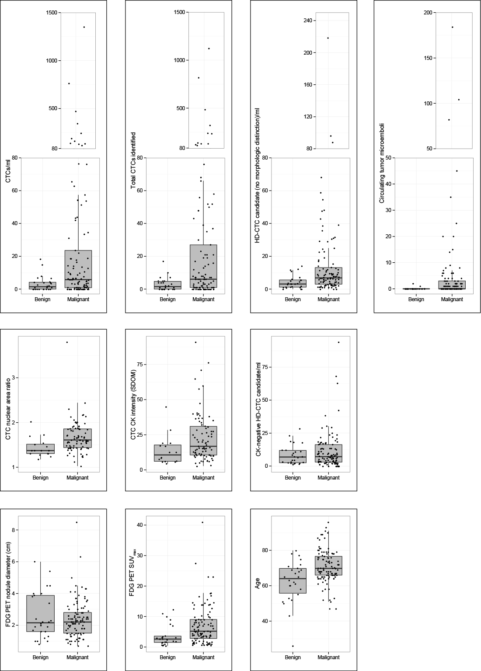Clinical (Age), imaging (Nodule Diameter and SUV_{max}) and HD-CTC variables (CTC concentration and Total CTCs, CTM, CTC size [small cells, or “SHCs,” and nuclear area] and fluorescence intensity [CK intensity and CK negative cells, “DHCs”]) are shown by benign (n=25) or NSCLC diagnosis (n=104).
Supplemental Figure 2. Predicted Cancer Risk by Disease Group

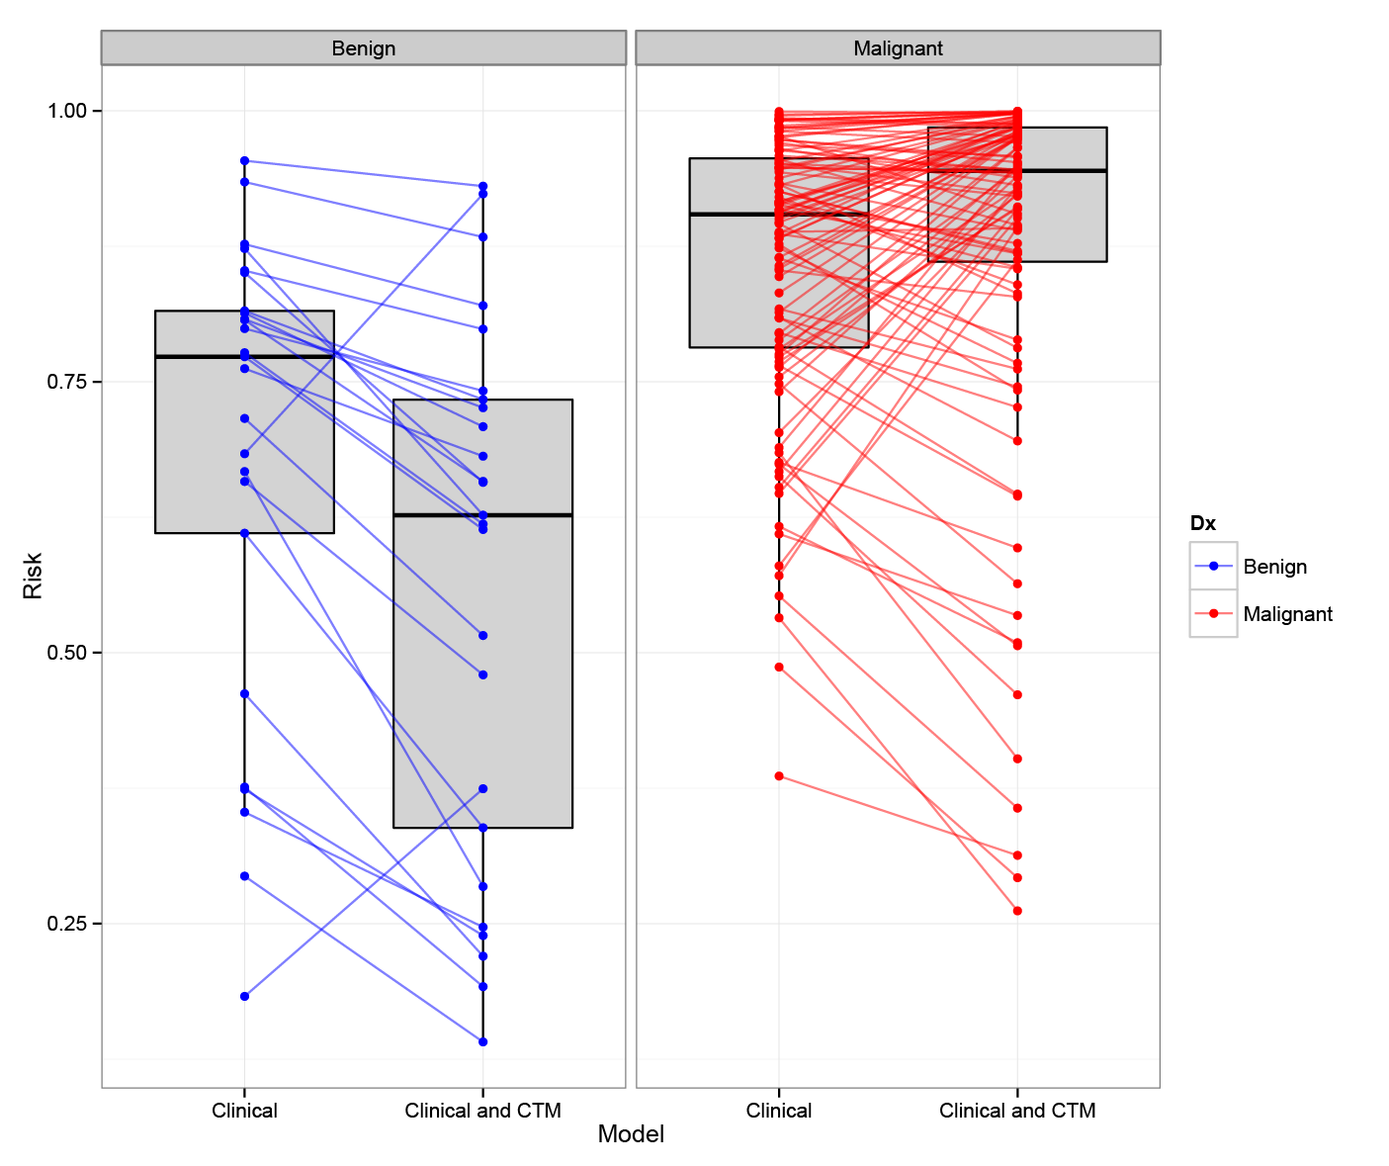

Risk scores calculated from regression modeling illustrate the high-risk nature of the benign cohort in comparison to the cases used for CTC analysis. Box plots are displayed with the median and interquartile range for predicted risk (y-axis) for models based on clinical variables alone (left in each panel), or with CTM (right in each panel). The lines indicate the change in an individual patient’s risk with the addition of CTM in modeling (benign patients = blue in the left panel; malignant patients = red in the right panel). The box plots illustrate the general increase in risk for malignant patients and decreased risk in benign patients as classified by the model containing CTM information.

Supplemental Figure 3. LASSO Model ROC Curves

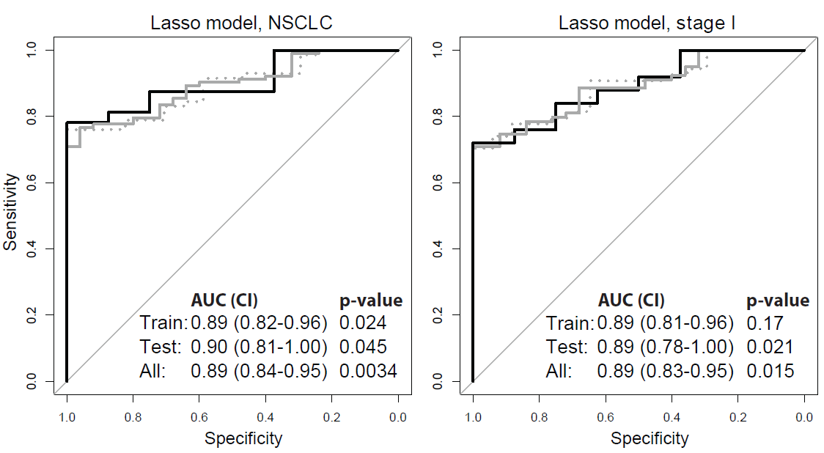

Receiver operating characteristic (ROC) curves for the LASSO model for all NSCLC patients and by stage I disease only across training (dashed gray line), test (solid black line) and all (solid gray line) patients. AUCs for each cohort are shown in the lower right corner of each graph with 95% confidence intervals. The p-values refer to the significance of the difference between each ROC curve and that of the clinical model, for each corresponding setting. The LASSO incorporated a combination of clinical, imaging and HD-CTC variables, including HD-CTM (See Supplementary Table 2), to yield the most discriminating model with consistency across cohorts.

