Appendix 2: Delphi voting tallies for final recommendations
E-Figure 2a: Delphi voting tally for recommendation 1
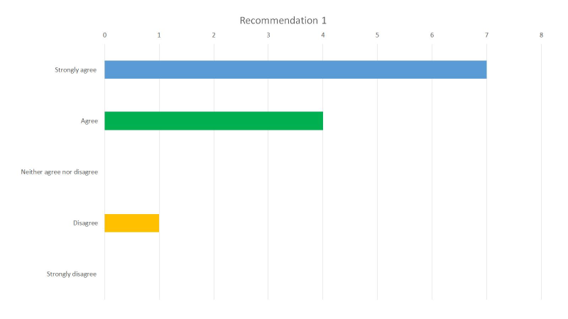
In patients with indwelling pleural catheters for the management of known or suspected malignant pleural effusions without evidence of trapped lung, we suggest daily drainage of the indwelling pleural catheter when, in addition to symptom control, achieving pleurodesis and catheter removal is an important patient-centered goal. When pleurodesis and catheter removal is unlikely or not considered important, less frequent drainage schedules or symptom-based drainage is appropriate (Ungraded Consensus-Based Statement).

E-Figure 2b: Delphi voting tally for recommendation 2
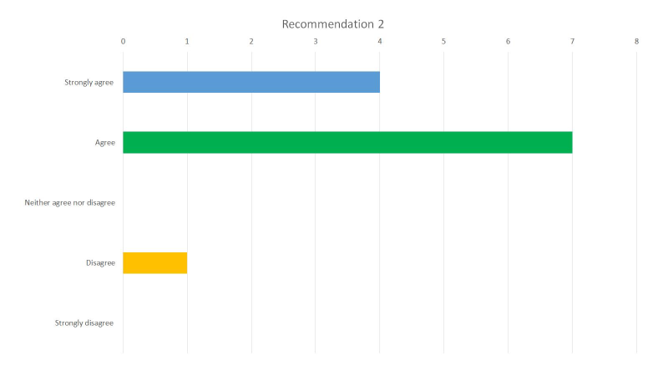
In patients with indwelling pleural catheters for the management of known or suspected malignant pleural effusions with suspected trapped lung, we suggest that the ideal drainage schedule is unknown and should be decided on an individual case basis. Daily drainage of the indwelling pleural catheter might be considered when, in addition to symptom control, achieving pleurodesis and catheter removal is considered an important goal, as pleurodesis might still be possible. Conversely, aggressive drainage may result in increased chest discomfort in some individuals, and if present should lead to less frequent or symptomatic driven drainage schedules (Ungraded Consensus-Based Statement).

E-Figure 2c: Delphi voting tally for recommendation 3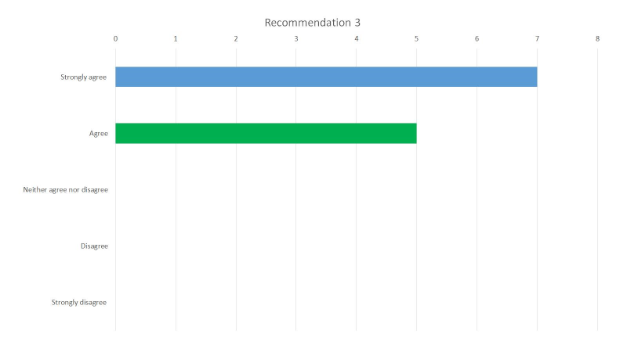
In patients with indwelling pleural catheters for the management of known or suspected malignant pleural effusions, we suggest that, even in the absence of catheter-related concerns, regular clinical follow-up with a provider experienced in the management of indwelling pleural catheters should be offered, with the frequency decided on an individual basis (Ungraded Consensus-Based Statement).

E-Figure 2d: Delphi voting tally for recommendation 4
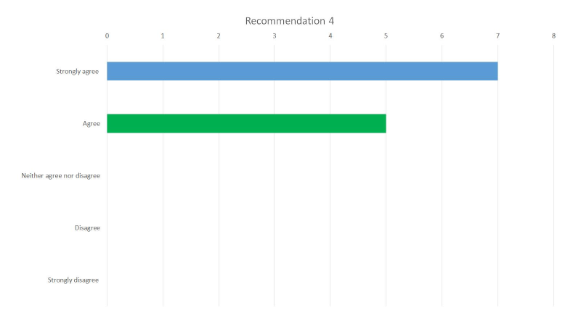
In patients with indwelling pleural catheters for the management of known or suspected malignant pleural effusions and symptomatic pleural fluid re-accumulation due to a non-draining pleural catheter, we suggest saline flushing of the catheter to relieve any obstruction. If saline is unsuccessful at relieving the obstruction, and there are no contraindications, instillation of fibrinolytics via the catheter should be attempted to restore flow. (Ungraded Consensus-Based Statement).

E-Figure 2e: Delphi voting tally for recommendation 5
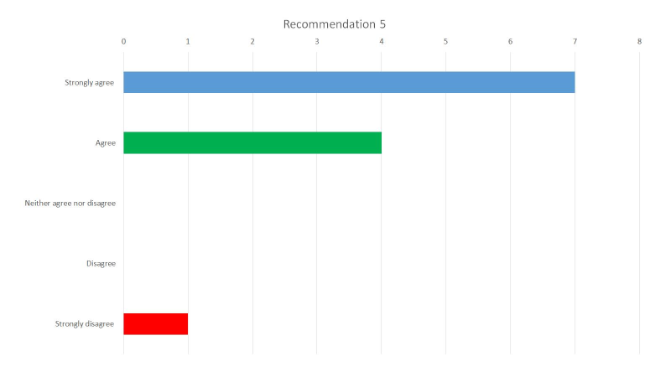In patients with indwelling pleural catheters for the management of known or suspected malignant pleural effusions and suspected catheter-related pleural space infections, we suggest obtaining pleural fluid for microbiological studies to guide antibiotic therapy. The optimal method of obtaining pleural fluid (for example, either by thoracentesis or directly from the indwelling pleural catheter) is unclear and warrants further study (Ungraded Consensus-Based Statement).

E-Figure 2f: Delphi voting tally for recommendation 6
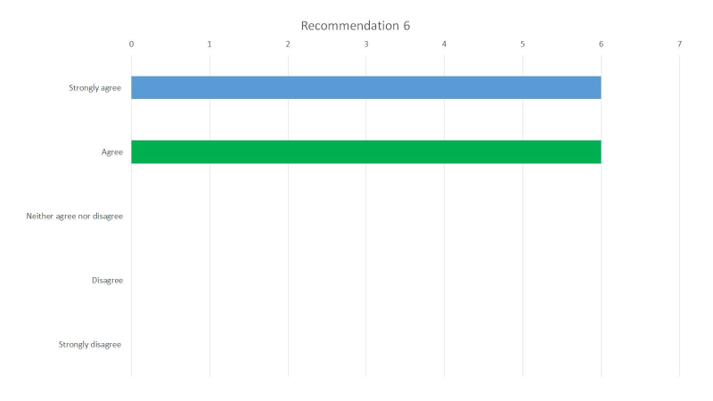
In patients with indwelling pleural catheters for known or suspected malignant pleural effusions and catheter-associated cellulitis or exit site infections, we suggest a trial of oral antibiotics with coverage for typical skin pathogens is appropriate, and catheter removal is only necessary in the setting of antibiotic failure (Ungraded Consensus-Based Statement).

E-Figure 2g: Delphi voting tally for recommendation 7
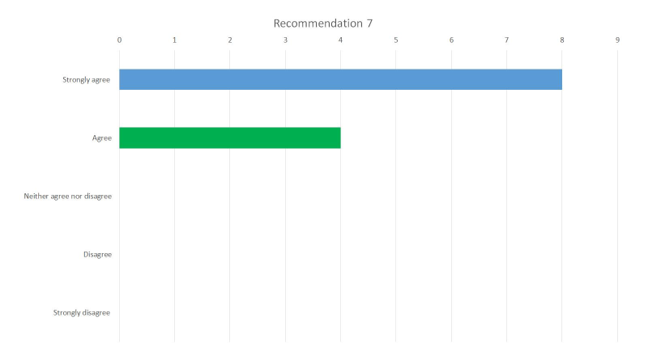
In patients with indwelling pleural catheters for the management of known or suspected malignant pleural effusions who develop a catheter-related pleural space infection without a concomitant tunnel tract infection, we suggest attempting continuous fluid drainage through the indwelling pleural catheter over catheter removal (Ungraded Consensus-Based Statement).

E-Figure 2h: Delphi voting tally for recommendation 8
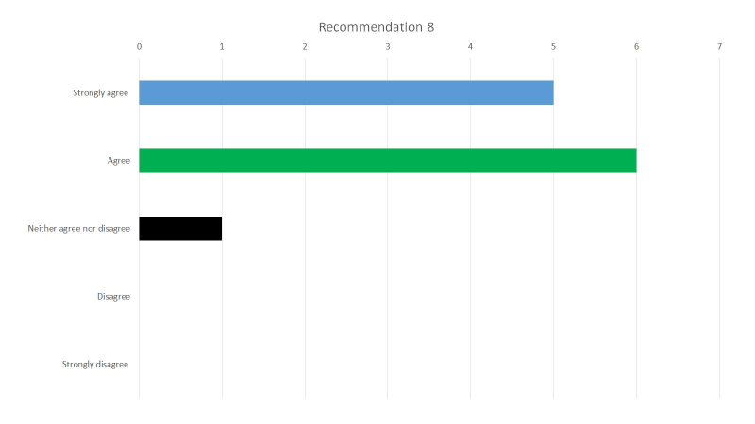
In patients with indwelling pleural catheters for the management of known or suspected malignant pleural effusions who develop a catheter-related pleural space infection which cannot be adequately drained despite continuous drainage, we suggest instillation of fibrinolytics and DNase via the catheter to aid in catheter drainage and clearance of infection (Ungraded Consensus-Based Statement).

E-Figure 2i: Delphi voting tally for recommendation 9
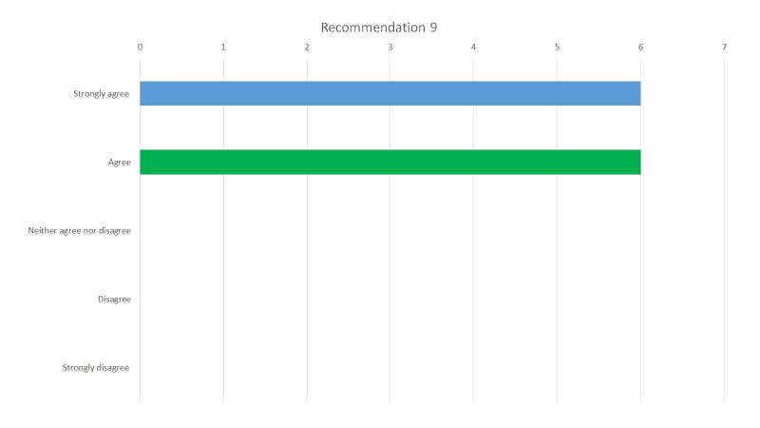
In patients with indwelling pleural catheters for the management of known or suspected malignant pleural effusions who develop a catheter-related pleural space infection, we suggest catheter removal and drainage of the pleural space with a new chest tube should be considered if any of the following are present: a tunnel tract infection, poor catheter drainage despite the use of fibrinolytics and DNase, or persistent sepsis despite antibiotics and drainage through the original indwelling pleural catheter (Ungraded Consensus-Based Statement).

E-Figure 2j: Delphi voting tally for recommendation 10
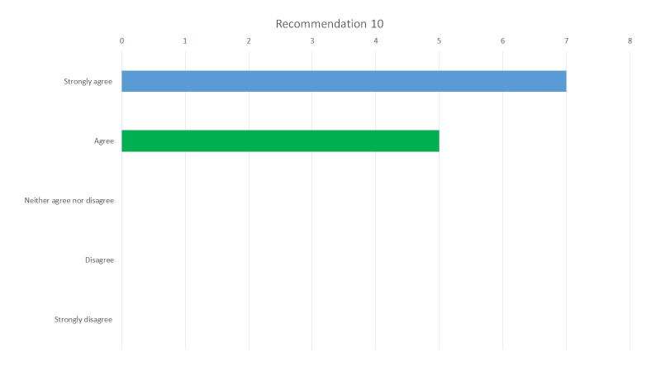
In patients with indwelling pleural catheters for the management of known or suspected malignant pleural effusions who develop a catheter-related pleural space infection, we suggest empiric antibiotics with broad coverage for catheter-related organisms including S. aureus and gram-negative organisms, while awaiting results of microbiological testing. (Ungraded Consensus-Based Statement).

E-Figure 2k: Delphi voting tally for recommendation 11
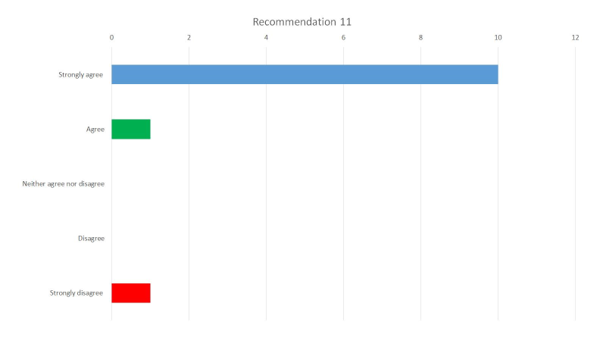
In patients with indwelling pleural catheters for the management of known or suspected malignant pleural effusions who are receiving chemotherapy, we suggest against removing the catheter for the purpose of reducing infection risk (Ungraded Consensus-Based Statement).

