Supplemental Figure 3: Location descriptors (for patient in the left lateral position)
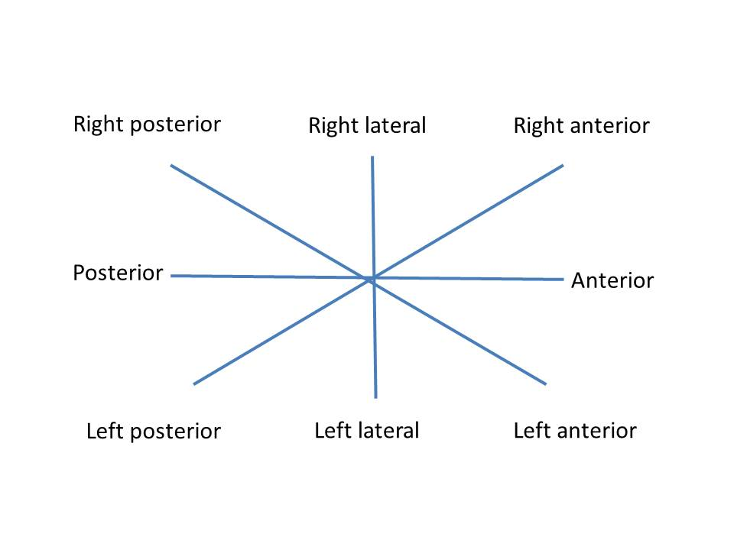
Note: these descriptors are markedly different if the patient is in a prone, lithotomy position or right lateral position

