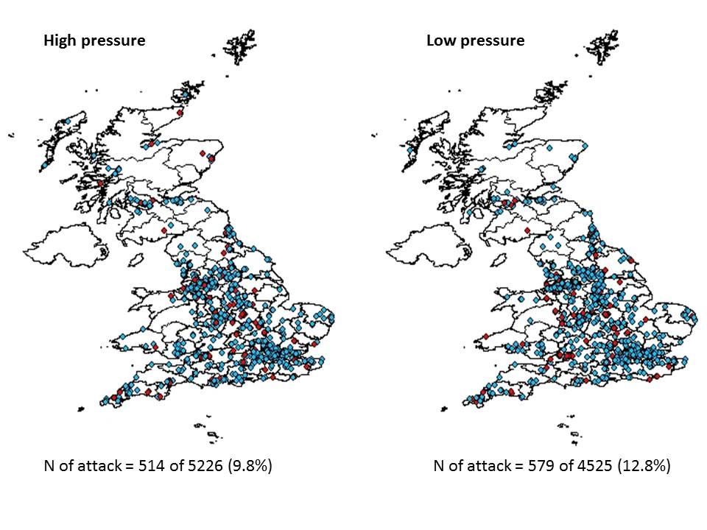
Supplementary Figure 1: UK Map representing the spread of users in the UK split with reports split by high and low atmospheric pressure. Red dots represent attacks and blue dots represent no attacks.

