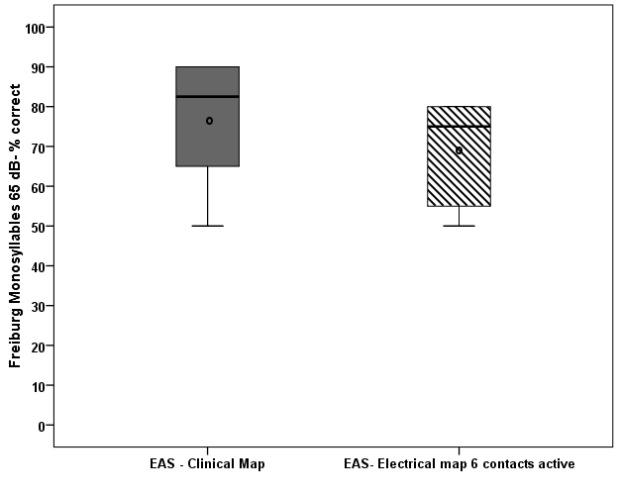
(A)

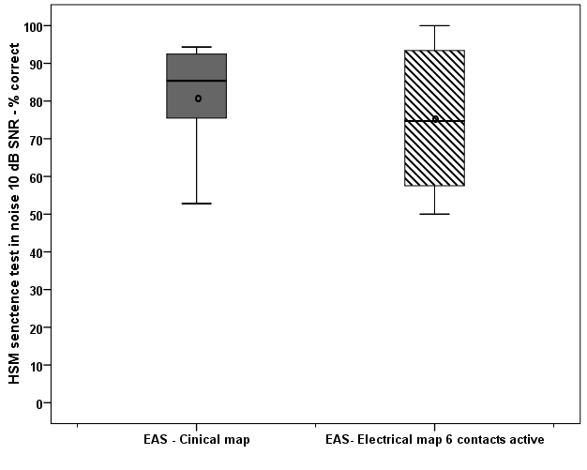
(B)
Fig. 1: Median, interquartile, minimum and maximum scores of (A) Freiburg Monosyllables, (B) HSM sentences in noise 10 dB SNR- comparing two fitting configuration 1. EAS - clinical map and 2. EAS-electrical map with 6 contacts active; no significant difference found

