Appendix

Search terms (all searches conducted on or before March 21, 2018)
Pubmed search: (("Hearing Loss"[Mesh] OR "sensorineural" "Persons With Hearing Impairments"[Mesh] OR "Deafness"[Mesh] OR ((hearing) AND (loss OR impair*)) OR deaf OR deafness OR deafness neurosensory OR dizziness OR ear disorder OR giddiness OR hearing impaired OR hypoacusis OR sudden hearing loss OR tinnitus OR vertigo OR vertigo positional) AND ("Sildenafil Citrate"[Mesh] OR "Phosphodiesterase Inhibitors"[Mesh] OR "Phosphodiesterase 5 Inhibitors"[Mesh] OR ("sildenafil*"[Title/Abstract]) OR ("desmethyl sildenafil"[Title/Abstract]) OR ("desmethylsildenafil"[Title/Abstract]) OR ("acetildenafil"[Title/Abstract]) OR ("homosildenafil"[Title/Abstract]) OR ("viagra*"[Title/Abstract]) OR ("revatio"[Title/Abstract] OR ("tadalafil"[Title/Abstract] or "vardenafil"[Title/Abstract] or "phosphodiesterase type 5 inhibitors"[title/Abstract])))
Scopus search: TITLE-ABS-KEY (hearing AND loss OR hearing AND impairment OR hearing OR deafness OR sudden AND hearing AND loss OR tinnitus ) AND TITLE-ABS-KEY (sildenafil OR viagra OR "Phosphodiesterase Inhibitors" OR "Phosphodiesterase 5 Inhibitors" OR vardenafil OR tadalafil OR "phosphodiesterase type 5 inhibitors" ) )
Cochrane library: hearing loss OR hearing impairment OR hearing OR persons with hearing impairments OR deafness OR sudden hearing loss OR tinnitus OR ear disorder in Title, Abstract, Keywords and sildenafil OR viagra OR "Phosphodiesterase Inhibitors" OR "Phosphodiesterase 5 Inhibitors" OR "phosphodiesterase type 5 inhibitors" OR vardenafil OR tadalafil OR "sildenafil citrate”

PRISMA Flow Chart
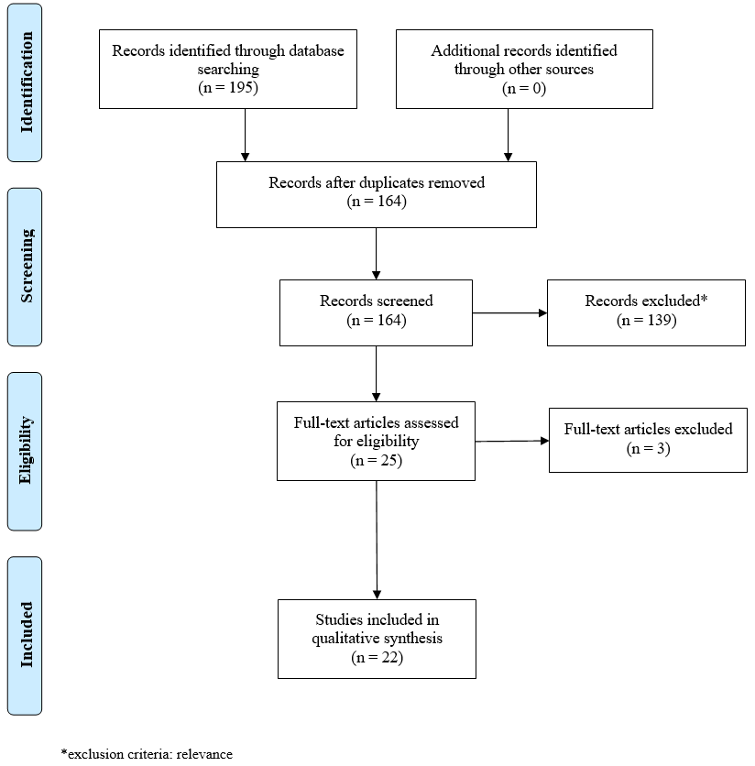
Adapted from International Journal of Surgery Moher D, Liberati A, Tetzlaff J, Altman DG, The PRISMA Group. Preferred Reporting Items for Systematic Reviews and Meta-Analyses: The PRISMA Statement. Int J Surg 2010; doi:10.1016/j.ijsu.2010.02.007

