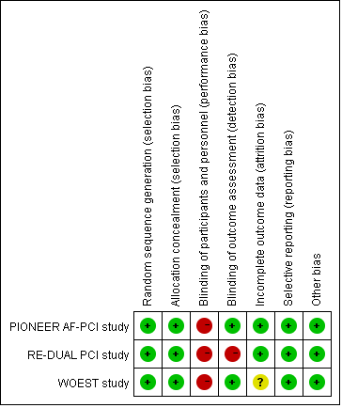
Online Figure 1: Risk of bias summary review authors’ judgements about each risk of bias item for each included study
Green means low risk of bias, yellow means intermediate risk, and red means high risk.

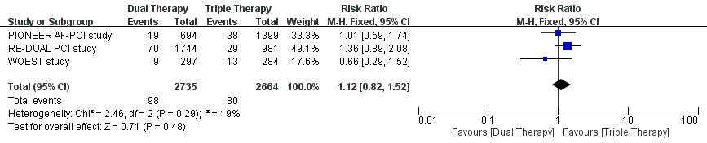
Online Figure 2:Meta-analysis with risk ratio and 95% CI for myocardial infarction
Boxes are the relative risk estimates from each study; the horizontal bars are 95% confidence intervals (CI). The size of the box is proportional to the weight of the study in the meta-analysis.

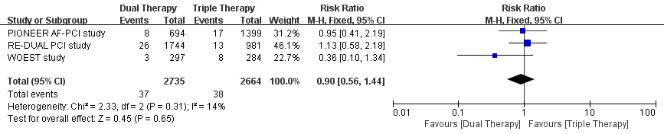
Online Figure 3:Meta-analysis with risk ratio and 95% CI for stroke
Boxes are the relative risk estimates from each study; the horizontal bars are 95% confidence intervals (CI). The size of the box is proportional to the weight of the study in the meta-analysis.

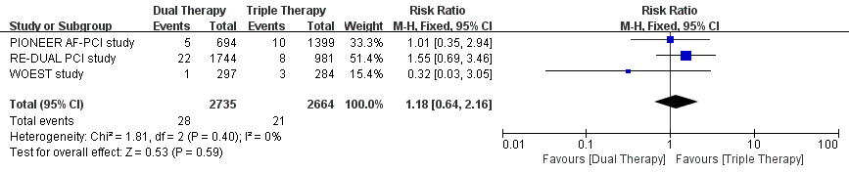
Online Figure 4:Meta-analysis with risk ratio and 95% CI for definite stent thrombosis
Boxes are the relative risk estimates from each study; the horizontal bars are 95% confidence intervals (CI). The size of the box is proportional to the weight of the study in the meta-analysis.

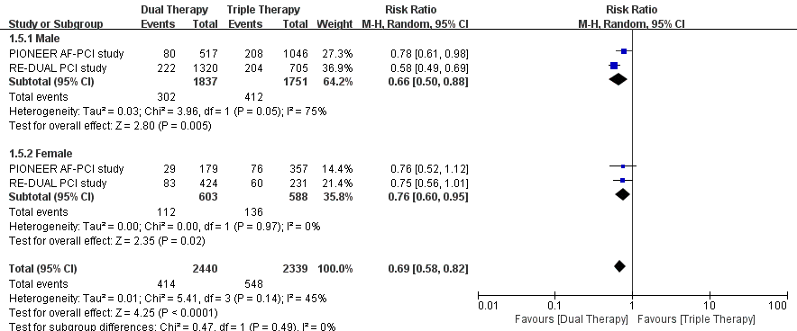
Online Figure 5:Meta-analysis with risk ratio and 95% CI for sex subgroup analysis of clinical bleeding events
Boxes are the relative risk estimates from each study; the horizontal bars are 95% confidence intervals (CI). The size of the box is proportional to the weight of the study in the meta-analysis.

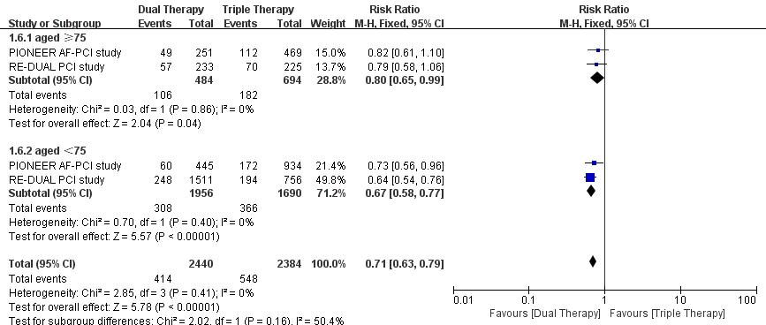
Online Figure 6:Meta-analysis with risk ratio and 95% CI for age subgroup analysis of clinical bleeding events
Boxes are the relative risk estimates from each study; the horizontal bars are 95% confidence intervals (CI). The size of the box is proportional to the weight of the study in the meta-analysis.

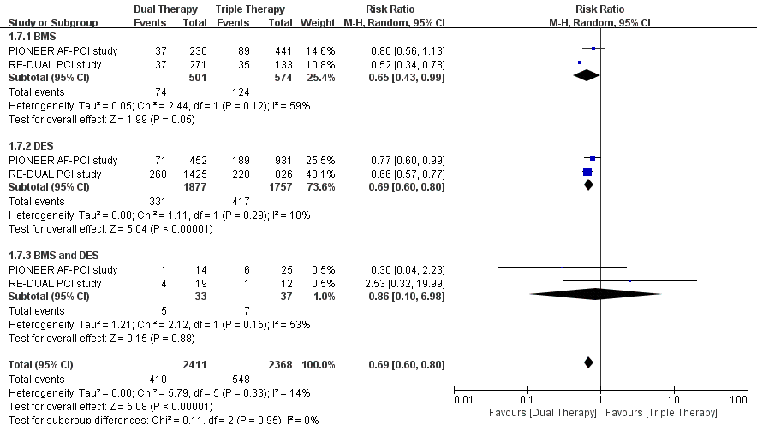
Online Figure 7:Meta-analysis with risk ratio and 95% CI for stent type subgroup analysis of clinical bleeding events
Boxes are the relative risk estimates from each study; the horizontal bars are 95% confidence intervals (CI). The size of the box is proportional to the weight of the study in the meta-analysis.

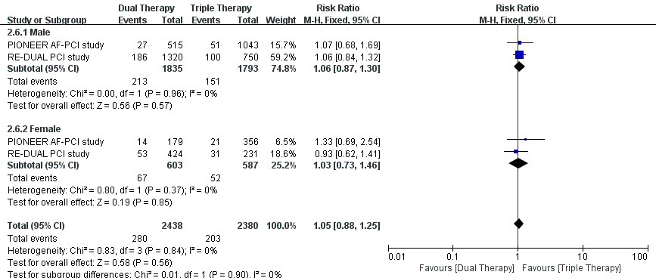
Online Figure 8:Meta-analysis with risk ratio and 95% CI for sex subgroup analysis of MACE
Boxes are the relative risk estimates from each study; the horizontal bars are 95% confidence intervals (CI). The size of the box is proportional to the weight of the study in the meta-analysis.

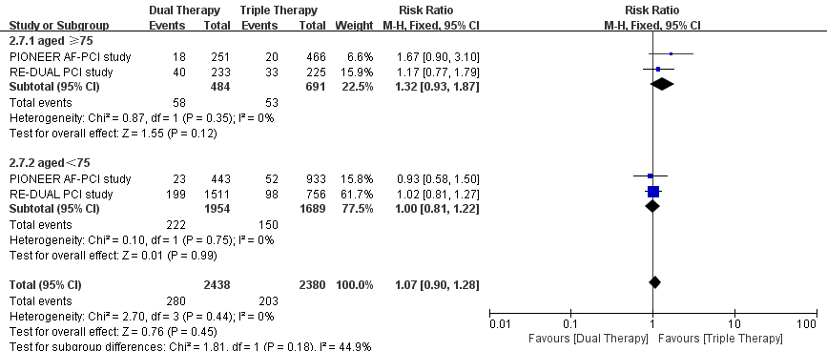
Online Figure 9:Meta-analysis with risk ratio and 95% CI for age subgroup analysis of MACE
Boxes are the relative risk estimates from each study; the horizontal bars are 95% confidence intervals (CI). The size of the box is proportional to the weight of the study in the meta-analysis.
In PIONEER AF-PCI trial, patients were grouped into those aged greater than 75 or not. In RE-DUAL PCI trial, patients were grouped into those aged greater than 80 or not.

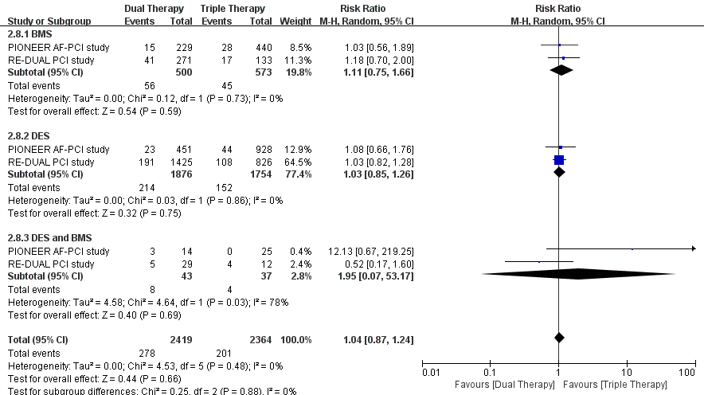
Online Figure 10:Meta-analysis with risk ratio and 95% CI for stent type subgroup analysis of MACE
Boxes are the relative risk estimates from each study; the horizontal bars are 95% confidence intervals (CI). The size of the box is proportional to the weight of the study in the meta-analysis.

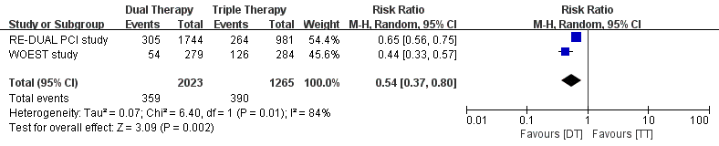
Online Figure 11:Odds ratios (with 95% confidence interval) of clinical bleeding events by slicing data to HAS-BLED score 0-2 (upper) and HAS-BLED score 3-6 (lower) from the PIONEER AF-PCI trial.
Boxes are the relative risk estimates from each study; the horizontal bars are 95% confidence intervals (CI). The size of the box is proportional to the weight of the study in the meta-analysis.

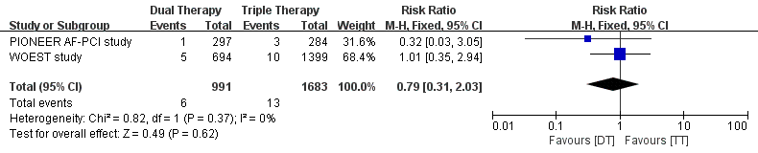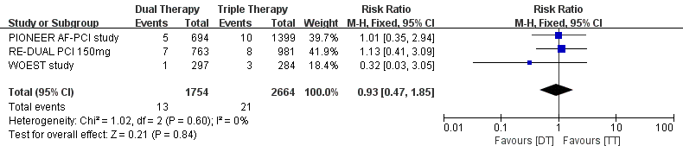
Online Figure 12:Odds ratios (with 95% confidence interval) of definite thrombosis by slicing data to dabigatran 110 mg(upper) and dabigatran 150 mg (lower) from the RE-DUAL PCI trial.
Boxes are the relative risk estimates from each study; the horizontal bars are 95% confidence intervals (CI). The size of the box is proportional to the weight of the study in the meta-analysis.

