MCN-D-18-00029R2
Supplemental Digital Content
Figures 1 and 2
Figure 1: Patient Education and Safety Contract

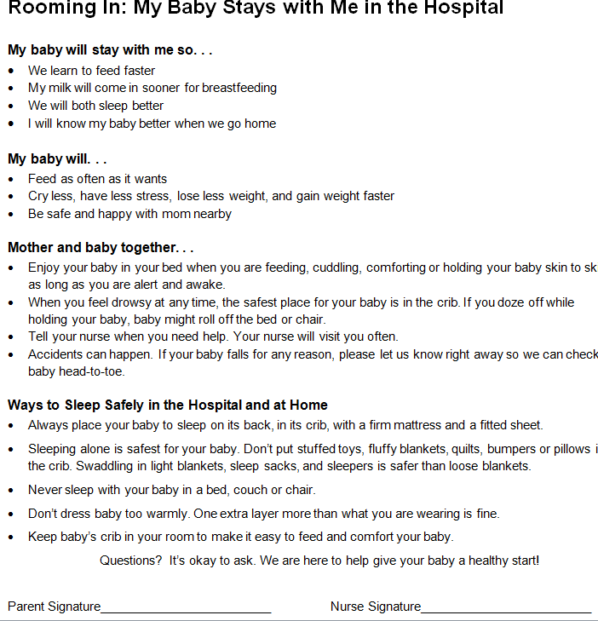

Figure 2: Patient Education TV Pop-Up

