Lober, A., Tussey, C., Gorny, J. (2021). Supporting Feeding of Late Preterm Infants in the Hospital: A Quality Improvement Project. MCN The American Journal of Maternal Child Nursing, 46(6).

Figure 1: Late Preterm Infant Feeding Record, pages 1 and 4

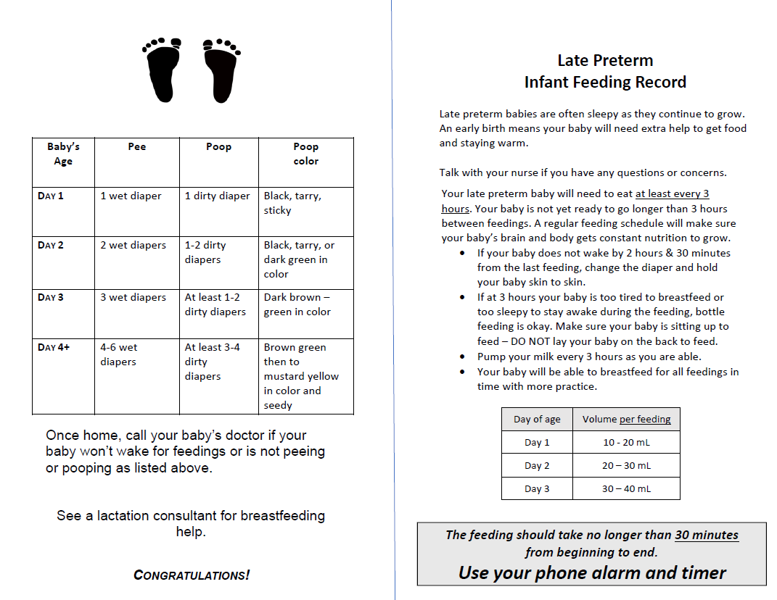
Note. Record is double sided and folded in half. Available for families in English and Spanish.
Late Preterm Infant Feeding Record, pages 2 and 3

