Is Long-term use of Benzodiazepines a risk for cancer?
Supplementary Appendix

S1. Definition of cases in this study 2
Table S1. Benzodiazepine medication used by two million sampling patients in Taiwan during the period from 1998 through 2009 3
Table S2. Detail of overall and each benzodiazepine use associated with cancer risk 4
Table S3. Detail of benzodiazepine class associated with cancer risk 7
Table S4. Detail DDD of overall and each benzodiazepine associated with risk for cancers 8
Table S5. Detail DDD of benzodiazepine class associated with risk for cancers 11
Figure S1. The BZDs use were checked during three year before the date of cancer diagnosis for both cases and control groups. The daily dose of BZD is calculated as the collected total amount of BZD at dispenses (i.e. d1, d2, d3) divided by the total time duration of dispenses (i.e. |t1-t2|, |t3-t4|, |t5-t6|). 12
Figure S2. Distribution of BZD dispenses 3 years before and 1 year after cancer diagnosis in case and control group. For cases, the dispense pattern before and after cancer diagnosis with the increased dispense after for short duration compared with before cancer diagnosis, likely explained by anxiety or sleeplessness. After that the slightly decreased dispense of BZDs which might be of the death of some cancer patients after a cancer diagnosis. For control, the dispense pattern before and after index date was likely similar. 13
Figure S3. Selection of cancer patients (case) and non-cancer patients (control) entering into the study by using propensity score (1:6) matched study 14
Figure S4. The BZDs use were checked by follow-up all subjects started from the initial BZDs dispense date or the first visit date of the cohort database until a cancer diagnosis/index date or until the time subject was censored for loss to follow-up, or termination of insurance. 15
Figure S5. Benzodiazepines (classes and individuals) and their association with overall cancer risk in Female patients 16
Figure S6. Benzodiazepines (classes and individuals) and their association with overall cancer risk in Male patients 17

S1. Definition of cases in this study
To clearly define all subjects with diagnosed cancers (International Classification of Disease, Clinical Modification, Ninth Revision [ICD-9-CM] codes 104 – 208) in this study who were eligible cases, we follow patients from the first diagnosis to their regular treatment. In most situations, when patients accept the diagnosis of cancer, they typically undergo regularly scheduled treatment. According to NHI reimbursement schemes, 4 main forms of cancer treatment are used:
- Surgery (ICD_op_code [NHI, Taiwan coding manual], varies for different types of cancer)
- Radiotherapy
- Chemotherapy
- Drugs used
Undergoing 1 of these 4 types of treatment after a diagnosis of cancer is considered regular treatment.

Table S1. Benzodiazepine medication used by two million sampling patients in Taiwan during the period from 1998 through 2009
Benzodiazepine Medication | ATC-code | Defined Daily Dose,  mg
Anxiolytics (N05BA)
diazepam | N05BA01 | 10
chloradiazepoxide | N05BA02 | 30
lorazepam | N05BA06 | 2·5
bromazepam | N05BA08 | 10
alprazolam | N05BA12 | 1
medazepam | N05BA03 | 20
oxazepam | N05BA04 | 50
fludiazepam | N05BA17 | 0·75
oxazolam | N05BA91, N05BA22 | 30ª
Hypnotics and sedatives (N05CD)
nitrazepam | N05CD02 | 5
flunitrazepam | N05CD03 | 1
lorametazepam | N05CD06 | 1
Antiepileptics (N03AE)
clonazepam | N03AE01 | 8
Benzodiazepine related drugs (N05CF)
zopiclone | N05CF01 | 7·5
zolpidem | N05CF02 | 10
Defined daily dose is the WHO recommended dose of medication for each patient per day.
Calculation of daily statin dose: A patient was prescribed 100 tablets of 4 mg diazepam in duration 1 months. The total dose for the 30 days is thus 400 mg. This corresponds to (400 mg/30 days)/10 mg/defined daily dose = 1·33 defined daily dose per day for the period. ª Taiwan used and none ATC code from WHO.

Table S2. Detail of overall and each benzodiazepine use associated with cancer risk
 | Case  (n = 42500) | Control  (n = 255000) | Unadjusted OR  (95% CI) | p-value | Adjusted OR  (95% CI) | p-value
Overall Benzodiazepines
No | 31576 | 202070 | 1·00 | < 0·0001 | 1·00 | < 0·0001
Yes | 10924 | 52930 | 1·32 (1·29 - 1·35) |  | 1·21 (1·18 - 1·24)
61 - 90 days | 1718 | 8277 | 1·33 (1·26 - 1·40)*** | p trend  < 0·0001 | 1·22 (1·16 - 1·29)*** | p trend  < 0·0001
91 - 180 days | 2556 | 12427 | 1·31 (1·26 - 1·37)*** |  | 1·20 (1·15 - 1·26)***
181 days - 1 year | 2137 | 10364 | 1·32 (1·25 - 1·38)*** |  | 1·20 (1·14 - 1·26)***
1 year - 2 years | 1968 | 9515 | 1·32 (1·26 - 1·39)*** |  | 1·22 (1·15 - 1·28)***
> 2 years | 2545 | 12347 | 1·32 (1·26 - 1·38)*** |  | 1·23 (1·17 - 1·29)***
Alprazolam
No | 39934 | 243140 | 1·00 | < 0·0001 | 1·00 | < 0·0001
Yes | 2566 | 11860 | 1·32 (1·26 - 1·38) |  | 1·18 (1·13 - 1·24)
61 - 90 days | 422 | 2025 | 1·26 (1·14 - 1·40)*** | p trend  < 0·0001 | 1·12 (1·01 - 1·25)* | p trend  < 0·0001
91 - 180 days | 680 | 3084 | 1·34 (1·23 - 1·46)*** |  | 1·18 (1·09 - 1·29)***
181 days - 1 year | 545 | 2591 | 1·28 (1·17 - 1·41)*** |  | 1·15 (1·05 - 1·26)**
1 year - 2 years | 495 | 2218 | 1·36 (1·23 - 1·50)*** |  | 1·24 (1·12 - 1·37)***
> 2 years | 424 | 1942 | 1·32 (1·19 - 1·47)*** |  | 1·23 (1·11 -1·37)***
Bromazepam
No | 41624 | 250946 | 1·00 | < 0·0001 | 1·00 | < 0·0001
Yes | 876 | 4054 | 1·30 (1·20 - 1·40) |  | 1·16 (1·08 - 1·25)
61 - 90 days | 184 | 826 | 1·34 (1·14 - 1·58)*** | p trend  < 0·0001 | 1·17 (1·00 - 1·38) | p trend  0·003
91 - 180 days | 233 | 1136 | 1·23 (1·06 - 1·41)** |  | 1·08 (0·94 - 1·25)
181 days - 1 year | 200 | 841 | 1·42 (1·21 - 1·66)*** |  | 1·26 (1·08 - 1·48)**
1 year - 2 years | 159 | 702 | 1·36 (1·14 - 1·61)** |  | 1·23 (1·03 - 1·46)*
> 2 years | 100 | 549 | 1·11 (0·90 - 1·38) |  | 1·05 (0·85 - 1·31)
Chlordiazepoxide
No | 42335 | 254239 | 1·00 | 0·001 | 1·00 | 0·097
Yes | 165 | 761 | 1·32 (1·11 - 1·56) |  | 1·16 (0·97 - 1·37)
61 - 90 days | 50 | 233 | 1·30 (0·96 - 1·76) | p trend  0·005 | 1·14 (0·83 - 1·54) | p trend  0·131
91 - 180 days | 58 | 252 | 1·41 (1·06 - 1·88)* |  | 1·21 (0·91 - 1·62)
181 days - 1 year | 29 | 152 | 1·15 (0·77 - 1·72) |  | 1·02 (0·69 - 1·53)
1 year - 2 years | 23 | 74 | 1·87 (1·19 - 2·98)** |  | 1·69 (1·05 - 2·70)*
> 2 years | 5 | 50 | 0·60 (0·24 - 1·51) |  | 0·57 (0·23 - 1·43)
Clonazepam
No | 41534 | 250592 | 1·00 | < 0·0001 | 1·00 | < 0·0001
Yes | 966 | 4408 | 1·32 (1·23 - 1·42) |  | 1·22 (1·13 - 1·31)
61 - 90 days | 171 | 772 | 1·34 (1·13 - 1·58)** | p trend  < 0·0001 | 1·24 (1·04 - 1·46)* | p trend  < 0·0001
91 - 180 days | 247 | 1104 | 1·35 (1·18 - 1·55)*** |  | 1·22 (1·06 - 1·40)**
181 days - 1 year | 225 | 964 | 1·38 (1·19 - 1·60)*** |  | 1·27 (1·10 - 1·48)**
1 year - 2 years | 191 | 859 | 1·35 (1·15 - 1·57)*** |  | 1·22 (1·04 - 1·43)*
> 2 years | 132 | 709 | 1·13 (0·94 - 1·37) |  | 1·10 (0·91 - 1·32)
* p < 0·05; ** p < 0·01; *** p < 0·001
Adjusted odd ratio were adjusted for the confounders as Comorbid conditions, other drugs, branch, and socio-economic status in Table 1.
OR, Odd ratio; CI, Confidence Interval
Table S2. (Continue.)
 | Case  (n = 42500) | Control  (n = 255000) | Unadjusted OR  (95% CI) | p-value | Adjusted OR  (95% CI) | p-value
Diazepam
No | 41227 | 248117 | 1·00 | 0·001 | 1·00 | 0·991
Yes | 1273 | 6883 | 1·11 (1·04 - 1·18) |  | 1·00 (0·94 - 1·06)
61 - 90 days | 399 | 2068 | 1·16 (1·04 - 1·29)** | p trend  0·023 | 1·03 (0·92 - 1·15) | p trend  0·906
91 - 180 days | 426 | 2361 | 1·08 (0·97 - 1·20) |  | 0·96 (0·87 - 1·07)
181 days - 1 year | 253 | 1329 | 1·13 (0·99 - 1·30) |  | 1·04 (0·90 - 1·19)
1 year - 2 years | 135 | 741 | 1·10 (0·91 - 1·32) |  | 1·03 (0·85 - 1·24)
> 2 years | 60 | 384 | 0·94 (0·72 - 1·24) |  | 0·91 (0·69 - 1·20)
Fludiazepam
No | 40477 | 245912 | 1·00 | < 0·0001 | 1·00 | < 0·0001
Yes | 2023 | 9088 | 1·35 (1·28 - 1·41) |  | 1·19 (1·13 - 1·25)
61 - 90 days | 530 | 2246 | 1·43 (1·30 - 1·58)*** | p trend  < 0·0001 | 1·25 (1·13 - 1·38)*** | p trend  < 0·0001
91 - 180 days | 681 | 2965 | 1·38 (1·27 - 1·51)*** |  | 1·21 (1·11 - 1·32)***
181 days - 1 year | 403 | 1888 | 1·29 (1·16 - 1·44)*** |  | 1·14 (1·02 - 1·27)*
1 year - 2 years | 246 | 1209 | 1·23 (1·07 - 1·42)** |  | 1·09 (0·95 - 1·26)
> 2 years | 163 | 780 | 1·26 (1·06 - 1·49)** |  | 1·20 (1·01 - 1·42)*
Flunitrazepam
No | 42105 | 253151 | 1·00 | < 0·0001 | 1·00 | 0·009
Yes | 395 | 1849 | 1·29 (1·15 - 1·44) |  | 1·16 (1·04 - 1·30)
61 - 90 days | 52 | 208 | 1·52 (1·12 - 2·06)** | p trend  < 0·0001 | 1·31 (0·97 - 1·79) | p trend  0·035
91 - 180 days | 87 | 368 | 1·43 (1·13 - 1·81)** |  | 1·27 (1·01 - 1·61)*
181 days - 1 year | 89 | 398 | 1·35 (1·07 - 1·70)* |  | 1·21 (0·96 - 1·53)
1 year - 2 years | 84 | 380 | 1·33 (1·05 - 1·69)* |  | 1·20 (0·94 - 1·52)
> 2 years | 83 | 495 | 1·00 (0·79 - 1·27) |  | 0·93 (0·74 - 1·18)
Lorazepam
No | 40074 | 243811 | 1·00 | < 0·0001 | 1·00 | < 0·0001
Yes | 2426 | 11189 | 1·32 (1·26 - 1·38) |  | 1·18 (1·13 - 1·24)
61 - 90 days | 524 | 2344 | 1·36 (1·24 - 1·50)*** | p trend  < 0·0001 | 1·21 (1·10 - 1·33)*** | p trend  < 0·0001
91 - 180 days | 708 | 3264 | 1·31 (1·21 - 1·42)*** |  | 1·15 (1·06 - 1·25)**
181 days - 1 year | 542 | 2425 | 1·36 (1·24 - 1·49)*** |  | 1·22 (1·11 - 1·34)***
1 year - 2 years | 367 | 1778 | 1·26 (1·12 - 1·41)*** |  | 1·15 (1·03 - 1·29)*
> 2 years | 285 | 1378 | 1·26 (1·11 - 1·43)*** |  | 1·18 (1·03 - 1·34)*
Lormetazepam
No | 42291 | 254028 | 1·00 | 0·001 | 1·00 | 0·027
Yes | 209 | 972 | 1·30 (1·12 - 1·51) |  | 1·19 (1·02 - 1·38)
61 - 90 days | 39 | 213 | 1·12 (0·79 - 1·57) | p trend  0·025 | 1·00 (0·71 - 1·41) | p trend  0·266
91 - 180 days | 59 | 268 | 1·34 (1·01 - 1·77)* |  | 1·19 (0·90 - 1·59)
181 days - 1 year | 57 | 244 | 1·39 (1·04 - 1·86)* |  | 1·29 (0·96 - 1·72)
1 year - 2 years | 35 | 158 | 1·35 (0·93 - 1·94) |  | 1·27 (0·88 - 1·84)
> 2 years | 19 | 89 | 1·28 (0·78 - 2·10) |  | 1·22 (0·74 - 2·01)
Medazepam
No | 42487 | 254960 | 1·00 | 0·031 | 1·00 | 0·080
Yes | 13 | 40 | 2·00 (1·07 - 3·75) |  | 1·76 (0·94 - 3·32)
61 - 90 days | 5 | 19 | 1·58 (0·59 - 4·23) | p trend  0·245 | 1·60 (0·59 - 4·30) | p trend  0·519
91 - 180 days | 5 | 12 | 2·73 (0·95 - 7·85) |  | 2·18 (0·75 - 6·32)
181 days - 1 year | 1 | 6 | 1·00 (0·12 - 8·30) |  | 0·83 (0·10 - 6·92)
1 year - 2 years | 1 | 2 | 3·00 (0·27 - 33·07) |  | 2·60 (0·23 - 28·72)
> 2 years | 1 | 1 | 6·00 (0·38 - 95·87) |  | 3·16 (0·20 - 50·62)
* p < 0·05; ** p < 0·01; *** p < 0·001
Adjusted odd ratio were adjusted for the confounders as Comorbid conditions, other drugs, branch, and socio-economic status in Table 1.
OR, Odd ratio; CI, Confidence Interval
Table S2. (Continue.)
 | Case  (n = 42500) | Control  (n = 255000) | Unadjusted OR  (95% CI) | p-value | Adjusted OR  (95% CI) | p-value
Nitrazepam
No | 42391 | 254380 | 1·00 | 0·559 | 1·00 | 0·867
Yes | 109 | 620 | 1·06 (0·87 - 1·30) |  | 0·98 (0·80 - 1·21)
61 - 90 days | 26 | 164 | 0·96 (0·63 - 1·45) | p trend  0·833 | 0·85 (0·56 - 1·29) | p trend  0·912
91 - 180 days | 41 | 205 | 1·21 (0·87 - 1·69) |  | 1·11 (0·79 - 1·56)
181 days - 1 year | 17 | 114 | 0·90 (0·54 - 1·50) |  | 0·88 (0·53 - 1·47)
1 year - 2 years | 17 | 83 | 1·23 (0·73 - 2·07) |  | 1·13 (0·67 - 1·90)
> 2 years | 8 | 54 | 0·91 (0·43 - 1·90) |  | 0·89 (0·42 - 1·88)
Oxazepam
No | 42435 | 254647 | 1·00 | 0·414 | 1·00 | 0·944
Yes | 65 | 353 | 1·12 (0·86 - 1·46) |  | 0·99 (0·76 - 1·29)
61 - 90 days | 13 | 95 | 0·83 (0·46 - 1·48) | p trend  0·360 | 0·70 (0·39 - 1·25) | p trend  0·503
91 - 180 days | 21 | 119 | 1·07 (0·67 - 1·70) |  | 0·97 (0·61 - 1·54)
181 days - 1 year | 17 | 70 | 1·50 (0·88 - 2·55) |  | 1·31 (0·77 - 2·24)
1 year - 2 years | 11 | 40 | 1·65 (0·85 - 3·21) |  | 1·47 (0·75 - 2·88)
> 2 years | 3 | 29 | 0·62 (0·19 - 2·04) |  | 0·63 (0·19 - 2·06)
Oxazolam
No | 41231 | 248820 | 1·00 | < 0·0001 | 1·00 | 0·008
Yes | 1269 | 6180 | 1·23 (1·16 - 1·31) |  | 1·09 (1·02 - 1·16)
61 - 90 days | 343 | 1670 | 1·23 (1·09 - 1·38)** | p trend  < 0·0001 | 1·08 (0·95 - 1·21) | p trend  0·155
91 - 180 days | 419 | 2032 | 1·25 (1·12 - 1·39)*** |  | 1·08 (0·97 - 1·20)
181 days - 1 year | 256 | 1231 | 1·26 (1·10 - 1·44)** |  | 1·12 (0·97 - 1·28)
1 year - 2 years | 153 | 778 | 1·16 (0·97 - 1·38) |  | 1·05 (0·88 - 1·26)
> 2 years | 98 | 469 | 1·25 (1·00 - 1·55)* |  | 1·19 (0·93 - 1·43)
Zopiclone
No | 41942 | 252360 | 1·00 | < 0·0001 | 1·00 | 0·006
Yes | 558 | 2640 | 1·27 (1·16 - 1·39) |  | 1·14 (1·04 - 1·25)
61 - 90 days | 99 | 501 | 1·17 (0·94 - 1·46) | p trend  < 0·0001 | 1·03 (0·82 - 1·28) | p trend  0·030
91 - 180 days | 168 | 786 | 1·28 (1·09 - 1·52)** |  | 1·12 (0·95 - 1·33)
181 days - 1 year | 138 | 580 | 1·43 (1·19 - 1·73)*** |  | 1·29 (1·07 - 1·56)**
1 year - 2 years | 85 | 469 | 1·10 (0·87 - 1·38) |  | 1·01 (0·80 - 1·28)
> 2 years | 68 | 304 | 1·35 (1·04 - 1·76)* |  | 1·29 (0·99 - 1·68)
Zolpidem
No | 40447 | 244926 | 1·00 | < 0·0001 | 1·00 | < 0·0001
Yes | 2053 | 10074 | 1·23 (1·18 - 1·30) |  | 1·13 (1·07 - 1·18)
61 - 90 days | 360 | 1784 | 1·23 (1·10 - 1·38)*** | p trend  < 0·0001 | 1·11 (0·99 - 1·24) | p trend  < 0·0001
91 - 180 days | 566 | 2716 | 1·26 (1·15 - 1·38)*** |  | 1·14 (1·04 - 1·25)**
181 days - 1 year | 481 | 2386 | 1·22 (1·11 - 1·35)*** |  | 1·12 (1·01 - 1·24)*
1 year - 2 years | 406 | 1886 | 1·30 (1·17 - 1·45)*** |  | 1·18 (1·06 - 1·32)**
> 2 years | 240 | 1302 | 1·12 (0·97 - 1·29) |  | 1·05 (0·91 - 1·20)
* p < 0·05; ** p < 0·01; *** p < 0·001
Adjusted odd ratio were adjusted for the confounders as Comorbid conditions, other drugs, branch, and socio-economic status in Table 1.
OR, Odd ratio; CI, Confidence Interval

Table S3. Detail of benzodiazepine class associated with cancer risk
 | Case  (n = 42500) | Control  (n = 255000) | Unadjusted OR  (95% CI) | p-value | Adjusted OR  (95% CI) | p-value
Antiepileptics (N03AE) Class
No | 41534 | 250592 | 1·00 | <0·0001 | 1·00 | <0·0001
Yes | 966 | 4408 | 1·32 (1·23 - 1·42) |  | 1·22 (1·13 - 1·31)
61 - 90 days | 171 | 772 | 1·34 (1·13 - 1·58)** | p trend  <0·0001 | 1·24 (1·04 - 1·46)* | p trend  <0·0001
91 - 180 days | 247 | 1104 | 1·35 (1·18 - 1·55)*** |  | 1·22 (1·06 - 1·40)**
181 days - 1 year | 225 | 964 | 1·38 (1·19 - 1·60)*** |  | 1·27 (1·10 - 1·48)**
1 year - 2 years | 191 | 859 | 1·35 (1·15 - 1·57)*** |  | 1·22 (1·04 - 1·43)*
> 2 years | 132 | 709 | 1·13 (0·94 - 1·37) |  | 1·10 (0·91 - 1·32)
Anxiolytics (N05BA) Class
No | 33477 | 211631 | 1·00 | <0·0001 | 1·00 | <0·0001
Yes | 9023 | 43369 | 131 (1·28 - 1·35) |  | 1·19 (1·16 - 1·22)
61 - 90 days | 1640 | 7829 | 1·33 (1·26 - 1·40)*** | p trend  <0·0001 | 1·21 (1·15 - 1·28)*** | p trend  <0·0001
91 - 180 days | 2364 | 11359 | 1·32 (1·25 - 1·37)*** |  | 1·18 (1·12 - 1·23)***
181 days - 1 year | 1851 | 9112 | 1·28 (1·22 - 1·35)*** |  | 1·15 (1·09 - 1·22)***
1 year - 2 years | 1603 | 7681 | 1·32 (1·24 - 1·39)*** |  | 1·19 (1·12 - 1·26)***
> 2 years | 1565 | 7388 | 1·33 (1·26 - 1·41)*** |  | 1·24 (1·17 - 1·31)***
Hypnotics and sedatives (N05CD) Class
No | 41663 | 251041 | 1·00 | <0·0001 | 1·00 | <0·0001
Yes | 837 | 3959 | 1·28 (1·19 - 1·38) |  | 1·16 (1·08 - 1·25)
61 - 90 days | 154 | 668 | 1·41 (1·18 - 1·68)*** | p trend  <0·0001 | 1·25 (1·05 - 1·50)* | p trend  0·001
91 - 180 days | 205 | 946 | 1·31 (1·13 - 1·53)*** |  | 1·17 (1·01 - 1·36)*
181 days - 1 year | 175 | 874 | 1·20 (1·02 - 1·41)* |  | 1·09 (0·93 - 1·29)
1 year - 2 years | 164 | 695 | 1·43 (1·21 - 1·70)*** |  | 1·31 (1·10 - 1·56)**
> 2 years | 139 | 776 | 1·08 (0·90 - 1·30) |  | 1·01 (0·84 - 1·21)
Related drugs (N05CF) Class
No | 39509 | 240727 | 1·00 | <0·0001 | 1·00 | <0·0001
Yes | 2991 | 14273 | 1·28 (1·23 - 1·33) |  | 1·17 (1·12 - 1·22)
61 - 90 days | 525 | 2423 | 1·33 (1·21 - 1·46)*** | p trend  <0·0001 | 1·21 (1·10 - 1·33)*** | p trend  <0·0001
91 - 180 days | 773 | 3694 | 1·28 (1·18 - 1·38)*** |  | 1·16 (1·07 - 1·26)***
181 days - 1 year | 671 | 3142 | 1·30 (1·19 - 1·41)*** |  | 1·18 (1·08 - 1·28)***
1 year - 2 years | 569 | 2741 | 1·27 (1·16 - 1·39)*** |  | 1·16 (1·06 - 1·28)**
> 2 years | 453 | 2273 | 1·21 (1·10 - 1·34)*** |  | 1·13 (1·02 - 1·26)*
* p < 0·05; ** p < 0·01; *** p < 0·001
Adjusted odd ratio were adjusted for the confounders as Comorbid conditions, other drugs, branch, and socio-economic status in Table 1.
OR, Odd ratio; CI, Confidence Interval

Table S4. Detail DDD of overall and each benzodiazepine associated with risk for cancers
 | Case  (n = 42500) | Control  (n = 255000) | Adjusted Odds Ratio  (95% CI) | p-value
Overall Benzodiazepines
0·0 (never users) | 33377 | 209926 | 1·00 | p trend  < 0·0001
< 0·10 | 1125 | 5204 | 1·23 (1·15 - 1·32)***
0·10 - 0·39 | 4899 | 23726 | 1·18 (1·13 - 1·22)***
0·40 - 0·69 | 2178 | 10837 | 1·18 (1·12 - 1·24)***
0·70 - 0·99 | 517 | 2712 | 1·14 (1·03 - 1·25)**
>= 1·00 | 404 | 2595 | 0·95 (0·85 - 1·06)
Alprazolam
0·0 (never users) | 39934 | 243140 | 1·00 | p trend  < 0·0001
< 0·10 | 11 | 34 | 1·64 (0·80 - 3·33)
0·10 - 0·39 | 370 | 1770 | 1·18 (1·05 - 1·32)**
0·40 - 0·69 | 1192 | 5560 | 1·17 (1·10 - 1·25)***
0·70 - 0·99 | 508 | 2172 | 1·25 (1·13 - 1·38)***
>= 1·00 | 485 | 2324 | 1·15 (1·04 - 1·27)**
Bromazepam
0·0 (never users) | 41625 | 250946 | 1·00 | p trend  0·001
< 0·10 | 16 | 126 | 0·72 (0·43 - 1·22)
0·10 - 0·39 | 584 | 2703 | 1·16 (1·06 - 1·27)**
0·40 - 0·69 | 217 | 930 | 1·26 (1·09 - 1·46)**
0·70 - 0·99 | 50 | 256 | 1·00 (0·73 - 1·36)
>= 1·00 | 8 | 39 | 0·94 (0·42 - 2·12)
Chlordiazepoxide
0·0 (never users) | 42335 | 254239 | 1·00 | p trend  0·124
< 0·10 | 1 | 10 | 0·54 (0·07 - 4·22)
0·10 - 0·39 | 51 | 239 | 1·16 (0·86 - 1·58)
0·40 - 0·69 | 61 | 235 | 1·38 (1·04 - 1·83)*
0·70 - 0·99 | 16 | 119 | 0·71 (0·42 - 1·20)
>= 1·00 | 36 | 158 | 1·19 (0·82 - 1·71)
Clonazepam
0·0 (never users) | 41534 | 250592 | 1·00 | p trend  < 0·0001
< 0·10 | 518 | 2470 | 1·17 (1·06 - 1·29)**
0·10 - 0·39 | 423 | 1782 | 1·31 (1·17 - 1·46)***
0·40 - 0·69 | 21 | 135 | 0·86 (0·54 - 1·36)
0·70 - 0·99 | 3 | 18 | 0·92 (0·27 - 3·17)
>= 1·00 | 1 | 3 | 1·59 (0·16 - 15·46)
Diazepam
0·0 (never users) | 41227 | 248120 | 1·00 | p trend  0·989
< 0·10 | 34 | 216 | 0·89 (0·62 - 1·28)
0·10 - 0·39 | 570 | 3022 | 1·01 (0·92 - 1·11)
0·40 - 0·69 | 580 | 3132 | 1·00 (0·91 - 1·10)
0·70 - 0·99 | 61 | 340 | 0·98 (0·74 - 1·29)
>= 1·00 | 28 | 170 | 0·95 (0·63 - 1·42)
* p < 0·05; ** p < 0·01; *** p < 0·001
Adjusted odd ratio were adjusted for the confounders as Comorbid conditions, other drugs, branch, and socio-economic status in Table 1.
DDD, Define daily dose; OR, Odd ratio; CI, Confidence Interval
Table S4. (Continue.)
 | Case  (n = 42500) | Control  (n = 255000) | Adjusted Odds Ratio (95% CI) | p-value
Fludiazepam
0·0 (never users) | 40477 | 245913 | 1·00 | p trend  < 0·0001
< 0·10 | 3 | 19 | 0·94 (0·28 - 3·20)
0·10 - 0·39 | 332 | 1747 | 1·07 (0·95 - 1·20)
0·40 - 0·69 | 849 | 3786 | 1·20 (1·11 - 1·30)***
0·70 - 0·99 | 544 | 2102 | 1·31 (1·19 - 1·44)***
>= 1·00 | 295 | 1433 | 1·11 (0·98 - 1·26)
Flunitrazepam
0·0 (never users) | 42105 | 253151 | 1·00 | p trend  < 0·0001
< 0·10 | 0 | 0 | -
0·10 - 0·39 | 8 | 4 | 10·83 (3·23 - 36·20)***
0·40 - 0·69 | 12 | 46 | 1·43 (0·75 - 2·71)
0·70 - 0·99 | 21 | 76 | 1·50 (0·92 - 2·45)
>= 1·00 | 354 | 1723 | 1·16 (0·99 - 1·25)
Lorazepam
0·0 (never users) | 40075 | 243812 | 1·00 | p trend  < 0·0001
< 0·10 | 76 | 376 | 1·14 (0·89 - 1·46)
0·10 - 0·39 | 1411 | 6357 | 1·21 (1·14 - 1·28)***
0·40 - 0·69 | 675 | 3243 | 1·14 (1·05 - 1·24)**
0·70 - 0·99 | 185 | 792 | 1·26 (1·07 - 1·49)**
>= 1·00 | 78 | 420 | 1·01 (0·79 - 1·30)
Lormetazepam
0·0 (never users) | 42291 | 254028 | 1·00 | p trend  0·034
< 0·10 | 0 | 0 | -
0·10 - 0·39 | 5 | 37 | 0·73 (0·29 - 1·86)
0·40 - 0·69 | 11 | 92 | 0·71 (0·38 - 1·32)
0·70 - 0·99 | 34 | 128 | 1·46 (1·00 - 2·14)
>= 1·00 | 159 | 715 | 1·22 (1·03 - 1·45)*
Medazepam
0·0 (never users) | 42487 | 254960 | 1·00 | p trend  0·202
< 0·10 | 0 | 0 | -
0·10 - 0·39 | 1 | 5 | 1·03 (0·12 - 8·88)
0·40 - 0·69 | 1 | 9 | 0·56 (0·07 - 4·41)
0·70 - 0·99 | 6 | 16 | 2·24 (0·86 - 5·81)
>= 1·00 | 5 | 10 | 2·58 (0·87 - 7·65)
Nitrazepam
0·0 (never users) | 42391 | 254380 | 1·00 | p trend  0·936
< 0·10 | 0 | 0 | -
0·10 - 0·39 | 6 | 42 | 0·77 (0·32 - 1·81)
0·40 - 0·69 | 12 | 65 | 1·00 (0·54 - 1·86)
0·70 - 0·99 | 16 | 74 | 1·19 (0·69 - 2·04)
>= 1·00 | 75 | 439 | 0·97 (0·76 - 1·24)
* p < 0·05; ** p < 0·01; *** p < 0·001
Adjusted odd ratio were adjusted for the confounders as Comorbid conditions, other drugs, branch, and socio-economic status in Table 1.
DDD, Define daily dose; OR, Odd ratio; CI, Confidence Interval

Table S4. (Continue.)
 | Case  (n = 42500) | Control  (n = 255000) | Adjusted Odds Ratio (95% CI) | p-value
Oxazepam
0·0 (never users) | 42435 | 254647 | 1·00 | p trend  0·485
< 0·10 | 2 | 2 | 4·82 (0·65 - 35·45)
0·10 - 0·39 | 33 | 163 | 1·08 (0·74 - 1·58)
0·40 - 0·69 | 18 | 120 | 0·82 (0·50 -1·35)
0·70 - 0·99 | 11 | 50 | 1·15 (0·60 - 2·23)
>= 1·00 | 1 | 18 | 0·34 (0·04 - 2·54)
Oxazolam
0·0 (never users) | 41235 | 248839 | 1·00 | p trend  0·018
< 0·10 | 12 | 30 | 2·16 (1·10 - 4·25)*
0·10 - 0·39 | 189 | 989 | 1·05 (0·90 - 1·23)
0·40 - 0·69 | 434 | 2175 | 1·06 (0·95 - 1·18)
0·70 - 0·99 | 323 | 1414 | 1·18 (1·04 - 1·33)**
>= 1·00 | 307 | 1553 | 1·05 (0·93 - 1·19)
Zopiclone
0·0 (never users) | 41861 | 251947 | 1·00 | p trend  0·019
< 0·10 | 0 | 0 | -
0·10 - 0·39 | 13 | 77 | 0·88 (0·49 - 1·59)
0·40 - 0·69 | 86 | 355 | 1·35 (1·06 - 1·71)*
0·70 - 0·99 | 122 | 525 | 1·23 (1·01 - 1·50)*
>= 1·00 | 418 | 2096 | 1·08 (0·97 - 1·20)
Zolpidem
0·0 (never users) | 40025 | 243094 | 1·00 | p trend  < 0·0001
< 0·10 | 0 | 2 | -
0·10 - 0·39 | 72 | 359 | 1·17 (0·90 - 1·50)
0·40 - 0·69 | 329 | 1685 | 1·09 (0·97 - 1·23)
0·70 - 0·99 | 687 | 3152 | 1·20 (1·10 - 1·30)***
>= 1·00 | 1387 | 6708 | 1·16 (1·09 - 1·23)***
* p < 0·05; ** p < 0·01; *** p < 0·001
Adjusted odd ratio were adjusted for the confounders as Comorbid conditions, other drugs, branch, and socio-economic status in Table 1.
DDD, Define daily dose; OR, Odd ratio; CI, Confidence Interval

Table S5. Detail DDD of benzodiazepine class associated with risk for cancers
 | Case  (n = 42500) | Control  (n = 255000) | Adjusted Odds Ratio (95% CI) | p-value
Overall Benzodiazepines
0·0 (never users) | 33377 | 209926 | 1·00 | p trend  <0·0001
< 0·10 | 1125 | 5204 | 1·23 (1·15 - 1·32)***
0·10 - 0·39 | 4899 | 23726 | 1·18 (1·13 - 1·22)***
0·40 - 0·69 | 2178 | 10837 | 1·18 (1·12 - 1·24)***
0·70 - 0·99 | 517 | 2712 | 1·14 (1·03 - 1·25)**
>= 1·00 | 404 | 2595 | 0·95 (0·85 - 1·06)
Antiepileptics (N03AE) Class
0·0 (never users) | 41534 | 250592 | 1·00 | p trend  <0·0001
< 0·10 | 518 | 2470 | 1·17 (1·06 - 1·29)**
0·10 - 0·39 | 423 | 1782 | 1·31 (1·17 - 1·46)***
0·40 - 0·69 | 21 | 135 | 0·86 (0·54 - 1·36)
0·70 - 0·99 | 3 | 18 | 0·92 (0·27 - 3·17)
>= 1·00 | 1 | 3 | 1·59 (0·16 - 15·46)
Anxiolytics (N05BA) Class
0·0 (never users) | 34906 | 217883 | 1·00 | p trend  <0·0001
< 0·10 | 811 | 3842 | 1·17 (1·08 - 1·27)***
0·10 - 0·39 | 4566 | 21938 | 1·17 (1·13 - 1·21)***
0·40 - 0·69 | 1678 | 8300 | 1·16 (1·10 - 1·23)***
0·70 - 0·99 | 318 | 1741 | 1·06 (0·94 - 1·20)
>= 1·00 | 221 | 1296 | 1·00 (0·87 - 1·16)
Hypnotics and sedatives (N05CD) Class
0·0 (never users) | 41698 | 251160 | 1·00 | p trend  0·007
< 0·10 | 1 | 4 | 1·48 (0·16 - 13·35)
0·10 - 0·39 | 46 | 180 | 1·34 (0·96 - 1·85)
0·40 - 0·69 | 115 | 501 | 1·25 (1·01 - 1·53)*
0·70 - 0·99 | 94 | 388 | 1·30 (1·04 - 1·64)*
>= 1·00 | 546 | 2767 | 1·09 (1·00 - 1·20)
Related drugs (N05CF) Class
0·0 (never users) | 39594 | 241043 | 1·00 | p trend  <0·0001
< 0·10 | 0 | 4 | -
0·10 - 0·39 | 133 | 740 | 1·00 (0·83 - 1·21)
0·40 - 0·69 | 679 | 3078 | 1·21 (1·11 - 1·32)***
0·70 - 0·99 | 723 | 3210 | 1·24 (1·14 - 1·34)***
>= 1·00 | 1371 | 6925 | 1·12 (1·06 - 1·19)***
* p < 0·05; ** p < 0·01; *** p < 0·001
Adjusted odd ratio were adjusted for the confounders as Comorbid conditions, other drugs, branch, and socio-economic status in Table 1.
DDD, define daily dose

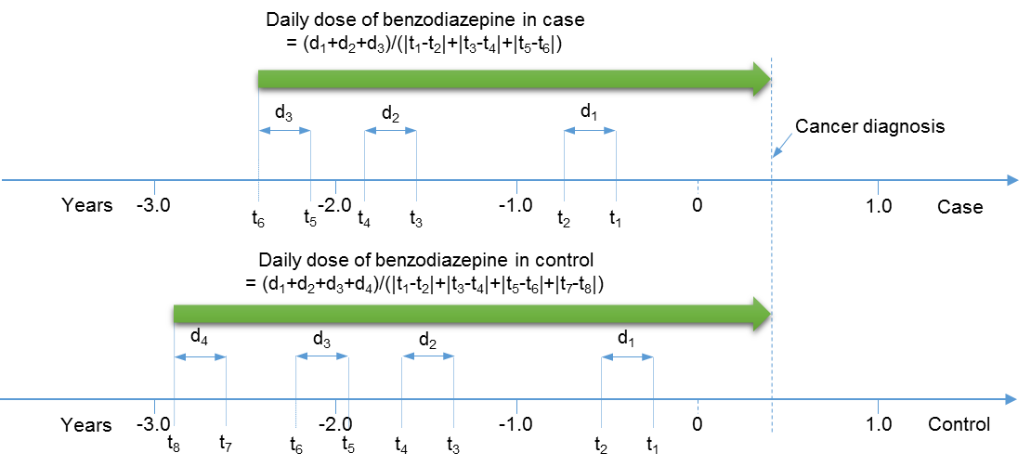

Figure S1. The BZDs use were checked during three year before the date of cancer diagnosis for both cases and control groups. The daily dose of BZD is calculated as the collected total amount of BZD at dispenses (i.e. d1, d2, d3) divided by the total time duration of dispenses (i.e. |t1-t2|, |t3-t4|, |t5-t6|).

Figure S2. Distribution of BZD dispenses 3 years before and 1 year after cancer diagnosis in case and control group. For cases, the dispense pattern before and after cancer diagnosis with the increased dispense after for short duration compared with before cancer diagnosis, likely explained by anxiety or sleeplessness. After that the slightly decreased dispense of BZDs which might be of the death of some cancer patients after a cancer diagnosis. For control, the dispense pattern before and after index date was likely similar.

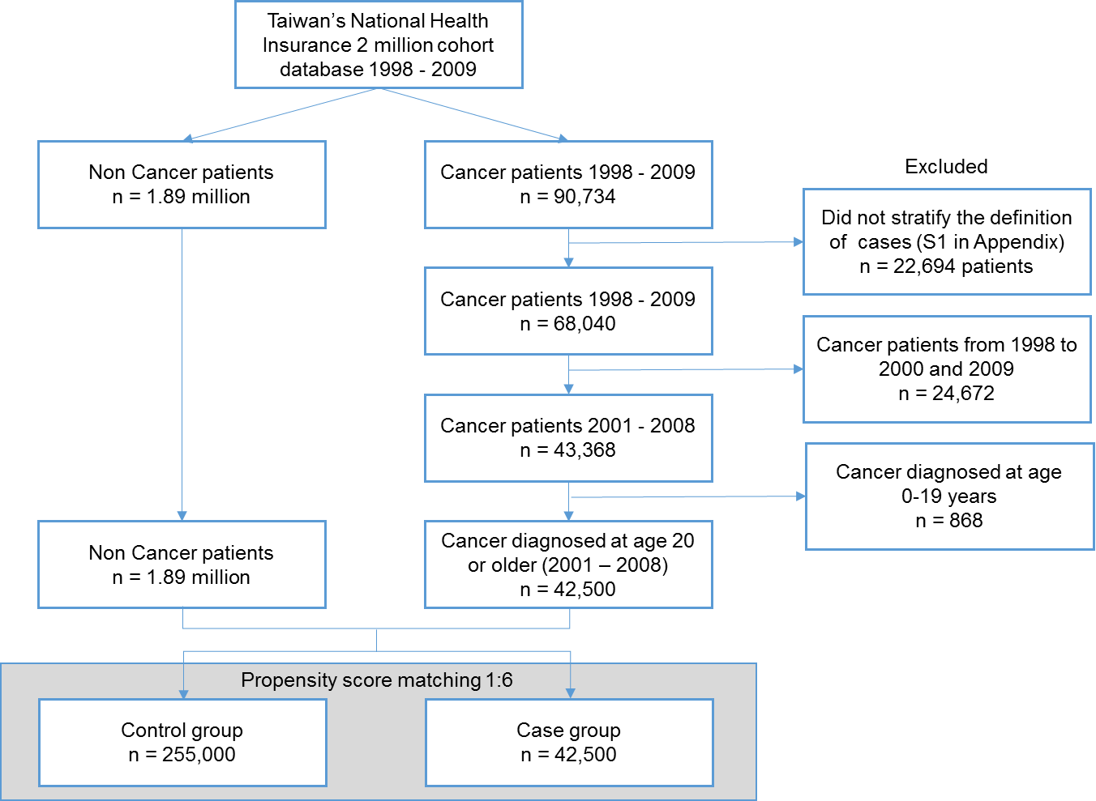
Figure S3. Selection of cancer patients (case) and non-cancer patients (control) entering into the study by using propensity score (1:6) matched study

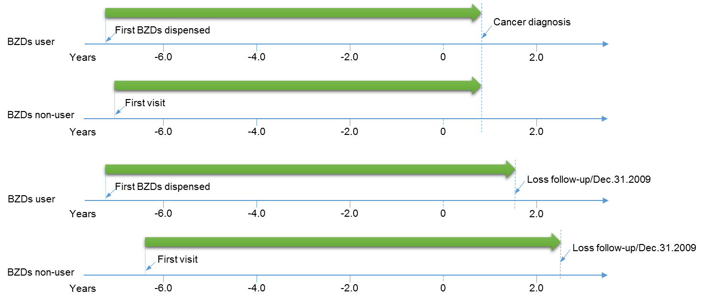

Figure S4. The BZDs use were checked by follow-up all subjects started from the initial BZDs dispense date or the first visit date of the cohort database until a cancer diagnosis/index date or until the time subject was censored for loss to follow-up, or termination of insurance.

Benzodiazepines used | Number of patientsª | Number of cancers^{b} | Hazard ratio^{c} (95% Confident Intervals) |  |  | p-value
No used (Overall) | 99082 | 13131 | 1.00
Benzo used (Overall) | 48975 | 7915 | 1.15 (1.11 - 1.19) |  |  | <0.0001
N03AE Class | 7390 | 1315 | 1.17 (1.11 - 1.24) |  |  | <0.0001
N05BA Class | 48457 | 7853 | 1.15 (1.12 - 1.19) |  |  | <0.0001
N05CD Class | 11947 | 1941 | 1.08 (1.03 - 1.13) |  |  | 0.003
N05CF Class | 22834 | 3836 | 1.14 (1.10 - 1.18) |  |  | <0.0001
Alprazolam | 26526 | 4484 | 1.15 (1.11 - 1.19) |  |  | <0.0001
Bromazepam | 14748 | 2548 | 1.15 (1.10 - 1.20) |  |  | <0.0001
Chlordiazepoxide* | 7955 | 1293 | 1.04 (0.98 - 1.10) |  |  | 0.146
Clonazepam | 7390 | 1315 | 1.17 (1.11 - 1.24) |  |  | <0.0001
Diazepam* | 33802 | 5400 | 0.93 (0.89 - 0.98) |  |  | 0.003
Fludiazepam | 28260 | 4786 | 1.15 (1.11 - 1.19) |  |  | <0.0001
Flunitrazepam | 4129 | 685 | 1.09 (1.01 - 1.18) |  |  | 0.028
Lorazepam | 31136 | 5158 | 1.14 (1.10 - 1.18) |  |  | <0.0001
Lormetazepam* | 3878 | 631 | 1.08 (0.99 - 1.17) |  |  | 0.053
Medazepam* | 782 | 116 | 0.96 (0.80 - 1.15) |  |  | 0.648
Nitrazepam* | 4793 | 775 | 1.06 (0.98 - 1.14) |  |  | 0.131
Oxazepam* | 2058 | 322 | 1.02 (0.91 - 1.14) |  |  | 0.706
Oxazolam | 29151 | 4846 | 1.12 (1.08 - 1.16) |  |  | <0.0001
Zopiclone | 8256 | 1428 | 1.13 (1.09 - 1.18) |  |  | <0.0001
Zolpidem | 19598 | 3300 | 1.14 (1.08 - 1.21) |  |  | <0.0001

ª Number of patient used individual and classes of benzodiazepines
^{b} Number of patient developed cancers
^{c} Hazard ratio were adjusted for the confounders as Comorbid conditions, other drugs, regions, and socio-economic status in Table 1
* Defined as safer benzodiazepines

Figure S5. Benzodiazepines (classes and individuals) and their association with overall cancer risk in Female patients

Benzodiazepines used | Number of patientsª | Number of cancers | Hazard ratio^{c} (95% Confident Intervals) |  |  | p-value
No used (Overall) | 109371 | 14671 | 1.00
Benzo used (Overall) | 40072 | 6783 | 1.14 (1.10 - 1.18) |  |  | <0.0001
N03AE Class | 6753 | 1213 | 1.13 (1.07 - 1.20) |  |  | <0.0001
N05BA Class | 39127 | 6668 | 1.15 (1.11 - 1.19) |  |  | <0.0001
N05CD Class | 9125 | 1596 | 1.10 (1.05 - 1.16) |  |  | <0.0001
N05CF Class | 17624 | 3118 | 1.14 (1.10 - 1.19) |  |  | <0.0001
Alprazolam | 17746 | 3116 | 1.12 (1.07 - 1.16) |  |  | <0.0001
Bromazepam | 10122 | 1794 | 1.11 (1.05 - 1.17) |  |  | <0.0001
Chlordiazepoxide | 5021 | 892 | 1.08 (1.01 - 1.16) |  |  | 0.020
Clonazepam | 6753 | 1213 | 1.13 (1.07 - 1.20) |  |  | <0.0001
Diazepam* | 24529 | 4199 | 1.00 (0.95 - 1.05) |  |  | 0.915
Fludiazepam | 19775 | 3544 | 1.15 (1.10 - 1.19) |  |  | <0.0001
Flunitrazepam | 3776 | 686 | 1.13 (1.05 - 1.23) |  |  | 0.001
Lorazepam | 22545 | 4031 | 1.18 (1.13 - 1.22) |  |  | <0.0001
Lormetazepam* | 2726 | 474 | 1.08 (0.99 - 1.19) |  |  | 0.092
Medazepam* | 451 | 81 | 1.11 (0.90 - 1.39) |  |  | 0.336
Nitrazepam* | 3113 | 535 | 1.08 (0.98 - 1.17) |  |  | 0.110
Oxazepam* | 1376 | 251 | 1.11 (0.98 - 1.26) |  |  | 0.096
Oxazolam | 19554 | 3362 | 1.09 (1.04 - 1.13) |  |  | <0.0001
Zopiclone | 6830 | 1196 | 1.14 (1.09 - 1.19) |  |  | <0.0001
Zolpidem | 14892 | 2646 | 1.10 (1.03 - 1.16) |  |  | 0.003

ª Number of patient used individual and classes of benzodiazepines
^{b} Number of patient developed cancers
^{c} Hazard ratio were adjusted for the confounders as Comorbid conditions, other drugs, regions, and socio-economic status in Table 1
* Defined as safer benzodiazepines

Figure S6. Benzodiazepines (classes and individuals) and their association with overall cancer risk in Male patients

