Supplementary Appendix 1
FDG PET images were acquired by using a PET/CT device (Discovery LS; GE Healthcare, Milwaukee, WI, USA), which consisted of a PET scanner (Advance NXi; GE Healthcare) and an eight section CT scanner (Light-Speed Plus; GE Healthcare). The CT scan was performed with 40 to 80 mAs adjusted to the patient’s body weight at a 140 kVp and a 5-mm section width. After the CT scan, an emission scan was performed from the thigh to the head for 4 min per frame, 45 min after intravenous injection of 370 MBq of 18F-FDG. Standardized uptake value (SUV) was normalized to the patient’s body weight.

Supplementary Appendix 2
Helical CT scans were obtained from the lung apices to the level of the middle portion of both kidneys immediately after the completion of intravenous contrast medium injection. A total of 1.5 mL/Kg (body weight) Iomeron 300 (Iomeprol, 300 mg iodine/mL; Bracco; Milan, Italy) was injected at an infusion rate of 3 mL/s using a power injector (MCT Plus; Medrad; Pittsburgh, PA, USA). For mediastinal window images, the image data were reconstructed using a soft-tissue algorithm and for lung window images, they were reconstructed using a bone algorithm. The reconstructed images were then interfaced directly with a picture archiving and communication system (PACS) (Centricity 2.0; GE Healthcare, Mt. Prospect, IL, USA), which displayed all image data on two monitors (1536 × 2048 matrix, 8-bit viewable gray scale, and 60-ft-Lambert luminescence). Both mediastinal (width, 400 HU; level, 20 HU) and lung (width, 1500 HU; level, −700 HU) window images were viewed on these monitors.

Supplementary Appendix 3
For physical features, the volume of the ROI was computed by multiplying the number of voxels by the unit volume of a voxel. Physical density (g/cm3) was estimated by extrapolating from the mean CT scan attenuation.¹Next, a histogram was derived from the distribution of voxel intensities within the ROI. From the histogram, we computed skewness, kurtosis, uniformity, entropy, and CT numbers or Hounsfield unit (HU) at the 2.5th, 25th, 50th, 75th and 97.5th percentiles. For regional features, ROI was computed based on the gray level size zone matrix. The value of the matrix’s (m, n) was defined by the number of homogenous regions given the homogeneous tumor size (n) to their intensity (m). The intensity variability and size-zone variability were also computed from the gray level size zone matrix.¹⁻⁵ For local features, a gray level co-occurrence matrix (GLCM),⁶ which describes the frequency of various combinations of grey values within an ROI, was created. For each ROI, GLCMs were created with 13 directions according to 1-voxel, 2-voxel, and 3-voxel distances (3 GLCMs for each ROI). From each GLCM, 12 local features (the energy, entropy, correlation, contrast, variance, sum mean, inertia, cluster shade, cluster tendency, homogeneity, maximum probability, and inverse variance) were computed. In summary, we extracted three physical, nine histogram-based, two regional, and 36 local features from the manually-derived ROI.

References
1. de Hoop B, Gietema H, van de Vorst S, Murphy K, van Klaveren RJ, Prokop M. Pulmonary ground-glass nodules: increase in mass as an early indicator of growth. Radiology. Apr 2010;255(1):199-206.
2. Thibault G, Fertil B, Navarro C, et al. Texture Indexes and Gray Level Size Zone Matrix Application to Cell Nuclei Classification. 2009.
3. Lee HY, Jeong JY, Lee KS, et al. Solitary pulmonary nodular lung adenocarcinoma: correlation of histopathologic scoring and patient survival with imaging biomarkers. Radiology. Sep 2012;264(3):884-893.
4. Chong Y, Kim JH, Lee HY, et al. Quantitative CT variables enabling response prediction in neoadjuvant therapy with EGFR-TKIs: are they different from those in neoadjuvant concurrent chemoradiotherapy? PloS one. 2014;9(2):e88598.
5. Chandarana H, Rosenkrantz AB, Mussi TC, et al. Histogram analysis of whole-lesion enhancement in differentiating clear cell from papillary subtype of renal cell cancer. Radiology. Dec 2012;265(3):790-798.
6. Haralick RM, Shanmugam K, Dinstein I. Textural features for image classification. IEEE Trans Syst Man Cybern. 1973;3:610–621.

SupplementaryAppendix 4
OS was calculated from the date of diagnosis to the date of death or last follow-up. RFS was defined from the day of first surgery until tumor progression, death, or end of follow-up. Survival analysis was estimated using the Kaplan–Meier method and compared between fusion-positive and -negative groups of patients using the log-rank test. Univariate analysis was performed, and the significance of differences in survival between the two groups was determined using the log-rank test. Cumulative survival curves and overall survival for the groups were computed according to the Kaplan–Meier method.

SupplementaryAppendix 5
Of the 64 patients with fusion-positive tumors, 28 ALK and 16 ROS1/RET fusion-positive patients underwent curative operations. The median follow-up durations were 43 and 52 months (range, 1-80 and 10-78 months, respectively) after the operation, respectively. Of the 28 ALK fusion-positive patients, recurrence occurred in 12 patients (42.9%) and four patient (14.3%) died of the disease. Of the 16 patients with ROS1/RET fusion-positive tumors, recurrence occurred in four patients (25%) and two patient (12.5%) died of the disease. Of the 475 patients with fusion-negative tumors, 374 patients underwent a curative operation. The mean follow-up duration was 42 months (range, 1-126 months) after the operation. Of the 374 fusion-negative patients, recurrence occurred in 142 patients (38%) and 65 patient (17.4%) died of the disease. There were no significant differences in OS and RFS between the fusion-positive and –negative patients (P = 0.551 and P = 0.739, respectively), ALK fusion-positive and ALK fusion-negative (P = 0.784 and P = 0.544, respectively), and ROS1/RET fusion-positive and ROS1/RET fusion-negative patients (P = 0.563 and P = 0.230, respectively). Kaplan-Meier survival curves and corresponding P-values are shown in Supplementary Figure 3.
Supplementary Figure 1: Examples of CT images showing typical qualitative features of lung adenocarcinomas.

1) Solidity
(A) Solid (B) Part- or non-solid

2) Location (Central or peripheral)
(A) Central* (B) Peripheral
* Central = medial to midclavicular line

3) Lymphangitic metastasis
(A) Yes (B) No

4) Pleural effusion
(A) No (B) Small (C) Moderate (D) Large

Supplementary Figure 2

The spectrum of concurrent EGFR/KRAS mutational status in the ALK, ROS1/RET fusion-positive and fusion-negative groups. Out of 539 lung adenocarcinoma patients, 47 patients were ALK fusion-positive (8.7%), 17 patients were ROS1/RET fusion-positive (3.2%), and 475 were fusion-negative (88.1%). ALK/ROS1/RET fusions were mutually exclusive. In the ALK fusion-positive group, one patient had a concurrent EGFR mutation. In the ROS1/RET fusion-positive group, one patient had a concurrent EGFR mutation. In the fusion-negative group, 167 patients had concurrent EGFR mutations.

Supplementary Figure 3

Kaplan–Meier survival curves of overall survival (OS) and recurrence-free survival (RFS) according to fusion status. There were no significant differences in OS (A) and RFS (B) between the fusion-positive and -negative patients (P = 0.551 and P = 0.739, respectively), ALK fusion-positive and ALKfusion-negative (P = 0.784 and P = 0.544, respectively), and ROS1/RET fusion-positive and ROS1/RET fusion-negative patients (P = 0.563 and P = 0.230, respectively). ALK = anaplastic lymphoma kinase; ROS1 = c-ros oncogene 1; RET = rearranged during transfection; ALK+ = ALK fusion-positive; ROS1/RET+ = ROS1/RET fusion-positive

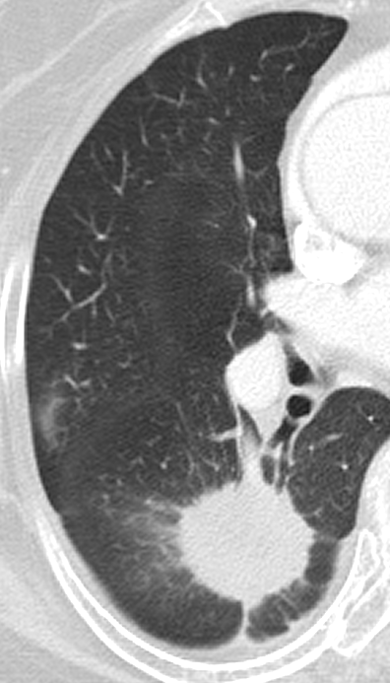

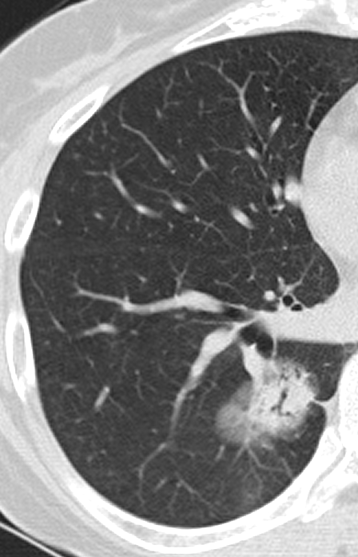

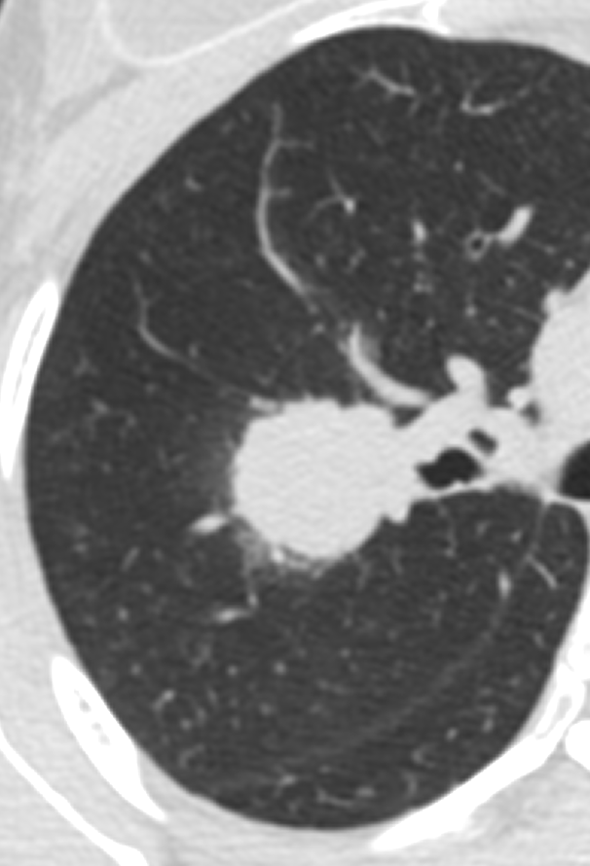

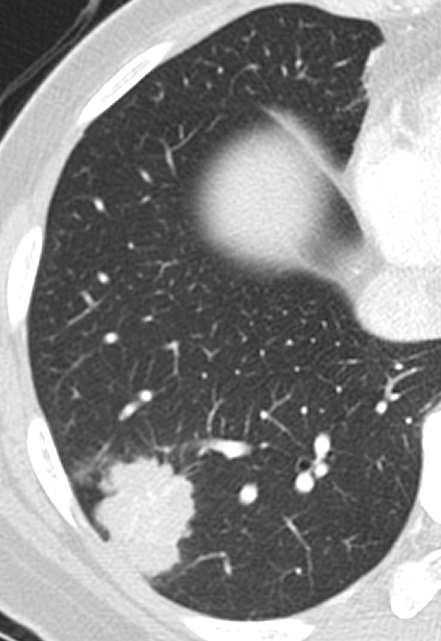

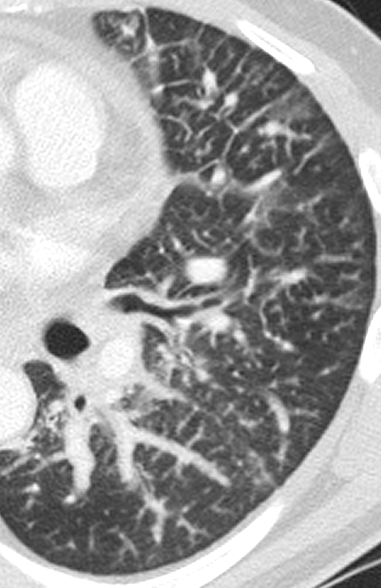

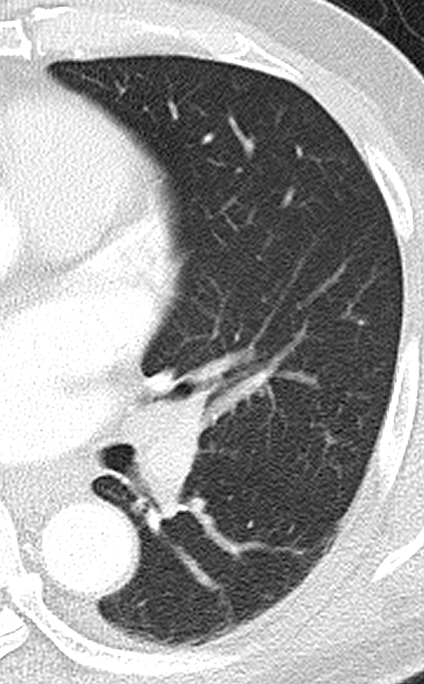

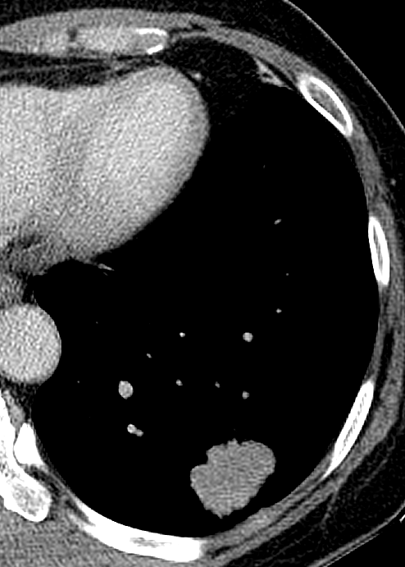

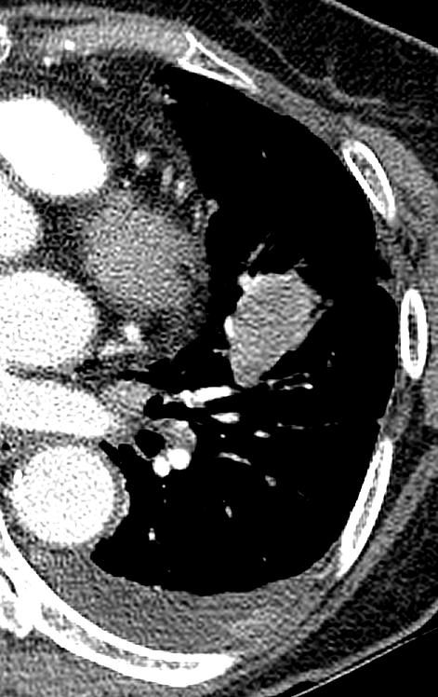

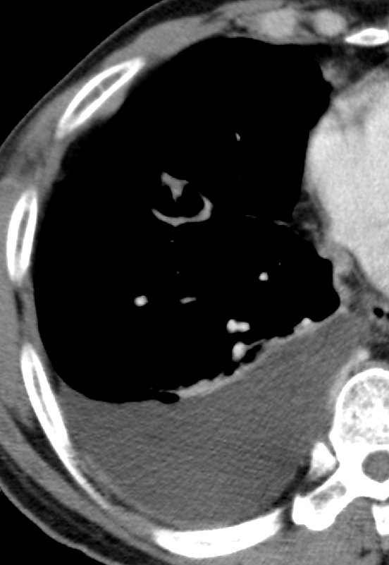

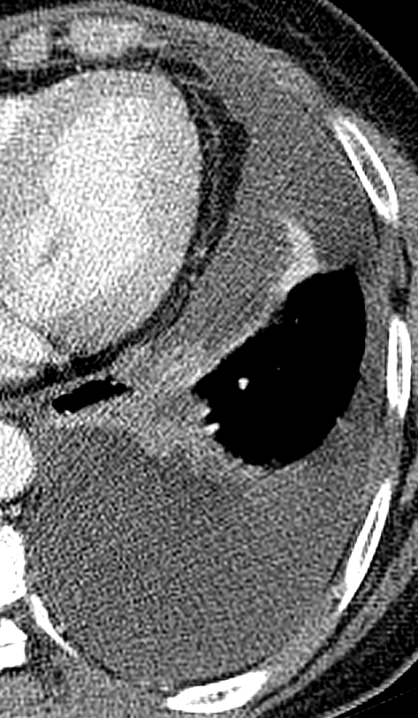

Supplementary Table 1

Comparison of Selected Variables Between Sampled Fusion-Positive (n=64) and Fusion-Negative (n=64)
 | Fusion-positive | Fusion-negative
Age (mean, years) | 52.9 | 62.5
Tumor stage (I/II : III/IV, n) | 27:37 | 41 : 23
Solidity (solid : part-/non-solid, n) | 60:4 | 43 : 21
Central tumor location (central† : peripheral, n) | 31:33 | 29 : 35
Mass | 14.25 | 9.01
Kurtosis | 8.92 | 13.02
HU at the 97.5th percentile on histogram | 5.18 | -130.64
Homogeneity on 1-voxel distance | 4171.75 | 2958.13
Contrast on 1-voxel distance | 3.98 | 3.30
Contrast on 2-voxel distance | 7.28 | 5.82
Contrast on 3-voxel distance | 9.96 | 7.36
Cluster shade on 1-voxel distance | 3.98 | 3.30
Cluster shade on 2-voxel distance | 7.28 | 5.82
Cluster shade on 3-voxel distance | 9.96 | 7.36
Inverse variance on 2-voxel distance | 0.38 | 0.40
Inverse variance on 3-voxel distance | 0.37 | 0.39
SUVmax | 10.63 | 8.01
Note. - All values for quantitative CT features and SUV_{max} are presented as the mean.
† Central = medial to midclavicular line

