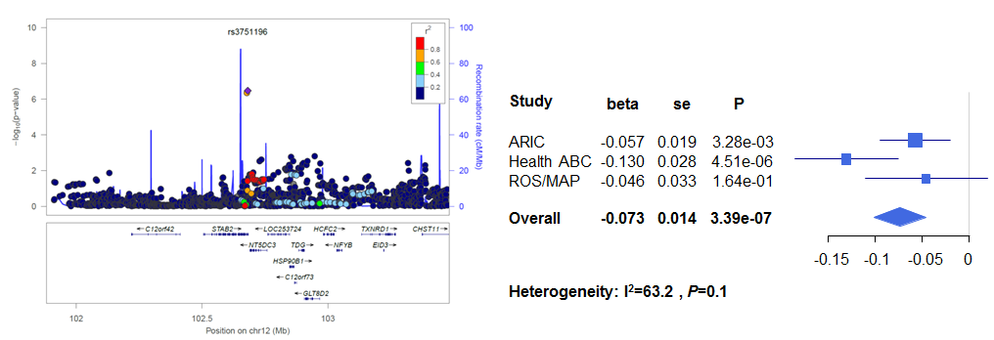
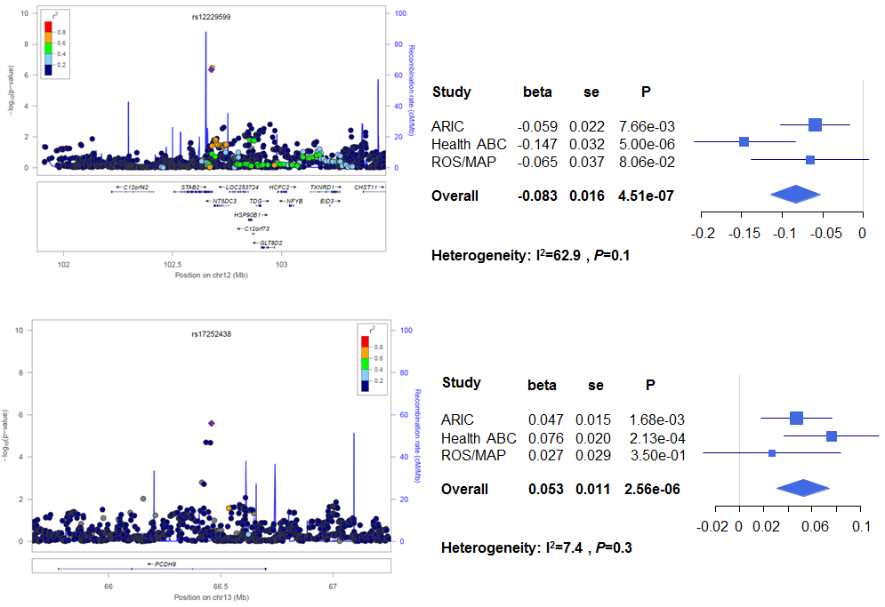
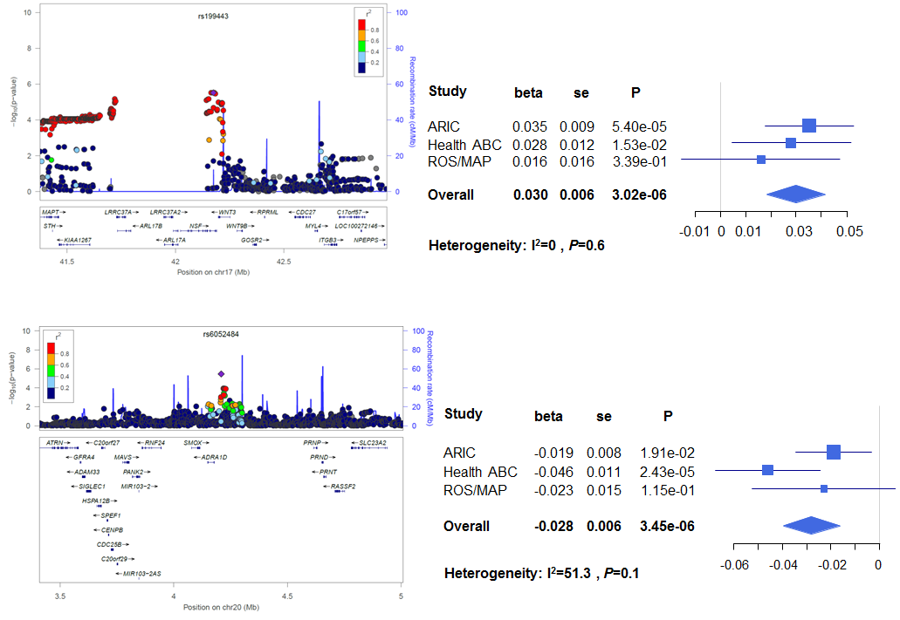
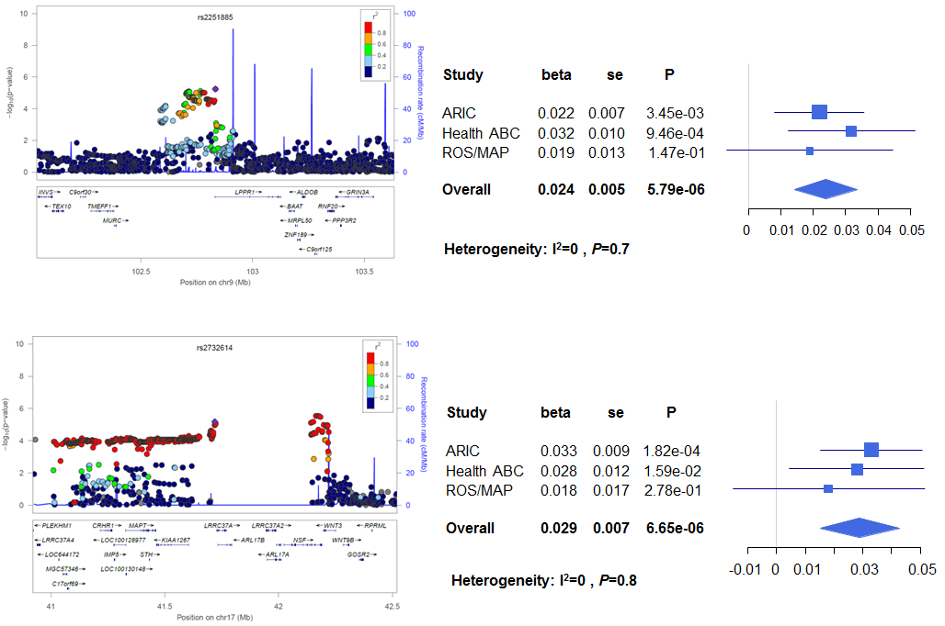
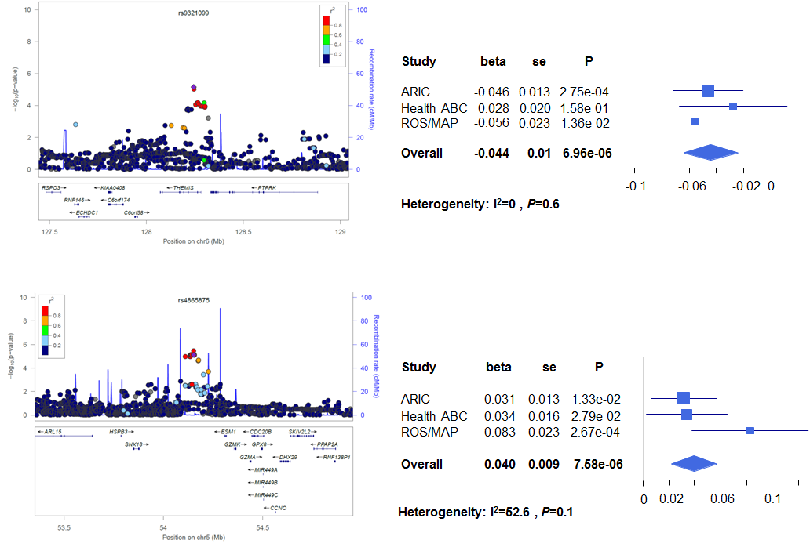
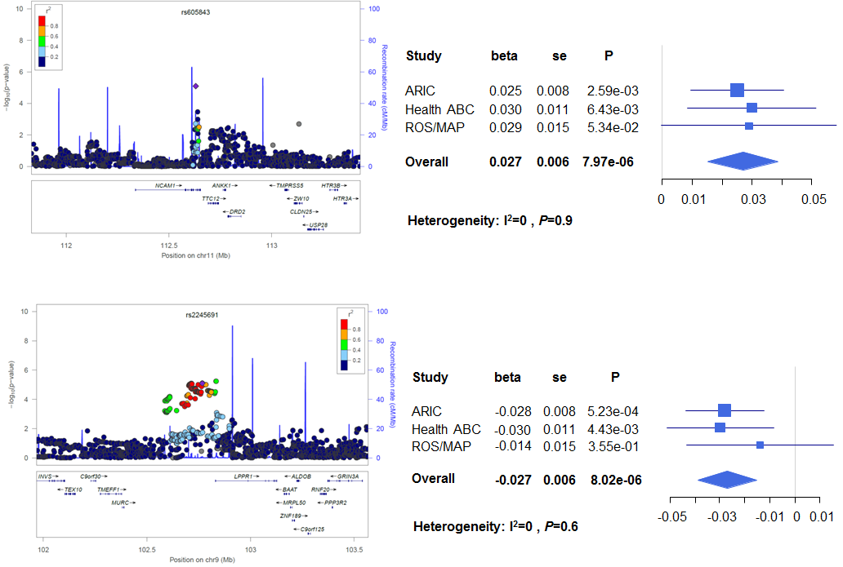
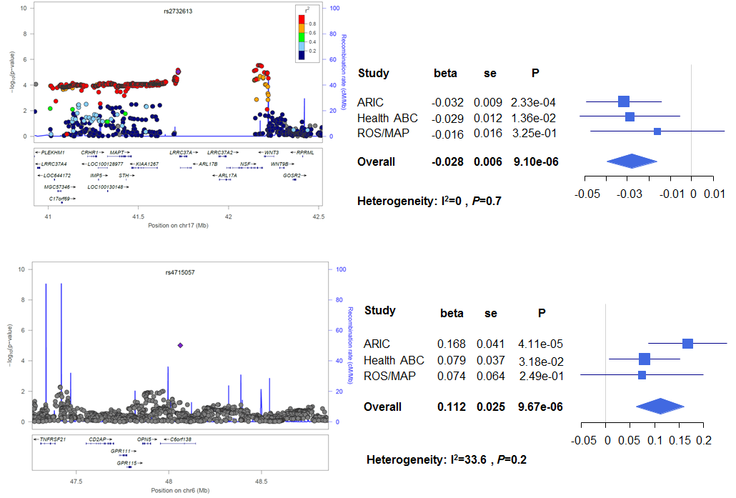
Supplementary Table 2. Top ranked SNPs (P_{meta} < 10⁻⁵) from the genome-wide meta-analysis on the sense of smell in Model 1 ª
SNP | Chr. | Gene | Position | Score ^{b} | A1 | A2 | MAF | Direction ^{c} | I² (%) | P for Cochran’s Q | Effect size ^{d} | s.e. | P
rs3751196 | 12 | STAB2 | 102681632 | 5 | A | G | 0.06 | --- | 63.20 | 0.07 | -0.07 | 0.01 | 2.34E-07
rs12229599 | 12 | STAB2 | 102678505 | 7 | T | C | 0.04 | --- | 66.10 | 0.05 | -0.08 | 0.02 | 3.15E-07
rs4111 | 3 | ERC2 | 55929255 | 6 | A | C | 0.15 | +++ | 0.00 | 0.39 | 0.03 | 0.01 | 1.01E-06
rs199443 | 17 | NSF | 42174733 | 1f | T | C | 0.20 | +++ | 0.00 | 0.60 | 0.03 | 0.01 | 4.01E-06
rs17252438 | 13 | PCDH9 | 66458613 | 7 | T | C | 0.05 | +++ | 19.60 | 0.29 | 0.05 | 0.01 | 4.15E-06
rs2075650 | 19 | TOMM40 | 50087459 | 1f | A | G | 0.13 | +++ | 0.00 | 0.68 | 0.04 | 0.01 | 4.24E-06
rs2251885 | 9 | PRG-3 | 102833365 | 6 | A | G | 0.37 | +++ | 0.00 | 0.83 | 0.02 | 0.01 | 4.85E-06
rs649892 | 9 | PRG-3 | 102834210 | 7 | T | G | 0.37 | --- | 0.00 | 0.82 | -0.02 | 0.01 | 5.02E-06
rs4715057 | 6 | C6orf1 | 48061760 | 5 | A | G | 0.02 | +++ | 39.10 | 0.19 | 0.11 | 0.02 | 5.75E-06
rs9321099 | 6 | C6orf1 | 128243832 | 5 | A | T | 0.09 | --- | 0.00 | 0.56 | -0.04 | 0.01 | 6.46E-06
rs6052484 | 20 | ADRA1D | 4208610 | 7 | A | G | 0.26 | --- | 56.20 | 0.10 | -0.03 | 0.01 | 6.52E-06
rs12291225 | 11 | SPON1 | 14212760 | 7 | A | C | 0.25 | +++ | 0.00 | 0.72 | 0.03 | 0.01 | 6.92E-06
rs2245691 | 9 | PRG-3 | 102767101 | 6 | T | C | 0.32 | --- | 0.00 | 0.65 | -0.03 | 0.01 | 7.19E-06
rs11174650 | 12 | PPM1H | 61466196 | 4 | T | C | 0.08 | --- | 39.60 | 0.19 | -0.04 | 0.01 | 8.13E-06
rs2732614 | 17 | KIAA1267--LRRC37 | 41719986 | 1a | T | C | 0.20 | +++ | 0.00 | 0.78 | 0.03 | 0.01 | 8.34E-06
rs16875528 | 4 | DHX15 | 23917177 | 6 | T | C | 0.01 | +++ | 0.00 | 0.59 | 0.10 | 0.02 | 8.52E-06
rs10005021 | 4 | DHX15 | 23919610 | 7 | T | C | 0.01 | +++ | 0.00 | 0.60 | 0.11 | 0.02 | 8.78E-06
rs520855 | 9 | PRG-3 | 102778230 | 7 | A | G | 0.36 | +++ | 0.00 | 0.56 | 0.02 | 0.01 | 9.47E-06
rs2243593 | 9 | PRG-3 | 102785082 | 5 | A | G | 0.36 | --- | 0.00 | 0.56 | -0.02 | 0.01 | 9.50E-06
ª Adjusted for age, gender, study center, cognitive function and the first two principal components.
^{b} Score: the functional annotation score from the RegulomeDB; lower score indicates stronger evidence for a variant to be functional. Category 1 variants are defined as ‘likely to affect binding and linked to expression of a gene target’; categories 2 and 3 as ‘likely’ and ‘less likely to affect binding’, respectively; categories 4-6 as ‘minimal binding evidence’; and category 7 as ‘lack of evidence’ for an association. This is especially notable for category 1 as it is the only variable included in the model explicitly tied to eQTL status.
^{c} The direction of effect in the order of the Atherosclerosis Risk in Communities study, the Health ABC Study and the Rush Religious Orders Study and Memory and Aging Project
^{d} Effect size in ln(smell score+1) per allele change.
Chr.: Chromosome. MAF: minor allele frequency. s.e.: standard error.

