Supplemental Figure 1: Coronal PET/CT images.
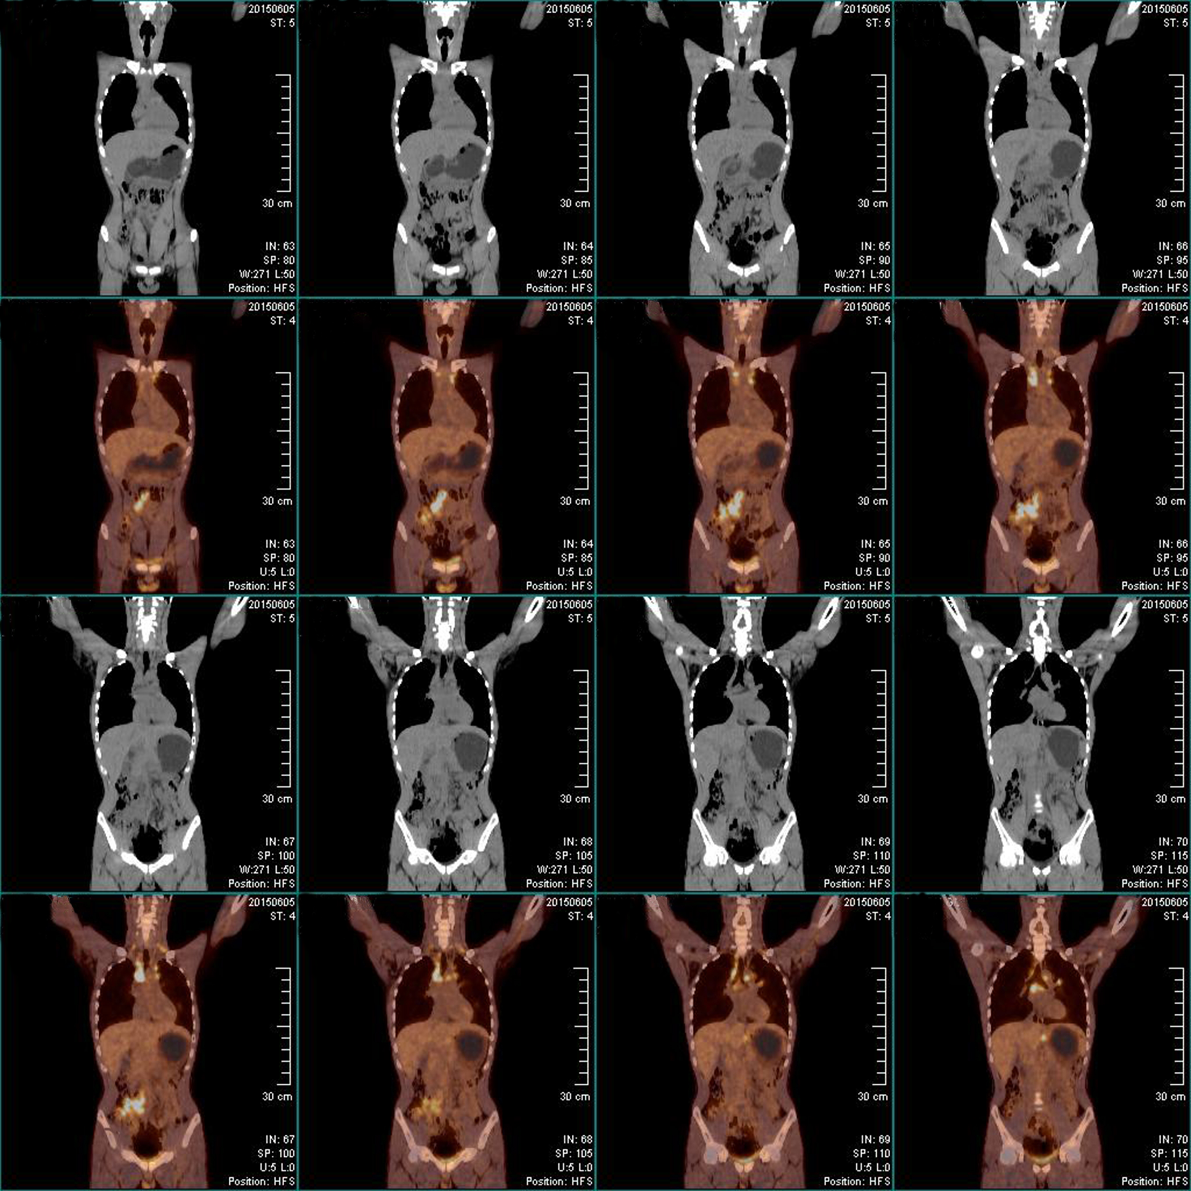

Supplemental Figure 2: Sagittal PET/CT images.


