Supplemental Materials
Table 1 Baseline demographics and various adiposity measures for the study cohort from annual health survey (n=362)
Baseline Demographics | Metabolic Score: 0 (n=78) | Metabolic Score: 1 – 2 (n=203) | Metabolic Score: 3 – 5 (n=81) | P for trend
Age, years | 49.1 ± 7 | 51.7 ± 8.8 | 54.3 ± 9.8※ | 0.001
Gender (female), % | 30 (38.5%) | 57 (28.1%) | 25 (30.9%) | 0.241
BMI, kg/m2 | 22.4 ± 2.0 | 24.6 ± 2.7※ | 26.4 ± 3.0※ | <0.001
Weight, kg | 60.5 ± 9.4 | 67.5 ± 9.9※ | 73 ± 11.7※* | <0.001
Waist, cm | 77.8 ± 8.2 | 84.7 ± 8※ | 89.3 ± 8.5※* | <0.001
Systolic Blood Pressure, mmHg | 112.5 ± 12.5 | 123 ± 17.1※ | 127.7 ± 15.8※ | <0.001
Diastolic Blood Pressure, mmHg | 71.3 ± 9 | 77.1 ± 10.6※ | 78.6 ± 10.6※ | <0.001
Biochemical Data & Cardiometabolic Profiles
Fasting Glucose, mg/dL | 91.1 ± 7.8 | 100.8 ± 21.6※ | 105.9 ± 19.5※ | <0.001
HbA1c level, % | 5.7 ± 0.3 | 6 ± 0.8※ | 6.2 ± 0.9※ | <0.001
Triglyceride, mg/dL | 95.3 ± 36.1 | 144.2 ± 87.8※ | 172.2 ± 80※* | <0.001
HDL, mg/dL | 56.7 ± 12.9 | 49 ± 12.8※ | 45.6 ± 11.2※ | <0.001
eGFR, ml/min/1.73m² | 89.8 ± 15.5 | 85.5 ± 15.4 | 80.8 ± 19.9※ | 0.001
Serum insulin level, µIU/mL | 4.7 ± 2.1 | 5.9 ± 3.1※ | 7.9 ± 4.0※* | <0.001
HOMA-IR level | 1 ± 0.54 | 1.49 ± 1.1※ | 2.1 ± 1.17※* | <0.001
hs-CRP, mg/dL | 0.11 ± 0.3 | 0.2 ± 0.19※ | 0.31 ± 0.31※* | <0.001
Metabolic Scores | 0 | 1.58 ± 0.49※ | 3.46 ± 0.69※* | <0.001
Various Adiposity Measures
Body Fat Composition, % | 24.1 ± 5,1 | 26.1 ± 6.8 | 29.1 ± 7.5※* | <0.001
PCF, ml | 71.2 ± 23.6 | 78.4 ± 25.6※ | 94.1 ± 24.4※* | <0.001
TAT, ml | 6.8 ± 3.0 | 8.0 ± 3.6※ | 9.5 ± 4.2※* | <0.001
AV Groove Fat, mm | 7.75 ± 4.17 | 8.64 ± 3.78 | 10.12 ± 4.52※ | <0.001
IAF, mm | 5.0 ± 1.6 | 5.7 ± 1.6※ | 6.4 ± 1.8※* | <0.001
Abbreviations as Table 1. ※p<0.05 compared to 1st Group; *p<0.05 compared 2nd Group.
Supplemental Materials
Table 2 The associations between baseline clinical variables and various adiposity measures for the study cohort from annual health survey (n=362)
 | PCF, ml |  | TAT, ml |  | AV Groove Fat, mm |  | IAF, mm
Variables | r value | p value | r value | p value | r value | p value | r value | p value
Age, years | 0.06 | 0.284 | 0.089 | 0.089 | 0.119 | 0.03 | 0.172 | 0.0011
BMI, kg/m2 | 0.225 | <0.001 | 0.142 | 0.0065 | 0.304 | <0.001 | 0.399 | <0.001
Weight, kg | 0.278 | <0.001 | 0.179 | <0.001 | 0.254 | <0.001 | 0.388 | <0.001
Waist, cm | 0.273 | <0.001 | 0.164 | 0.0017 | 0.318 | <0.001 | 0.44 | <0.001
Systolic Blood Pressure, mmHg | 0.163 | 0.019 | 0.11 | 0.036 | 0.142 | 0.0099 | 0.169 | 0.0014
Diastolic Blood Pressure, mmHg | 0.094 | 0.073 | -0.002 | 0.975 | 0.048 | 0.384 | 0.119 | 0.0242
Hb, g/dL | -0.077 | 0.224 | -0.026 | 0.684 | -0.023 | 0.818 | 0.075 | 0.435
RBC Count, x 10⁶ /µL | -0.097 | 0.126 | -0.091 | 0.149 | -0.108 | 0.106 | -0.102 | 0.1107
WBC Count, x 10⁶ /µL | 0.13 | 0.125 | 0.18 | 0.087 | 0.072 | 0.19 | 0.1147 | 0.03
Fasting Glucose, mg/dL | 0.079 | 0.134 | 0.103 | 0.072 | 0.239 | <0.001 | 0.255 | <0.001
Serum insulin level, µIU/mL | 0.06 | 0.381 | 0.08 | 0.283 | 0.16 | 0.0168 | 0.179 | 0.0075
HOMA-IR level | 0.05 | 0.381 | 0.082 | 0.285 | 0.213 | 0.0012 | 0.25 | <0.001
HbA1c level, % | 0.023 | 0.689 | 0.044 | 0.443 | 0.192 | 0.0013 | 0.199 | <0.001
Triglyceride, mg/dL | -0.001 | 0.986 | 0.001 | 0.985 | 0.169 | 0.0023 | 0.228 | <0.001
HDL, mg/dL | -0.163 | 0.002 | -0.104 | 0.048 | -0.169 | 0.0023 | -0.256 | <0.001
eGFR, ml/min/1.73m² | -0.024 | 0.647 | -0.04 | 0.407 | -0.0093 | 0.868 | -0.078 | 0.149
hs-CRP, mg/dL | 0.134 | 0.011 | 0.15 | 0.006 | 0.14 | 0.0143 | 0.292 | <0.001
MS | 0.269 | <0.001 | 0.226 | <0.001 | 0.24 | <0.001 | 0.339 | <0.001
MS: Metabolic Scores, other abbreviations as Table 1.

Supplemental Materials
Table 3 The diagnostic value of metabolic syndrome for various adiposity measures for the study participants from annual health survey (n=362)
Diagnostic Utility | Sensitivity | Specificity | PPV | NPV | ROC (95% CI) | Cut-Off Value
PCF (ml) | 77.80% | 53.38% | 32.65% | 89.29% | 0.66 (0.60 – 0.71) | 76.2 ml
TAT (ml) | 69.10% | 50.10% | 28.79% | 84.94% | 0.60 (0.54 – 0.66) | 7.02 ml
AV Groove Fat (mm) | 69.44% | 51.35% | 28% | 85.26% | 0.60 (0.53 – 0.66) | 7.47 mm
IAF (mm) | 50% | 77.20% | 39.42% | 83.86% | 0.64 (0.58 – 0.70) | 6.6 mm
PPV: positive predictive value, NPV: negative predictive value, ROC: receiver-operating characteristic curve.
The clinical cut-off, diagnostic feasibility of various visceral adiposity measures in identifying metabolic syndrome. The PCF yielded the highest sensitivity (77.8%) (cut-off value: 76.2 ml, AUROC: 66%, 95% CI: 0.60 – 0.71), and the IAF showed relatively high specificity (77.2%) (cut-off value: 6.6cm, AUROC: 64%, 95% CI: 0.58 – 0.70) in identifying MetS.

Supplemental Materials
Table 4 Matched comparisons of various adiposity, cardiac deformations and LA parameters in Healthy, Co-morbidity and HFpEF groups from Outpatient Cohort (total n=162)
 | Healthy Group | Co-morbidity Group | HFpEF Group | P (trend)
 | (N=27) | (N=95) | (N=40) | P (trend)
Baseline Characters
Age, years | 57.5±7.7 | 57.9±8.8 | 61±10.2 | 0.11
Gender (Female), % | 11(41%) | 31(33%) | 21(52.5%) | 0.10
Weight, kg | 65.2±8.2 | 71.4±14.9 | 68.7±10.6 | 0.469
BMI, kg/m2 | 24.6±2 | 26.3±3.8 | 26.2±2.6 | 0.09
Various Adiposity Measures
Body Fat Composition, % | 28.3±8.1 | 33.7±7.6※ | 35.9±8.2※ | 0.001
PCF, ml | 60.9±19.5 | 82.2±32.2※ | 92.3±35.2※ | <0.001
TAT, ml | 6.56±2.81 | 9.03±4.94※ | 8.31±4.48※ | 0.171
AV Groove Fat, mm | 9.49±3.86 | 13.04±5.81※ | 15.83±6.09※* | <0.001
IAF, mm | 6.39±1.74 | 8.48±2.6※ | 9.66±2.63※* | <0.001
Left Atrial Indices
LA Volume (Max), ml | 30.5±8.3 | 42.5±8.2※ | 56.3±10.9※* | <0.001
LA Volume (Min), ml | 13.9±3.9 | 20.1±5.2※ | 30.1±10.6※* | <0.001
LA Strain, % | 47.7±9.9 | 38.5±8.5※ | 29.2±6.3※* | <0.001
LA Stiffness, mmHg.% | 0.18±0.06 | 0.25±0.11 | 0.49±0.21※* | <0.001
Deformation Parameters
Longitudinal Strain, % | -20.0±1.83 | -18.37±1.66※ | -15.74±1.59※* | <0.001
Circumferential Strain, % | -32.73±3.91 | -30.36±4.93 | -27.65±5.59※* | <0.001
Radial Strain, % | 45.96±10.45 | 40.29±12.29 | 29.38±8.51※* | <0.001
LV Twist, degree | 11.48±3.47 | 12.74±3.24 | 11.03±2.56* | 0.457

Abbreviations as Table 1 & 2. ※p<0.05 compared to Healthy Group; *p<0.05 compared to co-morbidity Group.

Supplemental Materials
Table 5 Baseline electrocardiography information in Healthy, Co-morbidity and HFpEF groups from Outpatient Cohort (n=206)
Electrocardiography Measures | Healthy Group | Co-morbidity Group | HFpEF Group | P (trend)
Electrocardiography Measures | (N=40) | (N=108) | (N=58) | P (trend)
PR Interval, ms | 167.63±21.37 | 170.58±20.64 | 169.07±25.05 | 0.751
QRS Duration, ms | 95.28±15.43 | 89.49±8.5 | 92.93±16.42 | 0.368
QT Interval, ms | 399.75±26.36 | 392.46±33.42 | 394.6±37 | 0.453
QT Interval (Corrected), ms | 417.8±25.05 | 425.72±24.13 | 439.88±33.51※* | <0.001
P Duration, ms | 80±8.08 | 92.5±8.99※ | 108.1±14※* | <0.001
v1 Width, ms | 6.26±0.89 | 6.54±1.37 | 6.47±1.65 | 0.457
P Duration (Corrected) | 97.1±12.5 | 109.7±13.4※ | 125.9±21.3※* | <0.001
※p<0.05 compared to Healthy Group; *p<0.05 compared to co-morbidity Group

Supplemental Materials
Table 6 The associations between IAF and clinical outcomes for heart failure hospitalization in Healthy, Co-morbidity and HFpEF groups from Outpatient Cohort (n=206)
Variable | IAF (per SD increase) HR (95% CI) | Z Score | SE
Uni-variate Model | 3.71 (1.58–8.71) * | 3.01 | 1.62
MV Model 1 | 3.29 (1.39–7.78) * | 2.71 | 1.44
MV Model 2 | 3.32 (1.40–7.87) * | 2.72 | 1.46
MV Model 3
+ E/E' | 3.48 (1.27–9.58) * | 2.42 | 1.8
+ LV Mass Index | 4.11 (1.50–11.32) * | 2.74 | 2.12
+ LA Volume Index | 3.32 (1.28–8.65) * | 2.46 | 1.62
+ LV Strain | 2.76 (1.14–6.67) * | 2.26 | 1.24
Model 1: adjusted for age, Model 2: adjusted for age + gender; Model 3: adjusted for Model 2 + age + gender + Echo-derived indices;
MV: multivariable models.
*p<0.05 in mode

Supplemental Materials
Figure 1
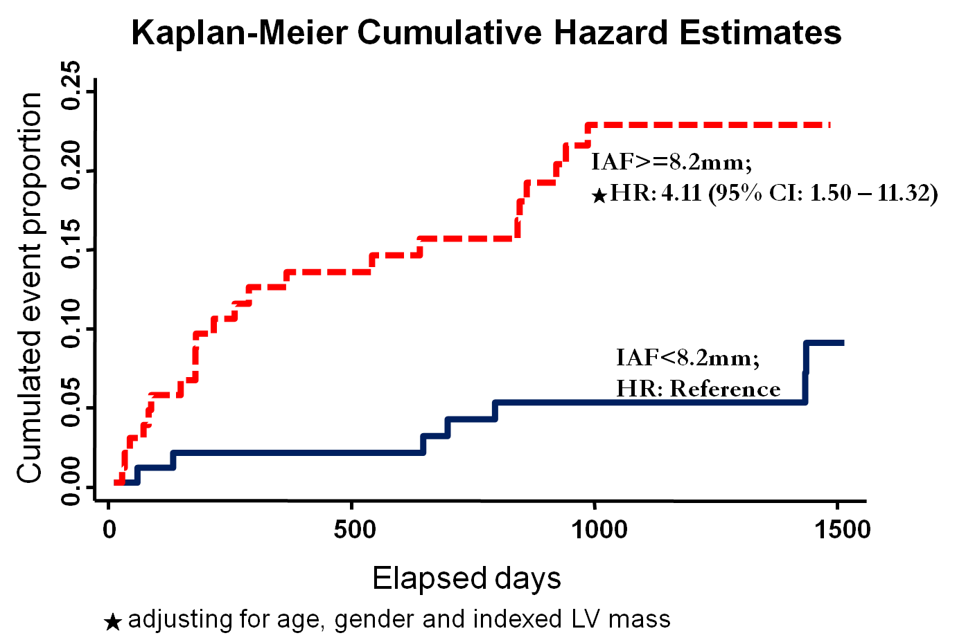
The survival functions between IAF and HF hospitalization, with greater IAF (>=8.2mm) was associated with higher incidence of HF even after accounting for age, gender and indexed LV size.

Supplemental Materials
Figure 2
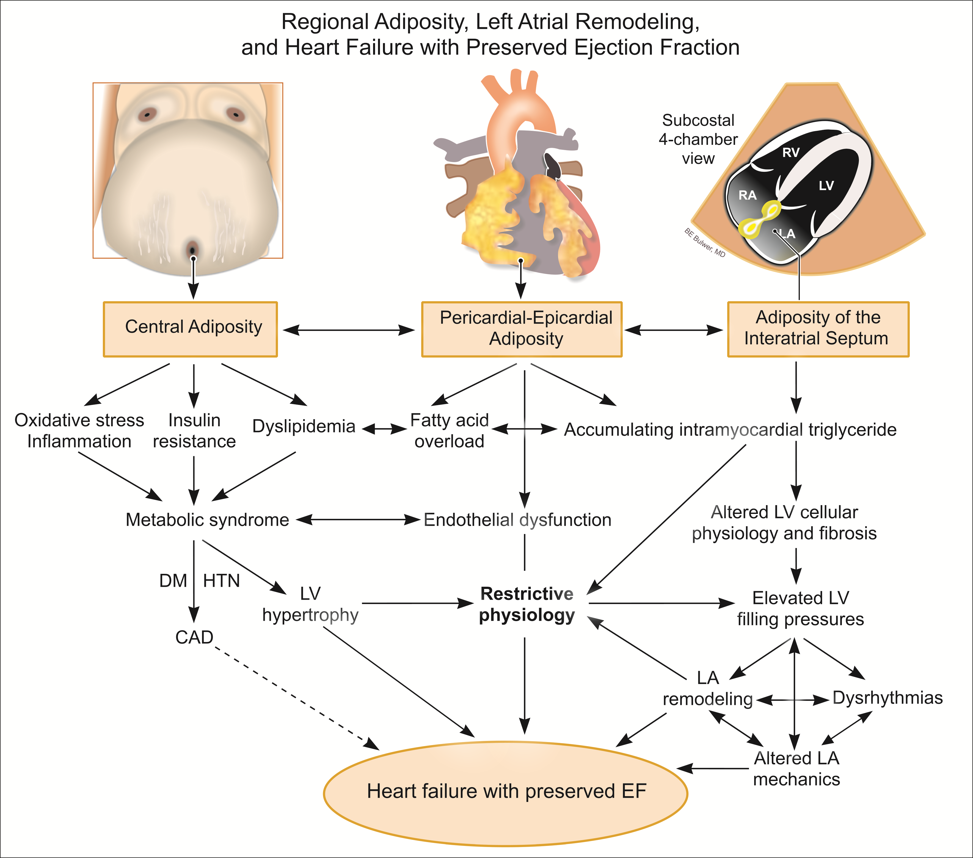
Schematic illustrations showing the potential influences of obesity and metabolic derangements on cardiac structural/functional remodeling, which may prone to the development of HFpEF though several possible pathogenetic pathways.

