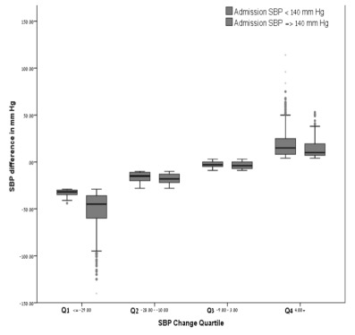

Figure 1: SBP change divided into quartiles according to the degree of change in patients with admission SBP under 140 mm Hg and patients with admission values equal or higher than 140 mm Hg.

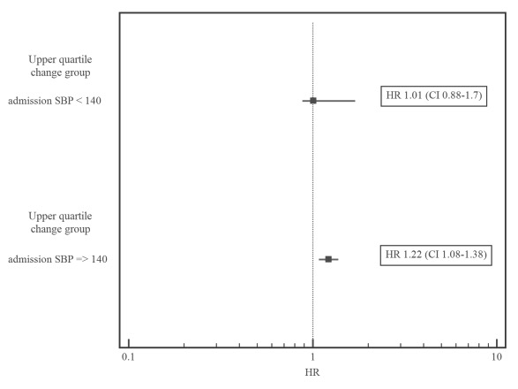
- P-value for interaction (Upper quartile by admission SBP product) = 0.22
- model further adjusted for age, gender, NYHA class, eGFR and LVEF

Figure 2: hazard ratio associated with upper quartile SBP change by dichotomized admission SBP values showing that increased SBP change is associated with mortality in patients with admission SBP ≥ 140 mm Hg, whereas patients with admission SBP < 140 mm Hg have no significant additional risk as a result of SBP increase.

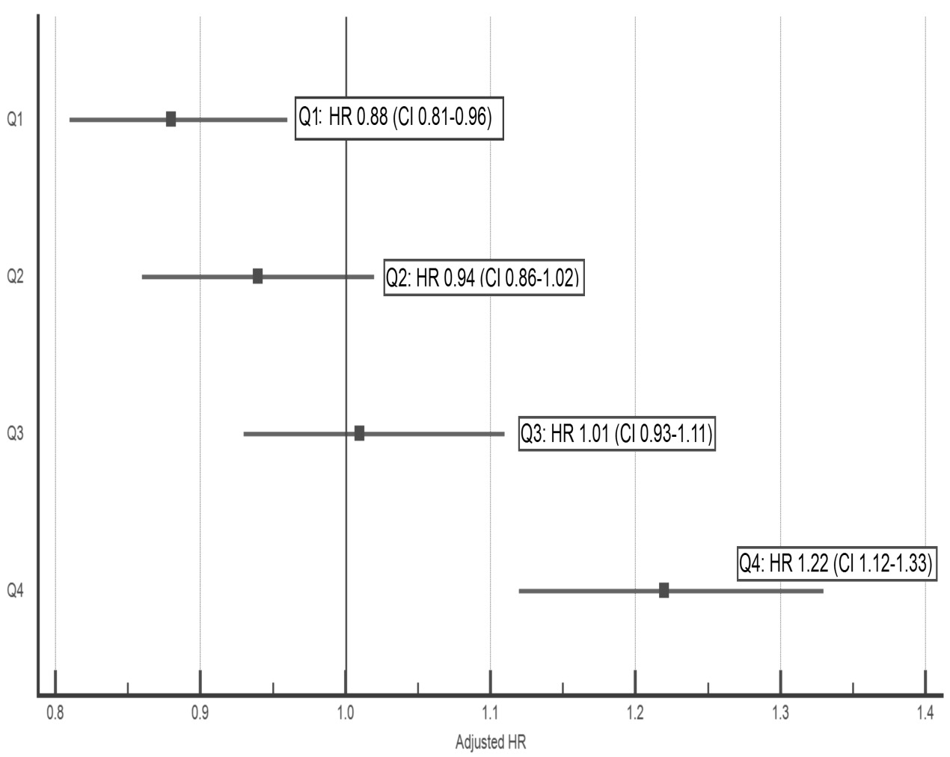

Figure 3: A forest plot of the independent risk associated with each quartile, showing that the low SBP change group (Q1) has the lowest mortality risk, whilst the high SBP change group (Q4) presented the highest risk of mortality.

Table 1. Medication changes by SBP change quartile groups (Q4 vs. Q1-3)

P value§ | Percent Change Q1-3 | Discharge Q1-3 | Admission Q1-3 | Percent Change in Q4 | Discharge Q4 | Admission Q4 | Drug
0.01 | + 4% | 1788 (70) | 1724 (66) | - 7% | 560 (67) | 609 (74) | ACE-I\ARB, n (%)
NS | + 12% | 1570 (61) | 1262 (49) | + 8% | 482 (58) | 420 (50) | β-Blockers, n (%)
NS | + 15% | 1901 (74) | 1526 (59) | 9% + | 620 (74) | 542 (65) | Furosemide, n (%)
NS | 0% | 683 (27) | 689 (27) | - 1% | 219 (26) | 226 (27) | Ca Blockers, n (%)
NS | + 1% | 934 (36) | 905 (35) | 0% | 287 (34) | 288 (34) | Nitrates, n (%)
NS | + 6% | 530 (21) | 349 (14) | +5% | 164 (20) | 122 (15) | MRA, n (%)

The data is presented as absolute frequencies and percentages. The change was calculated as the difference between the discharge and the admission values for each drug in each group.

§ P value for comparison between medication change in percentage (discharge minus admission) in Q4 vs. lower quartiles (Q1-3)

NS, not significant.

Table 2. Independent predictors of upper quartile SBP change*

 | OR | 95% CI |  | P-value
NYHA class > II | 1.06 | 0.95 | 1.19 | 0.27
eGFR < 60 mL/min/1.73 m² | 1.15 | 0.95 | 1.39 | 0.16
Hemoglobin < 11 g/dL | 1.43 | 1.17 | 1.76 | < 0.001
Admission SBP (per 1 mm Hg) | 0.95 | 0.94 | 0.95 | < 0.001
Heart rate (per 5 bpm increment) | 0.95 | 0.90 | 0.99 | 0.02
HFpSF (vs. HFrSF) | 1.29 | 1.02 | 1.64 | 0.03

* Model further adjusted for age and gender (both p=NS)
OR, odds ratio; CI, confidence interval; HFpSF, heart failure with preserved systolic function; HFrSF, heart failure with reduced systolic function.

Table 3. Analysis by Heart Failure with reduced ejection fraction (HFrEF ≤40%) and Heart Failure with preserved ejection fraction (HFpEF >40%) for the entire cohort
 |  | HFrSF ≤40% | HFpSF >40% | P-value
Age, years |  | 71 ± 12 | 72 ± 12 | 0.06
Age below 75 years |  | 59 | 55 | 0.1
Patients at the upper quartile of SBP change, % |  | 26 | 23 | 0.07
Coronary artery disease, % |  | 83 | 62 | <0.001
Diabetes Mellitus, % |  | 22 | 23 | 0.4
Hypertensive heart disease, % |  | 33 | 47 | <0.001
Cardiomyopathy, % |  | 19 | 11 | <0.001
Valvular heart disease, % |  | 22 | 31 | <0.001
Lung disease, % |  | 34 | 32 | 0.7
Rhythm disorder, % |  | 51 | 49 | 0.8
New York Heart Association class, % | 1 | 17 | 26 | <0.001
 | 2 | 40 | 41
 | 3 | 35 | 27
 | 4 | 8 | 6
Shortness of breath, % |  | 20 | 19 | 0.6
Fatigue, % |  | 58 | 62 | 0.2
Fluid, % |  | 52 | 48 | 0.4
No previous Hospitalization, % |  | 43 | 39 | 0.08
Precipitating factors:
Not compliant with therapy, % |  | 8 | 6 | 0.2
Renal dysfunction, % |  | 15 | 14 | 0.4
Infection, % |  | 14 | 15 | 0.3
Myocardial infarction, % |  | 35 | 33 | 0.3
Admission characteristics:
Admission SBP, mm Hg |  | 140 ± 28 | 150 ± 32 | <0.001
Admission DBP, mm Hg |  | 79 ± 16 | 79 ± 17 | 0.3
Admission heart rate, Bpm |  | 85 ± 22 | 83 ± 21 | 0.05
Clinically diagnosed, % |  | 70 | 71 | 0.5
Radiographically diagnosed, % |  | 51 | 51 | 0.95
Echocardiographically diagnosed, % |  | 73 | 60 | <0.001
Admission Pulmonary edema, % |  | 29 | 31 | 0.4
Discharge SBP, mm Hg |  | 127 ± 19 | 134 ± 21 | <0.001
Discharge DBP, mm Hg |  | 71 ± 11 | 72 ± 12 | 0.1
Discharge heart rate, Bpm |  | 73 ± 12 | 73 ± 13 | 0.7
Discharge pulmonary edema, % |  | 24 | 26 | 0.2

