Supplemental Fig 1. Result of sensitivity analysis of PD-L1 overexpression and OS in patients with solid tumor
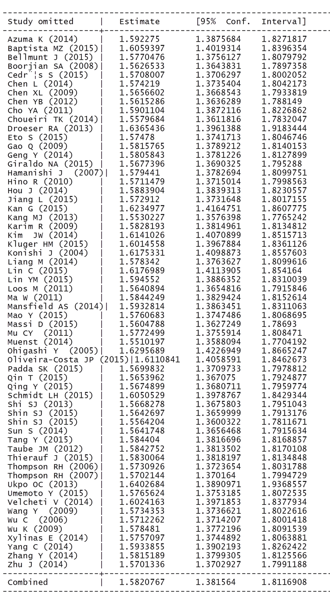
Supplemental Fig 2. Result of sensitivity analysis of PD-L1 overexpression and DFS/PFS in patients with solid tumor


