Supplementary Figure legend

Supplementary Figure 1. Contribution matrix of the network meta-analysis (outcome measure: healing rates at 4 weeks). Numbers represent percentage contribution of each direct comparison to the network meta-analysis estimate of each comparison. A=Omeprazole 20mg; B=Placebo; C=Pantoprazole 40mg; D=Lansoprazole 30mg; E=Rabeprazole 20mg; F= Esomeprazole 20mg; G= Esomeprazole 40mg.

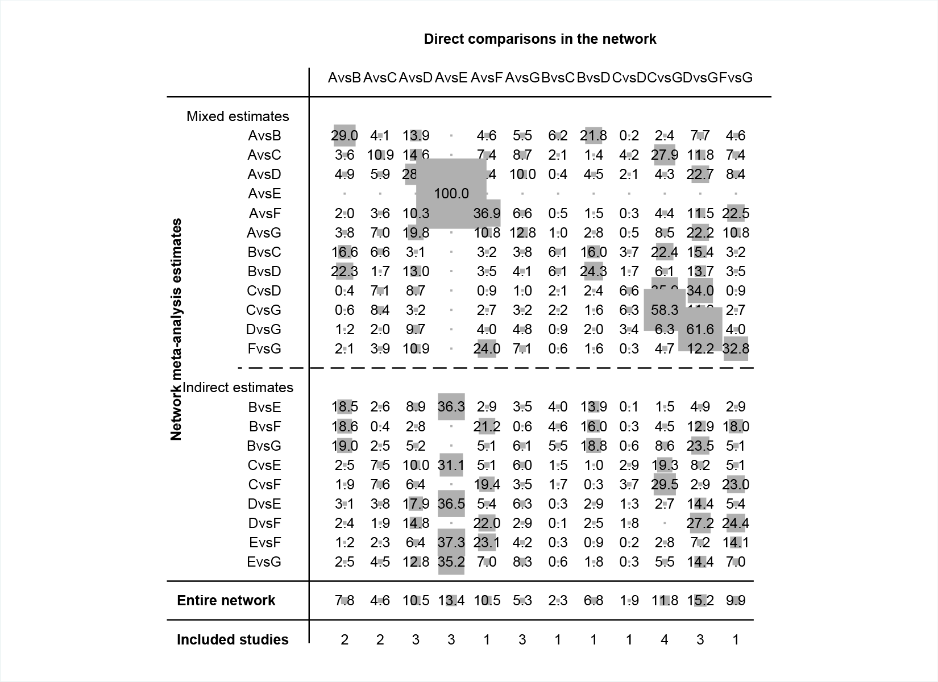

Supplementary Figure 2. Contribution matrix of the network meta-analysis for healing rates at 8 weeks. A=Omeprazole 20mg; B=Placebo; C=Pantoprazole 40mg; D=Lansoprazole 30mg; E=Rabeprazole 20mg; F= Esomeprazole 20mg; G= Esomeprazole 40mg; H=Dexlansoprazole 60mg.

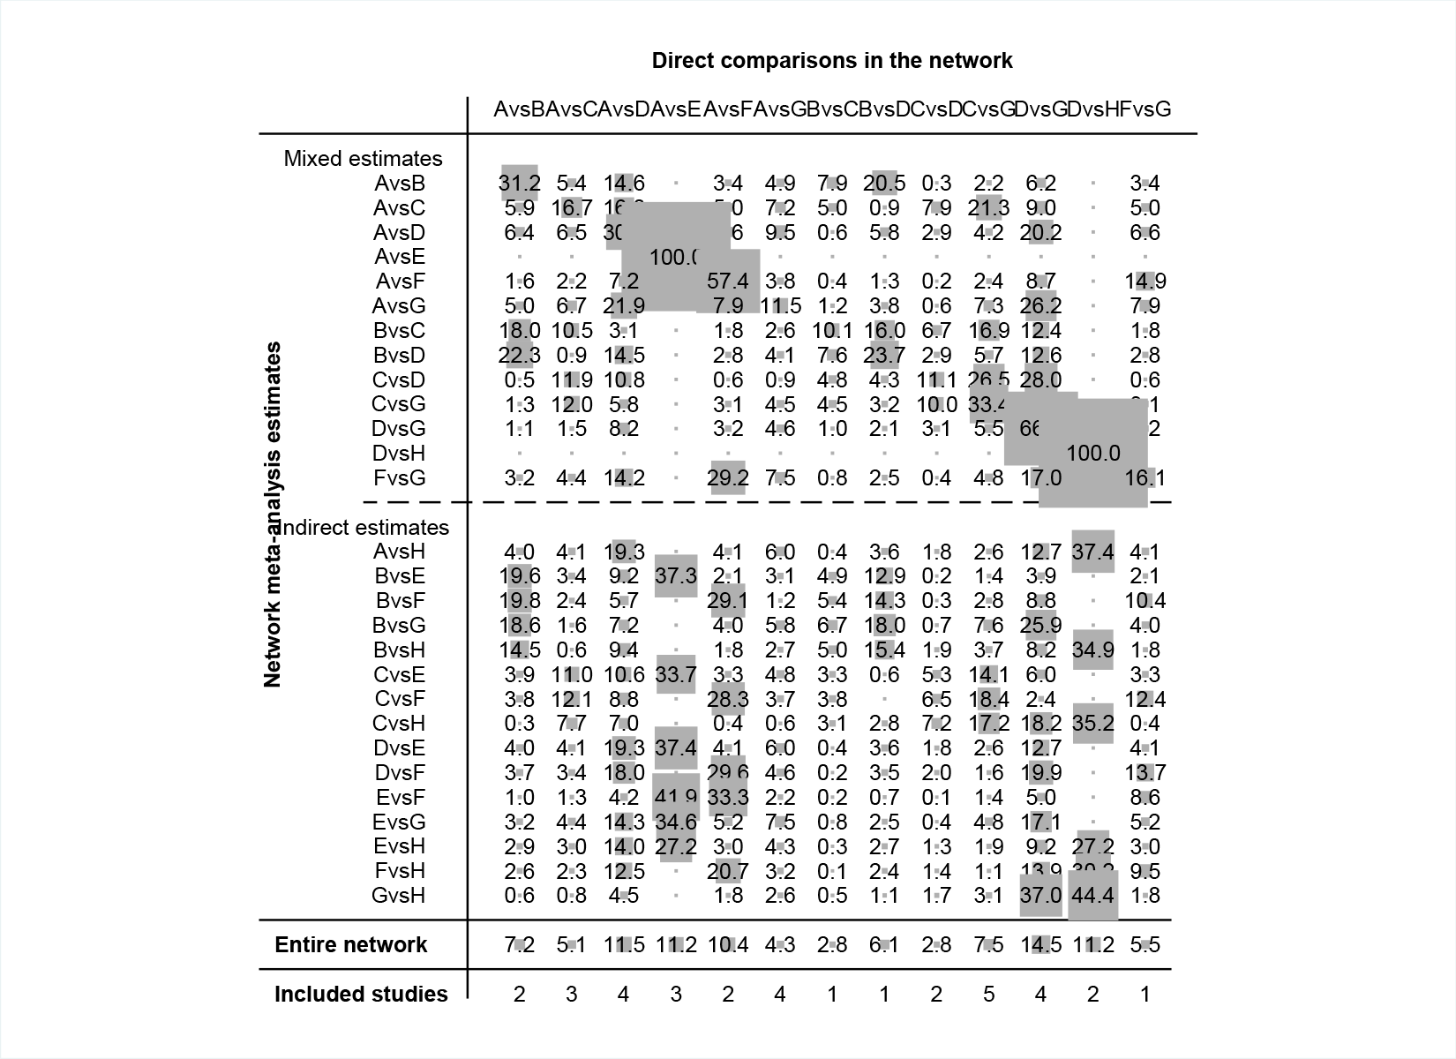

Supplementary Figure 3. Contribution matrix of the network meta-analysis for heartburn relief rates. A=Omeprazole 20mg; B=Pantoprazole 40mg; C=Lansoprazole 30mg; D=Rabeprazole 20mg; E= Esomeprazole 20mg; F= Esomeprazole 40mg.

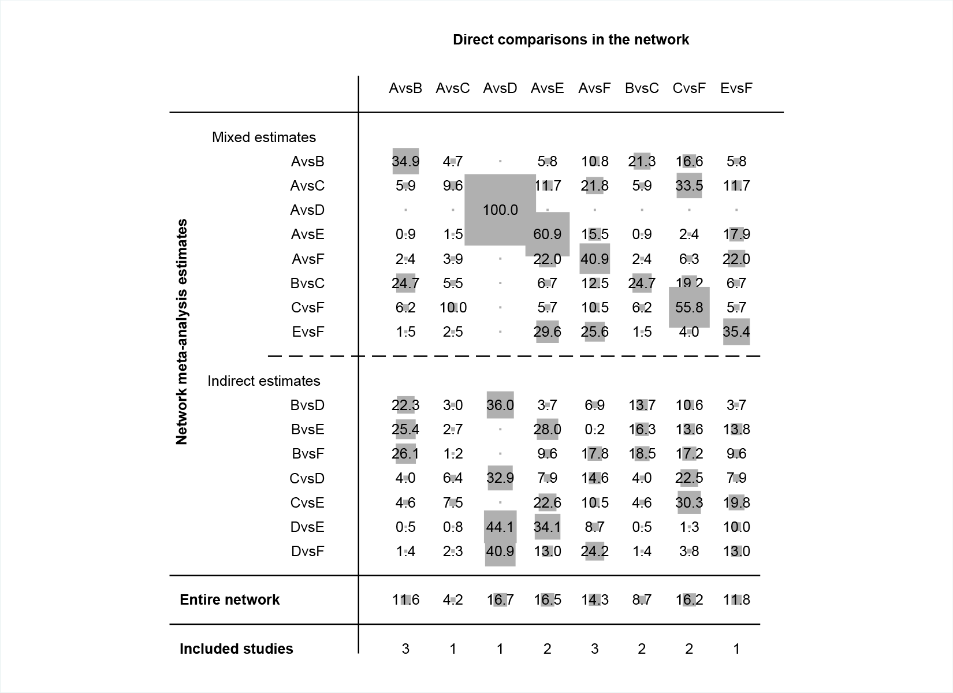

Supplementary Figure 4. Contribution matrix of the network meta-analysis for acceptability.

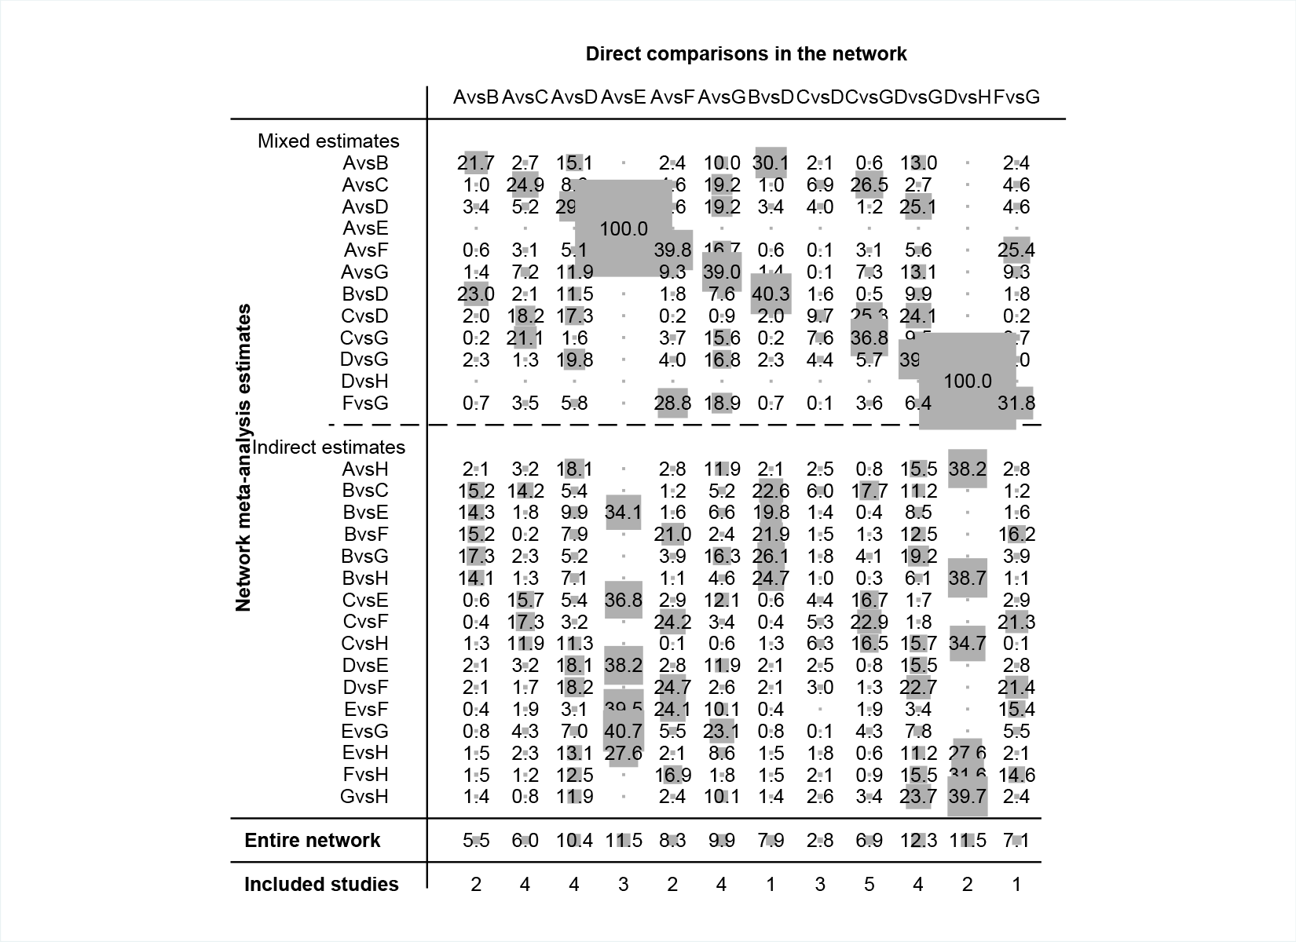

A=Omeprazole 20mg; B=Placebo; C=Pantoprazole 40mg; D=Lansoprazole 30mg; E=Rabeprazole 20mg; F= Esomeprazole 20mg; G= Esomeprazole 40mg; H=Dexlansoprazole 60mg.

Supplementary Figure 5. Network meta-analysis results: withdraw due to adverse events.

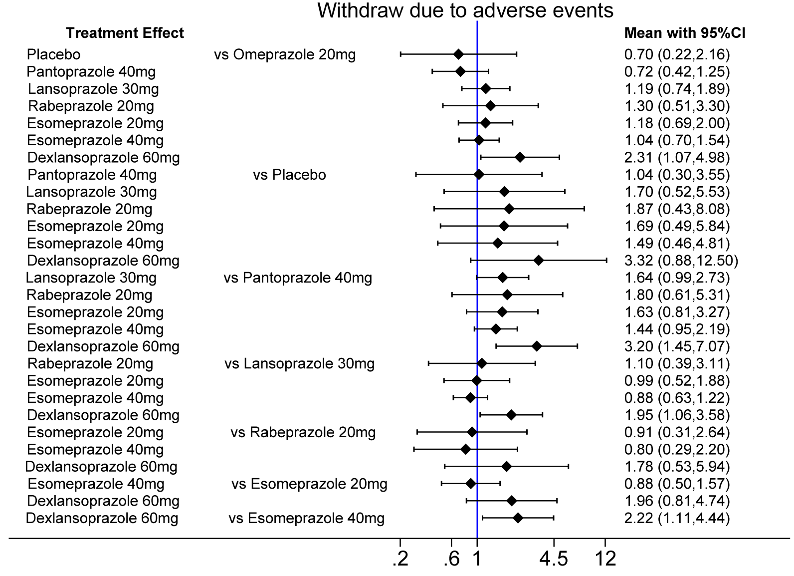

Supplementary Figure 6. SUCRA for healing rates at 4 weeks.

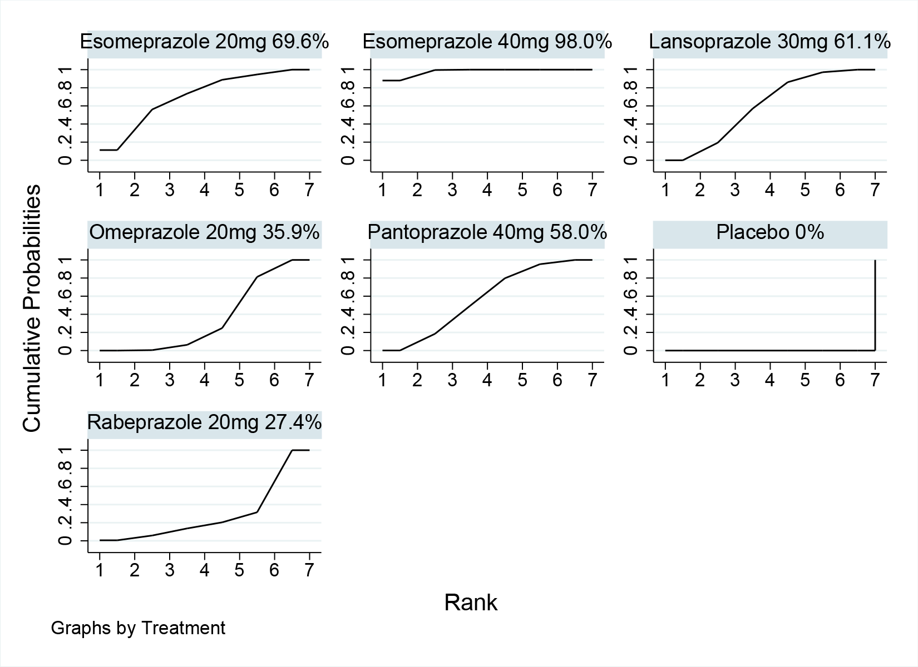

Supplementary Figure 7. SUCRA for healing rates at 8 weeks.

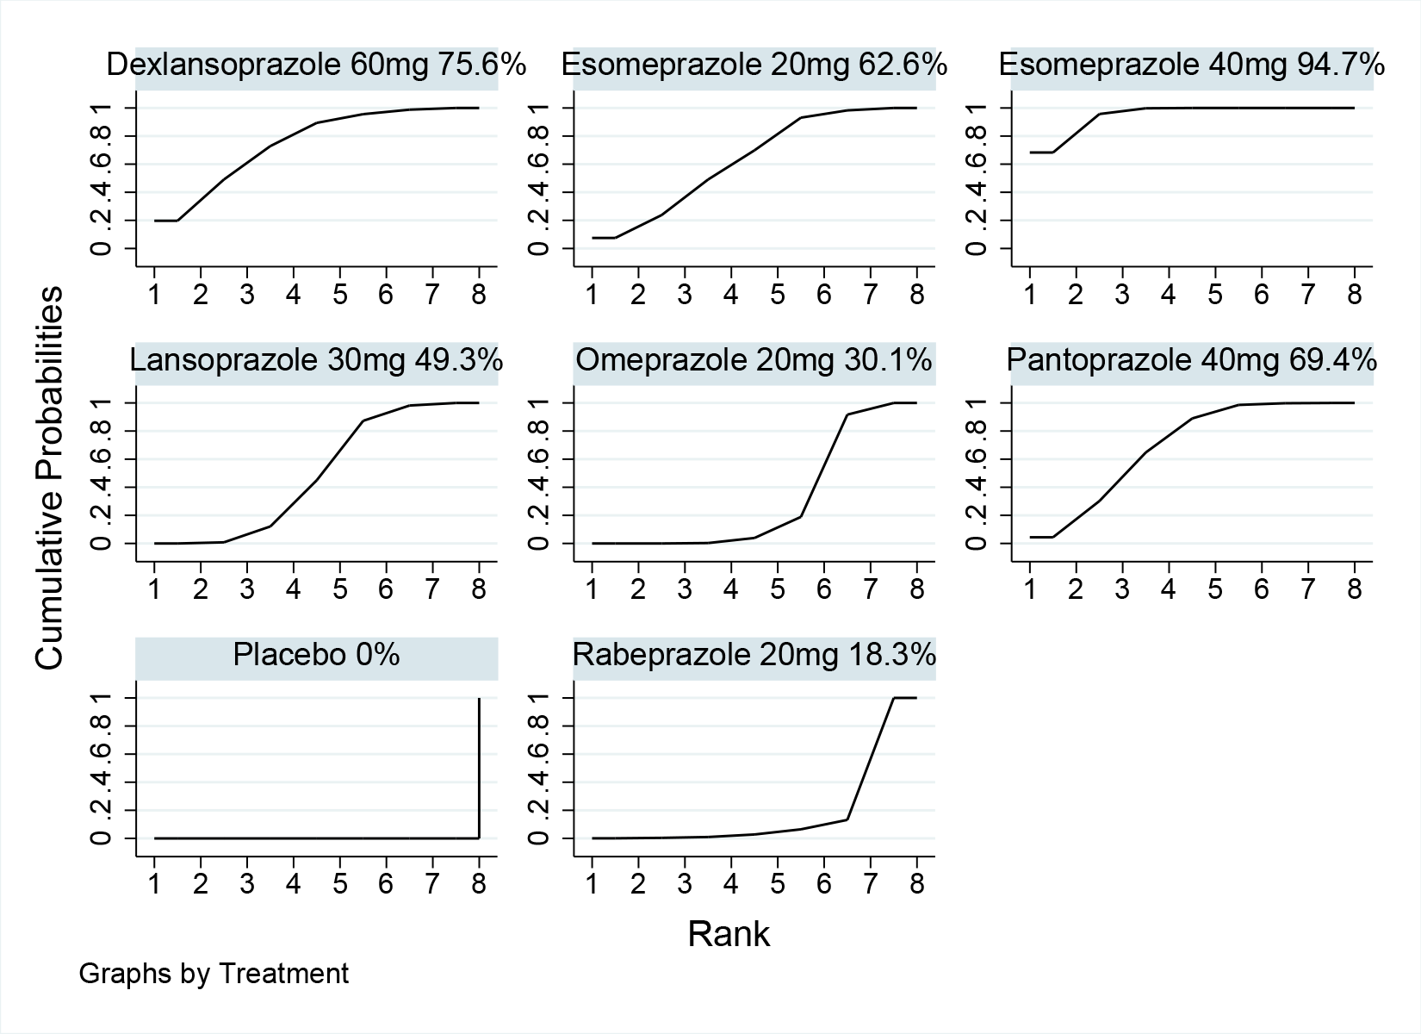

Supplementary Figure 8. SUCRA for heartburn relief rates.

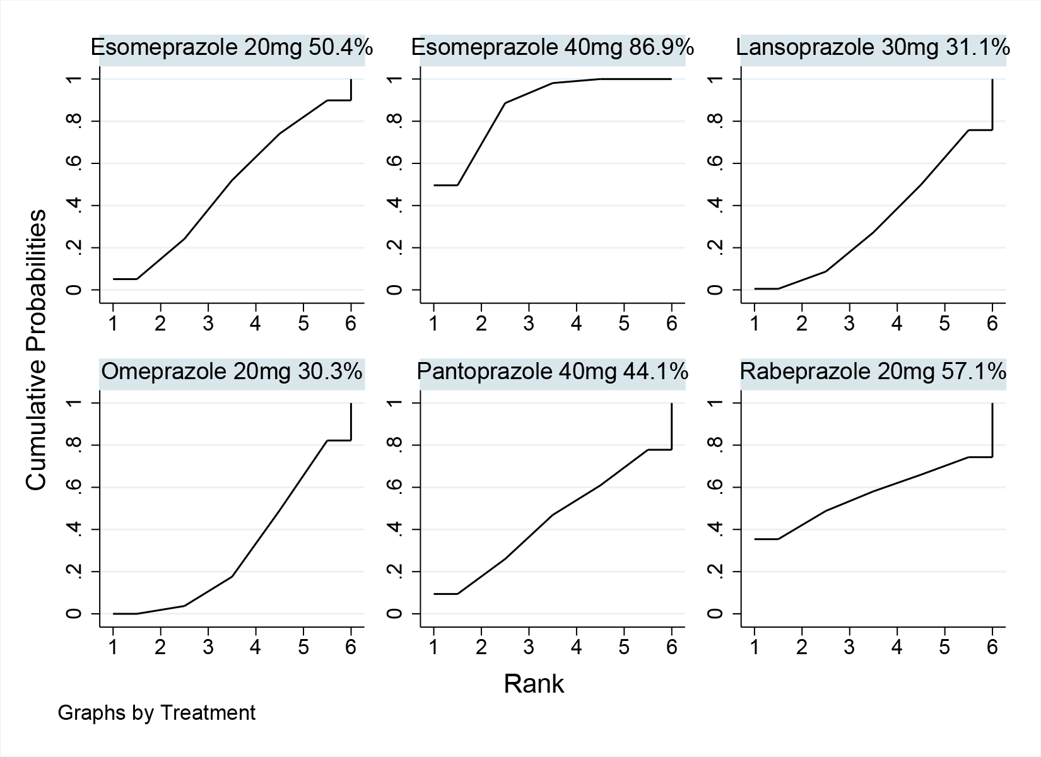

Supplementary Figure 9. SUCRA for acceptability.

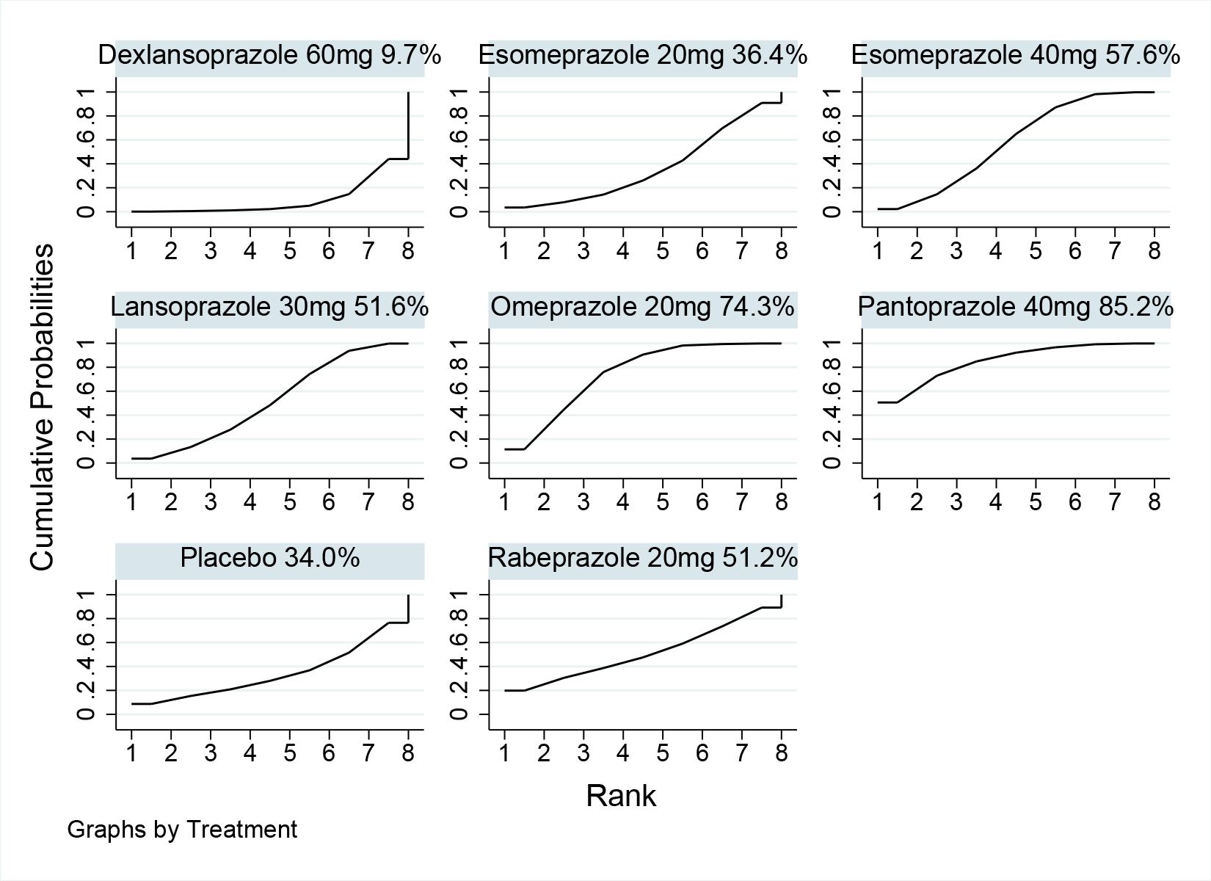

Supplementary Figure 10. Risk of bias by trial. Green: low risk; yellow: moderate risk; red: high risk.

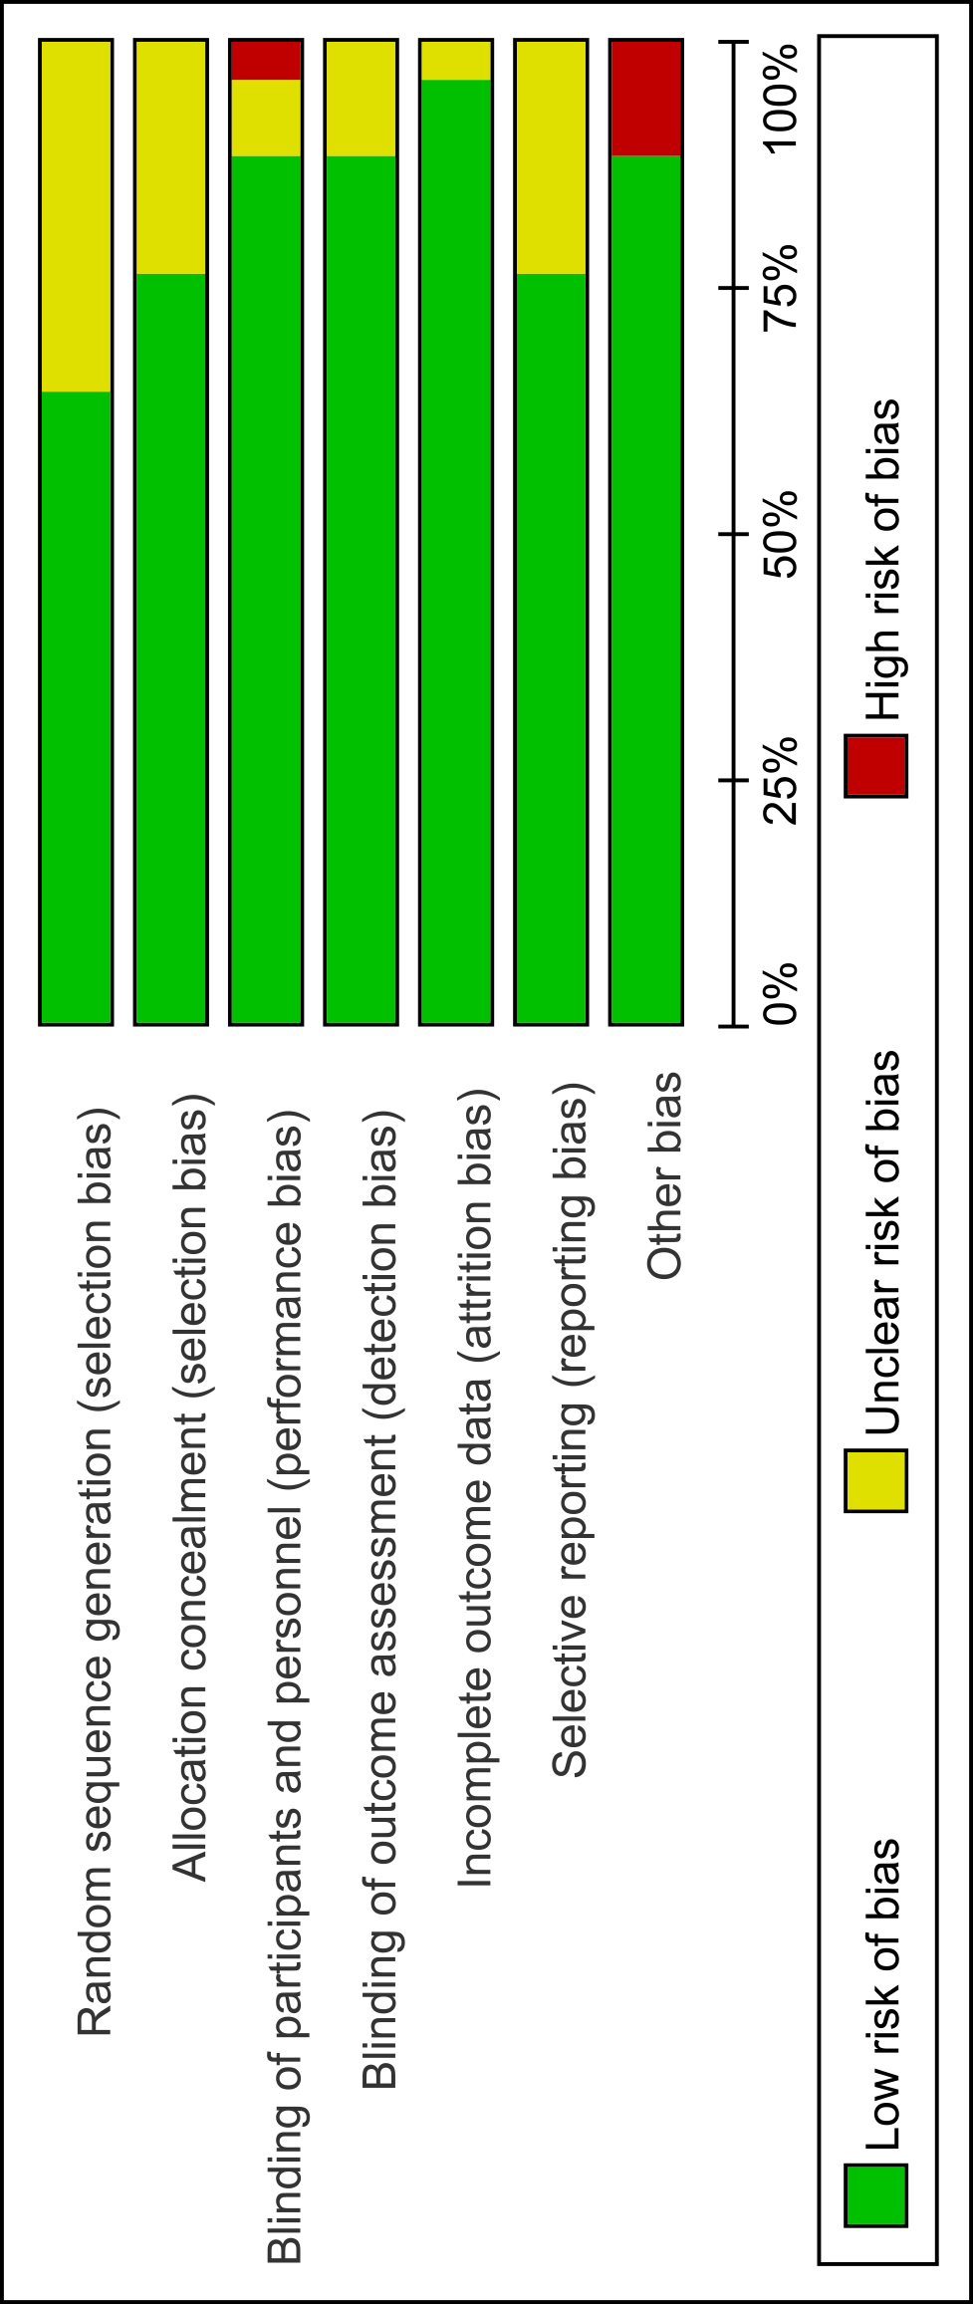

Supplementary Figure 11. Risk of bias summary.

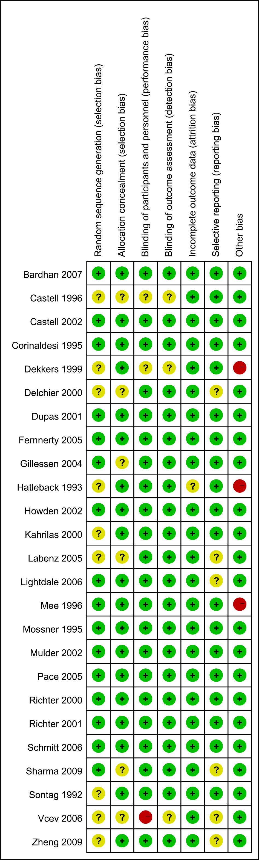

Supplementary Table 1. Node split results for the primary efficacy outcome healing rates at 4 and 8 weeks, secondary efficacy outcome heartburn relief rates, and primary safety outcome.
Healing rates at 4 weeks
Treatments |  | Direct |  | Indirect |  | Difference
X | Y | Mean | SD | Mean | SD | Mean | SD | P
Omeprazole 20mg | Placebo | -2.260846 | 0.2221873 | -2.40916 | 0.3171693 | 0.1483136 | 0.3794544 | 0.696
Omeprazole 20mg | Pantoprazole 40mg | -0.131534 | 0.2131033 | 0.1842384 | 0.1253311 | -0.3157724 | 0.2472234 | 0.202
Omeprazole 20mg | Lansoprazole 30mg | 0.0775972 | 0.1371889 | 0.1470563 | 0.1377292 | -0.0694591 | 0.1937428 | 0.72
Omeprazole 20mg | Esoprazole 20mg | 0.2587959 | 0.178464 | -0.1443848 | 0.3686695 | 0.4031807 | 0.4081819 | 0.323
Omeprazole 20mg | Esoprazole 40mg | 0.4303783 | 0.1000171 | 0.2701675 | 0.138379 | 0.1602108 | 0.1699587 | 0.346
Placebo | Pantoprazole 40mg | 2.821902 | 0.3873661 | 2.274234 | 0.2216009 | 0.5476679 | 0.4462725 | 0.22
Placebo | Lansoprazole 30mg | 2.270585 | 0.2302409 | 2.653287 | 0.2832661 | -0.3827022 | 0.3565059 | 0.283
Pantoprazole 40mg | Lansoprazole 30mg | -0.0641605 | 0.2722497 | 0.0282541 | 0.1280363 | -0.0924146 | 0.3008541 | 0.759
Pantoprazole 40mg | Esoprazole 40mg | 0.2563758 | 0.1136005 | 0.3112428 | 0.1750628 | -0.054867 | 0.2083374 | 0.792
Lansoprazole 30mg | Esoprazole 40mg | 0.2128165 | 0.108699 | 0.3473694 | 0.1443251 | -0.134553 | 0.1804281 | 0.456
Esoprazole 20mg | Esoprazole 40mg | 0.2762742 | 0.1829004 | -0.1269062 | 0.362088 | 0.4031804 | 0.4081819 | 0.323
Healing rates at 8 weeks
Treatments |  | Direct |  | Indirect |  | Difference
X | Y | Mean | SD | Mean | SD | Mean | SD | P
Omeprazole 20mg | Placebo | -2.671363 | 0.2273528 | -2.373186 | 0.3207578 | -0.2981761 | 0.3922163 | 0.447
Omeprazole 20mg | Pantoprazole 40mg | -0.0210252 | 0.2297239 | 0.4017528 | 0.1534178 | -0.422778 | 0.2758027 | 0.125
Omeprazole 20mg | Lansoprazole 30mg | 0.099081 | 0.1558732 | 0.1753042 | 0.1704606 | -0.0762232 | 0.2300764 | 0.74
Omeprazole 20mg | Esoprazole 20mg | 0.3103866 | 0.1552679 | -0.6746805 | 0.4969923 | 0.9850671 | 0.517599 | 0.057
Omeprazole 20mg | Esoprazole 40mg | 0.5745597 | 0.124056 | 0.2633955 | 0.161399 | 0.3111642 | 0.2021562 | 0.124
Placebo | Pantoprazole 40mg | 2.690855 | 0.3665132 | 2.90702 | 0.240936 | -0.2161652 | 0.4386138 | 0.622
Placebo | Lansoprazole 30mg | 2.67328 | 0.2616327 | 2.748007 | 0.2900717 | -0.0747277 | 0.3904185 | 0.848
Pantoprazole 40mg | Lansoprazole 30mg | -0.3293737 | 0.2791503 | -0.0744117 | 0.1532597 | -0.254962 | 0.3184817 | 0.423
Pantoprazole 40mg | Esoprazole 40mg | 0.1015185 | 0.1437595 | 0.3525434 | 0.2037072 | -0.2510249 | 0.2500831 | 0.315
Lansoprazole 30mg | Esoprazole 40mg | 0.2572441 | 0.1244927 | 0.4337904 | 0.1726953 | -0.1765463 | 0.2128749 | 0.407
Lansoprazole 30mg | Dexlansoprazole 60mg | 0.178992 | 0.1441248 | -0.2696414 | 110.9413 | 0.4486334 | 110.9414 | 0.997
Esoprazole 20mg | Esoprazole 40mg | 0.5460879 | 0.2564139 | -0.0256633 | 0.2351086 | 0.5717512 | 0.3535472 | 0.106
Heartburn relief rates
Treatments |  | Direct |  | Indirect |  | Difference
X | Y | Mean | SD | Mean | SD | Mean | SD | P
Omeprazole 20mg | Pantoprazole 40mg | 0.0262911 | 0.2422571 | 0.0852382 | 0.3773229 | -0.058947 | 0.4478975 | 0.895
Omeprazole 20mg | Lansoprazole 30mg | -0.3982257 | 0.3201681 | 0.0935787 | 0.1416458 | -0.4918044 | 0.3502743 | 0.16
Omeprazole 20mg | Esoprazole 20mg | 0.0819541 | 0.1446564 | 0.005225 | 0.43882 | 0.0767292 | 0.4618047 | 0.868
Omeprazole 20mg | Esoprazole 40mg | 0.2984724 | 0.0983196 | 0.0147488 | 0.2481458 | 0.2837236 | 0.2678965 | 0.29
Pantoprazole 40mg | Lansoprazole 30mg | -0.1134585 | 0.2405077 | 0.1028268 | 0.3558655 | -0.2162853 | 0.4282408 | 0.614
Lansoprazole 30mg | Esoprazole 40mg | 0.2135702 | 0.1206299 | 0.4796898 | 0.2881519 | -0.2661197 | 0.3138293 | 0.396
Esoprazole 20mg | Esoprazole 40mg | 0.1586974 | 0.2027714 | 0.2043225 | 0.2334942 | -0.0456251 | 0.3094271 | 0.883
Acceptability
Treatments |  | Direct |  | Indirect |  | Difference
X | Y | Mean | SD | Mean | SD | Mean | SD | P
Omeprazole 20mg | Placebo | 0.2512183 | 0.2864839 | 0.254794 | 0.6005361 | -0.0035757 | 0.6474507 | 0.996
Omeprazole 20mg | Pantoprazole 40mg | 0.0071755 | 0.2354253 | -0.1569737 | 0.1899552 | 0.1641492 | 0.3015983 | 0.586
Omeprazole 20mg | Lansoprazole 30mg | 0.1397752 | 0.1784533 | 0.0621587 | 0.1917139 | 0.0776165 | 0.2622949 | 0.767
Omeprazole 20mg | Esoprazole 20mg | 0.1250021 | 0.1828821 | 0.5784515 | 0.439905 | -0.4534494 | 0.481574 | 0.346
Omeprazole 20mg | Esoprazole 40mg | 0.0433134 | 0.1329282 | 0.1180408 | 0.1832182 | -0.0747273 | 0.2262858 | 0.741
Placebo | Lansoprazole 30mg | -0.2437433 | 0.3226024 | 0.0438693 | 0.4452477 | -0.2876126 | 0.5303665 | 0.588
Pantoprazole 40mg | Lansoprazole 30mg | 0.6490033 | 0.3965453 | 0.1016344 | 0.1818429 | 0.547369 | 0.4354577 | 0.209
Pantoprazole 40mg | Esoprazole 40mg | 0.164035 | 0.1540693 | 0.1547437 | 0.2463131 | 0.0092913 | 0.290156 | 0.974
Lansoprazole 30mg | Esoprazole 40mg | 0.0223472 | 0.1536105 | -0.1344379 | 0.2031216 | 0.1567851 | 0.2544493 | 0.538
Lansoprazole 30mg | Dexlansoprazole 60mg | 0.3253192 | 0.1570284 | -0.220563 | 182.1582 | 0.5458822 | 182.1583 | 0.998
Esoprazole 20mg | Esoprazole 40mg | -0.2405842 | 0.2019405 | 0.1985558 | 0.3463609 | -0.43914 | 0.4066407 | 0.28

Supplementary Table S2 The quality ratings for each outcome based on the GRADE system.
Healing rates at 4 weeks
Comparisons | Quality evaluation |  |  |  |  | Network meta-analysis
 | Risk of bias | Inconsistency | Indirectness | Imprecision | Publication bias | OR 95%CrIs | Quality of evidence
Placebo vs Omeprazole 20mg | -1†‖ | 0 | -2*¶ | 0 | 0 | 0.10(0.07,0.14) | Very Low
Pantoprazole 40mg vs Omeprazole 20mg | -1‖ | 0 | -2*¶ | 0 | 0 | 1.11(0.89,1.37) | Very Low
Lansoprazole 30mg vs Omeprazole 20mg | -1† | 0 | -2*¶ | 0 | 0 | 1.12(0.93,1.35) | Very Low
Rabeprazole 20mg vs Omeprazole 20mg | -1† | 0 | 0 | 0 | 0 | 0.89(0.62,1.28) | Moderate
Esomeprazole 20mg vs Omeprazole 20mg | -1† | 0 | -1* | 0 | 0 | 1.20(0.88,1.64) | Low
Esomeprazole 40mg vs Omeprazole 20mg | -1† | -1☩ | -1* | 0 | 0 | 1.46(1.24,1.71) | Very Low
Pantoprazole 40mg vs Placebo | -1‖ | 0 | -2*¶ | -1♊ | 0 | 11.12(7.63,16.22) | Very Low
Lansoprazole 30mg vs Placebo | -1†‖ | 0 | -2*¶ | -1♊ | 0 | 11.26(7.86,16.13) | Very Low
Rabeprazole 20mg vs Placebo | -1‖ | — | -1** | — | — | 8.92(5.36,14.83) | Low
Esomeprazole 20mg vs Placebo | -1‖ | — | -1** | — | — | 12.06(7.61,19.12) | Low
Esomeprazole 40mg vs Placebo | -1‖ | — | -1** | — | — | 14.62(10.17,21.02) | Low
Lansoprazole 30mg vs Pantoprazole 40mg | -1†‖ | 0 | -1* | 0 | 0 | 1.01(0.81,1.27) | Low
Rabeprazole 20mg vs Pantoprazole 40mg | -1‖ | — | -1** | — | — | 0.80(0.53,1.22) | Low
Esomeprazole 20mg vs Pantoprazole 40mg | -1‖ | — | -1** | — | — | 1.08(0.76,1.54) | Low
Esomeprazole 40mg vs Pantoprazole 40mg | -1† | 0 | -1* | 0 | 0 | 1.31(1.10,1.58) | Low
Rabeprazole 20mg vs Lansoprazole 30mg | -1‖ | — | -1** | — | — | 0.79(0.53,1.19) | Low
Esomeprazole 20mg vs Lansoprazole 30mg | -1♓ | — | -1** | — | — | 1.07(0.76,1.50) | Low
Esomeprazole 40mg vs Lansoprazole 30mg | 0 | 0 | -1* | 0 | 0 | 1.30(1.10,1.53) | Moderate
Esomeprazole 20mg vs Rabeprazole 20mg | -1‖ | — | -1** | — | — | 1.35(0.84,2.18) | Low
Esomeprazole 40mg vs Rabeprazole 20mg | -1‖ | — | -1** | — | — | 1.64(1.10,2.44) | Low
Esomeprazole 40mg vs Esomeprazole 20mg | 0 | 0 | -1* | 0 | 0 | 1.21(0.89,1.65) | Moderate
Healing rates at 8 weeks
 | Quality evaluation |  |  |  |  | Network meta-analysis
Comparisons | Risk of bias | Inconsistency | Indirectness | Imprecision | Publication bias | OR 95%CrIs | Quality of evidence
Placebo vs Omeprazole 20mg | -1†‖ | 0 | -1* | 0 | 0 | 0.08(0.05,0.11) | Low
Pantoprazole 40mg vs Omeprazole 20mg | -1‖ | 0 | -1* | -1♊ | 0 | 1.31(1.02,1.69) | Very Low
Lansoprazole 30mg vs Omeprazole 20mg | -1† | 0 | -1* | 0 | 0 | 1.15(0.92,1.43) | Low
Rabeprazole 20mg vs Omeprazole 20mg | -1† | 0 | 0 | 0 | 0 | 0.78(0.50,1.21) | Moderate
Esomeprazole 20mg vs Omeprazole 20mg | -1† | 0 | -1* | 0 | 0 | 1.25(0.92,1.69) | Low
Esomeprazole 40mg vs Omeprazole 20mg | -1† | -1☩ | -1* | 0 | 0 | 1.58(1.29,1.92) | Very Low
Dexlansoprazole 60mg vs Omeprazole 20mg | -1♓ | — | -1** | — | — | 1.37(0.96,1.97) | Low
Pantoprazole 40mg vs Placebo | -1‖ | 0 | -1* | -1♊ | 0 | 17.15(11.60,25.35) | Very Low
Lansoprazole 30mg vs Placebo | -1†‖ | 0 | -1* | 0 | 0 | 15.01(10.32,21.84) | Low
Rabeprazole 20mg vs Placebo | -1‖ | — | -1** | — | — | 10.20(5.77,18.03) | Low
Esomeprazole 20mg vs Placebo | -1‖ | — | -1** | — | — | 16.36(10.26,26.09) | Low
Esomeprazole 40mg vs Placebo | -1‖ | — | -1** | — | — | 20.63(14.13,30.12) | Low
Dexlansoprazole 60mg vs Placebo | -1♓ | — | -1** | — | — | 17.95(11.22,28.72) | Low
Lansoprazole 30mg vs Pantoprazole 40mg | -1†‖ | 0 | -1* | 0 | 0 | 0.88(0.67,1.14) | Low
Rabeprazole 20mg vs Pantoprazole 40mg | -1‖ | — | -1** | — | — | 0.59(0.36,0.99) | Low
Esomeprazole 20mg vs Pantoprazole 40mg | -1‖ | — | -1** | — | — | 0.95(0.65,1.40) | Low
Esomeprazole 40mg vs Pantoprazole 40mg | -1† | 0 | -1* | 0 | 0 | 1.20(0.96,1.50) | Low
Dexlansoprazole 60mg vs Pantoprazole 40mg | -1♓ | — | -1** | — | — | 1.05(0.71,1.54) | Low
Rabeprazole 20mg vs Lansoprazole 30mg | -1‖ | — | -1** | — | — | 0.68(0.42,1.11) | Low
Esomeprazole 20mg vs Lansoprazole 30mg | -1♓ | — | -1** | — | — | 1.09(0.76,1.56) | Low
Esomeprazole 40mg vs Lansoprazole 30mg | 0 | 0 | -1* | 0 | 0 | 1.37(1.13,1.67) | Moderate
Dexlansoprazole 60mg vs Lansoprazole 30mg | -1† | 0 | 0 | 0 | 0 | 1.20(0.90,1.59) | Moderate
Esomeprazole 20mg vs Rabeprazole 20mg | -1‖ | — | -1** | — | — | 1.60(0.94,2.73) | Low
Esomeprazole 40mg vs Rabeprazole 20mg | -1‖ | — | -1** | — | — | 2.02(1.25,3.27) | Low
Dexlansoprazole 60mg vs Rabeprazole 20mg | -1‖ | — | -1** | — | — | 1.76(1.00,3.10) | Low
Esomeprazole 40mg vs Esomeprazole 20mg | -1† | 0 | -1* | 0 | 0 | 1.26(0.90,1.76) | Low
Dexlansoprazole 60mg vs Esomeprazole 20mg | -1‖ | — | -1** | — | — | 1.10(0.69,1.73) | Low
Dexlansoprazole 60mg vs Esomeprazole 40mg | -1♓ | — | -1** | — | — | 0.87(0.62,1.23) | Low
Heartburn relief rates
Comparisons | Quality evaluation |  |  |  |  | Network meta-analysis
 | Risk of bias | Inconsistency | Indirectness | Imprecision | Publication bias | OR 95%CrIs | Quality of evidence
Pantoprazole 40mg vs Omeprazole 20mg | 0 | 0 | -1* | 0 | 0 | 1.05(0.71,1.56) | Moderate
Lansoprazole 30mg vs Omeprazole 20mg | 0 | 0 | -1* | 0 | 0 | 1.00(0.75,1.33) | Moderate
Rabeprazole 20mg vs Omeprazole 20mg | -1† | 0 | 0 | 0 | 0 | 1.17(0.59,2.30) | Moderate
Esomeprazole 20mg vs Omeprazole 20mg | -1† | 0 | -1* | 0 | 0 | 1.08(0.85,1.37) | Low
Esomeprazole 40mg vs Omeprazole 20mg | -1† | -1☩ | -1* | 0 | 0 | 1.29(1.07,1.56) | Very Low
Lansoprazole 30mg vs Pantoprazole 40mg | 0 | 0 | -1* | 0 | 0 | 0.96(0.65,1.42) | Moderate
Rabeprazole 20mg vs Pantoprazole 40mg | -1‖ | — | -1** | — | — | 1.11(0.51,2.44) | Low
Esomeprazole 20mg vs Pantoprazole 40mg | -1♓ | — | -1** | — | — | 1.03(0.65,1.62) | Low
Esomeprazole 40mg vs Pantoprazole 40mg | 0 | — | -1** | — | — | 1.23(0.83,1.84) | Moderate
Rabeprazole 20mg vs Lansoprazole 30mg | -1‖ | — | -1** | — | — | 1.16(0.56,2.43) | Low
Esomeprazole 20mg vs Lansoprazole 30mg | -1♓ | — | -1** | — | — | 1.08(0.76,1.52) | Low
Esomeprazole 40mg vs Lansoprazole 30mg | 0 | -1☩ | -1* | 0 | 0 | 1.29(1.03,1.62) | Low
Esomeprazole 20mg vs Rabeprazole 20mg | -1‖ | — | -1** | — | — | 0.92(0.45,1.90) | Low
Esomeprazole 40mg vs Rabeprazole 20mg | -1‖ | — | -1** | — | — | 1.11(0.55,2.24) | Low
Esomeprazole 40mg vs Esomeprazole 20mg | -1† | 0 | -1* | 0 | 0 | 1.20(0.91,1.57) | Low
Acceptability
Comparisons | Quality evaluation |  |  |  |  | Network meta-analysis
 | Risk of bias | Inconsistency | Indirectness | Imprecision | Publication bias | OR 95%CrIs | Quality of evidence
Placebo vs Omeprazole 20mg | -1†‖ | -1☩ | -1* | 0 | 0 | 1.29(0.77,2.16) | Very Low
Pantoprazole 40mg vs Omeprazole 20mg | -1‖ | 0 | -1* | -1♊ | 0 | 0.91(0.68,1.22) | Very Low
Lansoprazole 30mg vs Omeprazole 20mg | -1† | 0 | -1* | 0 | 0 | 1.11(0.86,1.43) | Low
Rabeprazole 20mg vs Omeprazole 20mg | -1† | 0 | 0 | 0 | 0 | 1.12(0.68,1.84) | Moderate
Esomeprazole 20mg vs Omeprazole 20mg | -1† | 0 | -1* | 0 | 0 | 1.22(0.88,1.69) | Low
Esomeprazole 40mg vs Omeprazole 20mg | -1† | -1☩ | -1* | 0 | 0 | 1.07(0.87,1.32) | Very Low
Dexlansoprazole 60mg vs Omeprazole 20mg | -1♓ | — | -1** | — | — | 1.54(1.03,2.29) | Low
Pantoprazole 40mg vs Placebo | -1‖ | — | -1** | — | — | 0.71(0.40,1.27) | Very Low
Lansoprazole 30mg vs Placebo | -1†‖ | 0 | -1* | 0 | 0 | 0.86(0.51,1.46) | Low
Rabeprazole 20mg vs Placebo | -1‖ | — | -1** | — | — | 0.87(0.42,1.78) | Low
Esomeprazole 20mg vs Placebo | -1‖ | — | -1** | — | — | 0.94(0.52,1.73) | Low
Esomeprazole 40mg vs Placebo | -1‖ | — | -1** | — | — | 0.83(0.49,1.43) | Low
Dexlansoprazole 60mg vs Placebo | -1♓ | — | -1** | — | — | 1.19(0.65,2.20) | Low
Lansoprazole 30mg vs Pantoprazole 40mg | -1†‖ | 0 | -1* | 0 | 0 | 1.22(0.88,1.68) | Low
Rabeprazole 20mg vs Pantoprazole 40mg | -1‖ | — | -1** | — | — | 1.23(0.69,2.18) | Low
Esomeprazole 20mg vs Pantoprazole 40mg | -1‖ | — | -1** | — | — | 1.33(0.89,2.00) | Low
Esomeprazole 40mg vs Pantoprazole 40mg | -1† | 0 | -1* | 0 | 0 | 1.18(0.91,1.52) | Low
Dexlansoprazole 60mg vs Pantoprazole 40mg | -1♓ | — | -1** | — | — | 1.68(1.08,2.63) | Low
Rabeprazole 20mg vs Lansoprazole 30mg | -1‖ | — | -1** | — | — | 1.01(0.58,1.76) | Low
Esomeprazole 20mg vs Lansoprazole 30mg | -1♓ | — | -1** | — | — | 1.10(0.74,1.61) | Low
Esomeprazole 40mg vs Lansoprazole 30mg | 0 | 0 | -1* | 0 | 0 | 0.97(0.76,1.23) | Moderate
Dexlansoprazole 60mg vs Lansoprazole 30mg | -1† | -1☩ | 0 | 0 | 0 | 1.38(1.02,1.88) | Low
Esomeprazole 20mg vs Rabeprazole 20mg | -1‖ | — | -1** | — | — | 1.09(0.60,1.97) | Low
Esomeprazole 40mg vs Rabeprazole 20mg | -1‖ | — | -1** | — | — | 0.96(0.56,1.64) | Low
Dexlansoprazole 60mg vs Rabeprazole 20mg | -1‖ | — | -1** | — | — | 1.37(0.73,2.59) | Low
Esomeprazole 40mg vs Esomeprazole 20mg | -1† | 0 | -1* | 0 | 0 | 0.88(0.63,1.23) | Low
Dexlansoprazole 60mg vs Esomeprazole 20mg | -1‖ | — | -1** | — | — | 1.26(0.77,2.07) | Low
Dexlansoprazole 60mg vs Esomeprazole 40mg | -1♓ | — | -1** | — | — | 1.43(0.97,2.12) | Low
—: Not available; †: Risk of bias from direct evidence; ♓: Low bias from other evidence; ‖:Moderate bias from other evidence; ☩: The heterogeneity of direct comparison is moderate; ¶: Intransitivity; *: Part of the evidence comes from indirect evidence; **: All of the evidence comes from indirect evidence; ♊: Severe imprecision.

