Figure S1: Forest graph showing the prevalence of anxiety in the cancer patient caregivers

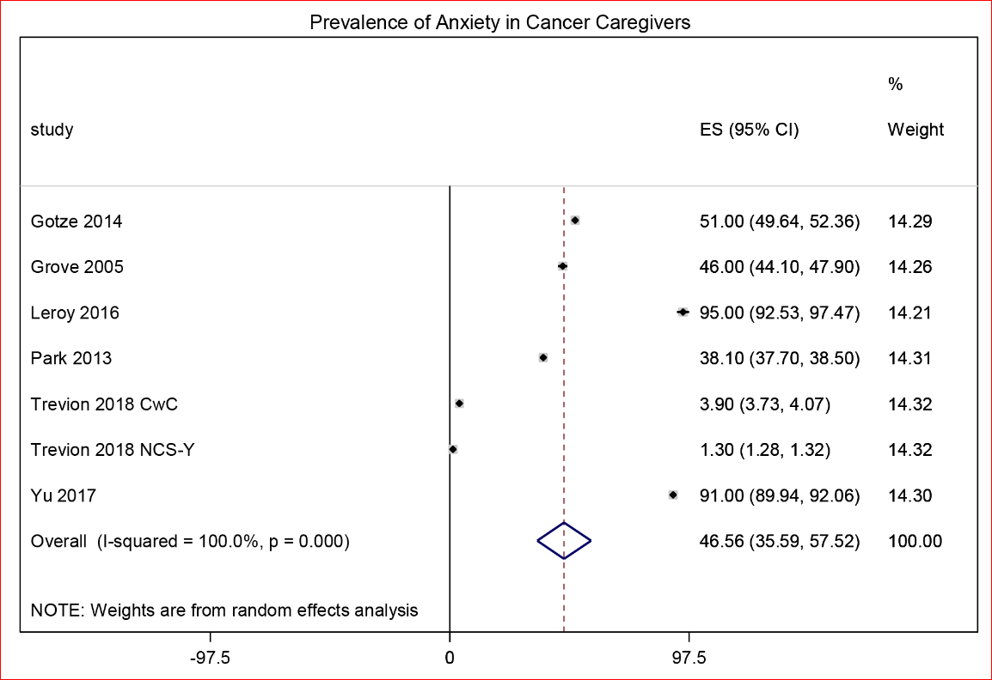

Figure S2: Forest graph showing the anxiety scores in the cancer patient caregivers with regards to psychometric tool used.

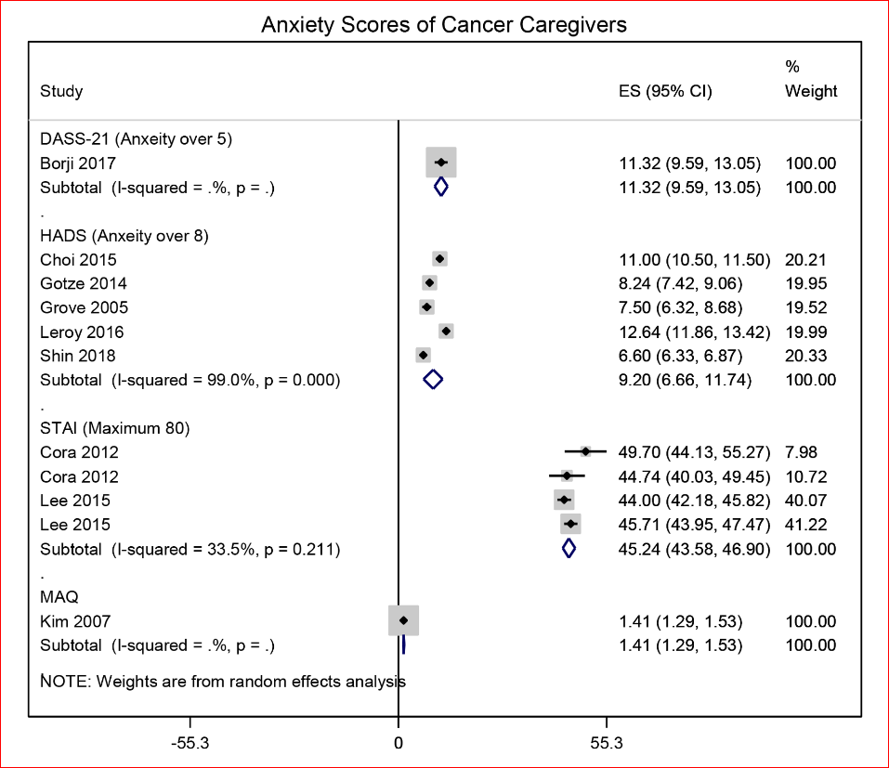

Table S1: Important characteristics of the included studies
Study | n | Design | Age | Males % | Psychometric tool | Quality of life tool | Caregiving duration | Cancer
Badger 2007 |  | Prospective/TIP-C | 51.7?4.8 | 74 | CESD |  |  | Breast
Borji 2017 | 40 | RCT/ CBT |  | 60 | DASS-21 |  |  | Prostate
Choi 2015 | 299 | Cross sectional | 49.1?3.7 | 25.4 | HADS | CQOLC |  | Several
Cora 2012 | 20 | Cross sectional | 50.1?2.32 | 10 | POMS/STAI |  | 16.39?9 | Several
Given 2004 | 152 | Cross sectional |  | 16 | CESD |  |  | Breast, colon, lung, prostate
Gotze 2014 | 106 | Cross sectional | 64.1?1.2 | 32 | HADS | EORTC QLQ/SF-8 |  | Several
Grove 2005 | 96 | Cross sectional | 60? | 38 | HADS | SF-36 |  | Breast
Heckel 2015 | 150 | Cross sectional | 56.4?2.6 | 47 | CESD |  |  | Several
Heckel 2018 | 107 | Prospective longitudinal / TOP | 56.3?4.2 | 39 | CESD |  |  | Several
Jeong 2017 | 52 | Cross sectional | 54.3?2.1 |  | HADS |  |  | Gastric
Kim 2007 | 98 | Cross sectional | 55?3.3 | 24.5 | CESD/MAQ |  |  | Colorectal
Lee 2015 | 172 | Cross sectional | 46?2 | 21 | CESD/STAI |  | 15.9 | Several
Lee 2018 | 95 | Prospective longitudinal | 50.9?2.7 | 32 | CESD |  |  | Several
Leroy 2016 | 60 | Cross sectional | 55.3?4.2 | 35 | HADS |  |  | Several
Nielsen 2017a | 2865 | Cross sectional | 60.5?2.3 | 31 | BDI |  |  | Several
Nielsen 2017b | 1989 | Prospective longitudinal | 62?1.8 | 30 | BDI |  |  | Several
Nik Jaafar 2005 | 130 | Cross sectional | 52?1 | 60 | DASS-21 |  |  | Breast
O'hara 2010 | 86 | Prospective longitudinal | 61.5?1.3 | 18 | CESD |  |  | Lung, breast, gut, genitourinary
Park 2013 | 897 | Cross sectional | 50.4?4.6 | 40 | HADS | CQOLC-K |  | Several
Price 2010 | 373 | Cross sectional |  |  | HADS |  |  | Ovarian
Rhee 2008 | 310 | Cross sectional |  | 36 | BDI | CQOLC |  | Several
Shaffer 2017 | 664 | Prospective longitudinal | 53.2?2.6 | 37 | CESD |  |  | Several
Shin 2018 | 990 | Cross sectional | 50?4.5 | 38 | HADS | CQOLC |  | Several
Siminoff 2010 | 190 | Cross sectional |  | 25 | CESD |  |  | Lung
Tang 2008 | 253 | Cross sectional | 51.6?3.1 | 32 | CESD |  | 5.5?6 | Several
Tang 2013 | 187 | Prospective longitudinal | 46.3?3.1 |  | CESD |  |  | Several
Tang 2017 | 170 | Cross sectional | 49.3?6 | 32 | CESD |  |  | Several
Trevino 2018 | 9822 | Cross sectional | 46?6 | 45 | DSM-IV |  |  | Several
Yang 2012 | 312 | Cross sectional | 46.6?1.2 |  | CESD |  | 5.5?8 | Several
Yu 2017 | 309 | Cross sectional | 41.1?0.8 | 45 | HADS | WHOQOL-BREF | 15.4?.9 | Leukemia
Abbreviations: BDI, Beck Depression Inventory; CBT, Cognitive Behavioral Therapy; CESD, Center for Epidemiologic Studies Depression measure; DASS-21, 21-item Depression Anxiety Stress Scales; EORTC QLQ-C15-PAL, 15-item Core Questionnaire of the European Organization for Research and Treatment of Cancer; HADS, Hospital Anxiety and Depression Scale; MAQ, Measure of Attachment Quality; CQOLC, Caregiver’s quality of life index – Cancer; SF-8, Short Form – 8; STAI, State-Trait Anxiety Inventory; TOP, Telephone Outcall Program; WHOQOL-BREF, World Health Organization Quality of Life Best Available Techniques Reference Document.

Table S2a: Regression analyses based statistically significant associations between depression in cancer patient caregivers and their quality of life or related factors
Study | Tool | Factor | Coefficient | se | p
Choi 2015 mild | HADS | Quality of life | -7.35 | 2.55 | ˂0.05
Choi 2015 moderate | HADS | Quality of life | -13.7 | 2.73 | ˂0.05
Choi 2015 severe | HADS | Quality of life | -19.5 | 3.52 | ˂0.05
Kim 2007 | CESD | Household income | -0.17 |  | ˂0.05
Kim 2007 | CESD | Outcomes at 2-months after diagnosis | 0.72 |  | ˂0.001
Lee 2015 | CESD | PSQI score | 0.1 | 0.03 | ˂0.002
Lee 2018 | CESD | Sleep quality | 0.06 | 0.02 | ˂0.001
Shin 2018 | HADS | Caregiver's attachment avoidance-FACC | 0.88 | 0.17 | ˂0.00001
Shin 2018 | HADS | Burdensome | 0.09 | 0.04 | ˂0.018
Shin 2018 | HADS | Patient's attachment avoidance-FACC | 0.88 | 0.17 | ˂0.001
Tang 2008 | CESD | Education | -3.42 | 1.35 | ˂0.01
Tang 2008 | CESD | Spouse | 4.174 | 1.56 | ˂0.01
Tang 2008 | CESD | Age | -0.12 | 0.043 | ˂0.007
Tang 2008 | CESD | Burdensome | 0.865 | 0.218 | ˂0.0001
Tang 2008 | CESD | Coherence | -0.44 | 0.038 | ˂0.0001
Tang 2013 | CESD | Duration of caregiving | 1.57 | 0.71 | ˂0.03
Tang 2013 | CESD | Spouse | 3.38 | 1.36 | ˂0.01
Tang 2013 | CESD | Age | -0.14 | 0.04 | ˂0.002
Tang 2013 | CESD | Burdensome | 2.27 | 0.52 | ˂0.0001
Tang 2013 | CESD | Patient age | -0.14 | 0.04 | ˂0.002
Tang 2013 | CESD | Time spent per day | -1.53 | 0.64 | ˂0.02
Tang 2013 | CESD | MOS social support total score | -0.13 | 0.03 | ˂0.0001
Tang 2013 | CESD | Impact on CG health | 2.27 | 0.52 | ˂0.0001
Yang 2012 | CESD | Relative | -0.25 | 0.3857 | ˂0.006
Yang 2012 | CESD | Employed | -0.13 | 2.0099 | ˂0.086
Yang 2012 | CESD | With chronic disease | 0.211 | 0.6883 | ˂0.008
Yang 2012 | CESD | Coherence | -0.36 | 0.0724 | ˂0.001
Leroy 2016 | HADS | Finance | -0.23 |  | ˂0.05
Leroy 2016 | HADS | Caregiver's health | 0.41 |  | ˂0.001
Siminoff 2010 | CESD | Caregiver's health | 0.41 | 0.06 | ˂0.001
Siminoff 2010 | CESD | Patient health | 0.46 | 0.04 | ˂0.001
Siminoff 2010 | CESD | FES Cohesion Caregiver | 0.58 | 0.16 | ˂0.001

Table S2b: Odds ratios based associations between depression in cancer patient caregivers and their quality of life or related factors
Study | Tool | Factor | OR | Lower 95% | Upper 95%
Nielsen 2017a | BDI | Preloss grief | 12.3 | 9.6 | 15.6
Nielsen 2017b | BDI | Preloss grief | 9.7 | 6.8 | 14
Park 2013 | HADS | female gender | 2.08 | 1.28 | 3.38
Park 2013 | HADS | Age over 50 | 0.6 | 0.38 | 0.95
Park 2013 | HADS | Education | 0.93 | 0.59 | 1.47
Park 2013 | HADS | Unemployment | 1.95 | 1.13 | 3.38
Park 2013 | HADS | Income | 0.72 | 0.49 | 1.06
Park 2013 | HADS | Spouse | 1.46 | 1.03 | 2.06
Park 2013 | HADS | Duration of caregiving over 1year | 0.98 | 0.64 | 1.49
Park 2013 | HADS | 2-5 hours caregiving per day | 1.44 | 0.89 | 2.35
Park 2013 | HADS | Burdensome | 4.28 | 2.89 | 6.34
Park 2013 | HADS | Poor CQOLC-burden | 2.29 | 1.38 | 3.82
Park 2013 | HADS | Poor CQOLC-disturbance | 2.13 | 1.26 | 3.6
Park 2013 | HADS | Poor CQOLC-positive adaptation | 2.05 | 1.34 | 3.13
Park 2013 | HADS | Poor CQOLC-finance | 2.73 | 1.06 | 7.02
Rhee 2008 | BDI | female gender | 2.4 | 1.47 | 3.92
Rhee 2008 | BDI | Unemployment | 1.56 | 0.95 | 2.56
Rhee 2008 | BDI | Education+C18 | 1.23 | 0.67 | 2.77
Rhee 2008 | BDI | Spouse | 0.63 | 0.39 | 1.02
Rhee 2008 | BDI | Income less than 1000$ month | 1.85 | 1.11 | 3.08
Rhee 2008 | BDI | Inpatient | 2.77 | 1.25 | 6.16
Rhee 2008 | BDI | Time since diagnosis less than 1 year | 0.38 | 0.22 | 0.67
Rhee 2008 | BDI | Burdensome | 7.59 | 4.44 | 13
Rhee 2008 | BDI | Patient's physical condition- ECOG PS 3/4 | 2.48 | 1.36 | 4.49
Tang 2007 | CESD | Spouse | 2.89 | 1.19 | 7.01
Tang 2007 | CESD | Perception of health decline | 1.27 | 1.09 | 1.47
Tang 2007 | CESD | Adaptability | 0.35 | 0.15 | 0.81
Tang 2007 | CESD | Confidence in caregiving | 0.47 | 0.25 | 0.88
Tang 2007 | CESD | Education | 1.27 | 1.03 | 1.57
Tang 2007 | CESD | Finance | 1.29 | 1.1 | 1.5

Table S2c: Correlation coefficient based associations between depression in cancer patient caregivers and their quality of life or related factors
Study | Tool | Factor | value | p
Cora 2012 | BDI | QPF-R | 0.46 | ˂0.04
Cora 2012 | BDI | POMS | 0.71 | ˂0.001
Cora 2013 | BDI | Heart rate | 0.45 | ˂0.048
Kim 2007 | CESD | Attachment anxiety | 0.28 | ˂0.005
Kim 2007 | CESD | Attachment anxiety | 0.23 | ˂0.05
Kim 2007 | CESD | Attachment avoidance | 0.6 | ˂0.0001
Kim 2007 | CESD | Attachment avoidance | 0.6 | ˂0.0001
Kim 2007 | CESD | Caregiving stress | 0.39 | ˂0.005
Kim 2007 | CESD | Caregiving stress | 0.6 | ˂0.0001
Lee 2015 | CESD | Global PSQI score | 0.55 | ˂0.01
Lee 2015 | CESD | Sleep quality | 0.4 | ˂0.01
Lee 2015 | CESD | Sleep latency | 0.4 | ˂0.01
Lee 2015 | CESD | Sleep duration | 0.3 | ˂0.01
Lee 2015 | CESD | Habitual sleep efficiency | 0.34 | ˂0.01
Lee 2015 | CESD | Sleep disturbance | 0.29 | ˂0.01
Lee 2015 | CESD | Use of sleep medicine | 0.24 | ˂0.01
Lee 2015 | CESD | Daytime function | -0.45 | ˂0.01
O'Hara 2010 | CESD | Patient QoL-FACIT-pal | -0.81 | ˂0.001
O'Hara 2010 | CESD | Edmonton Symptom Assessment Scale (ESAS) | 0.76 | ˂0.001
Siminoff 2010 | CESD | Patient CESD score | 0.26 | ˂0.001
Siminoff 2010 | CESD | Caregiver FES cohesion | 0.26 | ˂0.001
Siminoff 2010 | CESD | Patient FES cohesion | 0.33 | ˂0.001
Siminoff 2010 | CESD | Caregiver FES expressiveness | 0.32 | ˂0.001
Siminoff 2010 | CESD | Patient FES expressiveness | 0.27 | ˂0.001
Siminoff 2010 | CESD | Caregiver FES conflict | 0.29 | ˂0.001
Siminoff 2010 | CESD | Patient FES conflict | 0.24 | ˂0.01
Shin 2018 | HADS | Caregivers quality of life | -0.59 | ˂0.001

Table S3: Quality of life scores of the included studies
Study | Tool | Domain | Score | SD
Choi 2015 | CQOLC | Total | 68.6 | 17.2
Choi 2015 | CQOLC | Burden | 17.8 | 8.1
Choi 2015 | CQOLC | Disturbance | 14.2 | 5.4
Choi 2015 | CQOLC | Positive adaptation | 14.1 | 4.8
Choi 2015 | CQOLC | Financial concerns | 7.3 | 3.1
Grov 2005 | SF-36 | PCS | 50.2 | 10.4
Grov 2005 | SF-36 | MCS | 44 | 11.3
Park 2013 | CQOLC | Burden | 17.3 | 8.5
Park 2013 | CQOLC | Disturbance | 9.3 | 5.8
Park 2013 | CQOLC | Positive adaptation | 14.5 | 5.2
Park 2013 | CQOLC | Financial concerns | 4.7 | 3.5
Park 2013 | CQOLC | Total | 45.8 | 23
Rhee 2008 | CQOLC | Total | 62.4 | 19.1
Rhee 2008 | CQOLC | Burden | 14 | 8.9
Rhee 2008 | CQOLC | Disturbance | 13.4 | 6.1
Rhee 2008 | CQOLC | Positive adaptation | 15.5 | 4.7
Rhee 2008 | CQOLC | Financial concerns | 5.5 | 3.5
Shin 2018 | CQOLC | Total | 81.4 | 20
Yu 2017 | WHOQOL-BREF | Physical | 12.7 | 2.8
Yu 2017 | WHOQOL-BREF | Psychological | 12.2 | 2.5
Yu 2017 | WHOQOL-BREF | Social | 13.2 | 2.9
Yu 2017 | WHOQOL-BREF | Environment | 11.3 | 2.5
Yu 2017 | WHOQOL-BREF | Total | 49.4 | 10.7
Gotze 2014 | SF-8 | Physical component summary score | 48.1 | 10.3
Gotze 2014 | SF-8 | Physical functioning | 46 | 8.1
Gotze 2014 | SF-8 | Role physical | 45 | 8.9
Gotze 2014 | SF-8 | Bodily pain | 52.5 | 10.1
Gotze 2014 | SF-8 | General health | 43.9 | 6
Gotze 2014 | SF-8 | Mental component summary score | 41.8 | 11.3
Gotze 2014 | SF-8 | Vitality | 48.4 | 7.7
Gotze 2014 | SF-8 | Social functioning | 44.9 | 10.2
Gotze 2014 | SF-8 | Role emotional | 41.2 | 9
Gotze 2014 | SF-8 | Mental health | 42.4 | 10.6

