Appendix supplementary

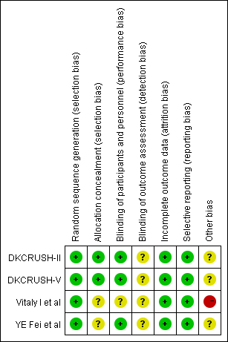

Low risk of bias High risk of bias unclear risk of bias

Figure 1. Risk of bias of the individual studies by Cochrane risk assessment tool.
Quality assessment scale of Newcastle-Ottawa Scale for non-randomized studies
Studies | Fan L et al  2016 |  | Chen SL et al  2012
Selection of cohort | (1) Representativeness of the exposed cohort: A, truly representative of the average patient with coronary bifurcation lesions; B, somewhat representative of the average patient with coronary bifurcation lesions; C, selected special group; and D, no description of the derivation of the cohort.  (2) Selection of the non-exposed cohort. A, drawn from the same community as the exposed cohort; B, drawn from a different source; and C, no description of the derivation of the non-exposed cohort.  (3) Ascertainment of exposure: A, secure record (e.g., surgical records); B structured interview; C, written self-report; and D, no description.  (4) Demonstration that outcome of interest was not present at start of study: A, yes; B, no.
1.Representativeness of the exposed cohort. | A |  | A
2.Selection of the non-exposed cohort. | A |  | A
3. Ascertainment of exposure. | A |  | A
4.Demonstration that outcome of interest was not present at start of study. | A |  | A
Comparability | Comparability of cohorts on the basis of the design or analysis: A, study controls for comorbidities.  B, study controls for additional risk factors (such as age and severity of illness); and C, not done.
Comparability of cohorts on the basis of the design or analysis. | A |  | A
Outcomes | (1) Assessment of outcome: A, independent blind assessment; B, record linkage; C, self-report; and  D, no description.  (2) Was follow-up long enough for outcomes to occur: A, yes; B, no.  (3) Adequacy of follow-up of cohort: A, complete follow-up all subjects accounted for; B, subjects lost to follow-up unlikely to introduce bias (small number lost), follow-up rate higher than 90%, or description provided of those lost; C, follow-up rate 90% or lower (select an adequate percentage) and no description of those lost; and D, no statement. Y: Yes; N: No.
1. Assessment of outcome. | A | A
2.Was follow-up long enough for outcomes to occur. | A | A
3.Adequacy of follow-up of cohorts | A | A

