Search Strategy
PubMed, Web of Science, Embase, OVID (searched on December 24, 2018)
Year (from inception to 2018)
Step 1: “Gastric cancer”/ all subheading [MeSH] OR “gastric carcinoma”/all subheadings [all fields] OR “stomach cancer”/ all subheadings [all fields] OR “gastric tumor” /all subheadings [all fields] OR “GC”/ all subheadings [all fields]
Step 2: “endoscopy ultrasonography”/all subheadings [all fields] OR “miniprobe endosopy ultrasonography”/all subheadings [all fields] OR “EUS” /all subheadings [all fields] AND results from Step 1
Step 3: ‘‘diagnostic test”/all subheadings [ail fields] OR " diagnostic ability”/ all subheadings [all fields] OR OR " sensitivity”/ all subheadings [all fields] OR " specificity”/ all subheadings [all fields] OR " ROC”/ all subheadings [all fields] OR " receiver operating characteristic curve”/ all subheadings [all fields] AND results from Step 2
Google Scholar (searched on December 24, 2018)
#1: gastric cancer AND (endoscopy ultrasonography OR EUS)
#2: gastric carcinoma AND (endoscopy ultrasonography OR EUS)
#3: stomach cancer AND (endoscopy ultrasonography OR EUS)
#4: gastric tumor AND (endoscopy ultrasonography OR EUS)
#5: gastric cancer AND (miniprobe endosopy ultrasonography OR EUS)
#6: gastric carcinoma AND (miniprobe endosopy ultrasonography OR EUS)

#7: stomach cancer AND (miniprobe endosopy ultrasonography OR EUS)
#8: gastric tumor AND (miniprobe endosopy ultrasonography OR EUS)
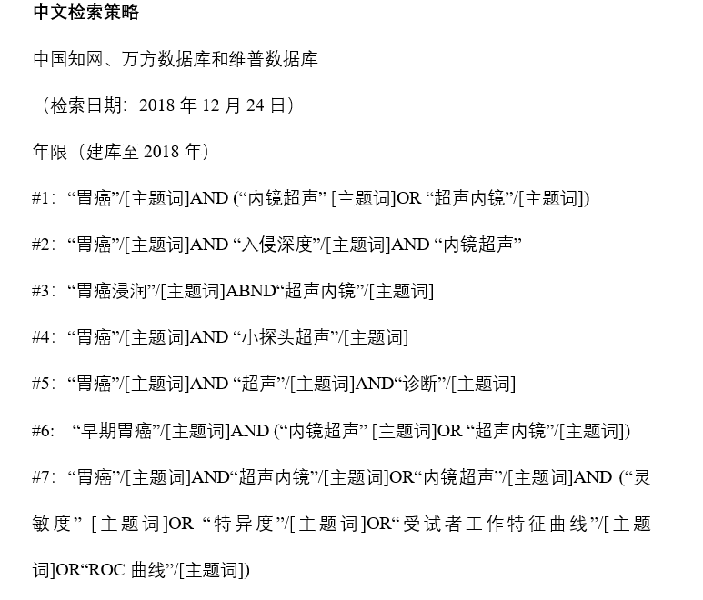中文检索策略
中国知网、万方数据库和维普数据库
（检索日期：2018年12月24日）
年限（建库至2018年）
#1：“胃癌”/[主题词]AND (“内镜超声” [主题词]OR “超声内镜”/[主题词])
#2：“胃癌”/[主题词]AND “入侵深度”/[主题词]AND “内镜超声”
#3：“胃癌浸润”/[主题词]ABND“超声内镜”/[主题词]
#4：“胃癌”/[主题词]AND “小探头超声”/[主题词]
#5：“胃癌”/[主题词]AND “超声”/[主题词]AND“诊断”/[主题词]
#6: “早期胃癌”/[主题词]AND (“内镜超声” [主题词]OR “超声内镜”/[主题词])
#7：“胃癌”/[主题词]AND“超声内镜”/[主题词]OR“内镜超声”/[主题词]AND (“灵敏度” [主题词]OR “特异度”/[主题词]OR“受试者工作特征曲线”/[主题词]OR“ROC曲线”/[主题词])

References
1.Jia Y, Deng Z and Wu J. Evaluation of EUS in Diagnosis and Treatment for Gastric Cancer. J New Med 2008; 18: 30-2.
2.Yan Y, Wu Q, Bu Z and Ji J. The Value of Endoscopic Ultrasound for the Diagnosis of Depth of Tumor Invasion in Early Gastric Cancer and Its Related Factors. China Cancer 2014; 123: 1039-43.
3.Xi W, Zhao C and Ren G. Preoperative endoscopic ultrasonography was used to evaluate the infiltration depth and surgical resection of gastric cancer. Chin J Dig Endosc 2003; 20: 45-6.
4.Yanai H, Noguchi T and Mizumachi S, et al. A blind comparison of the effectiveness of endoscopic ultrasonography and endoscopy in staging early gastric cancer. Gut 1999; 44: 361-65.
5.Yoshida S, Tanaka S and Kunihiro K, et al. Diagnostic ability of high-frequency ultrasound probe sonography in staging early gastric cancer, especially for submucosal invasion. Abdom Imaging 2005; 30: 518-23.
6.Okada K, Fujisaki J and Kasuga A, et al. Endoscopic ultrasonography is valuable for identifying early gastric cancers meeting expanded-indication criteria for endoscopic submucosal dissection. Surg Endosc 2011; 25: 841-48.
7.Kim SJ, Choi CW and Kang DH, et al. Factors associated with the efficacy of miniprobe endoscopic ultrasonography after conventional endoscopy for the prediction of invasion depth of early gastric cancer. Scand J Gastroenterol 2017; 52: 864-69.
8.Tsujii Y, Kato M and Inoue T, et al. Integrated diagnostic strategy for the invasion depth of early gastric cancer by conventional endoscopy and EUS. Gastrointest Endosc 2015; 82: 452-59.
9.Choi J, Kim SG, Im JP, et al. Is endoscopic ultrasonography indispensable in patients with early gastric cancer prior to endoscopic resection? Surg Endosc 2010; 24: 3177-85.
10.Ohashi S, Segawa K and Okamura S, et al. The utility of endoscopic ultrasonography and endoscopy in the endoscopic mucosal resection of early gastric cancer. Gut 45: 599-604, 1999.
11.Lee JY, Choi IJ and Kim CG, et al. Therapeutic Decision-Making Using Endoscopic Ultrasonography in Endoscopic Treatment of Early Gastric Cancer. Gut Liver 2016; 10: 42-50.
12.Watari J, Ueyama S and Tomita T, et al. What types of early gastric cancer are indicated for endoscopic ultrasonography staging of invasion depth? World J Gastrointest Endosc 2016; 8: 558-67.
13.Jieyao C, Xi W and Aiming Y, et al. Evaluation of preoperative endoscopic ultrasonography for diagnostic and therapeutic decision making in superficial gastric cancers. Chin J Dig Endosc 2016; 33: 663-66.
14.Xie S, Yu X, Jin X, et al. Value of endoscopic ultrasonography in evaluation of submucosal infiltration in early gastric cancer. Chin J Gastroenterol Hepatol 2016; 25: 517-19.
15.Wang J, Wu Q and Sun L, et al. Effects of mini-probe endoscopic ultrasonography for therapeutic decision-making in early gastric cancer prior to operation. Chin J Endosc 2016; 22: 15-21.
16.Fang Y, Ai-ming Y, Dong-sheng WU, et al. Diagnostic Value of Miniprobe Endoscopic Ultrasonography in Assessment of Tumor Invasion Depth in Early Gastric Cancer. Med J Peking Union Med College Hospital 2015; 6: 83-8.
17.Yang C, Huang M, Peng L, et al. Clinical study of endoscopic ultrasound in gastric cancer preparation staging. China Med Herald 2011; 8: 168-69.
18.Zhang H and Jiang J. The accuracy of endoscopic ultrasonography in evaluation of invasion depth in early gastric neoplasia. Chin J Gastroenterol Hepatol 2017; 26: 782-85.
19.Mouri R, Yoshida S, Tanaka S,et al. Usefulness of endoscopic ultrasonography in determining the depth of invasion and indication for endoscopic treatment of early gastric cancer. J Clin Gastroenterol 2009; 43: 318-22.

