Supplementary Sheet
Sensitivity analysis:

- Fixed effects analysis
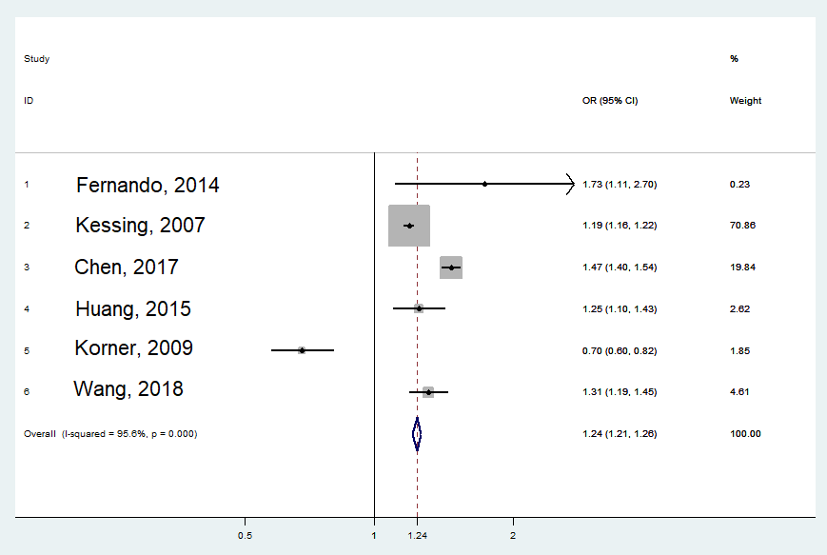
In this analysis fixed effects model was applied to evaluate if the result differs a lot compared to random-effect model. As we can see here, the risk increases slightly to 1.24 (1.21, 1.26) and the confidence interval becomes narrower. This is mainly due to the study Kessing 2007 and Chen, 2017. As their weight together are higher than 90%. However because of the high heterogeneity the result of the random-effect model should be chosen to interpret the data from all the studies.

- Strobe > 75%
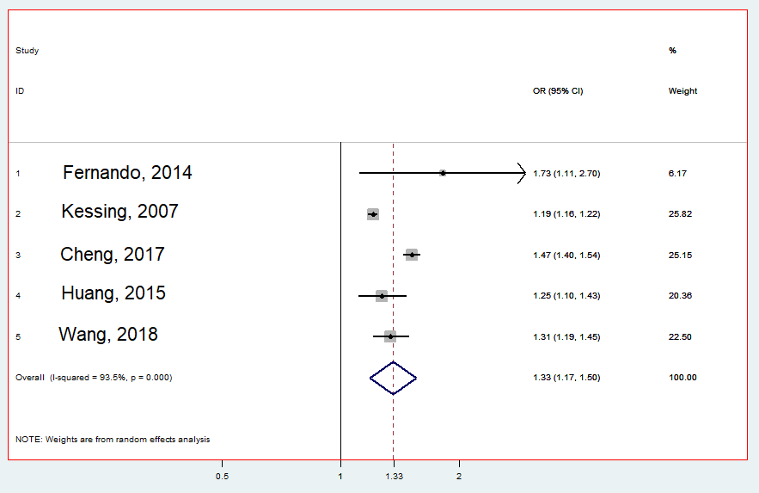
In this analysis Korner 2009 was excluded due to its low Strobe quality assessment score. We can see, that the risk increases to 1.33, because Korner, 2009 was the only study included in our meta-analysis, that showed a protective effect of Osteoarthritis on dementia.

- Only studies included, that described an adjustment of age and gender
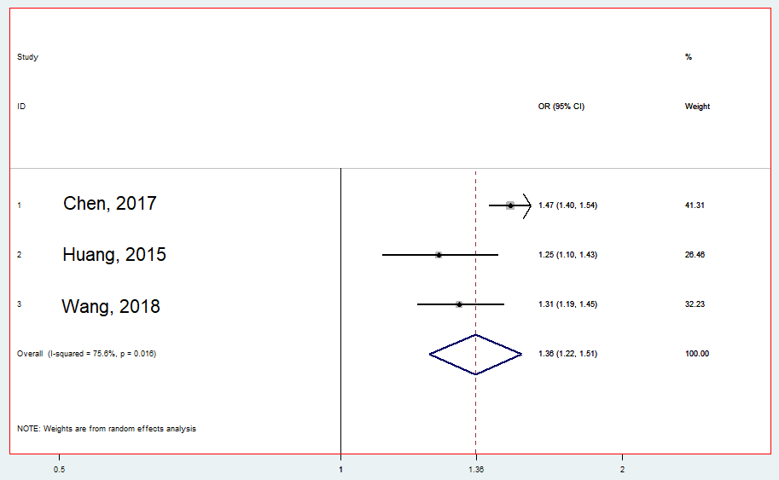
In this analysis only studies that described an adjustment of age and gender were included. Only the 3 studies in the plot fulfilled these criteria. The result shows an association between Osteoarthritis and risk of dementia, which is higher than the result obtained when all 6 studies are included.

- Exclusion of studies that are based on the same databases.

Explanation: We did this analysis, because there is a high probability, that the Taiwanese studies (Huang, 2015; Chen, 2017; Wang, 2018) have extracted overlapping data from the same database. The same may occur in the Denmark studies (Kessing, 2007; Korner, 2009), although it is less likely, because Kessing and Korner do show completely different results. Kessing reported Osteoarthritis as a risk factor, whereas Korner reported a protective factor. Therefore, we analysed the overall risk after excluding studies with the above-mentioned potential problem and run the analysis of all combinations.
Pattern 1 combination:
- Fernando, 2014 + Korner, 2009 + Huang, 2015
- Fernando, 2014 + Korner, 2009 + Chen, 2017
- Fernando, 2014 + Korner, 2009 + Wang, 2018
Patter 2 combination:
- Fernando, 2014 + Kessing 2007 + Huang, 2015
- Fernando, 2014 + Kessing 2007 + Chen, 2017
- Fernando, 2014 + Kessing 2007 + Wang, 2018

Pattern 1 combination:
- Fernando, 2014 + Korner, 2009 + Huang, 2015
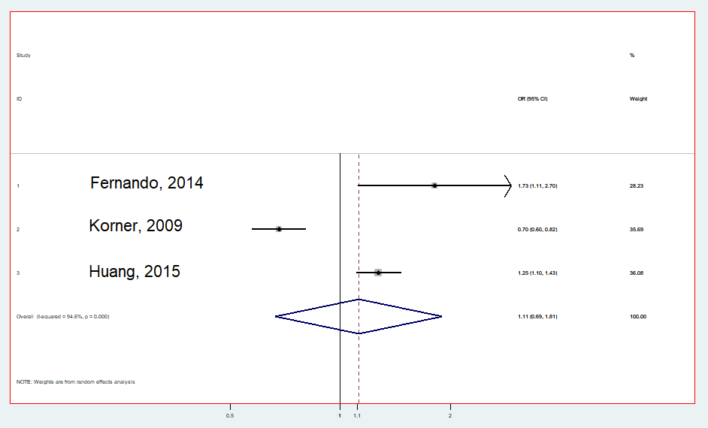

Pattern 1 combination:
- Fernando, 2014 + Korner, 2009 + Chen, 2017
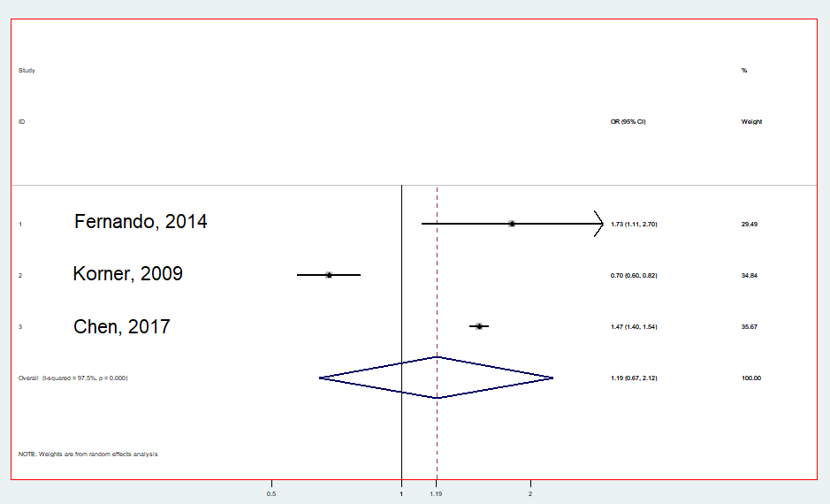

Pattern 1 combination:
- Fernando, 2014 + Korner, 2009 + Wang, 2018
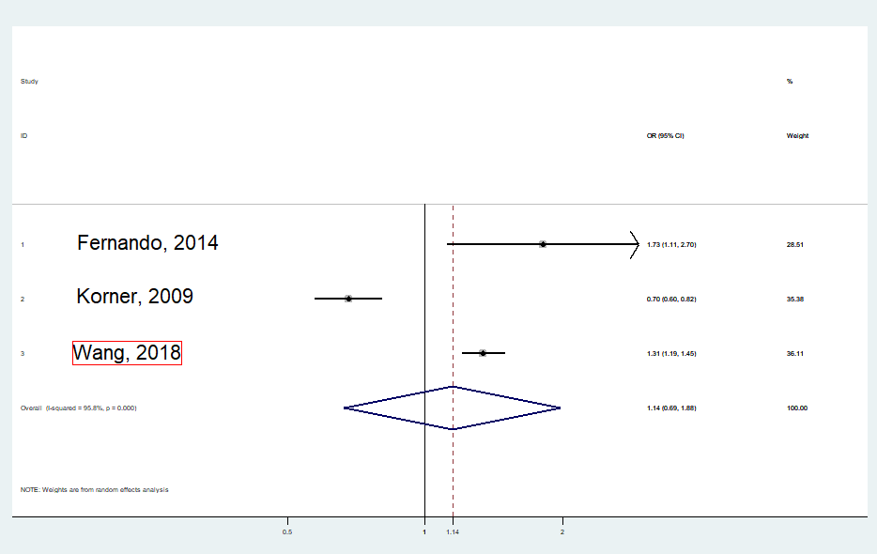

Patter 2 combination:
- Fernando, 2014 + Kessing 2007 + Huang, 2015
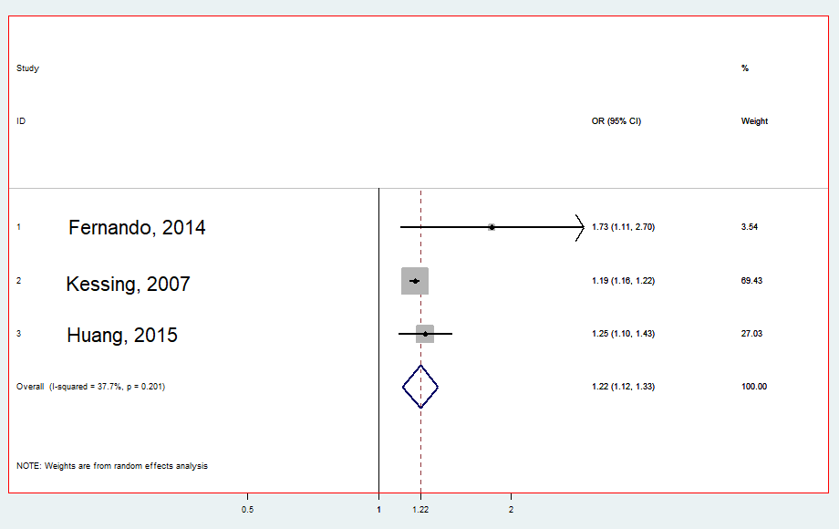

Patter 2 combination:
- Fernando, 2014 + Kessing 2007 + Chen, 2017
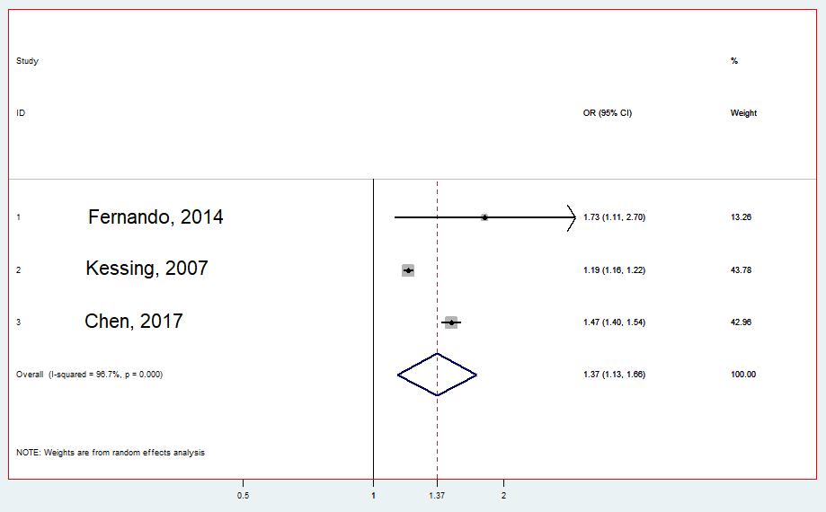

Patter 2 combination:
- Fernando, 2014 + Kessing 2007 + Wang, 2018
