**Table S1** Characteristics of stents in all trials

|  |  |  |  |  |  |  |  |  |  |  |
| --- | --- | --- | --- | --- | --- | --- | --- | --- | --- | --- |
| **Trial** | **Device** | **Stent name** | **Drug** | | | | | **Carrier** | **Platform** | |
| **Name** | **Dose (ug/cm2)** | **Kinetic profile** | | **Drug release** | **Strut thickness (mm)** | **Material** |
| **ISAR-TEST** | PF-SES | Yukon | Sirolimus | 479 | 66% in 6 days 100% after 21 days | B |  | Abluminal micropores | 115 | S-S |
| PP-PES | Taxus Express | Paclitaxel | 100 | 50% in 2 days 100% after14 days | B | 0  ` | Polymer | 132 | S-S |
| **ISAR-TEST2** | PF-SPES | Dual-DES | Sirolimus+  probucol+  shellac resin | 120 (sirolimus)  100 (probucol) | 80% after 21 days | B |  | Abluminal micropores | 87 | S-S |
| PP-SES | Cypher | Sirolimus | 140 | 66% in 7 days 100% after 30 days | B | 000000 | Polymer | 140 | S-S |
| PP-ZES | Endeavor | Zotarolimus | 160 | 95% in 15 days | B |  | Polymer | 91 | Co-Cr |
| **ISAR-TEST3** | PF-SES | Yukon | Sirolimus | 479 | 66% in 6 days 100% after 21 days | B |  | Abluminal micropores | 115 | S-S |
| PP-SES | Cypher | Sirolimus | 140 | 66% in 7 days 100% after 30 days | B | 000 | Polymer | 140 | S-S |
| **ISAR-TEST5** | PF-SPES | Dual-DES | Sirolimus+  probucol+  shellac resin | 120 (sirolimus)  100 (probucol) | 80% after 21 days | B |  | Abluminal micropores | 87 | S-S |
| PP-ZES | Endeavor | Zotarolimus | 160 | 95% in 15 days | B |  | Polymer | 91 | Co-Cr |
| **LIPSIA Yukon** | PF-SES | Yukon Choice | Sirolimus | 180 | 100% after 30 days | B |  | Abluminal micropores | 87 | S-S |
| PP-PES | Taxus Express | Paclitaxel | 100 | 50% in 2 days 100% after14 days | B | 0 | Polymer | 132 | S-S |

Continued

|  |  |  |  |  |  |  |  |  |  |  |
| --- | --- | --- | --- | --- | --- | --- | --- | --- | --- | --- |
| **Trial** | **Device** | **Stent name** | **Drug** | | | | | **Carrier** | **Platform** | |
| **Name** | **Dose (mg/cm2)** | **Kinetic profile** | | **Drug release** | **Strut thickness (mm)** | **Material** |
| **Cre8**  **(Next)** | PF-AES | Cre8 | Amphilimus | 90 | 100% after  90 days | B | 000 | Abluminal reservoirs | 80 | Co-Cr |
| PP-PES | Taxus Liberté | Paclitaxel | 100 | 50% in 2 days 100% after14 days | B | 0  ` | Polymer | 96 | S-S |
| **Dang 2012** | PF-PES | Yinyi | Paclitaxel | 100 | 42% in 24 hours 83% in15 days | B |  | Abluminal micropores | - | S-S |
| PP-SES | Partner | Sirolimus | 120 | 66% in 7 days 100% after 30 days | B | 000 | Polymer | 90 | S-S |
| **Zhang 2013** | PF-PES | Yinyi | Paclitaxel | 100 | 42% in 24 hours 83% in15 days | B |  | Abluminal micropores | - | S-S |
| PP-SES | Partner | Sirolimus | 120 | 66% in 7 days 100% after 30 days | B | 000 | Polymer | 90 | S-S |
| **Nano** | PF-SES | Nano | Sirolimus | 220 | 85% after  30 days | B | 000 | Abluminal nanopores | 100 | S-S |
| PP-SES | Partner | Sirolimus | 120 | 66% in 7 days 100% after 30 days | B | 000 | Polymer | 90 | S-S |
| **Shiratori 2014** | PF-PES | Axxion | Paclitaxel | 270 | 50% in 7 days 100% after 21 days | B | 000 | Synthetic glycocalix | 117 | S-S |
| PP-PES | Taxus Express | Paclitaxel | 100 | 50% in 2 days 100% after 14 days | B | 0 | Polymer | 132 | S-S |
| **Bio**  **Freedom FIM** | PF-BA9 | BioFreedom | Biolimus | 78~156 | 90% in 2 days 100% after 28days | A |  | Abluminal micropores | 119 | S-S |
| PP-PES | Taxus Express | Paclitaxel | 100 | 50% in 2 days 100% after14 days | B | 0 | Polymer | 132 | S-S |

**Supplemental Figure 1** Funnel plots after trim-fill.

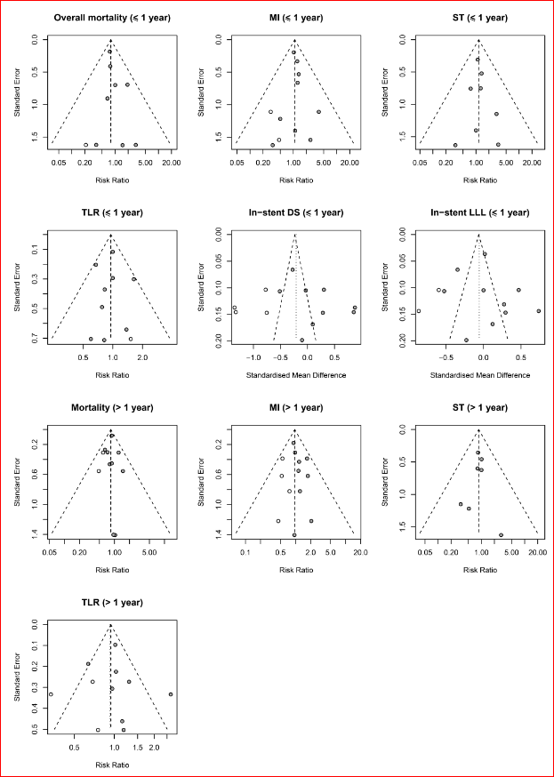

**Supplemental Figure 2** Forest plots of sensitivity analyses.

