Supplementary Tables and Figures
Figure S1. The leave-one-out sensitivity analyses for the associations between the childhood obesity and the risks of adult type 2 diabetes (A) and coronary artery disease (B) using the conventional IVW method under the IV1 model.
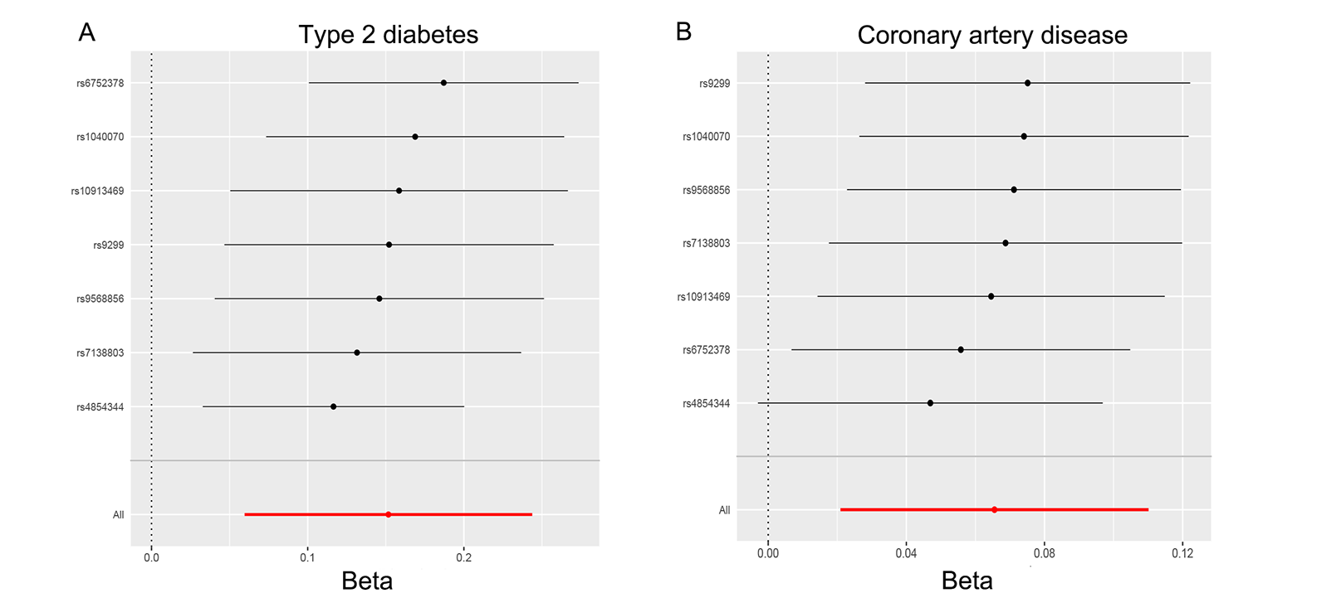

Figure S2. The leave-one-out sensitivity analyses for the associations between the childhood obesity and the BMI (A), hip circumference (B), waist circumference (C), and waist and hip ratio (D) in adults using the conventional IVW method under the IV1 model.
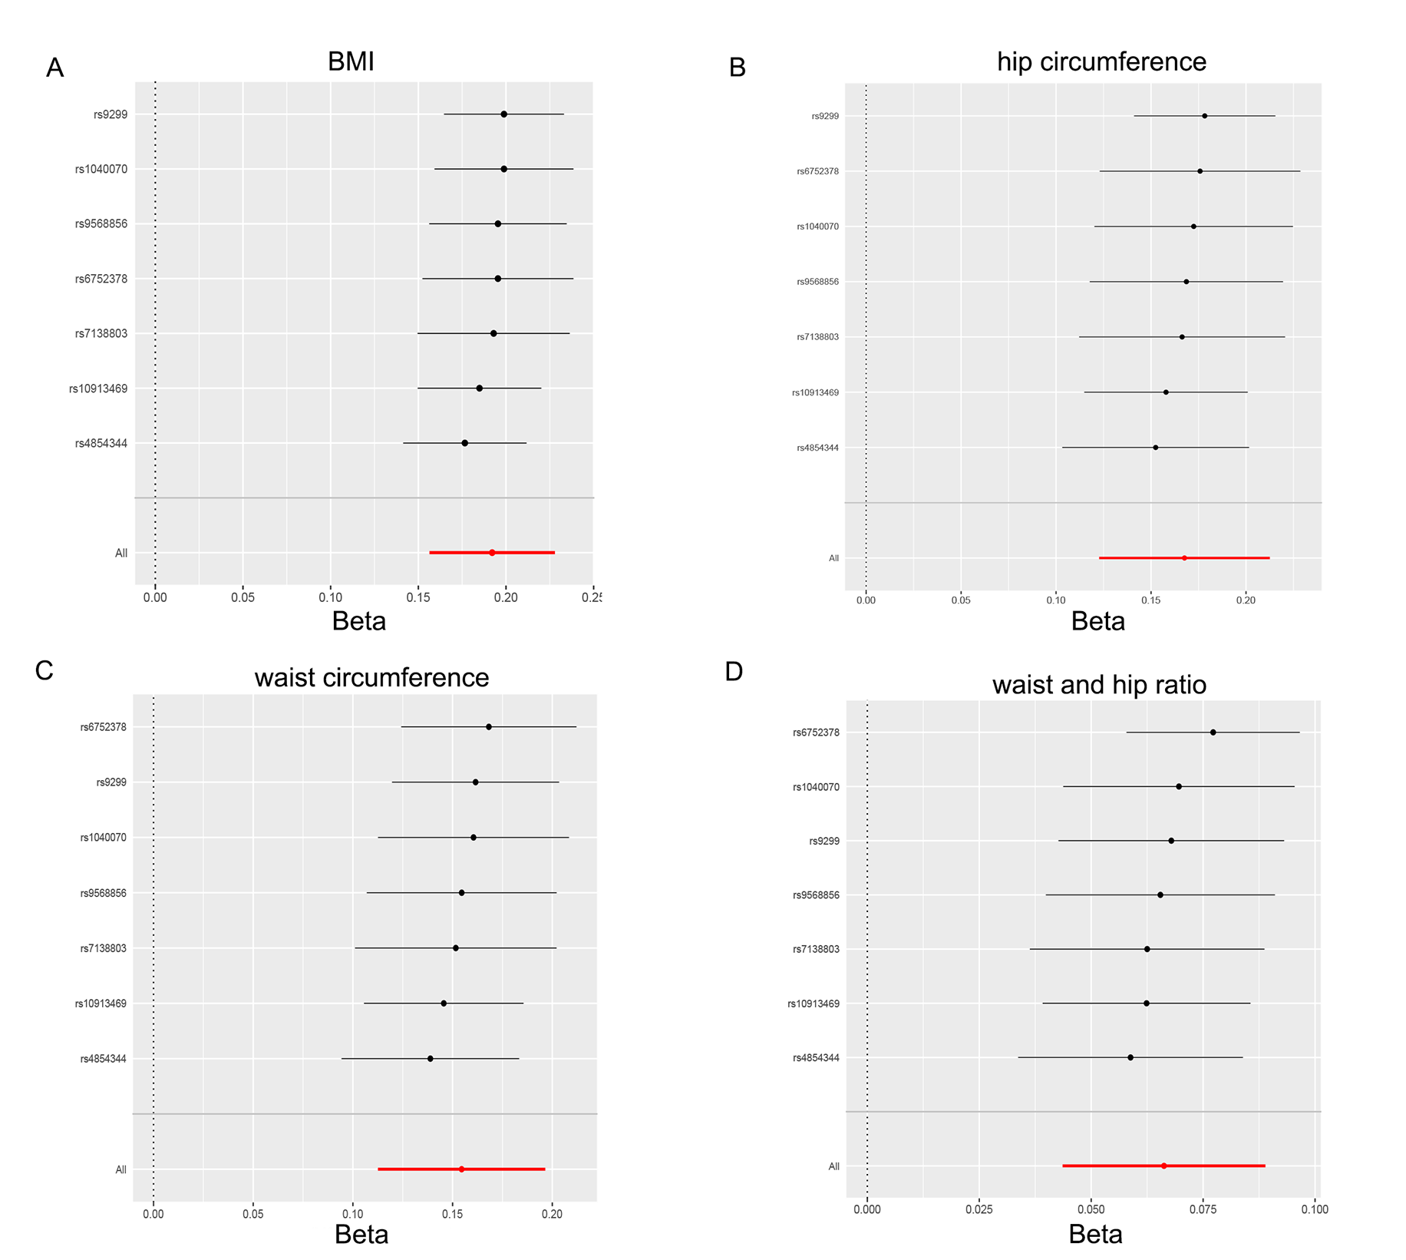
Figure S3. The leave-one-out sensitivity analyses for the associations between the childhood obesity and the fasting glucose (A), fasting insulin (B), HbA1c (C), 2-hour glucose (D), log HOMA-B (E) and log HOMA-IR (F) levels in adults using the conventional IVW method under the IV1 model.
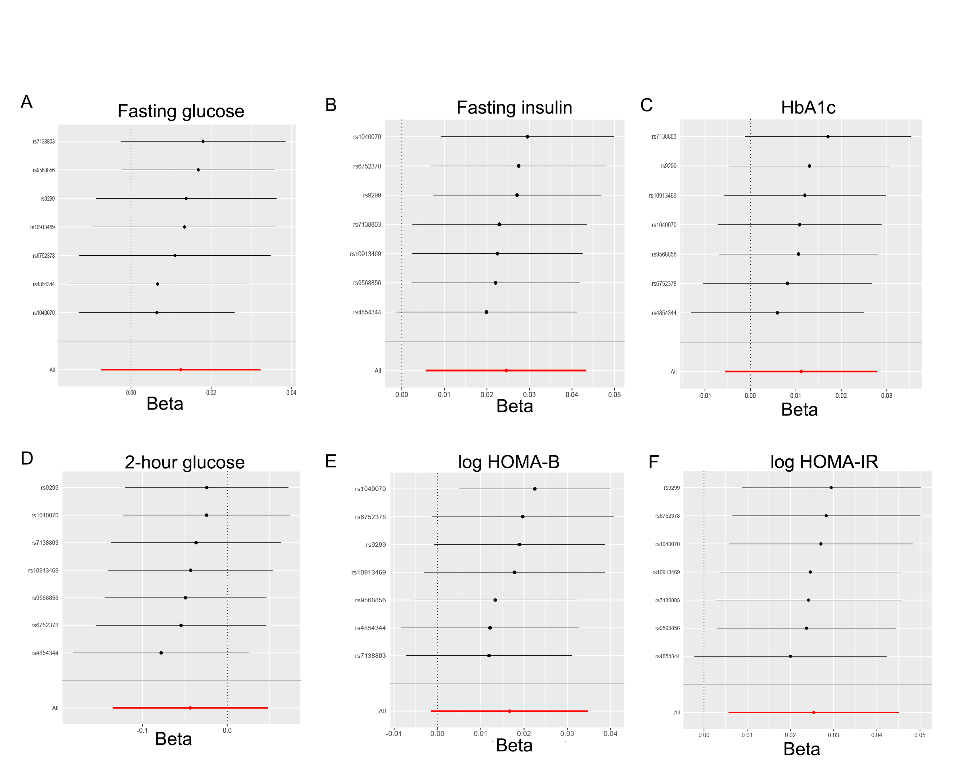
Figure S4. The leave-one-out sensitivity analyses for the associations between the childhood obesity and the HDL-c (A), LDL-c (B), total cholesterol (C) and triglycerides (D) levels in adults using the conventional IVW method under the IV1 model.
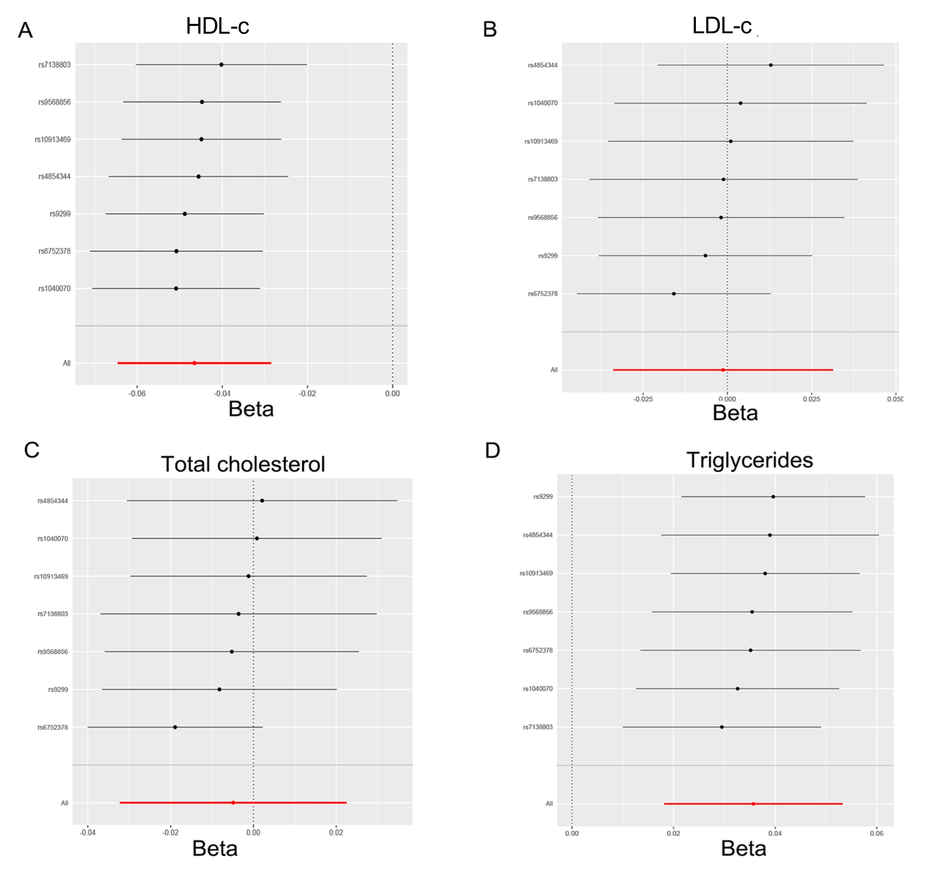
Table S1. The summary-level data for the associations between the selected SNPs and the risks of type 2 diabetes and coronary artery disease, and their associations with the cardiometabolic traits in adults.
SNP | Exposure | Study Source | PubMed ID | Year of Publication | Ancestry | Effect allele | Other allele | Genotype | EAF | beta | se | P-value | Unit
rs1040070 | Coronary artery disease | CARDIoGRAMplusC4D | 26343387 | 2015 | Mixed | G | C | G/C | 0.5018 | 0.000819 | 0.009652 | 0.9324 | log(OR)
rs10913469 | Coronary artery disease | CARDIoGRAMplusC4D | 26343387 | 2015 | Mixed | C | T | C/T | 0.192 | 0.01285 | 0.0117 | 0.2721 | log(OR)
rs4854344 | Coronary artery disease | CARDIoGRAMplusC4D | 26343387 | 2015 | Mixed | T | G | T/G | 0.1969 | 0.03404 | 0.0124 | 0.00604 | log(OR)
rs663129 | Coronary artery disease | CARDIoGRAMplusC4D | 26343387 | 2015 | Mixed | A | G | G/A | 0.7432 | 0.05816 | 0.01052 | 3.20E-08 | log(OR)
rs6752378 | Coronary artery disease | CARDIoGRAMplusC4D | 26343387 | 2015 | Mixed | A | C | A/C | 0.4735 | 0.01901 | 0.00928 | 0.04056 | log(OR)
rs7138803 | Coronary artery disease | CARDIoGRAMplusC4D | 26343387 | 2015 | Mixed | A | G | A/G | 0.3715 | 0.008175 | 0.009474 | 0.3882 | log(OR)
rs9299 | Coronary artery disease | CARDIoGRAMplusC4D | 26343387 | 2015 | Mixed | T | C | C/T | 0.625 | -0.002627 | 0.00961 | 0.7846 | log(OR)
rs9568856 | Coronary artery disease | CARDIoGRAMplusC4D | 26343387 | 2015 | Mixed | A | G | A/G | 0.1615 | 0.004754 | 0.01276 | 0.7094 | log(OR)
rs9941349 | Coronary artery disease | CARDIoGRAMplusC4D | 26343387 | 2015 | Mixed | T | C | C/T | 0.6037 | 0.02055 | 0.00945 | 0.02964 | log(OR)
rs1040070 | Type II diabetes | DIAGRAM | 24509480 | 2014 | Mixed | G | C | G/C | NA | 0 | 0.01531 | 0.85 | log(OR)
rs10913469 | Type II diabetes | DIAGRAM | 24509480 | 2014 | Mixed | C | T | C/T | NA | 0.0198 | 0.01501 | 0.21 | log(OR)
Continued.
SNP | Exposure | Study Source | PubMed ID | Year of Publication | Ancestry | Effect allele | Other allele | Genotype | EAF | beta | se | P-value | Unit
rs4854344 | Type II diabetes | DIAGRAM | 24509480 | 2014 | Mixed | T | G | T/G | NA | 0.07696 | 0.01891 | 1.40E-05 | log(OR)
rs663129 | Type II diabetes | DIAGRAM | 24509480 | 2014 | Mixed | A | G | G/A | NA | 0.07696 | 0.01418 | 4.50E-08 | log(OR)
rs6752378 | Type II diabetes | DIAGRAM | 24509480 | 2014 | Mixed | A | C | A/C | NA | 0 | 0.01269 | 0.89 | log(OR)
rs7138803 | Type II diabetes | DIAGRAM | 24509480 | 2014 | Mixed | A | G | A/G | NA | 0.03922 | 0.01233 | 0.0056 | log(OR)
rs9299 | Type II diabetes | DIAGRAM | 24509480 | 2014 | Mixed | T | C | C/T | NA | 0.0198 | 0.01501 | 0.2 | log(OR)
rs9568856 | Type II diabetes | DIAGRAM | 24509480 | 2014 | Mixed | A | G | A/G | NA | 0.03922 | 0.01963 | 0.041 | log(OR)
rs9941349 | Type II diabetes | DIAGRAM | 24509480 | 2014 | Mixed | T | C | C/T | NA | 0.08618 | 0.01176 | 1.10E-10 | log(OR)
rs1040070 | BMI | GIANT | 25673413 | 2015 | European | G | C | G/C | 0.4153 | 0.023 | 0.0031 | 1.46E-13 | SD
rs10913469 | BMI | GIANT | 25673413 | 2015 | European | C | T | C/T | 0.275 | 0.0468 | 0.0047 | 2.34E-23 | SD
rs4854344 | BMI | GIANT | 25673413 | 2015 | European | T | G | T/G | 0.125 | 0.0591 | 0.004 | 5.13E-49 | SD
rs663129 | BMI | GIANT | 25673413 | 2015 | European | A | G | G/A | 0.7167 | 0.0557 | 0.0036 | 8.80E-53 | SD
rs6752378 | BMI | GIANT | 25673413 | 2015 | European | A | C | A/C | 0.5 | 0.0302 | 0.0031 | 4.29E-23 | SD
rs7138803 | BMI | GIANT | 25673413 | 2015 | European | A | G | A/G | 0.4417 | 0.0315 | 0.0031 | 8.15E-24 | SD
rs9299 | BMI | GIANT | 25673413 | 2015 | European | T | C | C/T | 0.6417 | 0.0142 | 0.004 | 0.0003852 | SD
rs9568856 | BMI | GIANT | 25673413 | 2015 | European | A | G | A/G | 0.1167 | 0.0291 | 0.0058 | 5.24E-07 | SD
rs9941349 | BMI | GIANT | 25673413 | 2015 | European | T | C | C/T | 0.5333 | 0.0756 | 0.0031 | 9.33E-131 | SD
rs1040070 | Hip circumference | GIANT | 25673412 | 2015 | European | G | C | G/C | 0.4153 | 0.021 | 0.0036 | 2.60E-09 | SD
Continued.
SNP | Exposure | Study Source | PubMed ID | Year of Publication | Ancestry | Effect allele | Other allele | Genotype | EAF | beta | se | P-value | Unit
rs10913469 | Hip circumference | GIANT | 25673412 | 2015 | European | C | T | C/T | 0.275 | 0.047 | 0.0055 | 2.40E-17 | SD
rs4854344 | Hip circumference | GIANT | 25673412 | 2015 | European | T | G | T/G | 0.125 | 0.053 | 0.0047 | 2.60E-29 | SD
rs663129 | Hip circumference | GIANT | 25673412 | 2015 | European | A | G | G/A | 0.7167 | 0.05 | 0.0042 | 1.40E-32 | SD
rs6752378 | Hip circumference | GIANT | 25673412 | 2015 | European | A | C | A/C | 0.5 | 0.023 | 0.0035 | 2.00E-10 | SD
rs7138803 | Hip circumference | GIANT | 25673412 | 2015 | European | A | G | A/G | 0.4417 | 0.029 | 0.0037 | 1.90E-15 | SD
rs9299 | Hip circumference | GIANT | 25673412 | 2015 | European | T | C | C/T | 0.6417 | 0.0039 | 0.0047 | 0.41 | SD
rs9568856 | Hip circumference | GIANT | 25673412 | 2015 | European | A | G | A/G | 0.1167 | 0.03 | 0.0069 | 1.70E-05 | SD
rs9941349 | Hip circumference | GIANT | 25673412 | 2015 | European | T | C | C/T | 0.5333 | 0.067 | 0.0037 | 8.40E-76 | SD
rs1040070 | Waist circumference | GIANT | 25673412 | 2015 | European | G | C | G/C | 0.4153 | 0.018 | 0.0035 | 3.40E-07 | SD
rs10913469 | Waist circumference | GIANT | 25673412 | 2015 | European | C | T | C/T | 0.275 | 0.044 | 0.0054 | 5.00E-16 | SD
Continued.
SNP | Exposure | Study Source | PubMed ID | Year of Publication | Ancestry | Effect allele | Other allele | Genotype | EAF | beta | se | P-value | Unit
rs4854344 | Waist circumference | GIANT | 25673412 | 2015 | European | T | G | T/G | 0.125 | 0.05 | 0.0045 | 1.90E-29 | SD
rs663129 | Waist circumference | GIANT | 25673412 | 2015 | European | A | G | G/A | 0.7167 | 0.048 | 0.0041 | 8.10E-33 | SD
rs6752378 | Waist circumference | GIANT | 25673412 | 2015 | European | A | C | A/C | 0.5 | 0.017 | 0.0034 | 3.80E-07 | SD
rs7138803 | Waist circumference | GIANT | 25673412 | 2015 | European | A | G | A/G | 0.4417 | 0.028 | 0.0035 | 1.60E-15 | SD
rs9299 | Waist circumference | GIANT | 25673412 | 2015 | European | T | C | C/T | 0.6417 | 0.0087 | 0.0045 | 0.053 | SD
rs9568856 | Waist circumference | GIANT | 25673412 | 2015 | European | A | G | A/G | 0.1167 | 0.03 | 0.0067 | 8.70E-06 | SD
rs9941349 | Waist circumference | GIANT | 25673412 | 2015 | European | T | C | C/T | 0.5333 | 0.07 | 0.0035 | 3.40E-91 | SD
rs1040070 | Waist hip ratio | GIANT | 25673412 | 2015 | European | G | C | G/C | 0.4153 | 0.0071 | 0.0034 | 0.036 | SD
rs10913469 | Waist hip ratio | GIANT | 25673412 | 2015 | European | C | T | C/T | 0.275 | 0.019 | 0.0053 | 0.00026 | SD
rs4854344 | Waist hip ratio | GIANT | 25673412 | 2015 | European | T | G | T/G | 0.125 | 0.022 | 0.0044 | 4.50E-07 | SD
rs663129 | Waist hip ratio | GIANT | 25673412 | 2015 | European | A | G | G/A | 0.7167 | 0.025 | 0.004 | 5.50E-10 | SD
rs6752378 | Waist hip ratio | GIANT | 25673412 | 2015 | European | A | C | A/C | 0.5 | 0.004 | 0.0033 | 0.23 | SD
rs7138803 | Waist hip ratio | GIANT | 25673412 | 2015 | European | A | G | A/G | 0.4417 | 0.014 | 0.0035 | 3.50E-05 | SD
rs9299 | Waist hip ratio | GIANT | 25673412 | 2015 | European | T | C | C/T | 0.6417 | 0.0061 | 0.0044 | 0.17 | SD
Continued.
SNP | Exposure | Study Source | PubMed ID | Year of Publication | Ancestry | Effect allele | Other allele | Genotype | EAF | beta | se | P-value | Unit
rs9568856 | Waist hip ratio | GIANT | 25673412 | 2015 | European | A | G | A/G | 0.1167 | 0.015 | 0.0065 | 0.023 | SD
rs9941349 | Waist hip ratio | GIANT | 25673412 | 2015 | European | T | C | C/T | 0.5333 | 0.042 | 0.0034 | 6.30E-35 | SD
rs1040070 | HDL | GLGC | 24097068 | 2013 | European | G | C | G/C | 0.4591 | -0.0037 | 0.0034 | 0.3573 | SD
rs10913469 | HDL | GLGC | 24097068 | 2013 | European | C | T | C/T | 0.1887 | -0.0119 | 0.006 | 0.04666 | SD
rs4854344 | HDL | GLGC | 24097068 | 2013 | European | T | G | T/G | 0.1794 | -0.0121 | 0.0045 | 0.01001 | SD
rs663129 | HDL | GLGC | 24097068 | 2013 | European | A | G | G/A | 0.7691 | -0.0254 | 0.0041 | 5.54E-09 | SD
rs6752378 | HDL | GLGC | 24097068 | 2013 | European | A | C | A/C | 0.4565 | -0.0052 | 0.0034 | 0.1167 | SD
rs7138803 | HDL | GLGC | 24097068 | 2013 | European | A | G | A/G | 0.343 | -0.0122 | 0.0035 | 0.000553 | SD
rs9299 | HDL | GLGC | 24097068 | 2013 | European | T | C | C/T | 0.6821 | -0.0014 | 0.0051 | 0.6082 | SD
rs9568856 | HDL | GLGC | 24097068 | 2013 | European | A | G | A/G | 0.1161 | -0.0158 | 0.0081 | 0.05941 | SD
rs9941349 | HDL | GLGC | 24097068 | 2013 | European | T | C | C/T | 0.5699 | -0.0191 | 0.0035 | 1.25E-08 | SD
rs1040070 | LDL | GLGC | 24097068 | 2013 | European | G | C | G/C | 0.4591 | -0.0042 | 0.0037 | 0.2753 | SD
rs10913469 | LDL | GLGC | 24097068 | 2013 | European | C | T | C/T | 0.1887 | -0.0053 | 0.0065 | 0.4842 | SD
rs4854344 | LDL | GLGC | 24097068 | 2013 | European | T | G | T/G | 0.1794 | -0.0103 | 0.0048 | 0.01884 | SD
rs663129 | LDL | GLGC | 24097068 | 2013 | European | A | G | G/A | 0.7691 | 0.0019 | 0.0044 | 0.6106 | SD
rs6752378 | LDL | GLGC | 24097068 | 2013 | European | A | C | A/C | 0.4565 | 0.0092 | 0.0037 | 0.04499 | SD
rs7138803 | LDL | GLGC | 24097068 | 2013 | European | A | G | A/G | 0.343 | -3.00E-04 | 0.0038 | 0.6775 | SD
rs9299 | LDL | GLGC | 24097068 | 2013 | European | T | C | C/T | 0.6821 | 0.011 | 0.0055 | 0.03356 | SD
rs9568856 | LDL | GLGC | 24097068 | 2013 | European | A | G | A/G | 0.1161 | 0.0021 | 0.0089 | 0.6777 | SD
rs9941349 | LDL | GLGC | 24097068 | 2013 | European | T | C | C/T | 0.5699 | 0.0003 | 0.0037 | 0.8665 | SD
Continued.
SNP | Exposure | Study Source | PubMed ID | Year of Publication | Ancestry | Effect allele | Other allele | Genotype | EAF | beta | se | P-value | Unit
rs1040070 | Total cholesterol | GLGC | 24097068 | 2013 | European | G | C | G/C | 0.4591 | -0.0053 | 0.0036 | 0.1704 | SD
rs10913469 | Total cholesterol | GLGC | 24097068 | 2013 | European | C | T | C/T | 0.1887 | -0.0096 | 0.0064 | 0.2683 | SD
rs4854344 | Total cholesterol | GLGC | 24097068 | 2013 | European | T | G | T/G | 0.1794 | -0.0061 | 0.0046 | 0.1331 | SD
rs663129 | Total cholesterol | GLGC | 24097068 | 2013 | European | A | G | G/A | 0.7691 | -0.0052 | 0.0043 | 0.2525 | SD
rs6752378 | Total cholesterol | GLGC | 24097068 | 2013 | European | A | C | A/C | 0.4565 | 0.0079 | 0.0035 | 0.07415 | SD
rs7138803 | Total cholesterol | GLGC | 24097068 | 2013 | European | A | G | A/G | 0.343 | -0.0017 | 0.0036 | 0.4195 | SD
rs9299 | Total cholesterol | GLGC | 24097068 | 2013 | European | T | C | C/T | 0.6821 | 0.0068 | 0.0054 | 0.2511 | SD
rs9568856 | Total cholesterol | GLGC | 24097068 | 2013 | European | A | G | A/G | 0.1161 | 4.00E-04 | 0.0086 | 0.825 | SD
rs9941349 | Total cholesterol | GLGC | 24097068 | 2013 | European | T | C | C/T | 0.5699 | -0.0048 | 0.0036 | 0.1505 | SD
rs1040070 | Triglycerides | GLGC | 24097068 | 2013 | European | G | C | G/C | 0.4591 | 0.0077 | 0.0033 | 0.02671 | SD
rs10913469 | Triglycerides | GLGC | 24097068 | 2013 | European | C | T | C/T | 0.1887 | 0.0012 | 0.0058 | 0.6228 | SD
rs4854344 | Triglycerides | GLGC | 24097068 | 2013 | European | T | G | T/G | 0.1794 | 0.0063 | 0.0044 | 0.07957 | SD
Continued.
SNP | Exposure | Study Source | PubMed ID | Year of Publication | Ancestry | Effect allele | Other allele | Genotype | EAF | beta | se | P-value | Unit
rs663129 | Triglycerides | GLGC | 24097068 | 2013 | European | A | G | G/A | 0.7691 | 0.0121 | 0.004 | 0.000762 | SD
rs6752378 | Triglycerides | GLGC | 24097068 | 2013 | European | A | C | A/C | 0.4565 | 0.0064 | 0.0033 | 0.09386 | SD
rs7138803 | Triglycerides | GLGC | 24097068 | 2013 | European | A | G | A/G | 0.343 | 0.0103 | 0.0034 | 0.003131 | SD
rs9299 | Triglycerides | GLGC | 24097068 | 2013 | European | T | C | C/T | 0.6821 | -0.0034 | 0.0049 | 0.3763 | SD
rs9568856 | Triglycerides | GLGC | 24097068 | 2013 | European | A | G | A/G | 0.1161 | 0.0079 | 0.0078 | 0.5216 | SD
rs9941349 | Triglycerides | GLGC | 24097068 | 2013 | European | T | C | C/T | 0.5699 | 0.0167 | 0.0035 | 6.48E-06 | SD
rs1040070 | 2 hour fasting glucose | MAGIC | 20081857 | 2010 | European | G | C | G/C | NA | -0.025 | 0.019 | 0.1829 | mmol/l
rs10913469 | 2 hour fasting glucose | MAGIC | 20081857 | 2010 | European | C | T | C/T | NA | -0.0084 | 0.024 | 0.7233 | mmol/l
rs4854344 | 2 hour fasting glucose | MAGIC | 20081857 | 2010 | European | T | G | T/G | NA | 0.018 | 0.024 | 0.4545 | mmol/l
rs663129 | 2 hour fasting glucose | MAGIC | 20081857 | 2010 | European | A | G | G/A | NA | 0.029 | 0.022 | 0.191 | mmol/l
rs6752378 | 2 hour fasting glucose | MAGIC | 20081857 | 2010 | European | A | C | A/C | NA | 0.0013 | 0.019 | 0.9433 | mmol/l
rs7138803 | 2 hour fasting glucose | MAGIC | 20081857 | 2010 | European | A | G | A/G | NA | -0.013 | 0.019 | 0.5073 | mmol/l
rs9299 | 2 hour fasting glucose | MAGIC | 20081857 | 2010 | European | T | C | C/T | NA | -0.03 | 0.02 | 0.136 | mmol/l
Continued.
SNP | Exposure | Study Source | PubMed ID | Year of Publication | Ancestry | Effect allele | Other allele | Genotype | EAF | beta | se | P-value | Unit
rs9568856 | 2 hour fasting glucose | MAGIC | 20081857 | 2010 | European | A | G | A/G | NA | 0.0038 | 0.032 | 0.9044 | mmol/l
rs9941349 | 2 hour fasting glucose | MAGIC | 20081857 | 2010 | European | T | C | C/T | NA | 0.0021 | 0.019 | 0.9112 | mmol/l
rs1040070 | Fasting glucose | MAGIC | 20081858 | 2010 | European | G | C | G/C | NA | 0.0074 | 0.0037 | 0.0452 | mmol/l
rs10913469 | Fasting glucose | MAGIC | 20081858 | 2010 | European | C | T | C/T | NA | 9.00E-04 | 0.0048 | 0.8573 | mmol/l
rs4854344 | Fasting glucose | MAGIC | 20081858 | 2010 | European | T | G | T/G | NA | 0.008 | 0.0048 | 0.09845 | mmol/l
rs663129 | Fasting glucose | MAGIC | 20081858 | 2010 | European | A | G | G/A | NA | 0.0036 | 0.0044 | 0.4151 | mmol/l
rs6752378 | Fasting glucose | MAGIC | 20081858 | 2010 | European | A | C | A/C | NA | 0.0032 | 0.0037 | 0.3917 | mmol/l
rs7138803 | Fasting glucose | MAGIC | 20081858 | 2010 | European | A | G | A/G | NA | -0.0027 | 0.0038 | 0.4901 | mmol/l
rs9299 | Fasting glucose | MAGIC | 20081858 | 2010 | European | T | C | C/T | NA | -2.00E-04 | 0.0041 | 0.9598 | mmol/l
rs9568856 | Fasting glucose | MAGIC | 20081858 | 2010 | European | A | G | A/G | NA | -0.006 | 0.0059 | 0.3124 | mmol/l
rs9941349 | Fasting glucose | MAGIC | 20081858 | 2010 | European | T | C | C/T | NA | 0.0042 | 0.0038 | 0.2598 | mmol/l
rs1040070 | HbA1C | MAGIC | 20858683 | 2010 | European | G | C | G/C | NA | 0.002 | 0.0035 | 0.5614 | %
rs10913469 | HbA1C | MAGIC | 20858683 | 2010 | European | C | T | C/T | NA | 9.00E-04 | 0.0044 | 0.8379 | %
rs4854344 | HbA1C | MAGIC | 20858683 | 2010 | European | T | G | T/G | NA | 0.0071 | 0.0044 | 0.1117 | %
rs663129 | HbA1C | MAGIC | 20858683 | 2010 | European | A | G | G/A | NA | 0.0001 | 0.0041 | 0.9885 | %
rs6752378 | HbA1C | MAGIC | 20858683 | 2010 | European | A | C | A/C | NA | 0.0042 | 0.0034 | 0.2167 | %
rs7138803 | HbA1C | MAGIC | 20858683 | 2010 | European | A | G | A/G | NA | -0.0034 | 0.0036 | 0.3454 | %
rs9299 | HbA1C | MAGIC | 20858683 | 2010 | European | T | C | C/T | NA | -8.00E-04 | 0.0037 | 0.8232 | %
rs9568856 | HbA1C | MAGIC | 20858683 | 2010 | European | A | G | A/G | NA | 0.0034 | 0.0057 | 0.5461 | %
Continued.
SNP | Exposure | Study Source | PubMed ID | Year of Publication | Ancestry | Effect allele | Other allele | Genotype | EAF | beta | se | P-value | Unit
rs9941349 | HbA1C | MAGIC | 20858683 | 2010 | European | T | C | C/T | NA | 0.0061 | 0.0034 | 0.07411 | %
rs1040070 | log(Fasting insulin) | MAGIC | 20081858 | 2010 | European | G | C | G/C | NA | -8.00E-04 | 0.0038 | 0.8323 | pmol/l
rs10913469 | log(Fasting insulin) | MAGIC | 20081858 | 2010 | European | C | T | C/T | NA | 0.0071 | 0.005 | 0.1577 | pmol/l
rs4854344 | log(Fasting insulin) | MAGIC | 20081858 | 2010 | European | T | G | T/G | NA | 0.01 | 0.005 | 0.04061 | pmol/l
rs663129 | log(Fasting insulin) | MAGIC | 20081858 | 2010 | European | A | G | G/A | NA | 0.011 | 0.0047 | 0.02166 | pmol/l
rs6752378 | log(Fasting insulin) | MAGIC | 20081858 | 2010 | European | A | C | A/C | NA | 0.0018 | 0.0039 | 0.6438 | pmol/l
rs7138803 | log(Fasting insulin) | MAGIC | 20081858 | 2010 | European | A | G | A/G | NA | 0.0055 | 0.004 | 0.173 | pmol/l
rs9299 | log(Fasting insulin) | MAGIC | 20081858 | 2010 | European | T | C | C/T | NA | 0 | 0.0042 | 0.9952 | pmol/l
rs9568856 | log(Fasting insulin) | MAGIC | 20081858 | 2010 | European | A | G | A/G | NA | 0.0096 | 0.0062 | 0.1231 | pmol/l
rs9941349 | log(Fasting insulin) | MAGIC | 20081858 | 2010 | European | T | C | C/T | NA | 0.012 | 0.0039 | 0.002123 | pmol/l
rs1040070 | log(HOMA-B) | MAGIC | 20081858 | 2010 | European | G | C | G/C | NA | -0.0028 | 0.0033 | 0.3916 | NA
rs10913469 | log(HOMA-B) | MAGIC | 20081858 | 2010 | European | C | T | C/T | NA | 0.0014 | 0.0043 | 0.745 | NA
Continued.
SNP | Exposure | Study Source | PubMed ID | Year of Publication | Ancestry | Effect allele | Other allele | Genotype | EAF | beta | se | P-value | Unit
rs4854344 | log(HOMA-B) | MAGIC | 20081858 | 2010 | European | T | G | T/G | NA | 0.0082 | 0.0044 | 0.06119 | NA
rs663129 | log(HOMA-B) | MAGIC | 20081858 | 2010 | European | A | G | G/A | NA | 0.0094 | 0.004 | 0.01969 | NA
rs6752378 | log(HOMA-B) | MAGIC | 20081858 | 2010 | European | A | C | A/C | NA | 5.00E-04 | 0.0033 | 0.878 | NA
rs7138803 | log(HOMA-B) | MAGIC | 20081858 | 2010 | European | A | G | A/G | NA | 0.0068 | 0.0034 | 0.0458 | NA
rs9299 | log(HOMA-B) | MAGIC | 20081858 | 2010 | European | T | C | C/T | NA | -8.00E-04 | 0.0037 | 0.8217 | NA
rs9568856 | log(HOMA-B) | MAGIC | 20081858 | 2010 | European | A | G | A/G | NA | 0.0093 | 0.0052 | 0.07376 | NA
rs9941349 | log(HOMA-B) | MAGIC | 20081858 | 2010 | European | T | C | C/T | NA | 0.0067 | 0.0034 | 0.04822 | NA
rs1040070 | log(HOMA-IR) | MAGIC | 20081858 | 2010 | European | G | C | G/C | NA | 0.0023 | 0.004 | 0.5687 | NA
rs10913469 | log(HOMA-IR) | MAGIC | 20081858 | 2010 | European | C | T | C/T | NA | 0.0056 | 0.0053 | 0.2839 | NA
rs4854344 | log(HOMA-IR) | MAGIC | 20081858 | 2010 | European | T | G | T/G | NA | 0.011 | 0.0053 | 0.03362 | NA
rs663129 | log(HOMA-IR) | MAGIC | 20081858 | 2010 | European | A | G | G/A | NA | 0.012 | 0.0049 | 0.01631 | NA
rs6752378 | log(HOMA-IR) | MAGIC | 20081858 | 2010 | European | A | C | A/C | NA | 0.0021 | 0.004 | 0.5937 | NA
rs7138803 | log(HOMA-IR) | MAGIC | 20081858 | 2010 | European | A | G | A/G | NA | 0.0053 | 0.0042 | 0.2089 | NA
rs9299 | log(HOMA-IR) | MAGIC | 20081858 | 2010 | European | T | C | C/T | NA | -0.0018 | 0.0044 | 0.6806 | NA
rs9568856 | log(HOMA-IR) | MAGIC | 20081858 | 2010 | European | A | G | A/G | NA | 0.0081 | 0.0064 | 0.2064 | NA
rs9941349 | log(HOMA-IR) | MAGIC | 20081858 | 2010 | European | T | C | C/T | NA | 0.012 | 0.0041 | 0.002757 | NA
Abbreviations: BMI, body mass index; GIANT, Genetic Investigation of Anthropometric Traits; CARDIoGRAMplusC4D, the Coronary Artery Disease Genome-wide Replication and Meta-analysis (CARDIoGRAM) plus the Coronary Artery Disease (C4D) Genetics; EAF, effect allele frequency; GLGC, Global Lipids Genetics Consortium; HDL, high-density lipoprotein; HOMA-B, homeostatic model assessment of beta-cell; HOMA-IR, homeostatic model assessment of insulin resistance; LDL, low-density lipoprotein; NA, not available; OR, odds ratio; SD, standard deviation; SNP, single nucleotide polymorphism.

Table S2. The two-sample MR analyses of childhood obesity and the cardiometabolic traits based on IV2 model.
 |  |  | MR estimates, per unit increase in log odds of having childhood obesity
 |  |  | IVW method |  |  |  |  | Penalized robust IVW method |  |  | Weighted median method |  |  | MR-Egger regression
Outcomes | SNPs, n | Participants, n | beta (se) | P- value |  | P-heterogeneity |  | beta (se) | P-value |  | beta (se) | P-value |  | Intercept (se) | P-value
Disease
T2D | 9 | 26,488/83,964 | 0.241 (0.055) | < 0.001 |  | < 0.001 |  | 0.198 (0.054) | < 0.001 |  | 0.208 (0.051) | < 0.001 |  | -0.122 (0.056) | 0.028
CAD | 9 | 60,801/123,504 | 0.101 (0.031) | 0.001 |  | 0.007 |  | 0.073 (0.019) | < 0.001 |  | 0.086 (0.027) | 0.002 |  | -0.059 (0.03) | 0.050
Anthropometric traits (SD, GIANT)
BMI (kg/m²) | 9 | 322,102 | 0.238 (0.029) | < 0.001 |  |  | < 0.001 | 0.175 (0.009) | < 0.001 |  | 0.226 (0.023) | < 0.001 |  | -0.054 (0.029) | 0.058
HC (cm) | 9 | 212,997 | 0.208 (0.029) | < 0.001 |  |  | < 0.001 | 0.163 (0.058) | 0.005 |  | 0.202 (0.023) | < 0.001 |  | -0.058 (0.027) | 0.031
WC (cm) | 9 | 232,059 | 0.202 (0.031) | < 0.001 |  |  | < 0.001 | 0.173 (0.019) | < 0.001 |  | 0.192 (0.022) | < 0.001 |  | -0.057 (0.031) | 0.063
Waist and hip ratio | 9 | 212,159 | 0.100 (0.022) | < 0.001 |  |  | < 0.001 | 0.083 (0.011) | < 0.001 |  | 0.088 (0.015) | < 0.001 |  | -0.032 (0.023) | 0.170
Glycemic traits (clinical units, MAGIC)
Fasting glucose (mmol/L) | 9 | 46,186 | 0.015 (0.007) |  | 0.038 |  | 0.307 | 0.015 (0.007) | 0.038 |  | 0.019 (0.010) | 0.071 |  | -0.004 (0.009) | 0.654
2-hour glucose (mmol/L) | 9 | 15,234 | -0.011 (0.039) |  | 0.783 |  | 0.555 | -0.010 (0.035) | 0.771 |  | 0.009 (0.052) | 0.862 |  | -0.097 (0.043) | 0.025
HbA1c (%) | 9 | 46,368 | 0.013 (0.007) |  | 0.064 |  | 0.694 | 0.014 (0.007) | 0.051 |  | 0.017 (0.010) | 0.075 |  | -0.010 (0.008) | 0.213
Log fasting insulin (pmol/L) | 9 | 46,186 | 0.034 (0.008) |  | < 0.001 |  | 0.468 | 0.035 (0.009) | < 0.001 |  | 0.040 (0.011) | < 0.001 |  | -0.019 (0.009) | 0.036
Log HOMA-B | 9 | 46,186 | 0.023 (0.008) |  | 0.003 |  | 0.269 | 0.024 (0.008) | 0.004 |  | 0.034 (0.010) | 0.001 |  | -0.017 (0.008) | 0.027
Log HOMA-IR | 9 | 46,186 | 0.035 (0.008) |  | < 0.001 |  | 0.590 | 0.036 (0.008) | < 0.001 |  | 0.039 (0.012) | 0.001 |  | -0.019 (0.009) | 0.041
Lipids (SD, GLGC)
HDL (mg/dL) | 9 | 187,071 | -0.067 (0.012) |  | < 0.001 |  | < 0.001 | -0.06 (0.012) | < 0.001 |  | -0.057 (0.013) | < 0.001 |  | 0.018 (0.014) | 0.179
LDL (mg/dL) | 9 | 172,999 | 0.001 (0.012) |  | 0.951 |  | 0.030 | 0.000 (0.012) | 0.992 |  | 0.000 (0.012) | 0.976 |  | 0.019 (0.013) | 0.122
TC (mg/dL) | 9 | 187,238 | -0.011 (0.011) |  | 0.281 |  | 0.075 | -0.022 (0.005) | < 0.001 |  | -0.024 (0.011) | 0.021 |  | 0.013 (0.012) | 0.275
TG (mg/dL) | 9 | 177,769 | 0.048 (0.009 |  | < 0.001 |  | 0.127 | 0.047 (0.009) | < 0.001 |  | 0.052 (0.011) | < 0.001 |  | -0.005 (0.011) | 0.664

Abbreviations: BMI, body mass index; CAD, coronary artery disease; GIANT, Genetic Investigation of Anthropometric Traits; GLGC, Global Lipids Genetics Consortium; HC, hip circumference; HDL, high-density lipoprotein; HOMA-B, homeostatic model assessment of beta-cell; HOMA-IR, homeostatic model assessment of insulin resistance; IVW, inverse variance weighted; LDL, low-density lipoprotein; MAGIC, meta-analysis of Glucose and Insulin-Related Traits Consortium; MR, mendelian randomization; SD, standard deviation; SNP, single nucleotide polymorphism; T2D, type 2 diabetes; TC, total cholesterol; TG, triglycerides; WC, waist circumference; WHR, waist and hip ratio.
ªFor anthropometric traits, the summary-level data were obtained from the GIANT consortium (in SD), glycemic traits from the MAGIC consortium (in clinical units) and lipids from GLGC consortium (in SD).

