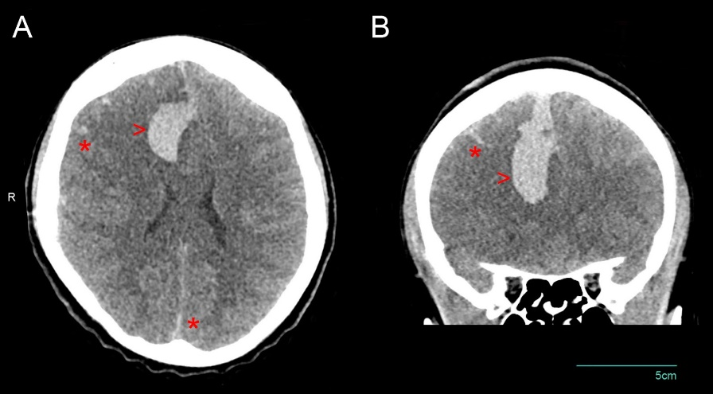
Box 1.
Case Report - Patient 13: A 30-year-old woman was brought to the Johns Hopkins Emergency Department by Emergency medical services (EMS) after family witnessed a generalized seizure at home. Neurologic examination revealed a fixed and dilated right pupil and extensor posturing. The patient’s initial head computed tomography (CT) demonstrated a right frontal intracerebral hemorrhage with subarachnoid hemorrhage with five millimeter midline shift. The patient was treated with hyperosmotic and hypertonic therapies, intubation, and blood products for reversal of her coagulopathy. The patient’s coagulation studies were markedly abnormal, with an elevated PT> 120 seconds, aPTT of 195.6 seconds, and an INR above nine on admission. In the emergency department, the patient received 30 milligrams of intravenous vitamin K followed by a total of an additional 365 milligrams over the subsequent 60 hours. The patient received 50 units/kilogram of Prothrombin Complex Concentrate (PCC), followed by an additional 35 units/kilogram two days later, and six units of packed red blood cells over this time course. The patient was admitted to the neurocritical care unit. Serial clinical examinations suggested diabetes insipidus, continued hemorrhage and brain herniation despite reversal of the coagulopathy and administration of hypertonic saline. The patient’s examination progressed toward complete loss of brain stem activity. The single-photon emission computed tomography (SPECT) scan confirmed brain death. The patient’s husband later reported that they had been worried about severe bruising in the patient’s legs for 2-3 days prior and confirmed that he had used synthetic cannabinoid with the patient. He was referred to the emergency department for evaluation. The presence of brodifacoum toxicity was confirmed via serum testing in both the patient and her husband.

Abbreviations: EMS: emergency medical services; CT: computed tomography; PT: prothrombin time; aPTT: activated partial thromboplastin time; INR: international normalized ratio; PCC: prothrombin complex concentrate; SPECT: single-photon emission computed tomography.

