Figure s1. Subgroup analysis of overall survival
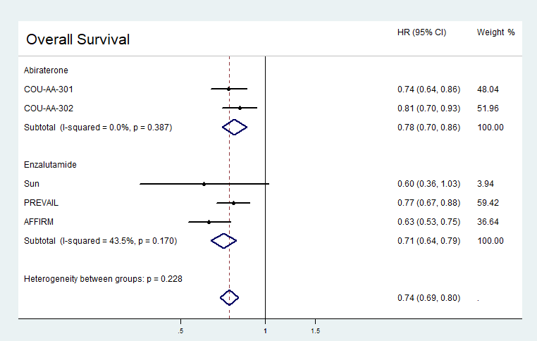

Figure s2. Subgroup analysis of radiographi progression-free survival and prostate-specific antigen progression-free survival.
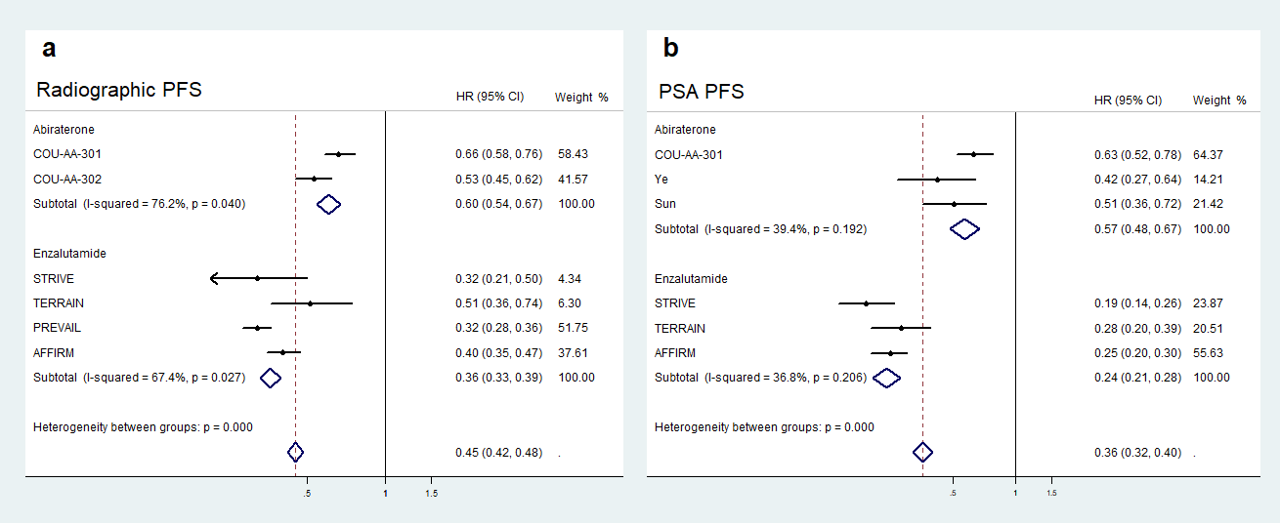

Figure s3. Prostate-specific antigen response rate subgrouped by androgen receptor signaling-axis inhibitor type.
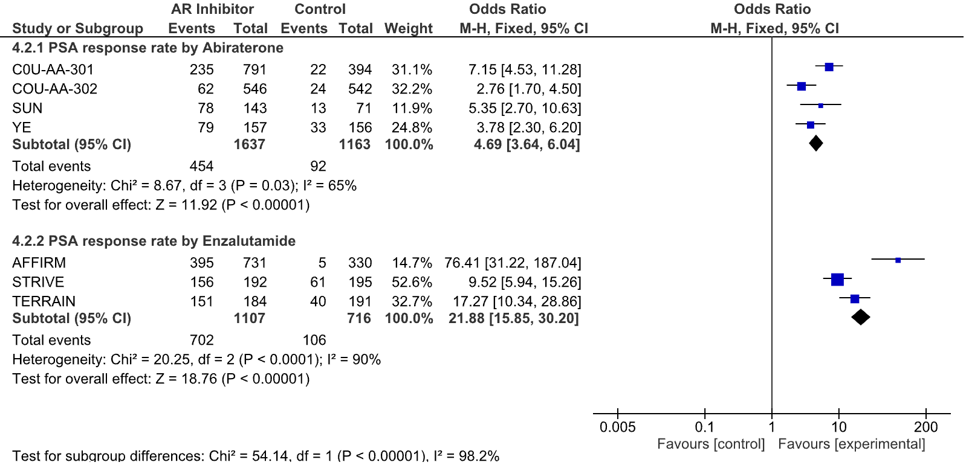

Figure s4. Any grade adverse events without significant difference between AR inhibitor and control groups
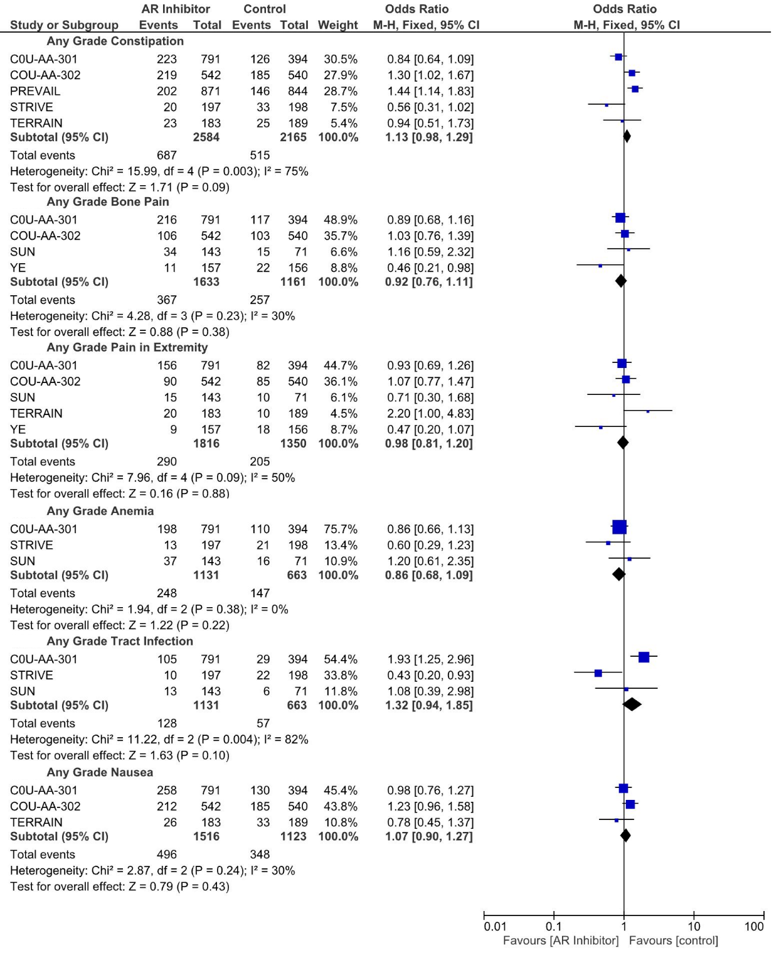

Figure s5. High grade (≥ grade 3) adverse events without significant difference between androgen receptor inhibitor and control groups.


