Supplementary Material
Supplementary Figure 1 Forest plot of MACE use random effect
In this study, MACE is the primary efficacy endpoint and 7 clinical trials reported this results. No significant difference was founded between bivalirudin and heparin on the risk of MACE in subgroup (Gureater GPI use subgroup: RR = 0.97; 95% CI = 0.83–1.13; P = 0.70; I2 = 0; Balance GPI use subgroup: RR = 1.03; 95% CI = 0.88–1.19; P = 0.73; I2 = 59%) and overall analysis (RR = 1.00; 95% CI = 0.90–1.11; P = 0.97; I2 = 16%) .
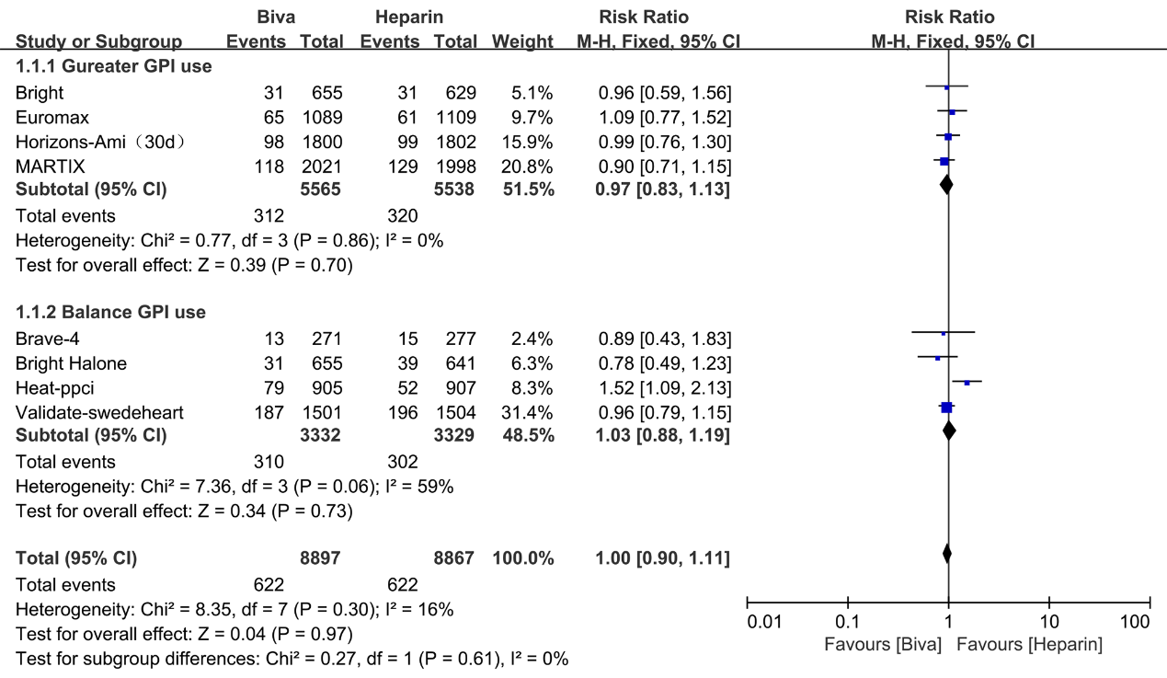

Supplementary Figure 2 Forest plot of major bleeding use random effect
Major bleeding, which served as the primary safety endpoint and there are 6 clinical trials reported this result. Risk of major bleeding was significantly decreased by bivalirudin used in Gureater GPI use subgroup (RR = 0.54; 95% CI = 0.45–0.65; P < 0.00001; I² = 21%) and overall analysis (RR = 0.64; 95% CI = 0.54–0.75; P < 0.00001; I² = 70%). There are no significant difference between bivalirudin and heparin on the risk of major bleeding in Balance GPI use subgroup analysis (RR 1.04; 95%CI 0.76 to 1.42; P<0.00001; I²=70%)
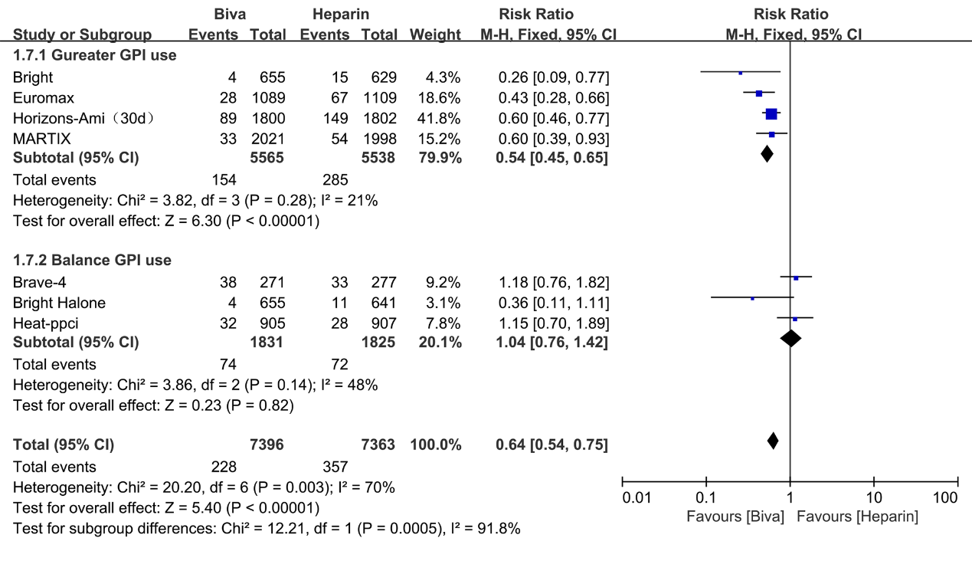

Supplementary Figure 3 Forest plot of mortality use random effect
Mortality was significantly decreased by bivalirudin used in Gureater GPI use subgroup (RR = 0.73; 95% CI = 0.58–0.91; P =0.007; I² = 0) and overall analysis (RR = 0.81; 95% CI = 0.67–0.99; P =0.04; I² = 2%). There are no significant difference between bivalirudin and heparin on the risk of mortality in Balance GPI use subgroup analysis (RR 1.06; 95%CI 0.74 to 1.50; P=0.76; I²=0)
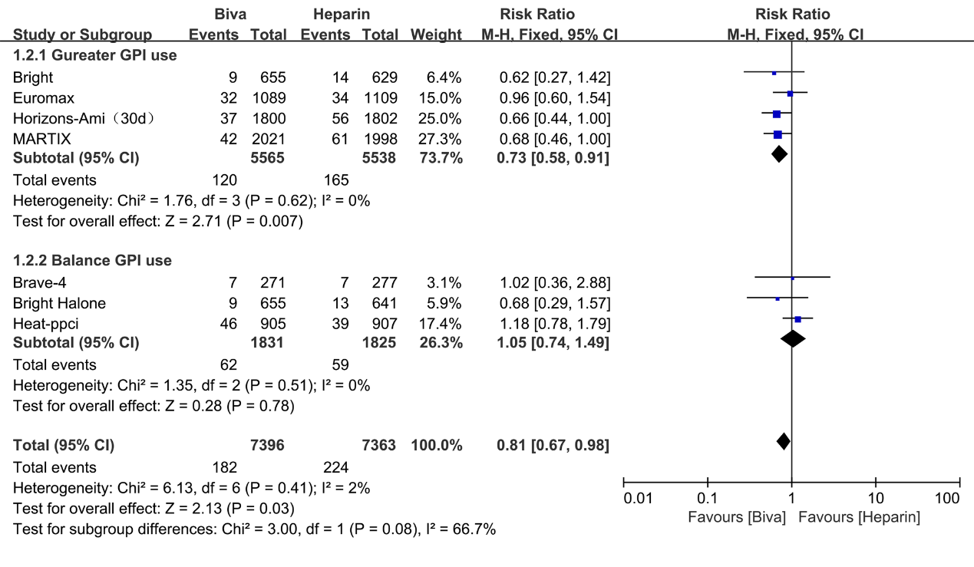

Supplementary Figure 4 Forest plot of MI use random effect
Risk of MI was significantly decreased by heparin used in Gureater GPI use subgroup (RR = 1.31; 95% CI = 1.03–1.66; P =0.03; I² = 2%) and overall analysis (RR = 1.37; 95% CI = 1.10–1.71; P=0.004; I² = 25%). There are no significant difference between bivalirudin and heparin on the risk of MI in Balance GPI use subgroup analysis (RR 1.75; 95%CI 1.01 to 3.01; P=0.05; I²=53%)
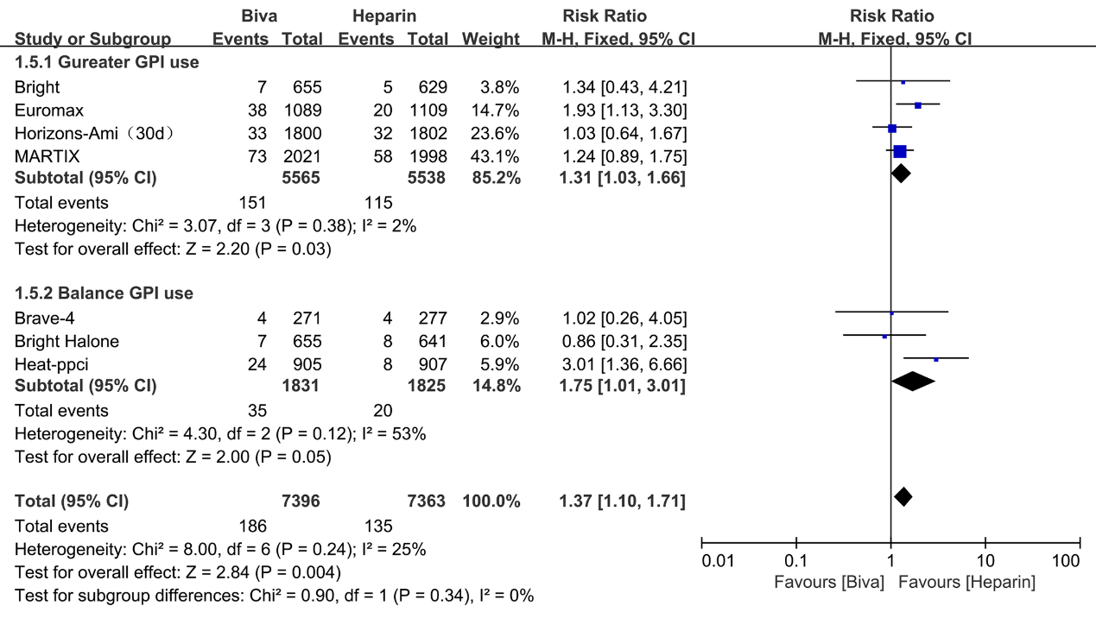

Supplementary Figure 5 Forest plot of ST use random effect
Risk of stent thrombosis was significantly decreased by heparin used in Gureater GPI use subgroup (RR = 1.62; 95% CI = 1.21–2.17; P =0.001; I² = 40%) and overall analysis (RR = 1.68; 95% CI = 1.29–2.18; P <0.00001; I² = 50%). There are no significant difference between bivalirudin and heparin on the risk of stent thrombosis in Balance GPI use subgroup analysis (RR 1.94; 95%CI 1.06 to 3.53; P=0.03; I²=71%)
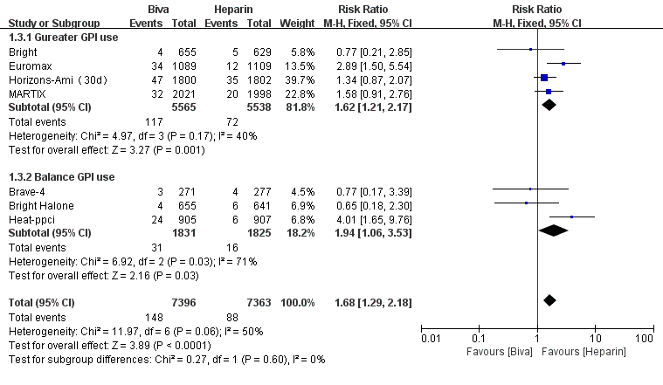

Supplementary Figure 6 Forest plot of TVR use random effect
No significant difference was found between bivalirudin and heparin on the risk of target vessel revascularization in Balance GPI use subgroup (RR = 1.57; 95% CI = 0.94–2.60; P = 0.08; I² =76%). Risk of TVR was significantly decreased by heparin used in Gureater GPI use subgroup (RR = 1.43; 95% CI = 1.01–2.03; P = 0.04; I² = 0) and overall analysis (RR = 1.47; 95% CI = 1.11–1.96; P = 0.008; I² = 46%)
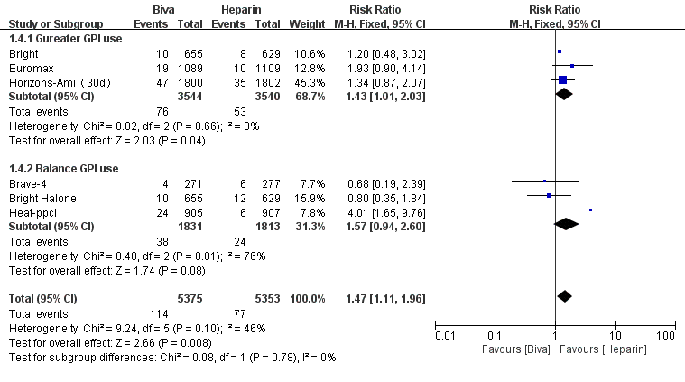

Supplementary Figure 7 Forest plot of block use random effect
No significant difference was found between bivalirudin and heparin on the risk of stock in subgroup (Gureater GPI use subgroup: RR = 0.75; 95% CI = 0.40–1.39; P =0.35; I² = 34%; Balance GPI use subgroup: (RR = 0.71; 95% CI = 0.27–1.84; P =0.48; I² = 0) and overall analysis (RR 0.74; 95%CI 0.47 to 1.17; P=0.20; I²=5%)
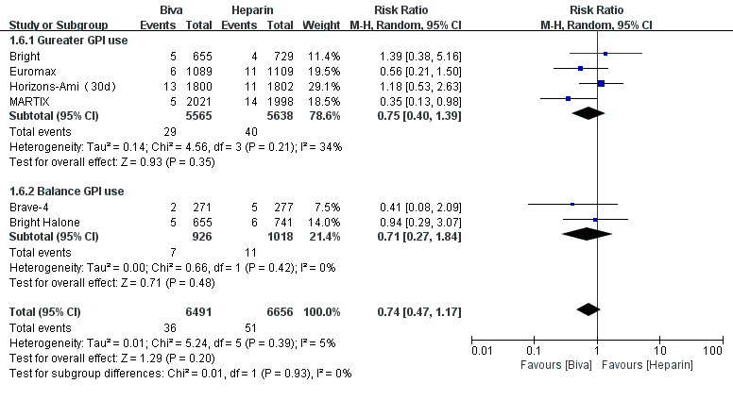

Supplementary Figure 8 Forest plot of thrombocytopenia use random effect
Risk of thrombocytopenia was significantly decreased by bivalirudin used in Gureater GPI use subgroup (RR = 0.39; 95% CI = 0.25–0.61; P < 0.0001; I² = 0). There are no significant difference between bivalirudin and heparin on the risk of major bleeding in Balance GPI use subgroup (RR 1.11; 95%CI 0.88 to 1.41; P<0.00001; I²=70%) and overall analysis (RR = 0.84; 95% CI = 0.68–1.03; P =0.09; I² = 74%)


