Supplementary Figure 2. Performance of NLR alone detection for the diagnosis of rKD. (A) Pooled sensitivity. (B) Pooled specificity. (C) Overall DOR. (D) The SROC curves for all data sets. The point estimates from each study are shown as solid squares. The pooled estimates are shown as a solid diamond. Effect sizes were pooled by random-effects models. Each square in the SROC curve represents one study. Sample size is indicated by the size of the square. Error bars represent 95% CIs. CI, conﬁdence interval; SROC; summary receiver operating characteristic curves value; OR, odds ratio.
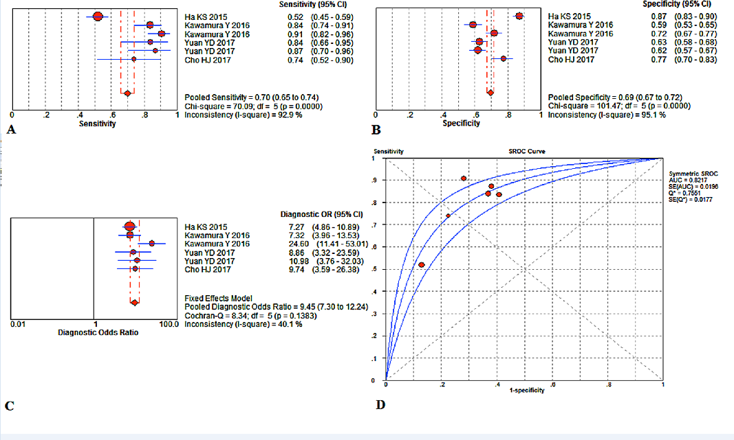

Supplementary Figure 3. Performance of NLR in combination with other indicators detection for the diagnosis of rKD. (A) Pooled sensitivity. (B) Pooled specificity. (C) Overall DOR. (D) The SROC curves for all data sets. The point estimates from each study are shown as solid squares. The pooled estimates are shown as a solid diamond. Effect sizes were pooled by random-effects models. Each square in the SROC curve represents one study. Sample size is indicated by the size of the square. Error bars represent 95% CIs. CI, conﬁdence interval; SROC; summary receiver operating characteristic curves value; OR, odds ratio.
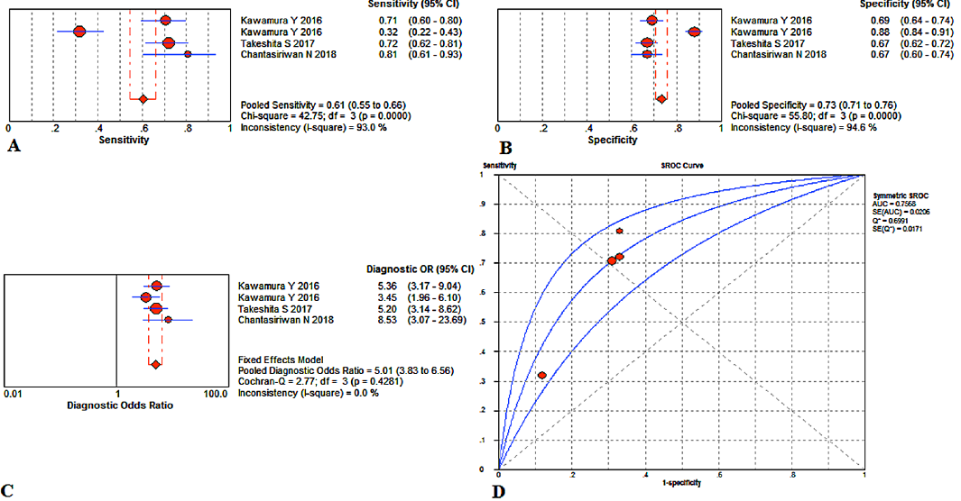

Supplementary Figure 4. Performance of NLR detection before IVIG for the diagnosis of rKD. (A) Pooled sensitivity. (B) Pooled specificity. (C) Overall DOR. (D) The SROC curves for all data sets. The point estimates from each study are shown as solid squares. The pooled estimates are shown as a solid diamond. Effect sizes were pooled by random-effects models. Each square in the SROC curve represents one study. Sample size is indicated by the size of the square. Error bars represent 95% CIs. CI, conﬁdence interval; SROC; summary receiver operating characteristic curves value; OR, odds ratio.
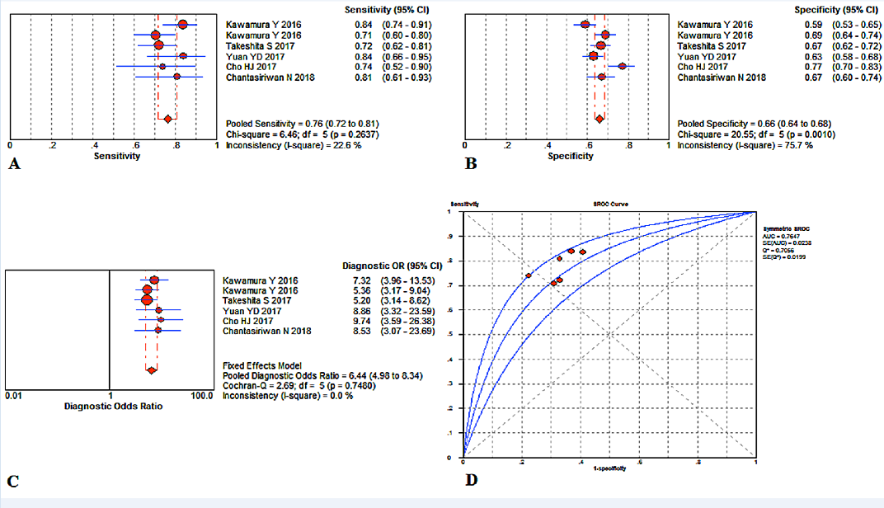

Supplementary Figure 5. Performance of NLR detection after IVIG for the diagnosis of rKD. (A) Pooled sensitivity. (B) Pooled specificity. (C) Overall DOR. (D) The SROC curves for all data sets. The point estimates from each study are shown as solid squares. The pooled estimates are shown as a solid diamond. Effect sizes were pooled by random-effects models. Each square in the SROC curve represents one study. Sample size is indicated by the size of the square. Error bars represent 95% CIs. CI, conﬁdence interval; SROC; summary receiver operating characteristic curves value; OR, odds ratio.
