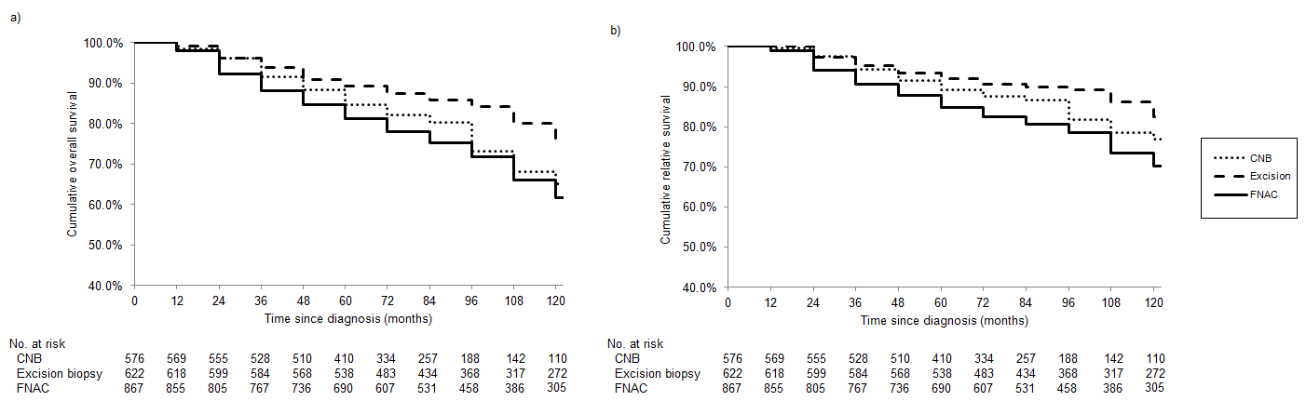

Supplementary Figure 1. a) Cumulative overall survival and b) Cumulative relative survival, by method of biopsy in breast cancer patients receiving adjuvant radiotherapy.

