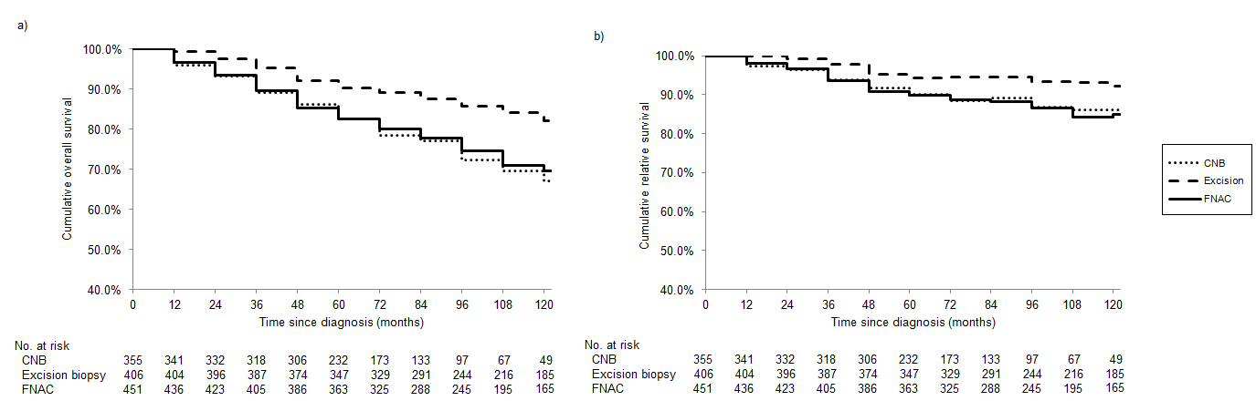
Supplementary Figure 2. a) Cumulative overall survival and b) Cumulative relative survival, by method of biopsy in breast cancer patients not receiving adjuvant radiotherapy.

