Supplemental Digital Content. Figure 3 that demonstrates the enhanced dynamic 16-multidetector CT scan with 20 seconds time interval.

The enhanced dynamic 16-multidetector CT scan with 20 seconds time interval
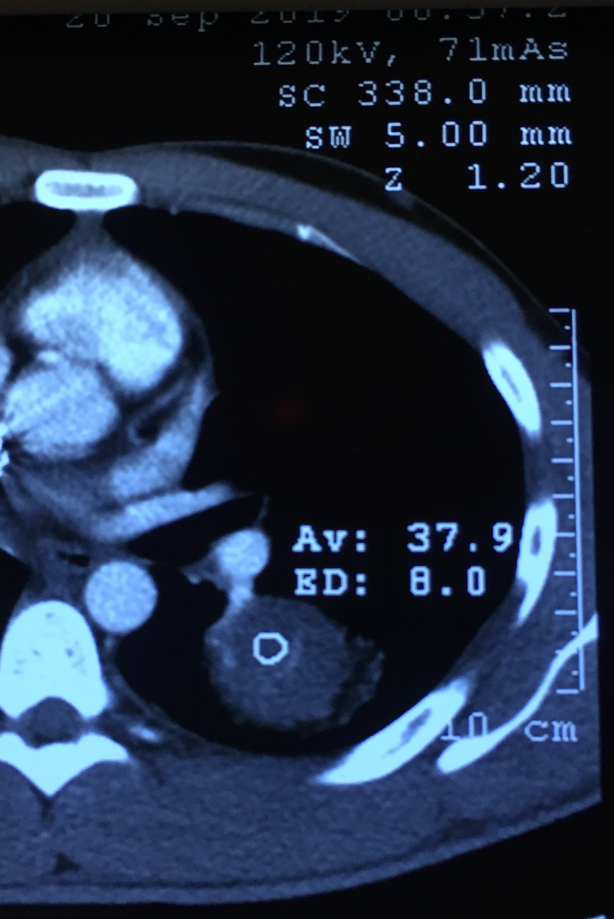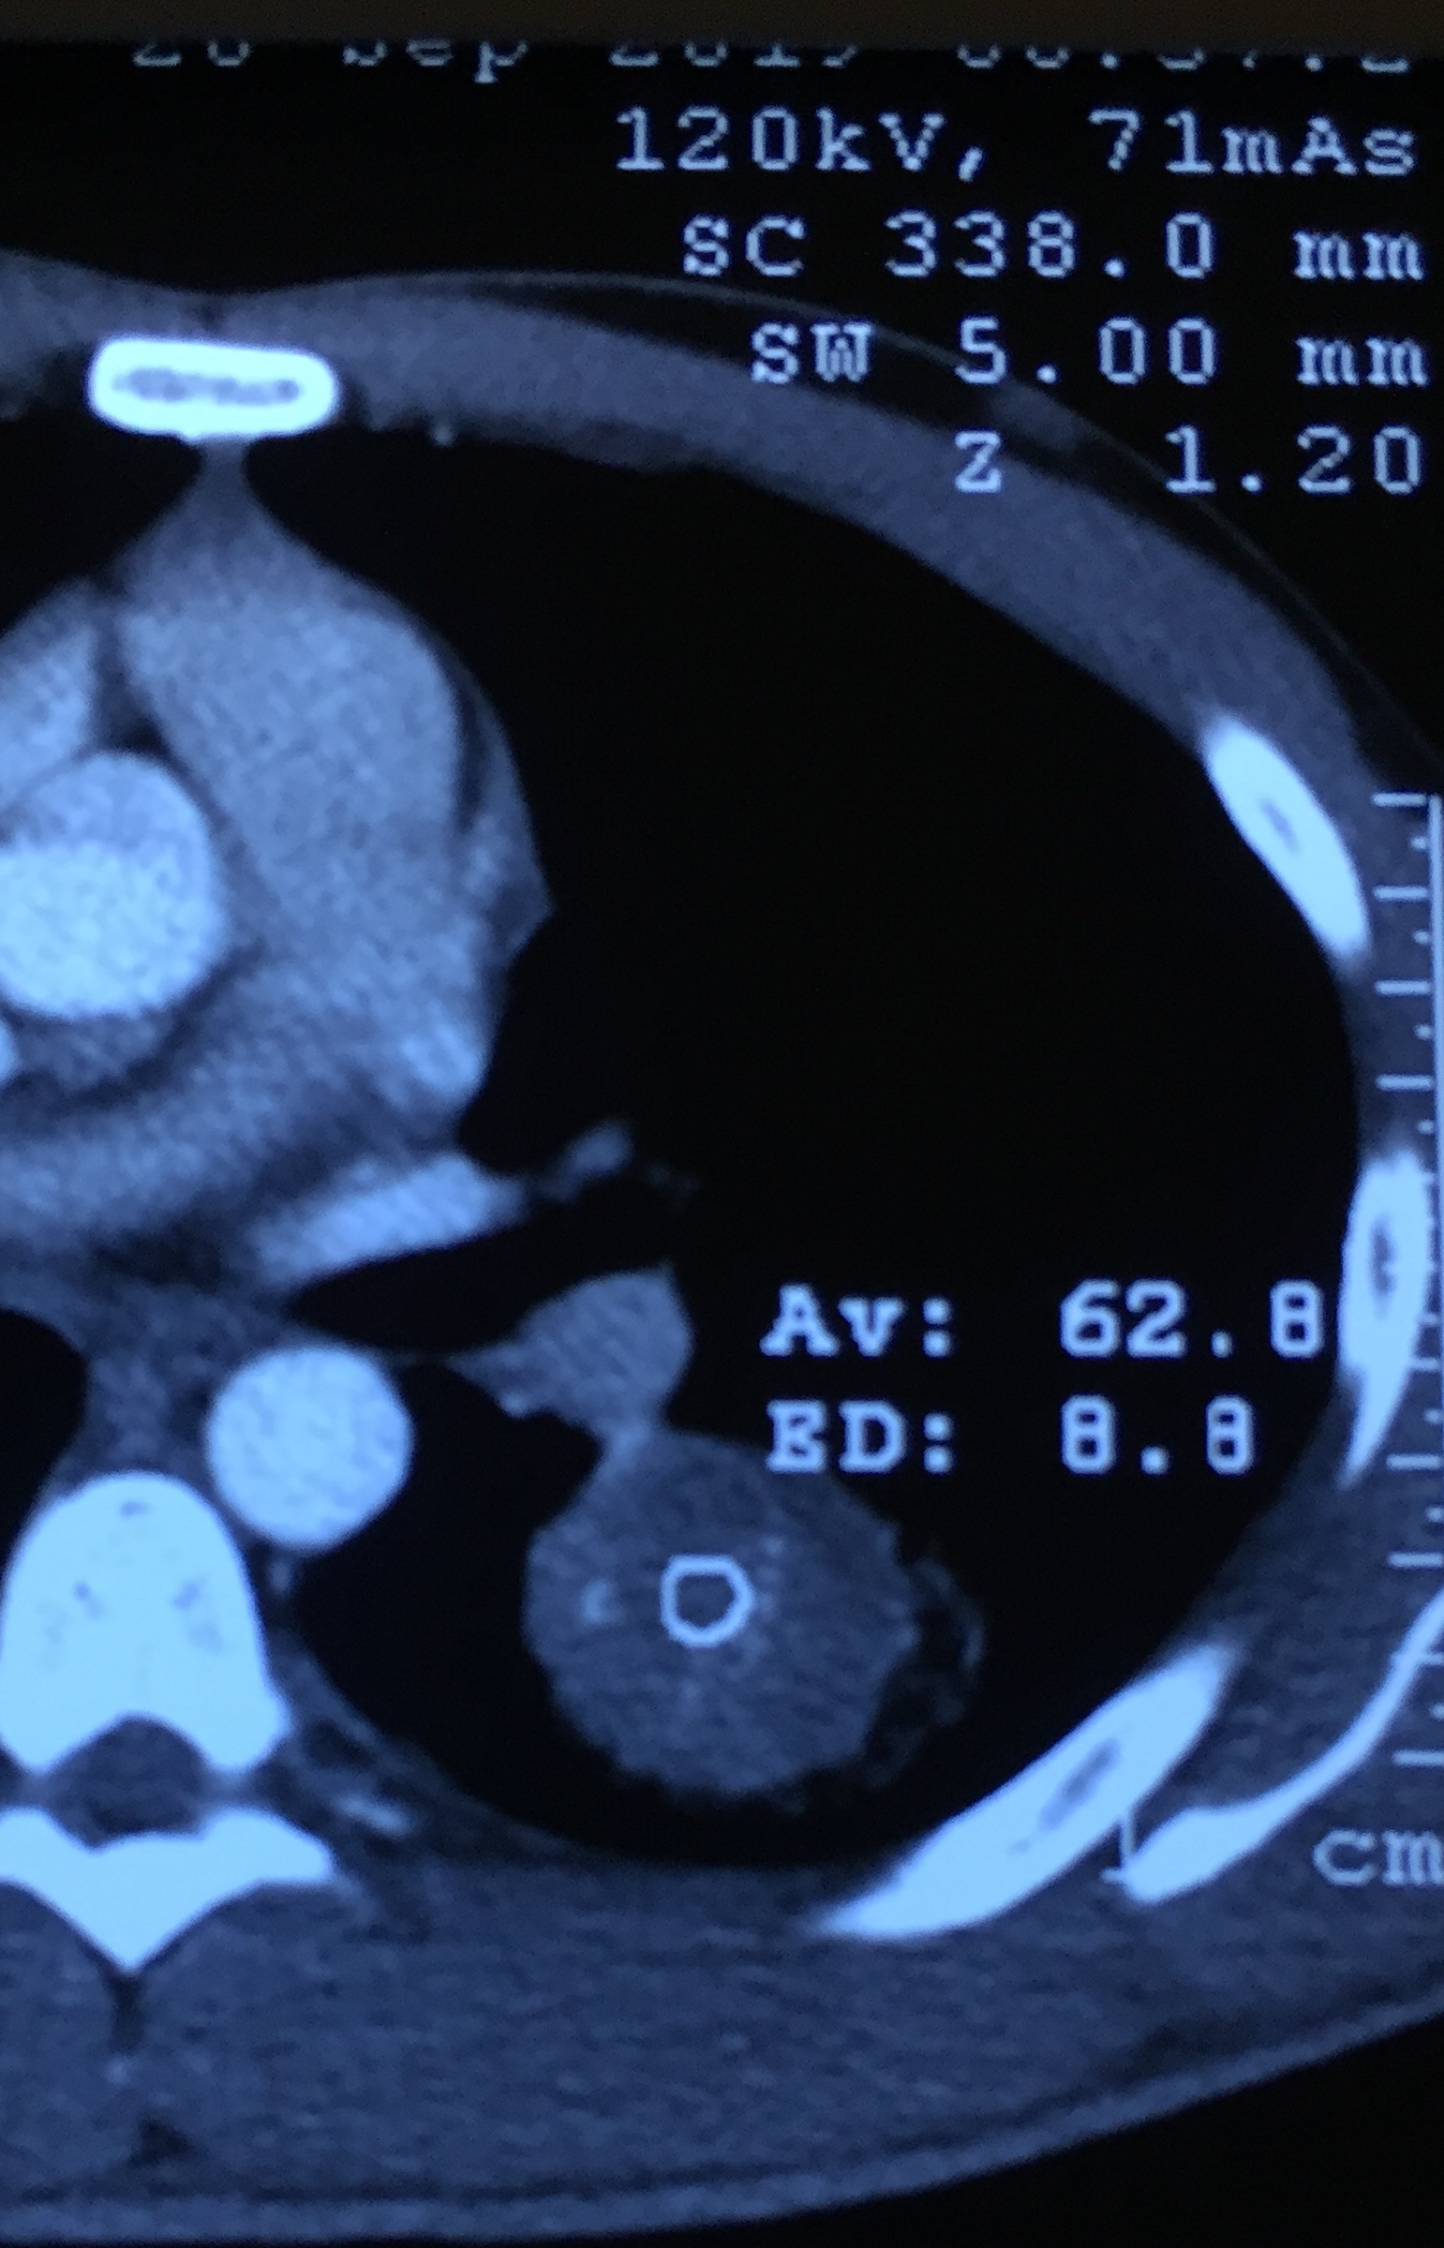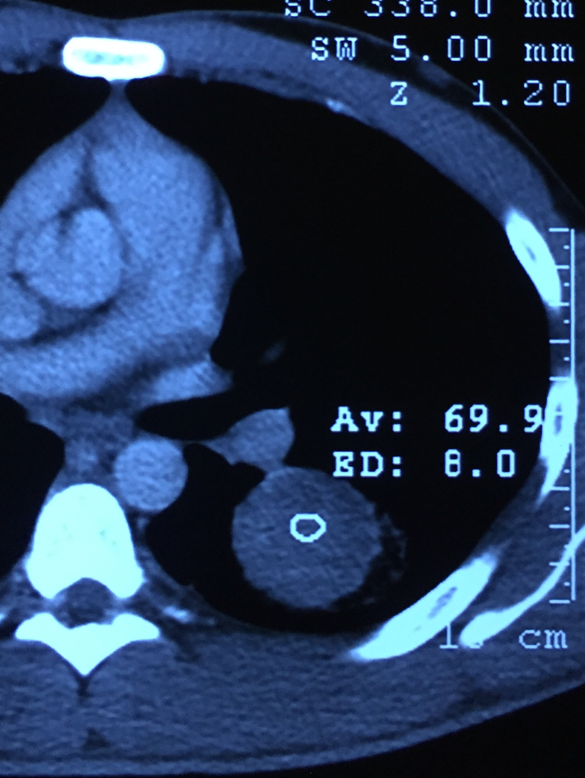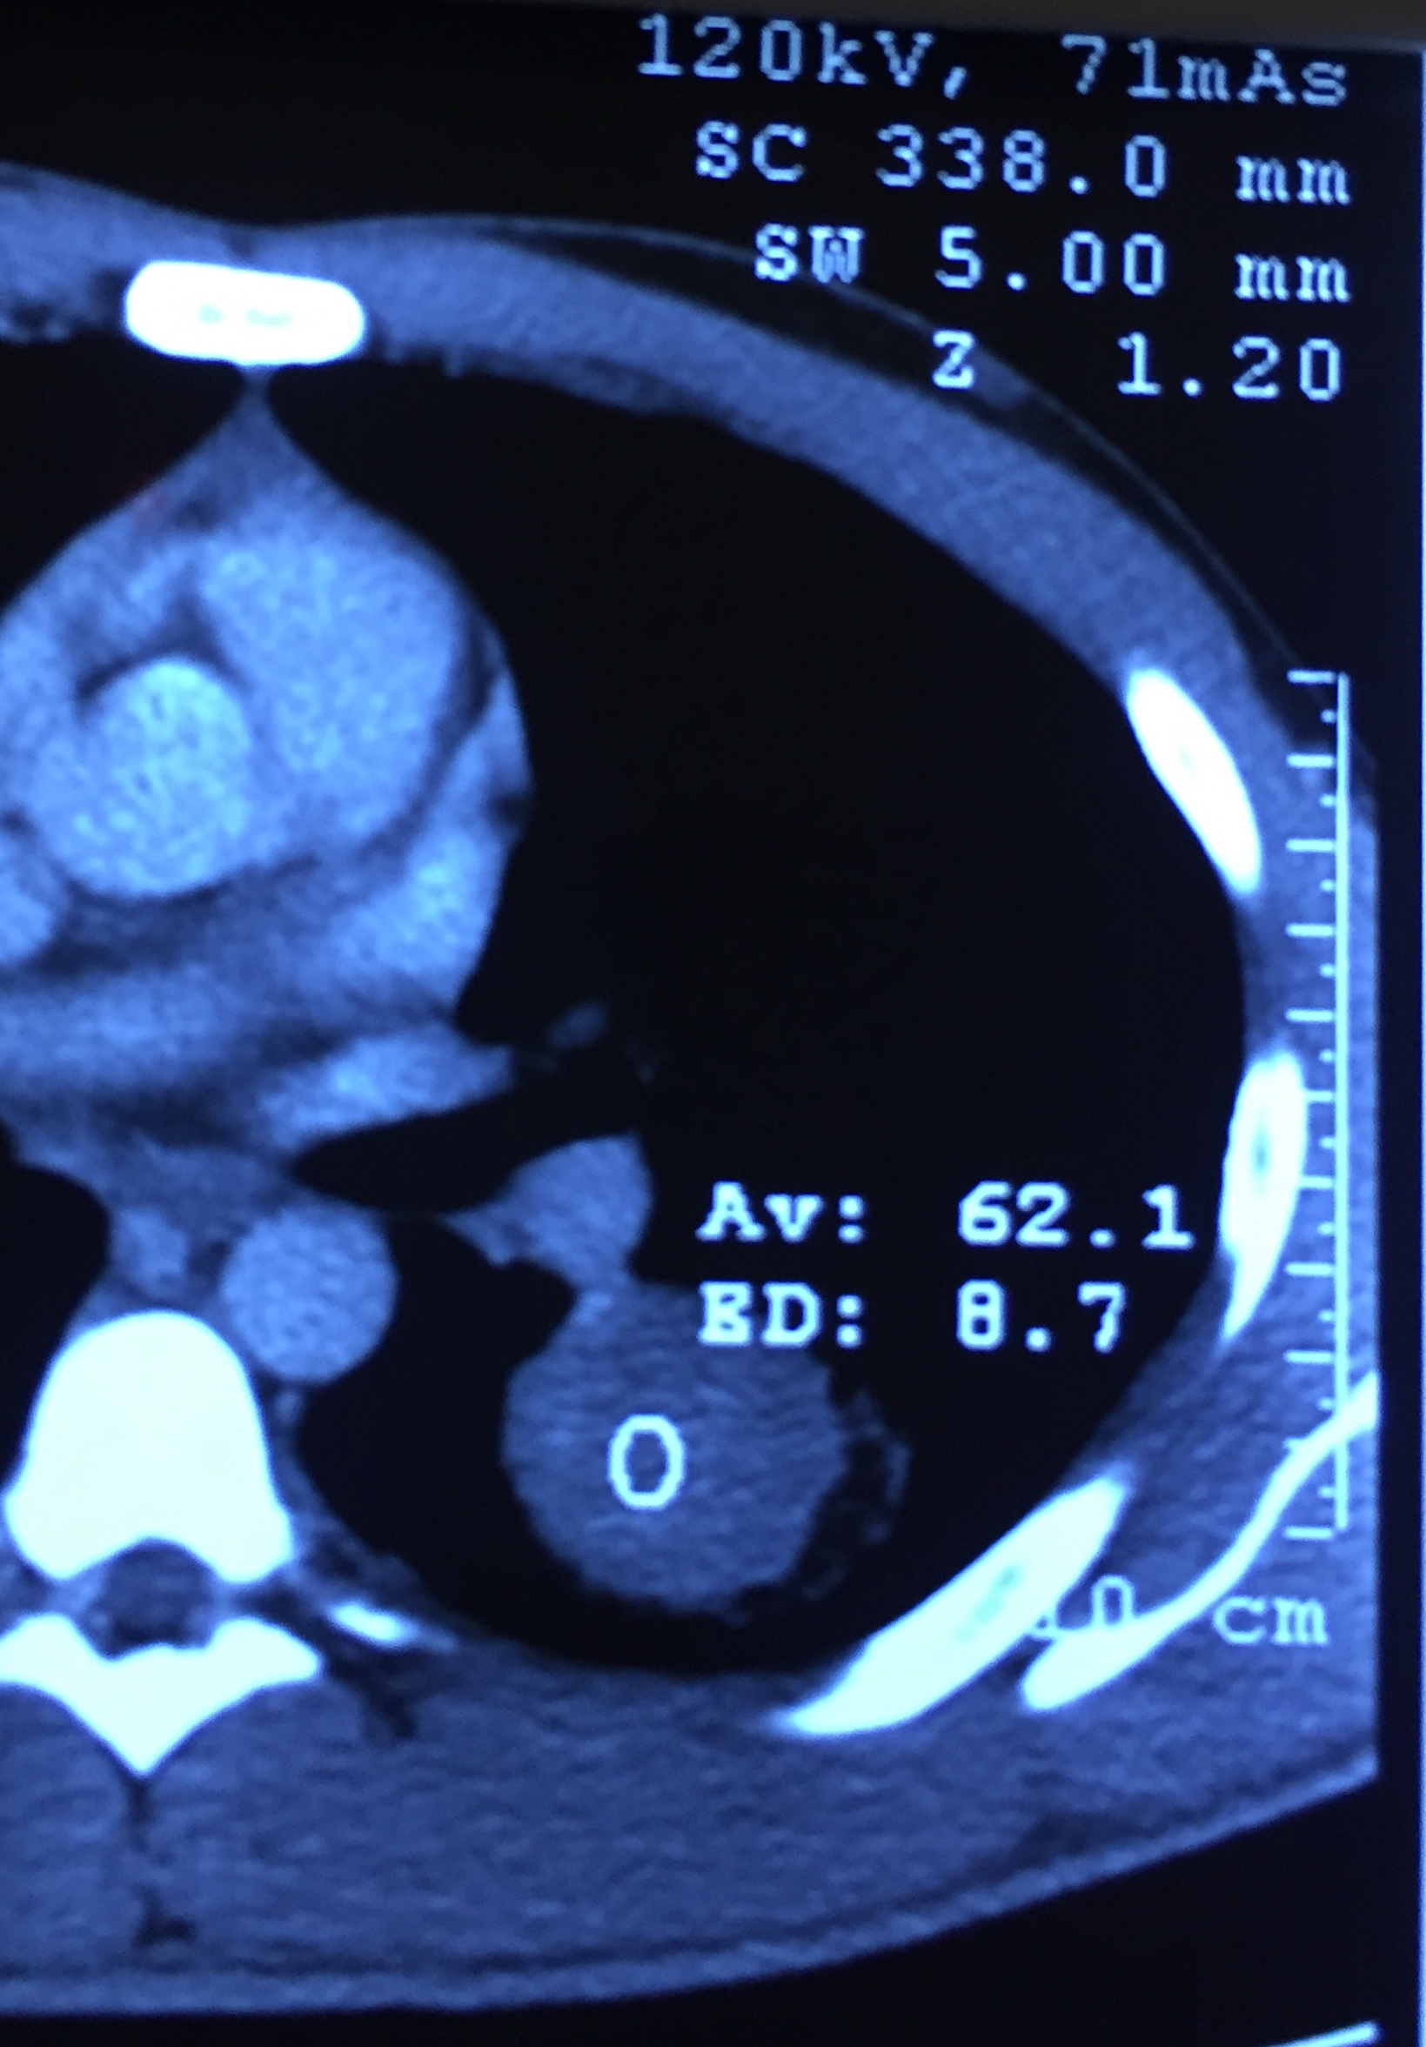
0s
60s
40s
20s
80s
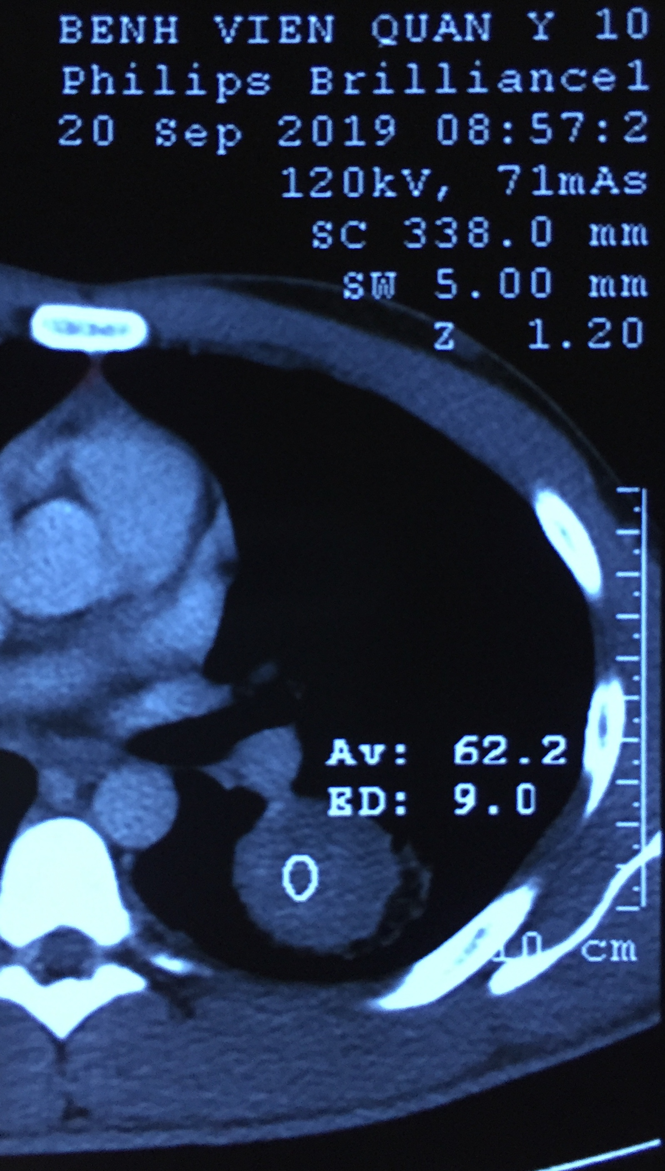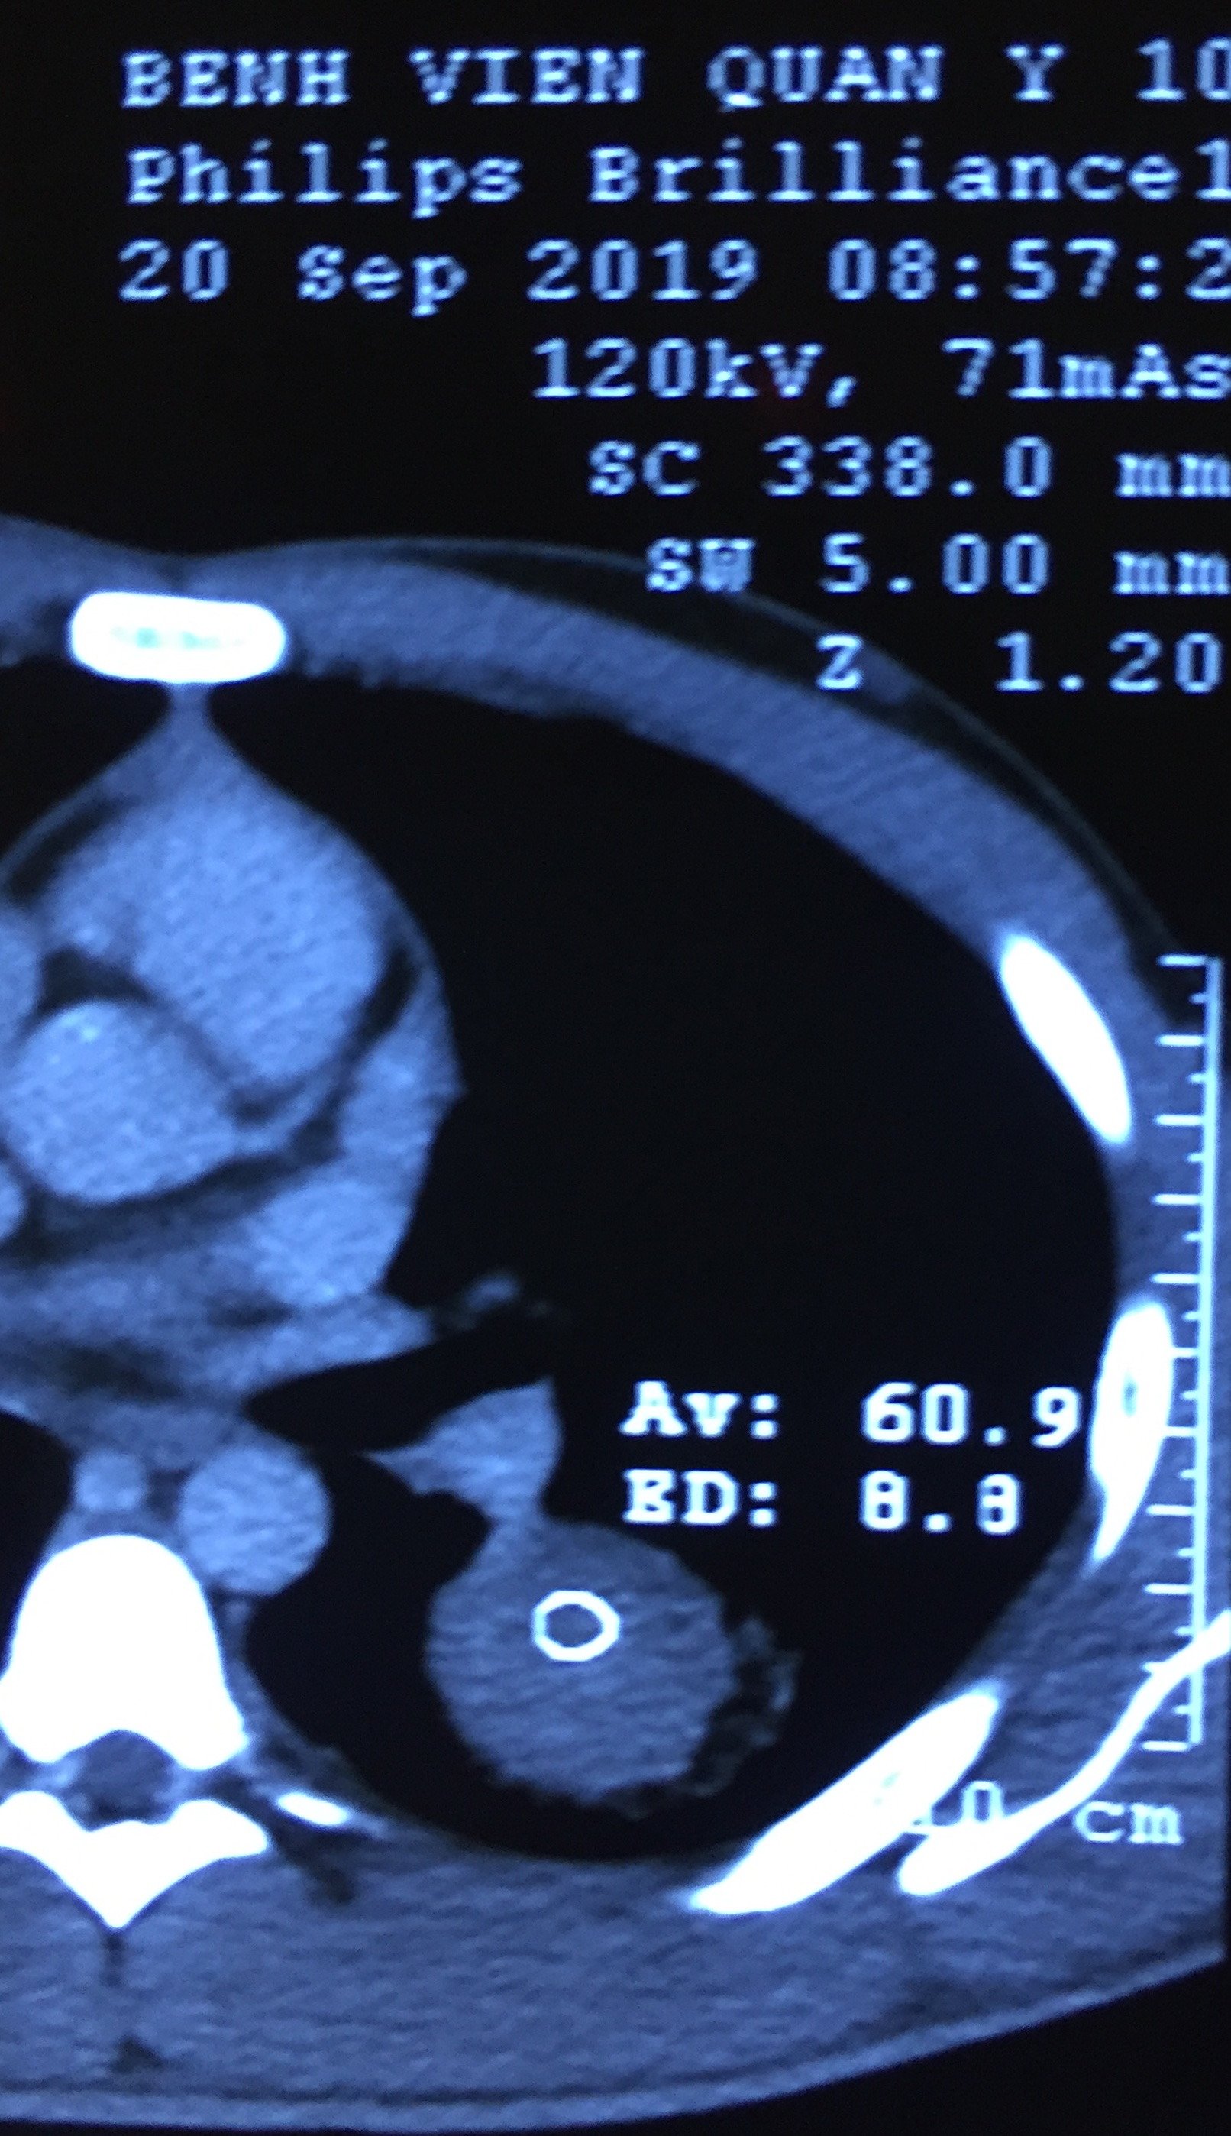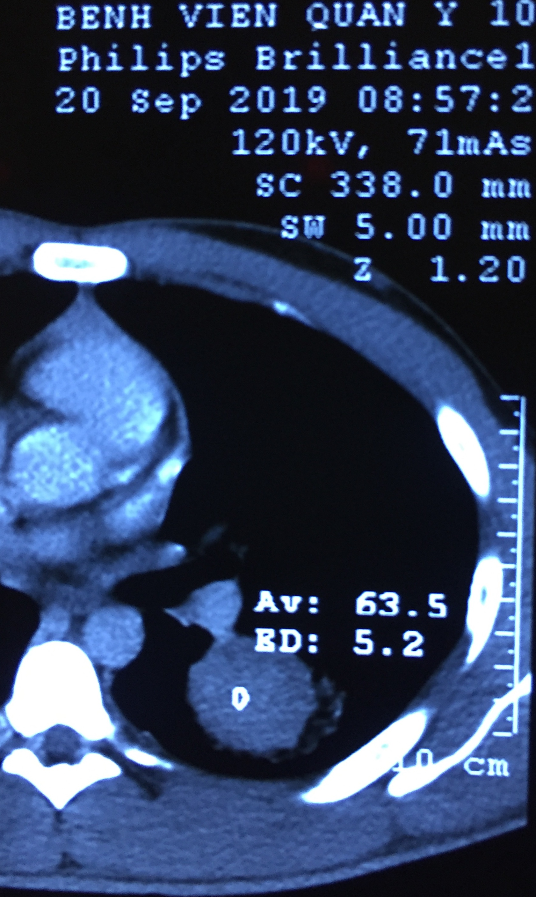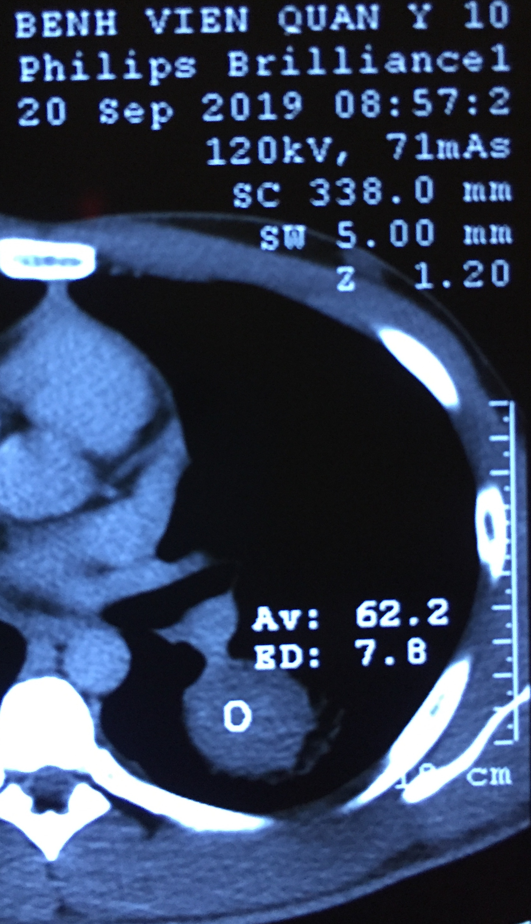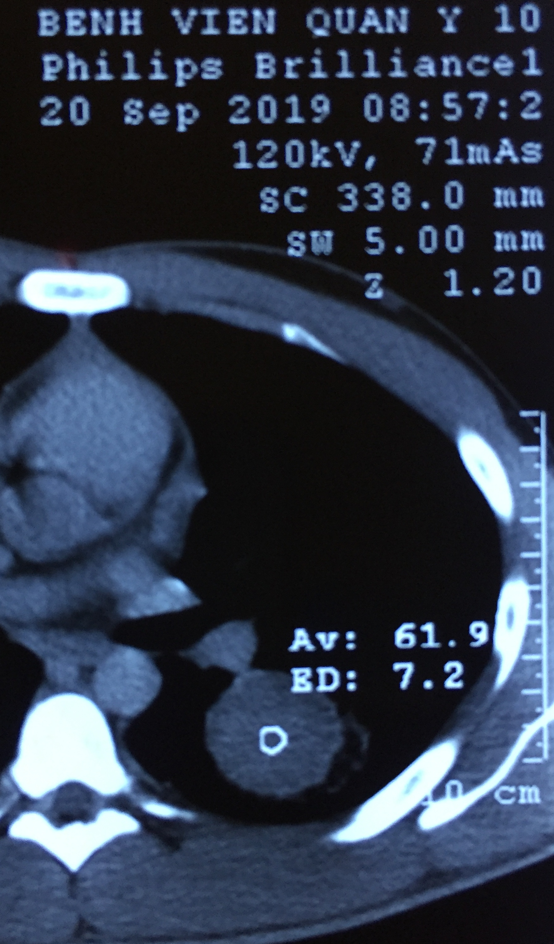
100s
120s
140s
160s
180s

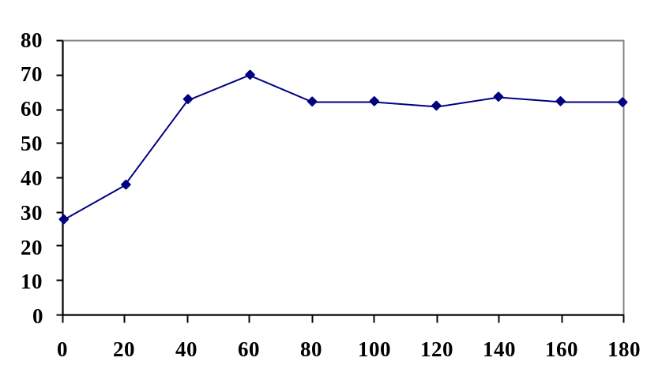Time-attenuation curve obtained at 20-second intervals and at similar levels show enhancement dynamics of the nodule. Peak enhancement is 69.9 HU; net enhancement, 42.1 HU; and time to peak enhancement, 60 seconds.
Attenuation (HU)

