Figure, Supplemental Digital Content: The subgroup analysis of the GLI1 expression and the prognosis of pancreatic cancer patients in the western world.
A.The forset plot of GLI1 expression and the prognosis of pancreatic cancer patient.B.The funnel plot of GLI1 expression and the prognosis of pancreatic cancer patient.
A.
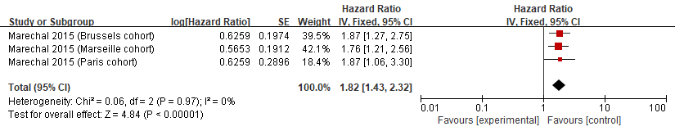
B.
