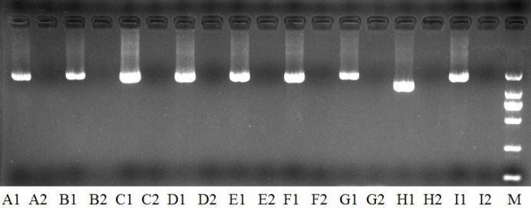Supplementary Figure 1 Platelet mitochondrion whole-gene fragmentation electrophoresis (A1 is a pair of primers to amplify a patient sample, A2 is A a pair of primers to amplify a negative control, and so on).

