Supplementary Digital Content (SDC)
For
Evaluating the Impact of Integrated Behavioral Health Intervention: Evidence from Rhode Island

TABLE OF CONTENTS

Part A: Region of Common Support 2
Part B: Examination of Parallel Trends
B.1. Utilization measures 3
B.2. Cost measures 5
Part C: Testing Maintenance Effects
C.1. Utilization measures 8
C.2. Cost measures 9
Part D: Identifying Outcome Measures in the Claims Database ……………………………………..11
Part E: Cost Categories …………………………………………………………………………………11

Part A. Region of Common Support

Figures A1.1 and A1.2 show the distribution of propensity scores before and after matching. p-score treatment refers to the propensity score of the intervention group while the p-score control refers to the propensity score for the matched comparison group.

Figure A1: Common support before matching
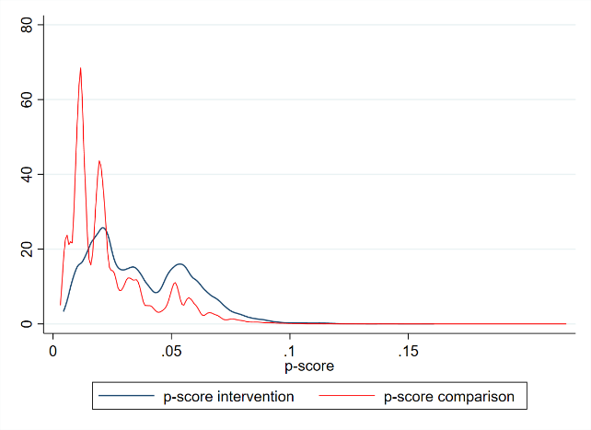

Figure A2: Common support after matching
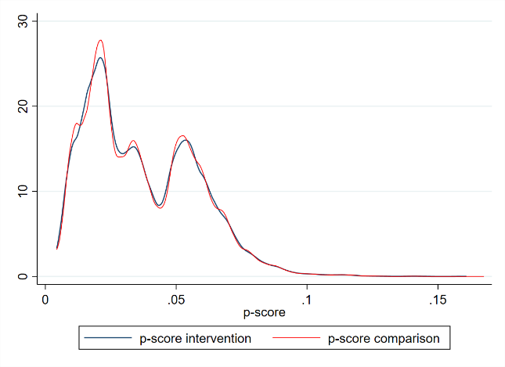

PART B. Examining Outcomes Trends
Figures below (A3 through A10) show linear trends in outcomes, measured per person per quarter, for participants in both the intervention group and the comparison group. Across all the figures, the blue line represents the comparison group and the brown line represents the intervention (IBH) group. Sections B.1 includes figures for utilization otucomes while sections B.2 includes figures for cost outcomes.

B.1. Utilization measures
Figure A3: ED visits Figure A4: Hospitalizations
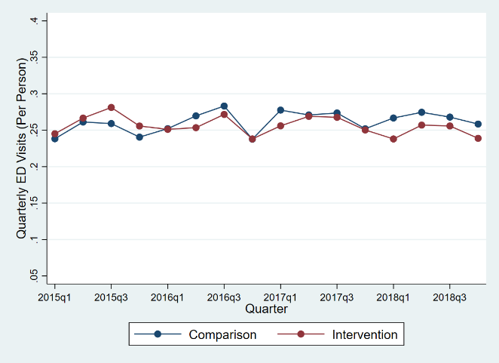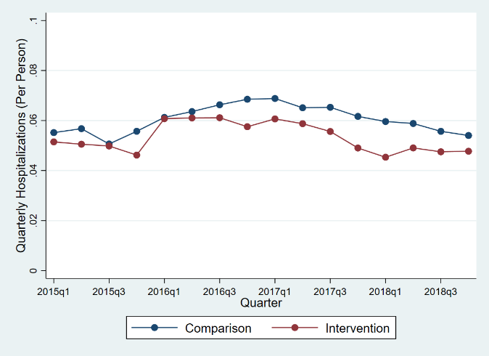

Figure A5: Office visits
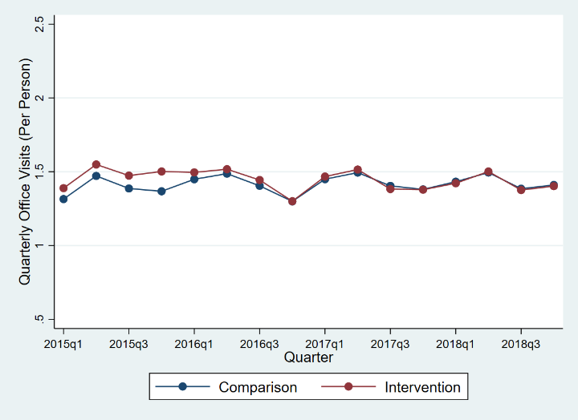

B.2. Cost measures

Figure A6: Outpatient cost Figure A7: Inpatient cost
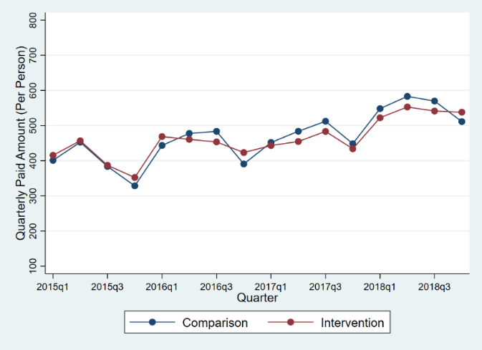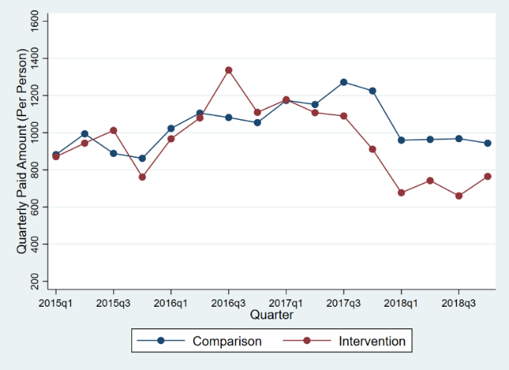

Figure A8: Professional services cost Figure A9: Pharmacy cost
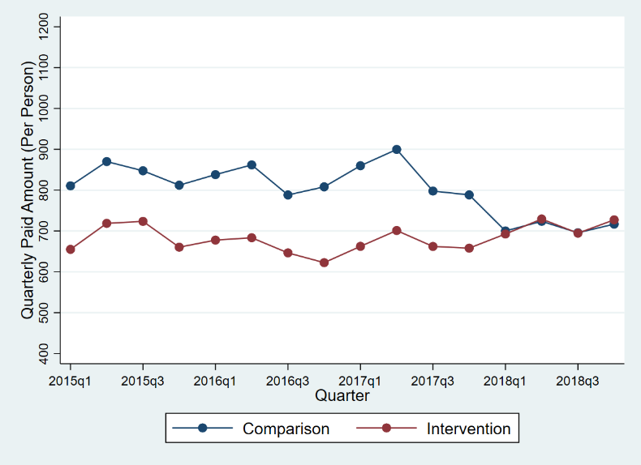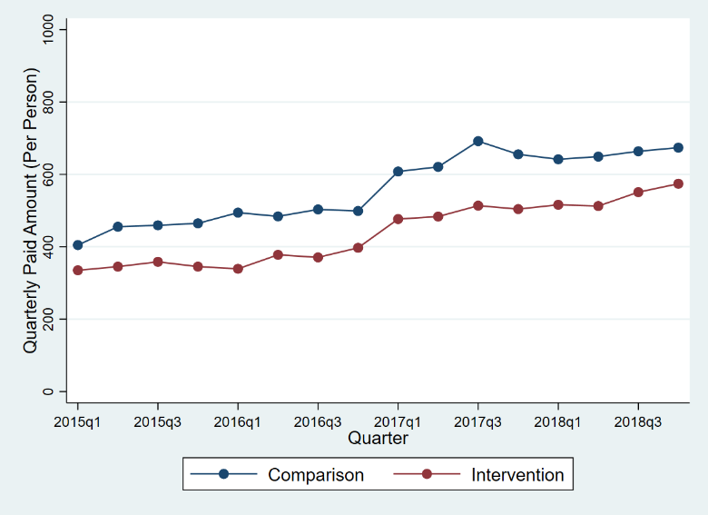

Figure A10: Total cost
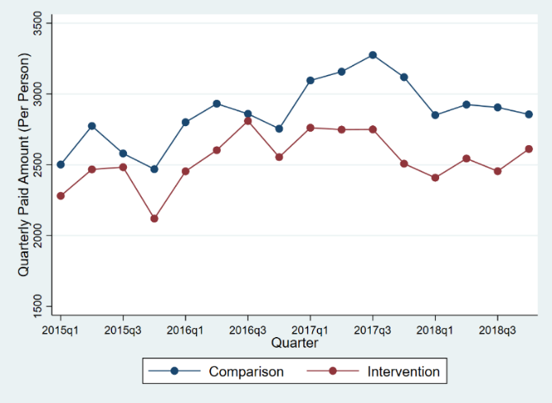

PART C. Testing Maintenance Effects

C.1. Utilization measures

Table A1: Effects of IBH intervention on utilization
Outcome | Comparison |  | Intervention |  | Difference-in-Differences
 | Pre | Post | Pre | Post
ED Visits | 86.6 | 91.3 | 88.5 | 85.6 | -7.6** [-11.9, -3.3]
Office Visits | 467.0 | 491.0 | 500.0 | 492.4 | -31.6*** [-41.5, -21.7]
Hospitalizations | 24.1 | 20.4 | 20.9 | 17.0 | -0.2 [-2.1, 1.7]
Table shows # of ED visits, office visits and hospitalizations per 1000 people per month before (pre) and after (post) the intervention. Difference-in-differences estimates (and their 95% confidence intervals) are shown at the right most column. The value of N, which represents the # of person-months during the study window, is 2,004,356. ED = Emergency Department. IBH = Integrated Behavioral Health.

*** p<0.001
**p<0.01
*p<0.05

C.2. Cost measures

Table A2: Effects of IBH intervention on cost measures
Outcome | Comparison |  | Treatment |  | Difference-in-Differences
 | Pre | Post | Pre | Post
Total cost of care
Model: Part I | 0.680 | 0.697 | 0.704 | 0.704 | 0.913*** [0.882, 0.945]
Model: Part II | 1279.3 | 1462.1 | 1085.8 | 1233.7 | -34.9 [-117.5, 47.6]
Inpatient
Model: Part I | 0.016 | 0.026 | 0.013 | 0.019 | 0.914* [0.840, 0.995]
Model: Part II | 28715.4 | 16393.8 | 31872.0 | 17115.5 | -2434.9 [-6293.9, 1424.0]
Outpatient
Model: Part I | 0.202 | 0.206 | 0.214 | 0.202 | 0.900*** [0.874, 0.928]
Model: Part II | 603.0 | 724.0 | 583.1 | 714.2 | 10.1 [-31.0, 51.1]
Professional
Model: Part I | 0.496 | 0.500 | 0.507 | 0.495 | 0.931*** [0.906, 0.958]
Model: Part II | 460.0 | 488.2 | 411.3 | 445.5 | 6.1 [-8.6, 20.7]
Pharmacy
Model: Part I | 0.517 | 0.564 | 0.527 | 0.564 | 0.960* [0.930, 0.991]
Model: Part II | 246.2 | 363.8 | 184.5 | 283.8 | -18.3 [-46.6, 10.1]
Part I models the probability of observing non-zero costs while part II models the level of costs for those that incur non-zero costs. Difference-in-differences estimates for part I represent odds ratios while for part II represent mean marginal monthly cost per person. The value of N, which represents the # of person-months during the study window, for part I is 2,004,356 and for part II, averages 868,379 across the five cost measures considered. IBH = Integrated Behavioral Health.

***p<0.001
**p<0.01
*p<0.05

D. Identifying Outcome Measures in the Claims Database
- Outpatient visit rates and costs
  - CPT Codes: 99201 – 99205, 99211 - 99215
- ED visit rates and costs
  - CPT Codes: 99281 – 99285, 99288, 99289
  - Revenue center codes: 0451-0459
  - Place of service: emergency room
- Hospitalization rates and costs
  - Unique discharge IDs for each hospitalization

E. Cost Categories
What is Included? ↓ | Cost Measures
 | Inpatient | Outpatient | Professional | Pharmacy
Inp-Acute Inp or Hospital | X
Inp-ICF | X
Inp-Other | X
Inp-Residential | X
Inp-SNF | X
Inp-Swing Beds | X
Emergency |  | X
Surgery |  | X
Observation |  | X
Ambulance |  | X
DME/Prosthetics/Supplies |  | X
Lab/Pathology |  | X
Radiology Services |  | X
Other |  | X
Office Visits |  |  | X
Surgery |  |  | X
Preventive Visits |  |  | X
Administered Drugs |  |  | X
Administration of Drugs |  |  | X
Anesthesia |  |  | X
Pathology/Lab |  |  | X
Radiology |  |  | X
Other |  |  | X
Prescription Drugs |  |  |  | X
Table presents the breakdown of the five cost categories. An X indicates whether or not a particular sub-category is applicable for a given cost category. Inp = Inpatient; ICF= intermediate care facility; SNF = Skilled Nursing Facility; and DME=Durable Medical Equipment. The total cost category, not shown here, is the sum of the four cost categories (i.e., inpatient, outpatient, professional and pharmacy).

