e-Tables
e-Table 1: Disease risk input data
Disease conditions stratified by age group (years) | Hazard Ratio | Data Sources
Breast Cancer
50-59 | 0.76 | Manson JE, et. al. (2013)
60-69 | 0.78 | ¹Manson JE, et. al. (2013)
70-79 | 0.85 | ¹Manson JE, et. al. (2013)
All | 0.79 | ¹Manson JE, et. al. (2013)
CHD
50-59 | 0.65 | ¹Manson JE, et. al. (2013)
60-69 | 1.00 | ¹Manson JE, et. al. (2013)
70-79 | 1.01 | ¹Manson JE, et. al. (2013)
All | 0.94 | ¹Manson JE, et. al. (2013)
Stroke
50-59 | 0.96 | ¹Manson JE, et. al. (2013)
60-69 | 1.25 | ¹Manson JE, et. al. (2013)
70-79 | 1.12 | ¹Manson JE, et. al. (2013)
All | 1.15 | ¹Manson JE, et. al. (2013)
Pulmonary Embolism
50-59 | 1.06 | ¹Manson JE, et. al. (2013)
60-69 | 1.45 | ¹Manson JE, et. al. (2013)
70-79 | 0.82 | ¹Manson JE, et. al. (2013)
All | 1.15 | ¹Manson JE, et. al. (2013)
Colorectal Cancer
50-59 | 0.76 | ¹Manson JE, et. al. (2013)
60-69 | 1.04 | ¹Manson JE, et. al. (2013)
70-79 | 1.61 | ¹Manson JE, et. al. (2013)
All | 1.13 | ¹Manson JE, et. al. (2013)
Hip Fracture
50-59 | 0.88 | ¹Manson JE, et. al. (2013)
60-69 | 0.95 | ¹Manson JE, et. al. (2013)
70-79 | 0.89 | ¹Manson JE, et. al. (2013)
All | 0.91 | ¹Manson JE, et. al. (2013)
Global Index
50-59 | 0.82 | ¹Manson JE, et. al. (2013)
60-69 | 1.03 | ¹Manson JE, et. al. (2013)
70-79 | 1.10 | ¹Manson JE, et. al. (2013)
All | 1.02 | ¹Manson JE, et. al. (2013)

e-Table 2: Medical expenditure input data
Disease condition | Expenditure ($) | Data source
Base-case analysis
Breast Cancer | 6027.91 | MEPS
CHD | 4415.65 | MEPS
Stroke | 5761.94 | MEPS
Pulmonary Embolism | 4257.01 | MEPS
Colorectal Cancer | 13618.06 | MEPS
Hip Fracture | 15812.83 | MEPS
Global Index | 8315.01 | MEPS
Sensitivity analysisª
Breast Cancer | 5299.88 | Shreibati JB, et. al. (2018)
CHD | 1336.91 | ¹Shreibati JB, et. al. (2018)
Stroke | 2809.64 | ¹Shreibati JB, et. al. (2018)
Pulmonary Embolism | 1089.45 | ¹Shreibati JB, et. al. (2018)
Colorectal Cancer | 4526.06 | ¹Shreibati JB, et. al. (2018)
Hip Fracture | 2316.45 | ¹Shreibati JB, et. al. (2018)
Global Index | 2632.56 | ¹Shreibati JB, et. al. (2018)
ªThe base-case analysis was repeated using medical expenditure data from WHI participants with Medicare fee-for-service benefits. This expenditure data (1998 – 2012) comes directly from WHI participants based on healthcare spending Medicare Carrier, Hospice, Home Health and Durable Medical Equipment claims.

e-Table 3: Differences in medical expenditures (using Medicare data) for treating disease conditions between real and hypothetical non-WHI scenarios over a 13-year cumulative period (2003-2015): Only Women with Hysterectomy
Disease conditions stratified by age groups (years) | Counts of disease attributable to ET (rates in ET group minus rate in placebo) | ªCumulative medical expenditure differences between real and hypothetical non-WHI scenarios ($millions)
 |  | Annual | 13-Year (95%LCL,95%UCL)
Breast Cancer
50-59 | -10109 | -53 | -696
60-69 | -15426 | -82 | -1063
70-79 | -6181 | -33 | -426
Coronary heart disease (CHD)
50-59 | -15887 | -21 | -276
60-69 | 0 | 0 | 0
70-79 | 0 | 0 | 0
Stroke
50-59 | -2888 | -8 | -105
60-69 | 17355 | 49 | 634
70-79 | 8651 | 24 | 316
Pulmonary Embolism
50-59 | 1446 | 2 | 20
60-69 | 11569 | 13 | 164
70-79 | -6179 | -7 | -87
Colorectal Cancer
50-59 | -4333 | -20 | -255
60-69 | 0 | 0 | 0
70-79 | 13599 | 62 | 800
Hip Fracture
50-59 | -1447 | -3 | -43
60-69 | 0 | 0 | 0
70-79 | -8653 | -20 | -260
Global Index
50-59 | -37549 | -99 | -1285
60-69 | 13495 | 36 | 462
70-79 | 40792 | 107 | 1396
The unit expenditure per disease based on Medicare data are: $5299.88, breast cancer; $1336.91, CHD; $2809.64, stroke; $1089.45, PE; $4526.06, colorectal cancer; $2316.45, hip fracture; $2632.56, global index
ªThe annual expenditures accrued during each year of the observation period, 2003-2015, were summed up to generate 13-year cumulative expenditures associated with treating chronic condition. A positive difference in the medical expenditures corresponds to excess cost of treatment of excess diseases. Conversely, negative differences correspond to monetary savings in medical expenditures for diseases averted.

e-Table 4: Differences in medical expenditures (using Medicare data) for treating disease conditions between real and hypothetical non-WHI scenarios over a 13-year cumulative period (2003-2015) compared to a pre-WHI period from 1996-2001: Only Women with Hysterectomy
Disease conditions stratified by age groups (years) | Counts of disease attributable to ET (rates in ET group minus rate in placebo) | ªCumulative medical expenditure differences between real and hypothetical non-WHI scenarios ($millions)
 |  | Annual | 13-Year (95%LCL,95%UCL)
Breast Cancer
50-59 | -12614 | -76 | -988
60-69 | -20277 | -122 | -1589
70-79 | -8203 | -49 | -643
Coronary heart disease (CHD)
50-59 | -19820 | -87 | -1138
60-69 | 0 | 0 | 0
70-79 | 0 | 0 | 0
Stroke
50-59 | -3602 | -21 | -270
60-69 | 22814 | 131 | 1709
70-79 | 11484 | 66 | 860
Pulmonary Embolism
50-59 | 1806 | 8 | 100
60-69 | 15210 | 65 | 842
70-79 | -8201 | -35 | -454
Colorectal Cancer
50-59 | -5406 | -74 | -957
60-69 | 0 | 0 | 0
70-79 | 18051 | 246 | 3196
Hip Fracture
50-59 | -1803 | -28 | -371
60-69 | 0 | 0 | 0
70-79 | -11485 | -182 | -2361
Global Index
50-59 | -46850 | -389 | -5064
60-69 | 17742 | 148 | 1918
70-79 | 54149 | 450 | 5853
The unit expenditure per disease based on Medicare data are: $5299.88, breast cancer; $1336.91, CHD; $2809.64, stroke; $1089.45, PE; $4526.06, colorectal cancer; $2316.45, hip fracture; $2632.56, global index
ªThe annual expenditures accrued during each year of the observation period, 2003-2015, were summed up to generate 13-year cumulative expenditures associated with treating chronic condition. A positive difference in the medical expenditures corresponds to excess cost of treatment of excess diseases. Conversely, negative differences correspond to monetary savings in medical expenditures for diseases averted.

e-Table 5a: Differences in medical expenditures for treating disease conditions between real and hypothetical non-WHI scenarios over a 13-year cumulative period (2003-2015): Only Women with Hysterectomy using LCL of Hazard Ratio
Disease conditions stratified by age groups (years) | Counts of disease attributable to ET (rates in ET group minus rate in placebo) | ªCumulative medical expenditure differences between real and hypothetical non-WHI scenarios ($millions)
 |  | Annual | 13-Year (95%LCL,95%UCL)
Breast Cancer
50-59 | -24552 | -148 | -1924
60-69 | -32776 | -198 | -2574
70-79 | -23486 | -142 | -1846
Coronary heart disease (CHD)
50-59 | -30329 | -134 | -1742
60-69 | -26992 | -119 | -1547
70-79 | -29667 | -131 | -1703
Stroke
50-59 | -14442 | -83 | -1079
60-69 | -3856 | -22 | -286
70-79 | -17306 | -100 | -1300
Pulmonary Embolism
50-59 | -7221 | -31 | -403
60-69 | -1928 | -8 | -104
70-79 | -19778 | -84 | -1092
Colorectal Cancer
50-59 | -12998 | -177 | -2301
60-69 | -13496 | -184 | -2392
70-79 | 0 | 0 | 0
Hip Fracture
50-59 | -7221 | -114 | -1482
60-69 | -13496 | -213 | -2769
70-79 | -32139 | -508 | -6604
Global Index
50-59 | -69324 | -576 | -7488
60-69 | -25064 | -208 | -2704
70-79 | -19778 | -164 | -2132
The unit expenditure per disease based on MEPS (2003-2015) data are: $6027.91, breast cancer; $4415.65, CHD; $5761.94, stroke; $4257.01, PE; $13618.06, colorectal cancer; $15812.83, hip fracture; $8315.01, global index. The unit expenditure for the global index was calculated as the arithmetic average of the 6 comprising diseases.
ªThe annual expenditures accrued during each year of the observation period, 2003-2015, were summed up to generate 13-year cumulative expenditures associated with treating chronic condition. A positive difference in the medical expenditures corresponds to excess cost of treatment of excess diseases. Conversely, negative differences correspond to monetary savings in medical expenditures for diseases averted.

e-Table 5b: Differences in medical expenditures for treating disease conditions between real and hypothetical non-WHI scenarios over a 13-year cumulative period (2003-2015): Only Women with Hysterectomy using UCL of Hazard Ratio
Disease conditions stratified by age groups (years) | Counts of disease attributable to ET (rates in ET group minus rate in placebo) | ªCumulative medical expenditure differences between real ($millions)
 |  | Annual | 13-Year
Breast Cancer
50-59 | 4333 | 26 | 338
60-69 | 1928 | 12 | 156
70-79 | 11125 | 67 | 871
Coronary heart disease (CHD)
50-59 | -1444 | -6 | -78
60-69 | 26992 | 119 | 1547
70-79 | 29667 | 131 | 1703
Stroke
50-59 | 8665 | 50 | 650
60-69 | 38560 | 222 | 2886
70-79 | 34611 | 199 | 2587
Pulmonary Embolism
50-59 | 10110 | 43 | 559
60-69 | 25064 | 107 | 1391
70-79 | 7417 | 32 | 416
Colorectal Cancer
50-59 | 4333 | 59 | 767
60-69 | 13496 | 184 | 2392
70-79 | 27194 | 370 | 4810
Hip Fracture
50-59 | 4333 | 69 | 897
60-69 | 13496 | 213 | 2769
70-79 | 14833 | 235 | 3055
Global Index
50-59 | -5777 | -48 | -624
60-69 | 52056 | 433 | 5629
70-79 | 101361 | 843 | 10959
The unit expenditure per disease based on MEPS (2003-2015) data are: $6027.91, breast cancer; $4415.65, CHD; $5761.94, stroke; $4257.01, PE; $13618.06, colorectal cancer; $15812.83, hip fracture; $8315.01, global index. The unit expenditure for the global index was calculated as the arithmetic average of the 6 comprising diseases.
ªThe annual expenditures accrued during each year of the observation period, 2003-2015, were summed up to generate 13-year cumulative expenditures associated with treating chronic condition. A positive difference in the medical expenditures corresponds to excess cost of treatment of excess diseases. Conversely, negative differences correspond to monetary savings in medical expenditures for diseases averted.

e-Figures
e-Figure 1: Temporal trends of prevalence of estrogen-alone utilization before and after publication of the WHI ET results in the overall population of women
e-Figure 1a: Trends of prevalence in 50-59 year olds overall
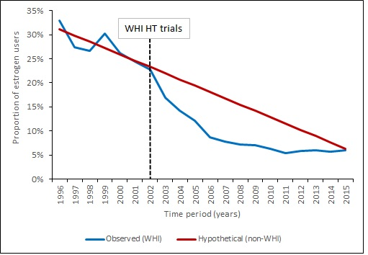

e-Figure 1b: Trends of prevalence in 60-69 year olds overall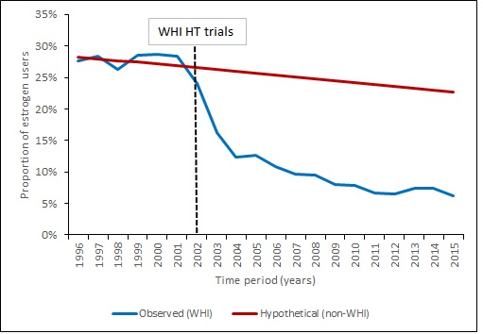

e-Figure 1c: Trends of prevalence in 70-79 year olds overall
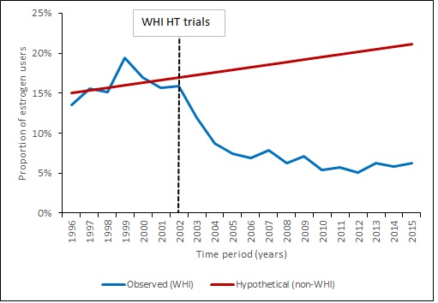

e-Figure 2: Trends in excess global disease index attributable to estrogen therapy between observed and hypothetical non-WHI scenarios stratified by age groups among women with a history of hysterectomy

e-Figure 2a: Trends of attributable global disease index among 50-59 year group among women with a history of hysterectomy
WHI HT trials

e-Figure 2b: Trends of attributable global disease index among 60-69 year group among women with a history of hysterectomy
WHI HT trials

e-Figure 2c: Trends of attributable global disease index among 70-79 year group among women with a history of hysterectomy

e-Figure 3: Trends in excess individual chronic diseases attributable to estrogen therapy between observed and hypothetical non-WHI scenarios stratified by age groups
e-Figure 3a: Trends of attributable breast cancer among 50-59 year group with history of hysterectomy
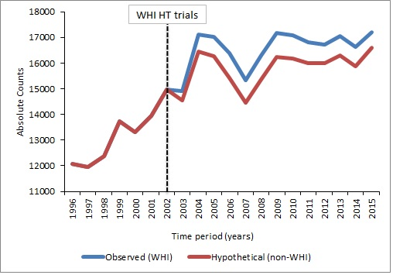

e-Figure 3b: Trends of attributable breast cancer among 60-69 year group with history of hysterectomy
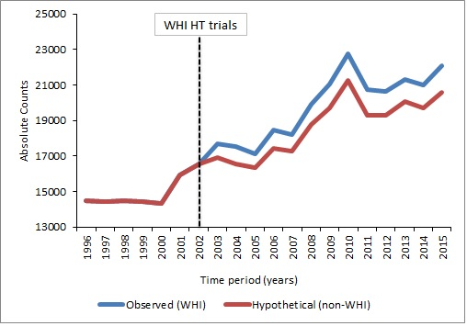

e-Figure 3c: Trends of attributable breast cancer among 70-79 year group with history of hysterectomy
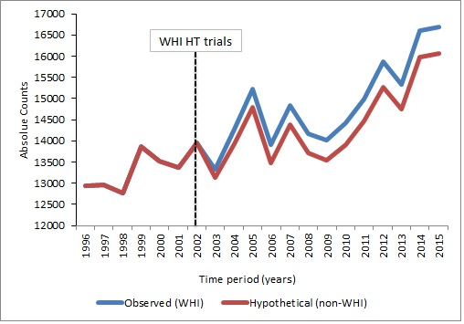

e-Figure 3d: Trends of attributable CHD among 50-59 year group with history of hysterectomy
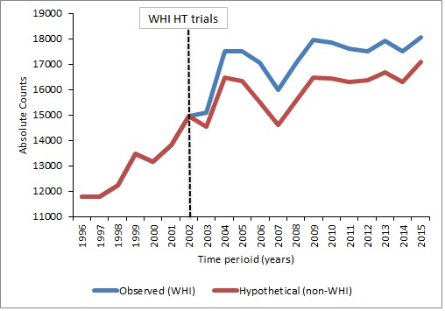

e-Figure 3e: Trends of attributable CHD among 60-69 year group with history of hysterectomy
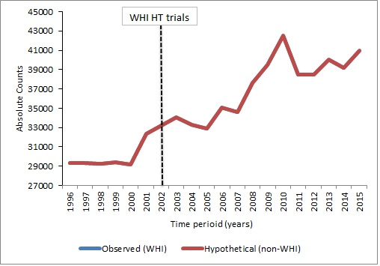

e-Figure 3f: Trends of attributable CHD among 70-79 year group with history of hysterectomy
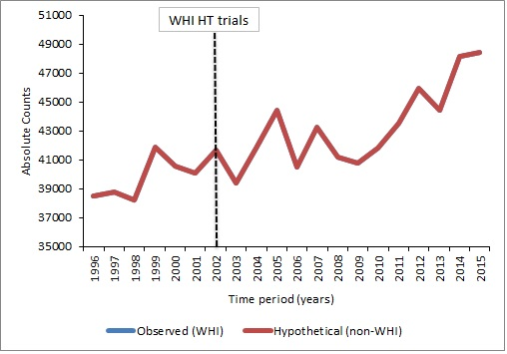

e-Figure 3g: Trends of attributable stroke among 50-59 year group with history of hysterectomy
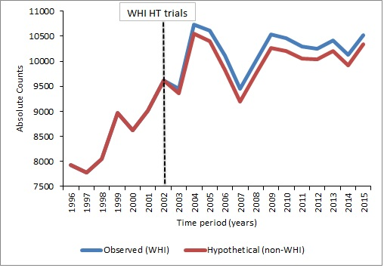

e-Figure 3h: Trends of attributable stroke among 60-69 year group with history of hysterectomy
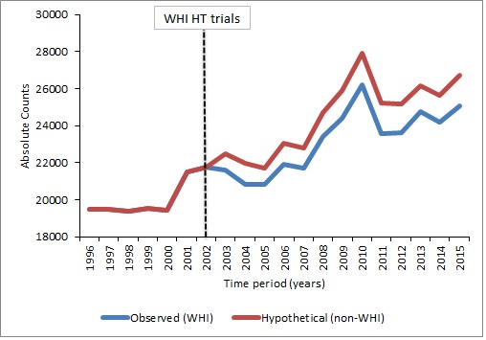

e-Figure 3i: Trends of attributable stroke among 70-79 year group with history of hysterectomy
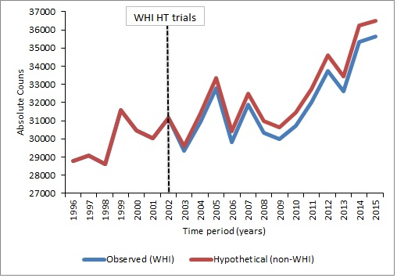

e-Figure 3j: Trends of attributable pulmonary embolism among 50-59 year group with history of hysterectomy
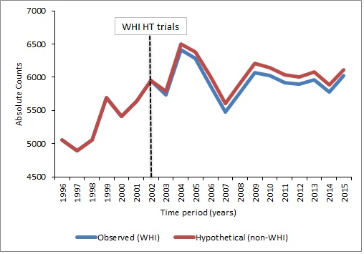

e-Figure 3k: Trends of attributable pulmonary embolism among 60-69 year group with history of hysterectomy
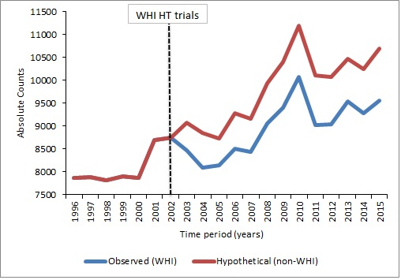

e-Figure 3l: Trends of attributable pulmonary embolism among 70-79 year group with history of hysterectomy
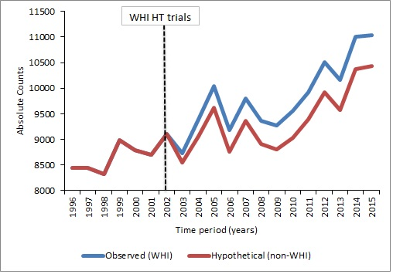

e-Figure 3m: Trends of attributable colorectal cancer among 50-59 year group with history of hysterectomy
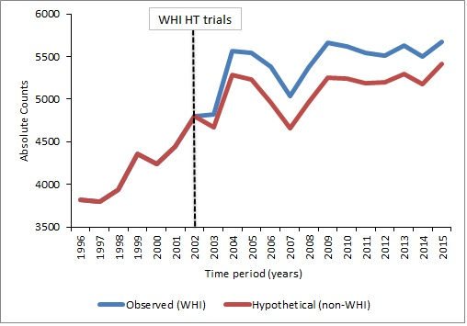

e-Figure 3n: Trends of attributable colorectal cancer among 60-69 year group with history of hysterectomy
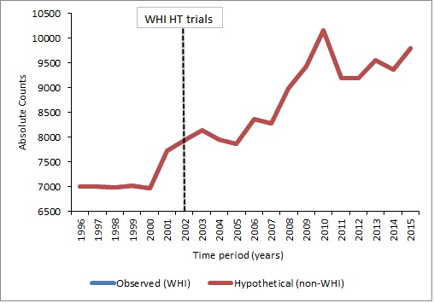

e-Figure 3o: Trends of attributable colorectal cancer among 70-79 year group with history of hysterectomy
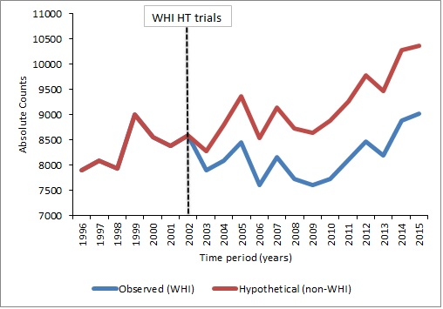

e-Figure 3p: Trends of attributable hip fracture among 50-59 year group with history of hysterectomy
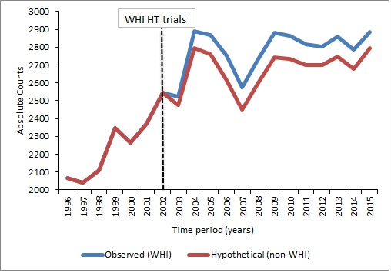

e-Figure 3q: Trends of attributable hip fracture among 60-69 year group with history of hysterectomy
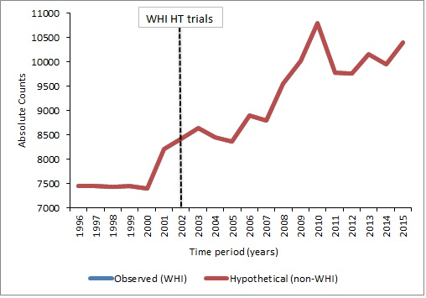

e-Figure 3r: Trends of attributable hip fracture among 70-79 year group with history of hysterectomy
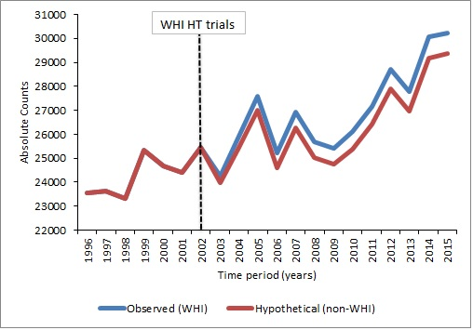
e-Figure 4: Trends in excess individual chronic diseases attributable to estrogen therapy between observed and hypothetical non-WHI scenarios stratified by age groups: Overall women with or without hysterectomy.
e-Figure 4a: Trends of attributable breast cancer among 50-59 year group overall
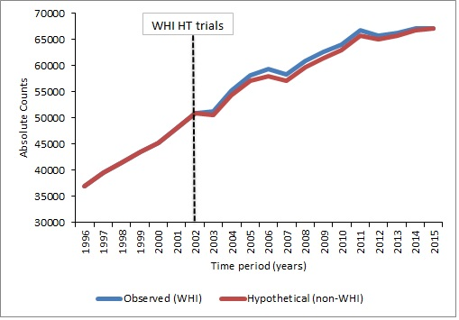

e-Figure 4b: Trends of attributable breast cancer among 60-69 year group overall
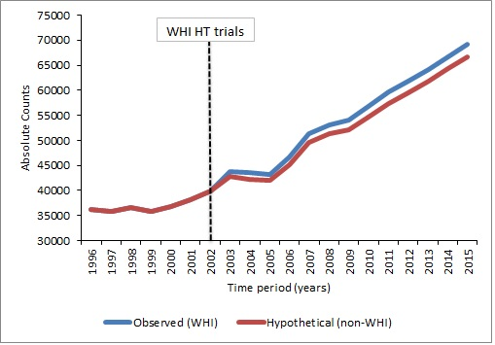

e-Figure 4c: Trends of attributable breast cancer among 70-79 year group overall
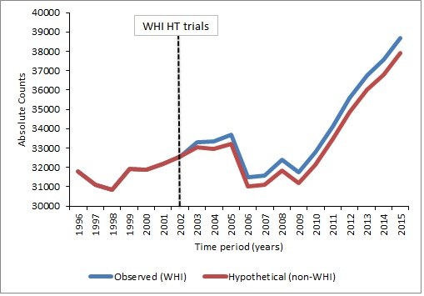

e-Figure 4d: Trends of attributable CHD among 50-59 year group overall
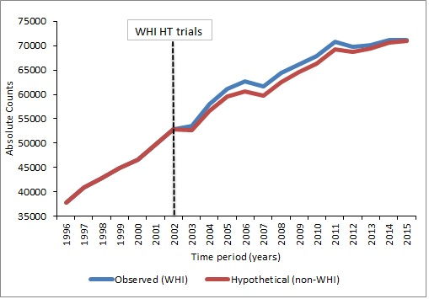

e-Figure 4e: Trends of attributable CHD among 60-69 year group overall
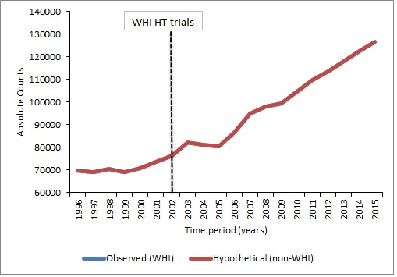

e-Figure 4f: Trends of attributable CHD among 70-79 year group overall
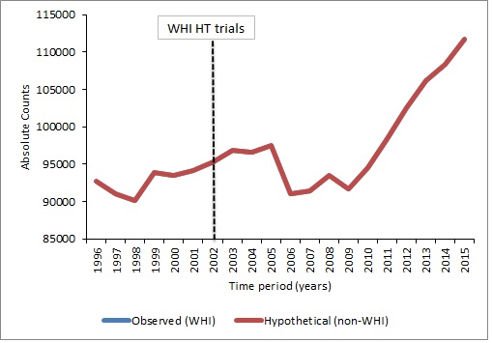

e-Figure 4g: Trends of attributable stroke among 50-59 year group overall
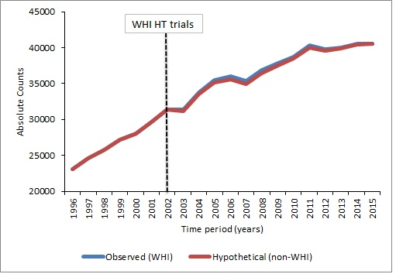

e-Figure 4h: Trends of attributable stroke among 60-69 year group overall
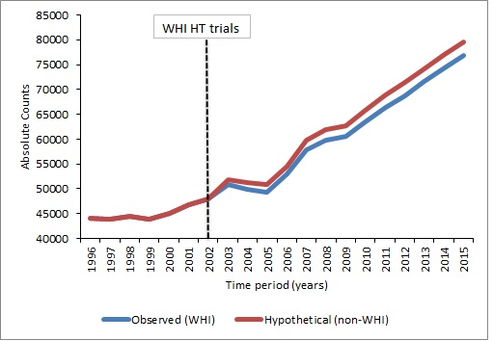

e-Figure 4i: Trends of attributable stroke among 70-79 year group overall
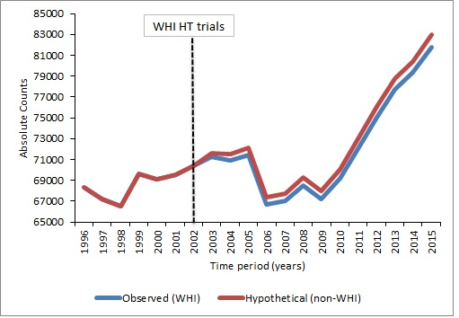

e-Figure 4j: Trends of attributable pulmonary embolism among 50-59 year group overall
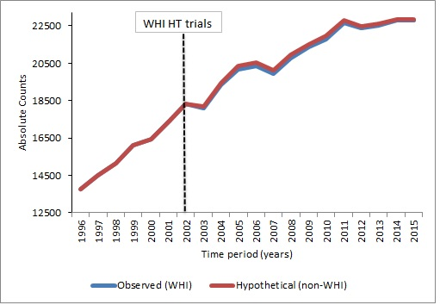

e-Figure 4k: Trends of attributable pulmonary embolism among 60-69 year group overall
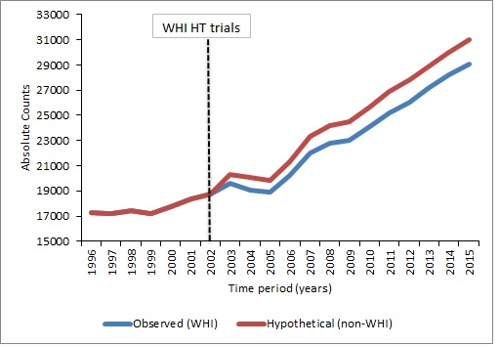

e-Figure 4l: Trends of attributable pulmonary embolism among 70-79 year group overall
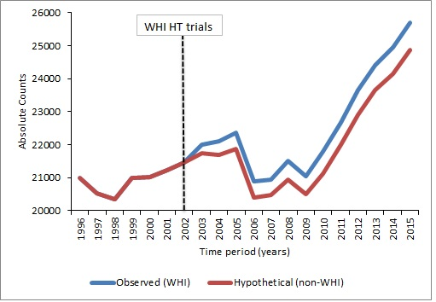

e-Figure 4m: Trends of attributable colorectal cancer among 50-59 year group overall
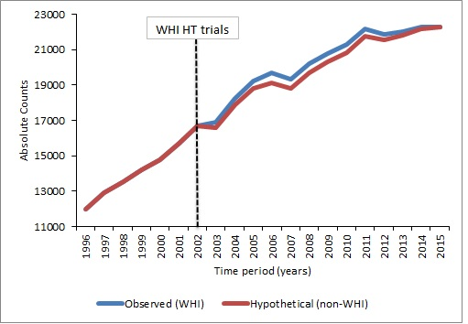

e-Figure 4n: Trends of attributable colorectal cancer among 60-69 year group overall
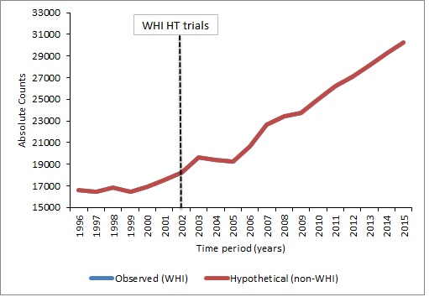

e-Figure 4o: Trends of attributable colorectal cancer among 70-79 year group overall
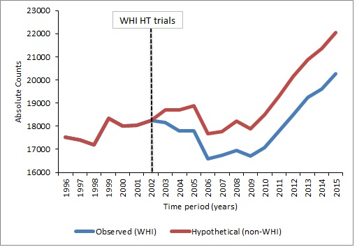

e-Figure 4p: Trends of attributable hip fracture among 50-59 year group overall
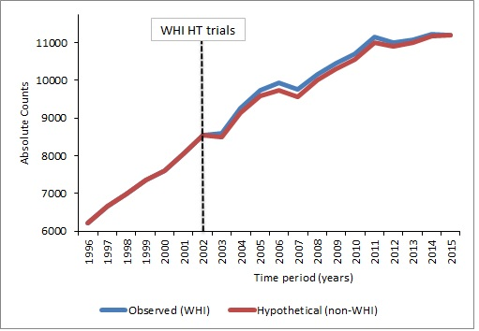

e-Figure 4q: Trends of attributable hip fracture among 60-69 year group overall
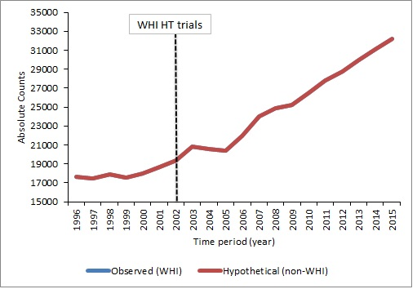

e-Figure 4r: Trends of attributable hip fracture among 70-79 year group overall
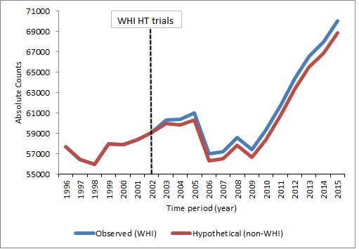

e-Figure 4s: Trends of attributable global index among 50-59 year group overall
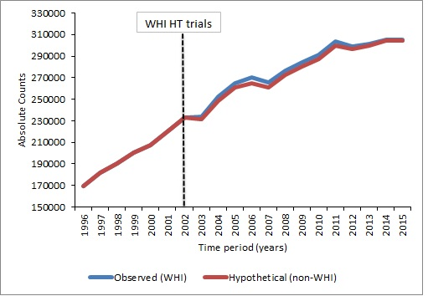

e-Figure 4t: Trends of attributable global index among 60-69 year group overall
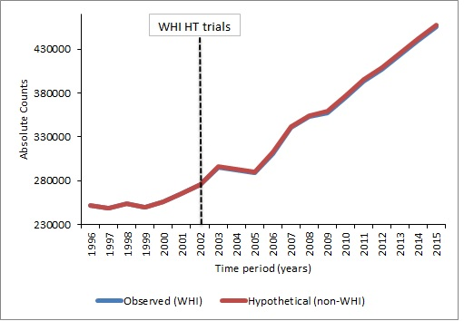

e-Figure 4u: Trends of attributable global index among 70-79 year group overall
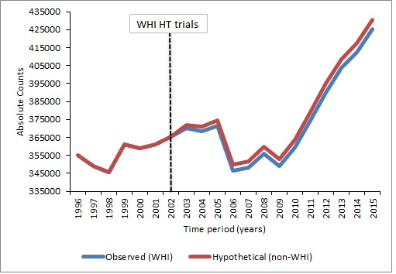

e-Figure 5: Temporal trends of incidence (new users) of estrogen-alone utilization before and after publication of the WHI ET results, overall and among women with a history of hysterectomy
e-Figure 5a: Temporal trends of new-user 50-59 year-old women with a history of hysterectomy before and after publication of the WHI ET results
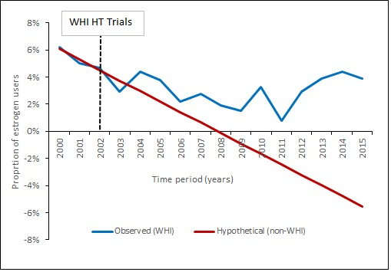
e-Figure 5b: Temporal trends of new-user 60-69 year-old women with a history of hysterectomy before and after publication of the WHI ET results
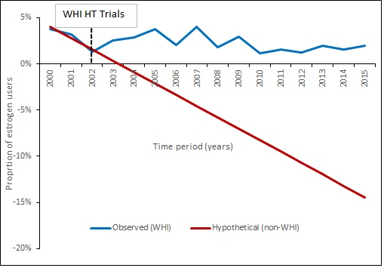

e-Figure 5c: Temporal trends of new-user 70-79 year-old women with a history of hysterectomy before and after publication of the WHI ET results
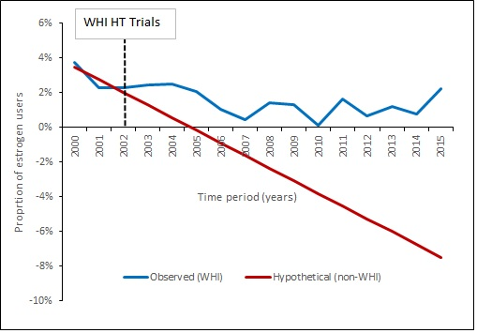

e-Figure 5d: Temporal trends of new-user 50-59 year-old women overall before and after publication of the WHI ET results
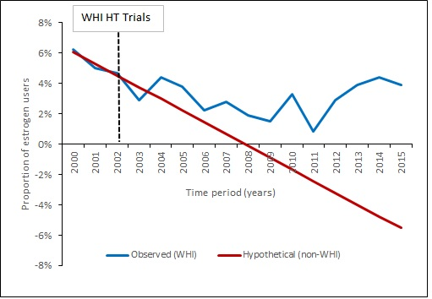

e-Figure 5e: Temporal trends of new-user 60-69 year-old women overall before and after publication of the WHI ET results
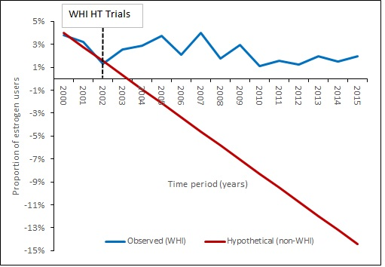

e-Figure 5f: Temporal trends of new-user 70-79 year-old women overall before and after publication of the WHI ET results
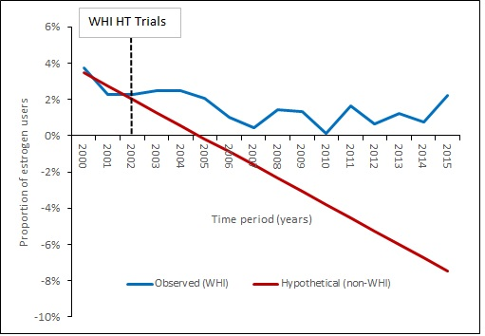

Manson JE, Chlebowski RT, Stefanick ML, Aragaki AK, Rossouw JE, Prentice RL, Anderson G, Howard BV, Thomson CA, LaCroix AZ, Wactawski-Wende J, Jackson RD, Limacher M, Margolis KL, Wassertheil-Smoller S, Beresford SA, Cauley JA, Eaton CB, Gass M, Hsia J, Johnson KC, Kooperberg C, Kuller LH, Lewis CE, Liu S, Martin LW, Ockene JK, O'Sullivan MJ, Powell LH, Simon MS, Van Horn L, Vitolins MZ, Wallace RB. Menopausal hormone therapy and health outcomes during the intervention and extended poststopping phases of the Women's Health Initiative randomized trials. JAMA. 2013;310(13):1353-68. Epub 2013/10/03. doi: 10.1001/jama.2013.278040. PubMed PMID: 24084921; PMCID: PMC3963523.
Shreibati JB, Manson JE, Margolis KL, Chlebowski RT, Stefanick ML, Hlatky MA. Impact of hormone therapy on Medicare spending in the Women's Health Initiative randomized clinical trials. Am Heart J. 2018;198:108- 14. Epub

